UNIT 5 · LESSON 5 STANDARD 6.GR.2

Determine the Volume of Rectangular Prisms (Flagship)
Student Notes Packet
Name: ______________________ Date: ____________ Period: ________
Level 3 · Enrichment

Today's Goals
Content: I can find the volume of a rectangular prism with whole-number edges using length × width × height.
Language: I can explain my work using the words volume, rectangular prism, cubic units, and edge.

Key Vocabulary
Look at the picture, read the word, then read what it means.
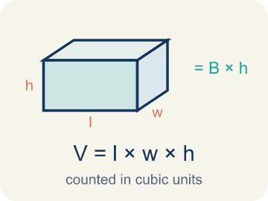 | Volume with Whole-Number Edges Volumen con aristas de números enteros  The number of unit cubes inside a rectangular prism. Formula: V = l × w × h.  Example: V = l × w × h; 3 × 4 × 5 = 60 cubic units.
 | Volume Volumen  How much space is inside a solid shape.  Example: A box 3 × 2 × 4 holds 24 unit cubes, so V = 24 cubic units
 | Rectangular prism Prisma rectangular  A solid box shape with six flat rectangle sides.  Example: A cereal box or shoe box — it has length, width, and height
 | Cubic units Unidades cúbicas  The units used to measure space inside, like cubic inches.  Example: A tiny cube that is 1 in × 1 in × 1 in = 1 in³ (one cubic inch)
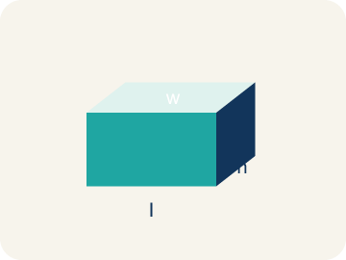 | Length, width, height Largo, ancho, altura  How long, how wide, and how tall a box is.  Example: V = l × w × h: for a box 5 × 3 × 2, volume = 30 cubic units
 | Net Plantilla (desarrollo plano)  A flat shape that folds up into a solid.  Example: A cross-shaped pattern of 6 rectangles folds into a rectangular box
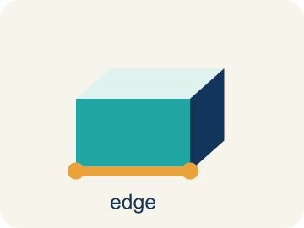 | Edge Arista  The line where two flat sides of a solid meet.  Example: A cube has 12 edges — 4 along the top, 4 along the bottom, 4 vertical
Unit cube Cubo unitario
A cube that measures one unit on every edge.
Example: Unit cubes fill a prism with no gaps.
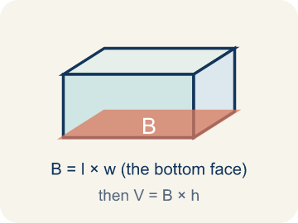 | Base area Área de la base  The area of the bottom face of a prism.  Example: B = length × width

Guided Notes
Fill in each blank as we go. Use the Word Bank to help you.
WORD BANK
Volume with Whole-Number Edges • Volume • Rectangular prism • Cubic units • Length, width, height • Net • Edge • Unit cube • Base area

1. The number of unit cubes inside a prism, found with V = l × w × h, is the ________________.
2. The amount of space inside a three-dimensional solid is its ________________.
3. A solid with six rectangular faces, like a box, is a ________________.
4. The unit used to measure volume, like cubic centimeters, is ________________.
5. The three edge measurements of a rectangular prism are its ________________.
6. A flat pattern that folds up into a solid is a ________________.
7. A line segment where two faces of a solid meet is an ________________.
8. A cube that is one unit on every edge is a ________________.
9. The area of the bottom face of a prism is the ________________.

Write About the Math
How many more cubic inches does the large box hold than the medium box?
¿Cuántas pulgadas cúbicas más tiene la caja grande que la caja mediana?
Say your answer to a partner first. Then write it, using at least two of these words:
☐ Volume · Volumen
☐ Rectangular prism · Prisma rectangular
☐ Cubic units · Unidades cúbicas
☐ Length, width, height · Largo, ancho, altura
☐ Net · Plantilla (desarrollo plano)
Model: Volume measures space in three directions, so you need length, width, and height. — Students explain that volume is three-dimensional, so all three edges (length, width, height) are needed; two measurements only give area of one face.

Start Most language support
Complete the frames. Use the word bank.
Completa las oraciones. Usa el banco de palabras.
The large box volume is ___ in³ because V = ___ × ___ × ___. The medium box volume is ___ in³. The large box holds ___ more cubic inches.
My answer is ___ because ___.
Mi respuesta es ___ porque ___.

Build Some language support
Write two connected sentences. Use because, so, or but.
Escribe dos oraciones conectadas. Usa porque, entonces o pero.
My claim is ___.
Mi afirmación es ___.
My evidence is ___, so ___.
Mi evidencia es ___, entonces ___.

Explain Light language support
Write a claim, give math evidence, and explain your reasoning.
Escribe una afirmación, da evidencia matemática y explica tu razonamiento.

Check Your Explanation three quick checks
☐ I answered the question.
☐ I used math evidence: numbers, an equation, or a model.
☐ I used at least two math words.

Worked Example

Watch & Read I Do — follow along with your teacher
Time Capsule Project
Your team is building time capsule containers to store class memories. Each container is a rectangular prism, and you need to figure out how much each one can hold. That means calculating the volume using whole number dimensions!

Think about:
• What three measurements do you need to find the volume of a box?
• What does volume tell us about a container?
• How is volume different from the area of one face?
• If two containers have the same volume, must they have the same shape?
• What happens to the volume if you double just one dimension?

Solved Example I Do — watch each step
Problem: What is the volume of a rectangular prism with l = 7 in, w = 3 in, h = 4 in?
A) 14 in³
B) 42 in³
C) 84 in³
D) 84 in²
Step 1: V = l × w × h = 7 × 3 × 4 = 84 cubic inches.
Answer: C. 84 in³

Independent Practice

On Your Own You Do — show your work
Solve each problem. Show your thinking in the work box.

Level 2 Enrichment stretch your thinking
1. A shipping crate is 12 ft long, 3 ft wide, and 2 ft tall. How many 1-foot cubes exactly fill it?
A) 17 cubes
B) 36 cubes
C) 72 cubes
D) 144 cubes

2. Two prisms have the same volume of 48 cm³. Prism A is 4 × 4 × 3. Prism B is 8 × 3 × h. What is h?
A) 2 cm
B) 3 cm
C) 4 cm
D) 6 cm

Exit Ticket
Answer on your own. This shows what you learned today.
★ A rectangular prism has l = 11 in, w = 5 in, h = 4 in. What is the volume?
A) 55 in³
B) 200 in³
C) 220 in³
D) 220 in²

Answer Key & Teacher Guide
Teacher reference — remove or fold back before distributing to students.

Guided Notes (Fill-in)
Notes 1: Volume with Whole-Number Edges
Notes 2: Volume
Notes 3: Rectangular prism
Notes 4: Cubic units
Notes 5: Length, width, height
Notes 6: Net
Notes 7: Edge
Notes 8: Unit cube
Notes 9: Base area

Worked Notes (I Do / We Do)
I Do: C. 84 in³
We Do: A. 3 cm

Independent Practice
Watch for this mistake: A common mistake in Volume with Whole Number Edges is multiplying only two of the three edges and stopping there — for example, seeing a box that is 6 in long, 4 in wide, and 3 in tall, multiplying just 6 × 4 = 24, and calling that the volume, when 24 is only the area of the bottom face (in square inches), not the volume of the whole box. The height must also be multiplied in: V = 6 × 4 × 3 = 72 cubic inches. A second common mistake is adding the three edges instead of multiplying them (6 + 4 + 3 = 13 instead of 6 × 4 × 3 = 72 cubic inches). Volume always MULTIPLIES all three edges, and the answer is always labeled in cubic units (in³), never square units (in²) or plain units (in).

Level 1 Support
1. B) Cubic inches (in³) — Volume measures 3D space, so it uses cubic units like in³. Square units (in²) are for area, and inches are for length.

On Level
2. A) Bin B by 12 in³ — Bin A: 8 × 6 × 5 = 240 in³. Bin B: 9 × 4 × 7 = 252 in³. Bin B holds 12 in³ more.
3. D) 160 cm³ — V = l × w × h = 8 × 5 × 4 = 160 cm³.
4. B) 3 in — Height = V ÷ (l × w) = 72 ÷ (6 × 4) = 72 ÷ 24 = 3 in.

Level 2 Enrichment
5. C) 72 cubes — The number of unit cubes equals the volume: 12 × 3 × 2 = 72 cubes.
6. A) 2 cm — Prism A volume = 4 × 4 × 3 = 48 cm³. For Prism B, h = 48 ÷ (8 × 3) = 48 ÷ 24 = 2 cm.

Exit Ticket
C) 220 in³ — V = 11 × 5 × 4 = 220 cubic inches. Remember: volume uses cubic units (in³).

Math Writing Criteria
The support level changes the amount of language scaffolding, not the mathematical expectation.
☐ The answer to the math question is correct.
☐ The evidence is real lesson mathematics (numbers, equation, or model), not restated claim.
☐ The support level changed the language scaffolding, never the mathematical expectation.

