Name |  | Date |  | Period
Lesson 5-5 · Session 1 · Version 2
Guided Practice · Version 2
Volume of Rectangular Prisms
VOCABULARY read and say each word before you begin
volume  Spanish: volumen | How much space is inside a solid shape. | V = l × w × h
rectangular prism  Spanish: prisma rectangular | A solid box shape with six flat rectangle faces. | a cereal box
unit cube | A cube that measures one unit on every edge. | fills space, no gaps
base area | The area of the bottom face of the prism. | B = length × width
cubic units  Spanish: unidades cúbicas | The units volume is measured in. | cm³, in³, ft³
EXPLORE TOGETHER Class Launch · 8–10 min
1. Cube-filled Toy Chest  Maya organizes a toy chest shaped like a rectangular prism. It holds cubes 1 ft on each edge: 5 cubes across the length, 4 cubes across the width, and 3 cubes up the height.  a. Sketch. Sketch Maya’s toy chest as a box. Label length 5 ft, width 4 ft, and height 3 ft.  b. One Layer. Find the number of cubes in the bottom layer: ______ × ______ = ______ cubes  c. Stack. How many layers fill the chest? ______ Total cubes: ______ × ______ = ______  d. Units. Volume: ______ ft³. Explain why the chest’s volume uses cubic units instead of square units. __________ | e. Sketch. Draw and label the toy chest on the grid below. Let one square stand for a convenient number of units, and mark the perpendicular height with a square corner.​  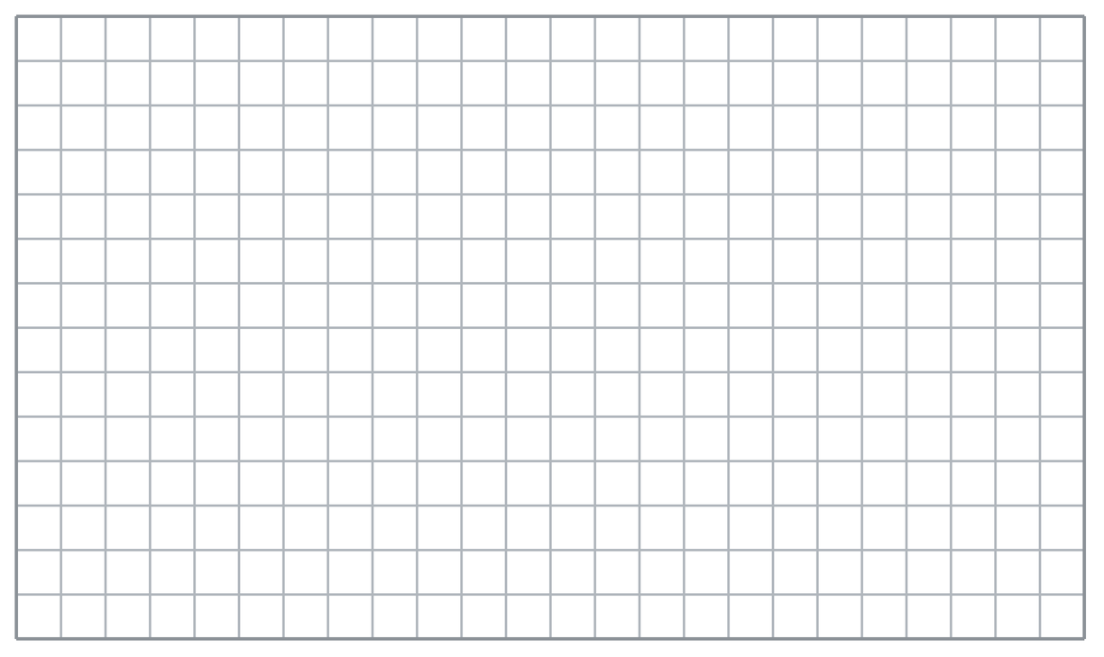
  TURN AND TALK
  How is counting layers of cubes the same as multiplying length by width by height?
PRACTICE WITH A PARTNER You Do Together · 10–12 min
2. Fish Tank. A rectangular fish tank is 16 in. long, 11 in. wide, and 5 in. tall.  a. Area of the planter’s base __________  b. Volume of the planter box __________ | 3. Two Cartons. Carton A measures 18 cm by 5 cm by 11 cm. Carton B measures 15 cm by 11 cm by 5 cm.  a. Volume of Gift Box A __________  b. Which gift box holds more? __________
  PARTNER TALK
  Why does multiplying the base area by the height give you the volume?
  PARTNER TALK
  Could two boxes with different edge lengths hold the same amount? Explain how.

4. Locker Space. A hallway locker is a rectangular prism 12 in. wide, 15 in. deep, and 48 in. tall.
a. Area of the planter’s base __________
b. Volume of the cabinet __________
PARTNER TALK
How many base layers stack up inside this locker? How do you know?

PRACTICE ON YOUR OWN You Do · 8 problems · 18–20 min
5. Moving Carton. A moving carton is a rectangular prism 22 in. long, 14 in. wide, and 5 in. tall.  Sketch Ms. Rivera’s moving carton, label its edges, and calculate its volume.  Hint Find the rectangular base area, multiply by the height, and label the volume in cubic inches.  Answer carton volume in in³ | Sketch. Draw and label the moving carton on the grid below. Let one square stand for a convenient number of units, and mark the perpendicular height with a square corner.​
  Show your work.

6. Sandbox Fill. A sandbox is a rectangular prism 26 ft long and 11 ft wide. Sand is poured in to a depth of 2 ft.  Find the volume of soil needed to fill the garden bed.  Hint Use the soil’s depth as the prism’s height. First find the area of the garden bed’s base.  Answer volume of soil in ft³ | 7. Ian’s Box. A box measures 17 cm long, 13 cm wide, and 5 cm tall. Ian says its volume is 221 cm³.  Justify or correct Zara’s answer. Complete the sentence: Zara used __________, but finding volume also requires __________.  Hint Determine which dimensions Zara multiplied. A rectangular prism’s volume depends on all three dimensions.  Answer true volume (Is Zara right?)

8. Camp Cooler. A camp cooler is a rectangular prism 24 in. long, 16 in. wide, and 12 in. tall.  Sketch Eli’s camp cooler, label its edges, and calculate its volume.  Hint Multiply the cooler’s base area by its height. Write the volume in cubic inches.  Answer carton volume in in³ | Sketch. Draw and label the moving carton on the grid below. Let one square stand for a convenient number of units, and mark the perpendicular height with a square corner.​
  Show your work.

9. Truck Bed. The bed of a small truck is a rectangular prism 9 ft long, 6 ft wide, and 2 ft deep.  Find the volume the cargo trailer holds.  Hint Treat the cargo space’s depth as its height and multiply the three dimensions.  Answer cargo volume in ft³ | 10. Storage Box. A storage box is 8 cm long, 6 cm wide, and 9 cm tall. Find its volume.  Hint Multiply the pencil case’s length, width, and height.  Answer volume in cm³

11. Shipping Crate. A crate is 5 ft long, 4 ft wide, and 3 ft tall. Find its volume.  Hint 6 × 3 × 2.  Answer volume in ft³ | 12. Base and Height. A prism has a rectangular base with an area of 42 in² and a height of 7 in.  a. Which volume formula uses the given base area and height? __________  b. Find the package’s volume. __________  Hint Use V = B × h, with B representing the base area.  Answer a. formula and b. volume
ANALYZE THE ERROR 5 min
13. Read the work below. Explain the mistake, then show the correct reasoning.
ANALYZE TOMÁS’S WORK
A crate is 15 ft long, 11 ft wide, and 4 ft tall. Tomás wrote: ‘V = 15 + 11 + 4 = 30 ft³.’
a. Explain mistake: Malik added the three dimensions. Complete the sentence: Malik used __________, but volume requires __________. | b. Show correct work using the volume formula.  Correct answer
  Show the correct work.
STRETCH YOUR THINKING multi-step reasoning · 8 min
14. Aquarium. An aquarium is 60 cm long, 30 cm wide, and 40 cm tall. One liter of water fills 1,000 cm³.
a. Find the volume of the water reservoir.
b. Find how many liters of water fill the reservoir completely.
c. The reservoir is filled only to 32 cm deep. Find the liters of water used.
Answer reservoir volume, full liters, and partial liters
TEST PRACTICE multiple choice · fill one box · 6 min
15. A prism 3 cm by 4 cm by 5 cm has volume — | 16. Volume is measured in —
  □ A. 47 cm³ | □ B. 12 cm³ | □ C. 60 cm² | □ D. 60 cm³
  □ A. cubic units | □ B. square units | □ C. linear units | □ D. degrees

17. A prism with base area 20 m² and height 6 m has volume — | 18. In V = B × h, the letter B stands for the —
  □ A. 26 m³ | □ B. 120 m³ | □ C. 120 m² | □ D. 3.3 m³
  □ A. bottom edge | □ B. base length | □ C. base area | □ D. box
SPIRAL REVIEW earlier skills · keep them sharp · 6 min
19. From Lesson 5-4 Session 2. A 50 m² rectangle has a 12 m² triangle removed. Find the remaining area.  Answer | 20. From Lesson 5-3 Session 2. A trapezoid has bases 10 cm and 14 cm and height 6 cm. Find its area.  Answer

21. From Lesson 4-2 Session 1. Write 0.65 as a percent.  Answer | 22. From Lesson 3-6 Session 2. Convert 2500 grams to kilograms.  Answer
CHECK YOUR UNDERSTANDING 5 min
23. Storage Bin. A storage bin is a rectangular prism 21 in. long, 13 in. wide, and 5 in. tall.
a. Area of the planter’s base __________
b. Volume of the supply tray __________
Hint Find the area of the tray’s rectangular bottom, then multiply by its height to count the stacked layers.
Answer

□ 4 — Can teach it | □ 3 — Got it | □ 2 — Need hint | □ 1 — Need help
Circle your confidence. Star one problem that shows your learning.

