UNIT 5 · LESSON 6 STANDARD 6.GR.4

Represent Three-Dimensional Figures in Two Dimensions
Student Notes Packet
Name: ______________________ Date: ____________ Period: ________
Level 3 · Enrichment

Today's Goals
Content: I can find the surface area of a solid by using its net.
Language: I can explain my work using the words surface area, net, face, and two-dimensional.

Key Vocabulary
Look at the picture, read the word, then read what it means.
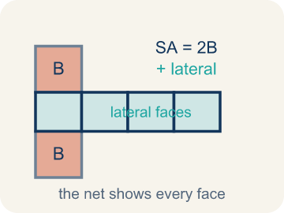 | Surface Area Using Nets Área de superficie usando redes  The total area of all the faces of a solid. A net unfolds the solid flat so you can see every face and add their areas.  Example: A box with 6 faces: 2(8×5) + 2(8×3) + 2(5×3) = 158 square units
 | Surface area Área de superficie  The total area of all the flat sides of a solid.  Example: A box 6 × 4 × 2: SA = 2(24) + 2(12) + 2(8) = 88 in² — like wrapping paper needed
 | Net Plantilla (desarrollo plano)  A flat shape that folds up into a solid.  Example: Cut along the edges of a cereal box and unfold it flat — you see all 6 faces
 | Face Cara  One flat side of a solid shape.  Example: A rectangular prism has 6 faces: top, bottom, front, back, left, right
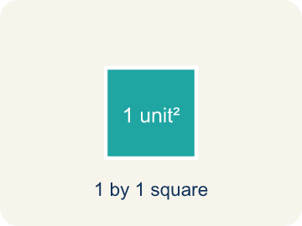 | Two-dimensional Bidimensional  A flat shape with length and width, but no thickness.  Example: A rectangle drawn on paper is 2D — it has length and width but no depth
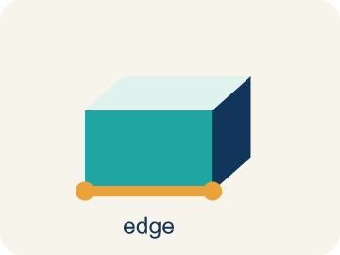 | Edge Arista  The line where two flat sides of a solid meet.  Example: A cube has 12 edges — the lines where two flat faces connect
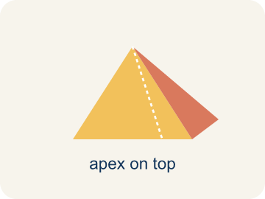 | Pyramid Pirámide  A solid with one base and triangular sides that meet at a point.  Example: A square base with 4 triangles.
 | Vertex Vértice  A corner point where edges meet.  Example: A cube has 8 vertices.

Guided Notes
Fill in each blank as we go. Use the Word Bank to help you.
WORD BANK
Surface Area Using Nets • Surface area • Net • Face • Two-dimensional • Edge • Pyramid • Vertex

1. The total area of every face, found by adding the faces in a net, is the ________________.
2. The total area of all the faces of a solid is its ________________.
3. A flat pattern that folds up into a solid is a ________________.
4. A flat surface of a solid figure is a ________________.
5. A flat shape with length and width but no thickness is ________________.
6. A line segment where two faces meet is an ________________.
7. A solid with one base and triangular faces that meet at a point is a ________________.
8. A corner point where edges meet is a ________________.

Write About the Math
How many sheets of wrapping paper are needed to cover the entire box?
¿Cuántas hojas de papel de regalo se necesitan para cubrir toda la caja?
Say your answer to a partner first. Then write it, using at least two of these words:
☐ Surface area · Área de superficie
☐ Net · Plantilla (desarrollo plano)
☐ Face · Cara
☐ Two-dimensional · Bidimensional
☐ Edge · Arista
Model: A net lays every face flat so you can see and measure all six faces. — Students explain a rectangular prism has 6 faces, and the net unfolds the solid into a flat (two-dimensional) pattern so every face is visible to measure.

Start Most language support
Complete the frames. Use the word bank.
Completa las oraciones. Usa el banco de palabras.
The box's surface area is ___ in² because SA = 2(___×___) + 2(___×___) + 2(___×___) = ___ + ___ + ___ = ___. You need ___ sheets because ___ ÷ 400 ≈ ___.
My answer is ___ because ___.
Mi respuesta es ___ porque ___.

Build Some language support
Write two connected sentences. Use because, so, or but.
Escribe dos oraciones conectadas. Usa porque, entonces o pero.
My claim is ___.
Mi afirmación es ___.
My evidence is ___, so ___.
Mi evidencia es ___, entonces ___.

Explain Light language support
Write a claim, give math evidence, and explain your reasoning.
Escribe una afirmación, da evidencia matemática y explica tu razonamiento.

Check Your Explanation three quick checks
☐ I answered the question.
☐ I used math evidence: numbers, an equation, or a model.
☐ I used at least two math words.

Worked Example

Watch & Read I Do — follow along with your teacher
Time Capsule Project
Your class is designing custom wrapping paper for time capsule boxes. To figure out how much paper you need, you have to find the total surface area of each box. The trick? Unfold the box into a net so you can see every face laid flat!

Think about:
• How many faces does a rectangular prism have?
• What shapes do you see when the box is unfolded?
• Are all the faces the same size?
• Is there more than one way to unfold a box into a net?
• How does a net help you find surface area more easily than looking at the 3D shape?

Solved Example I Do — watch each step
Problem: A rectangular prism has l = 6 in, w = 4 in, h = 2 in. What is its surface area?
A) 44 in²
B) 48 in²
C) 88 in²
D) 88 in³
Step 1: SA = 2(6×4) + 2(6×2) + 2(4×2) = 48 + 24 + 16 = 88 in².
Answer: C. 88 in²

Exit Ticket
Answer on your own. This shows what you learned today.
★ A rectangular prism has l = 9 in, w = 5 in, h = 3 in. What is the surface area?
A) 87 in²
B) 135 in²
C) 174 in²
D) 174 in³

