Name Date Period
Lesson 5-6 · Homework Packet · Sheet 1 of 2
Drawing Nets of Solids
Maryland Standard 6.G.A.4 · Learning target — I can draw the net of a solid by unfolding its faces onto a flat surface.

REMEMBER  • A net is a flat pattern that folds into a solid. Each face appears once, with no overlaps.  • Rectangular prism: 6 rectangles. Square pyramid: 1 square + 4 triangles. Triangular prism: 2 triangles + 3 rectangles. | WORKED EXAMPLE  Plan a net for a box 5 cm × 3 cm × 2 cm.  Step 1 Faces come in pairs: 5 × 3, 5 × 2, 3 × 2  Step 2 Draw the 5 × 3 base. Attach a 5 × 2 face to each long edge.  Step 3 Attach a 3 × 2 face to each short edge. Add the 5 × 3 top to one 5 × 2 face.  Answer 6 rectangles, two of each size
PRACTICE show your work · label units

1. Draw a net for this box. Label the length and width of every face.  Face sizes | 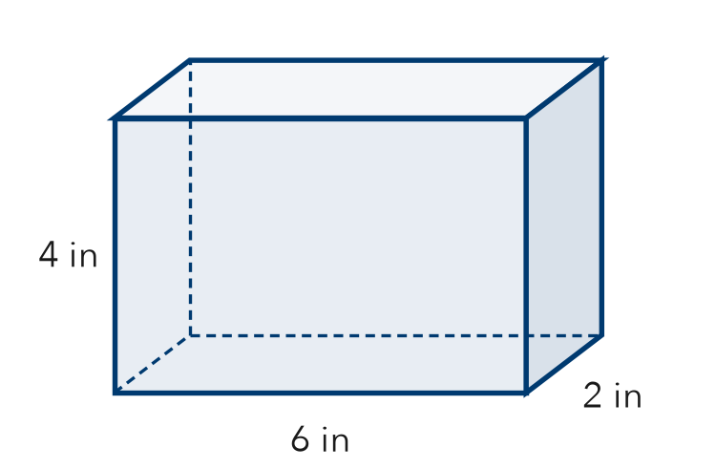
  Draw the net here.

2. How many of each shape are in the net?
a. cube: squares | b. square pyramid: triangles
c. triangular prism: rectangles | d. pentagonal pyramid: triangles

3. The net of this square pyramid has a square and 4 triangles.  a. Area of the square cm²  b. Area of one triangle cm²  All 4 triangles cm² | 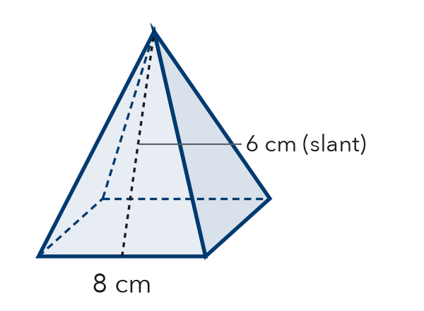

4. Cereal Box. A cereal box is 8 in long, 3 in wide, and 12 in tall. List the sizes of the 3 pairs of matching faces in its net.
Face pairs

5. Will It Fold? Jamal draws 6 squares in one long row and says it is a net for a cube. Is he right? Explain.

CHECK YOURSELF | □ I can do this on my own | □ I need a little help | □ I have a question about #
AT HOME Open an empty cereal box along its edges. Show someone its net.
Name Date Period
Lesson 5-6 · Homework Packet · Sheet 2 of 2
Reading Nets and Solids
Maryland Standard 6.G.A.4 · Learning target — I can name the solid a net makes by reading the shapes in the net.

REMEMBER  • Prism: 2 matching bases + rectangles. Pyramid: 1 base + triangles that meet at a point.  • The base shape names the solid (triangular, square, pentagonal …). | WORKED EXAMPLE  A net has 1 hexagon and 6 triangles.  Step 1 One base with triangles around it means a pyramid.  Step 2 The base is a hexagon.  Answer hexagonal pyramid
PRACTICE show your work · label units

1. Look at the net. | 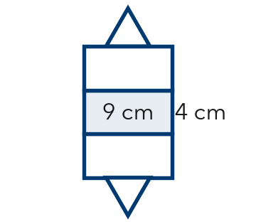
  a. Solid:
  b. Number of faces:

2. Name the solid each net makes.
a. 1 rectangle + 4 triangles: | b. 2 hexagons + 6 rectangles:
c. 2 triangles + 3 rectangles: | d. 1 pentagon + 5 triangles:
e. 6 squares: | f. 2 pentagons + 5 rectangles:

3. This net folds into a square pyramid. | 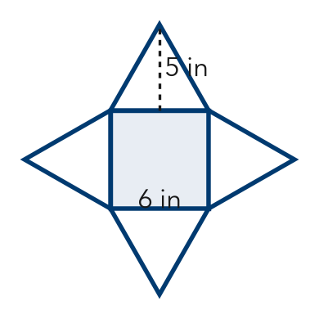
  a. Area of the base: in²
  b. Area of all 4 triangles: in²

4. Mystery Box. A net has 2 squares, 4 cm on each side, and 4 rectangles, 4 cm × 9 cm. Name the solid and its dimensions.
Answer

TEST PRACTICE choose the best answer
5. A triangular prism has 5 faces. How many edges does it have?
A 5 | B 6 | C 9 | D 12

6. How many faces does a hexagonal pyramid have?
A 6 | B 7 | C 8 | D 12

CHECK YOURSELF | □ I can do this on my own | □ I need a little help | □ I have a question about #
AT HOME Find a box at home. Tell someone what shapes its net would have and how many of each.

