Name |  | Date |  | Period

Lesson 5-6 · Session 1
Homework
Drawing Nets of Solids
Maryland Standard 6.G.A.4 · Learning target — I can draw the net of a solid by unfolding its faces onto a flat surface.
Show a model, calculation, or explanation for each exercise. Label units and answer every part.
Exercises 1–12 earn 1 point for a correct response and 1 for supporting work. Spiral Review and Test Practice earn 1 point each.
REMEMBER review this before you start
• A net is a 2-D pattern that folds up into a 3-D solid.
• Match each face of the net to a face on the solid — count the faces to check your net is complete.
• Watch out — a net must fold up without any face overlapping another.
• Check it — count the shapes in your net against the faces of the solid.
WORKED EXAMPLE the same steps you practiced in class
Drawing a Net from a Solid’s Attributes A triangular prism has 2 triangle bases and 3 rectangular side faces. Draw and describe its net.
Step 1 List the attributes. bases: 2 triangles side faces: 3 rectangles
Step 2 Draw the 3 rectangles in a row — these wrap around the outside.
Step 3 Attach 1 triangle to the top edge of the row and 1 to the bottom edge.
Step 4 Check: five flat pieces, and every folding edge has a partner.
Answer The net is a row of 3 rectangles with a triangle on the top edge and one on the bottom.
EXERCISES 12 exercises · 24 points
1. Draw a net for a cube. How many square faces does it need? ______

Net. Draw the net on the grid and label every face.​
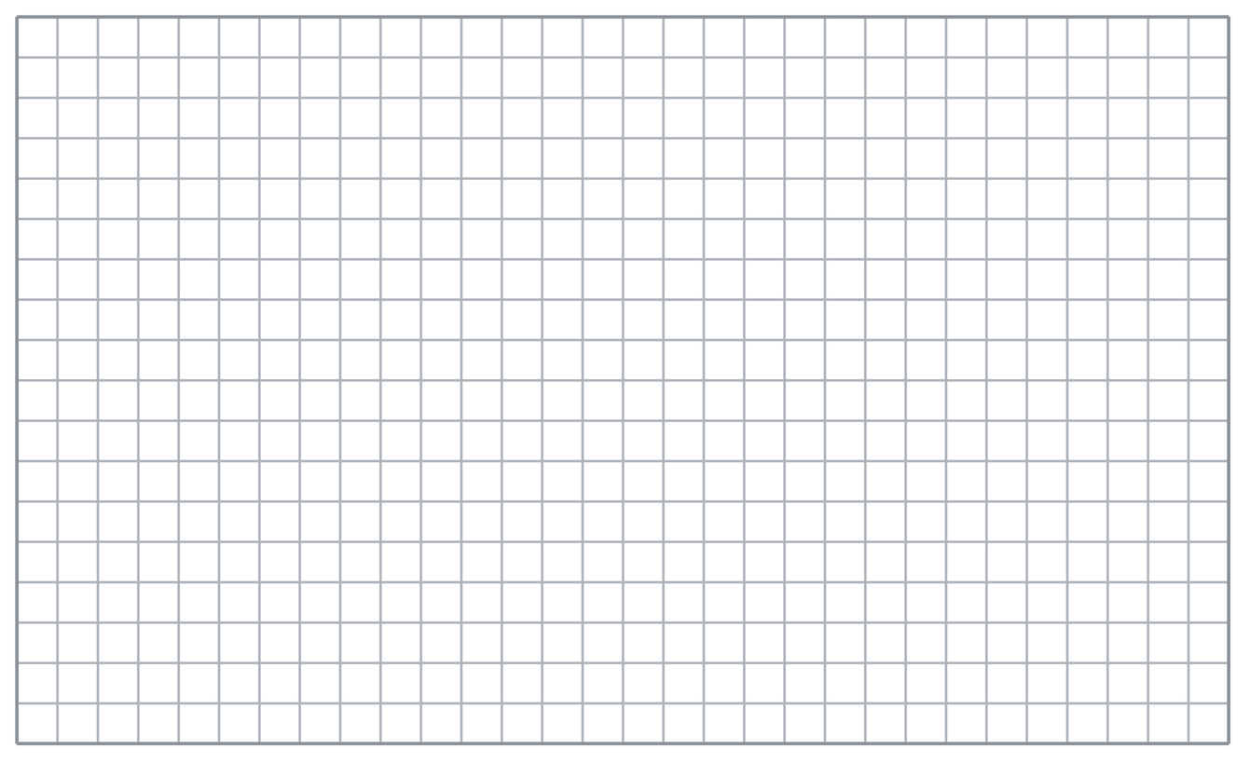
Show your work.
Answer
2. Draw a net for a rectangular prism that is not a cube (has 3 different face sizes).

Net. Draw the net on the grid and label every face.​
Show your work.
Answer
3. How many faces does a triangular prism have, and what shapes are they?

Show your work.
Answer
4. Count the flat pieces each net needs.
a. a cube’s net has ______ squares
b. a square pyramid’s net has 1 square and ______ triangles
c. a rectangular prism’s net has ______ rectangles
d. a triangular prism’s net has ______ triangles and ______ rectangles

Answer
5. Snack Box. A snack box is a rectangular prism 9 cm long, 5 cm wide, and 4 cm tall. Draw a net for the box and label the three different rectangle sizes.

Net. Draw the net on the grid and label every face.​
Show your work.

Answer
6. Tent Model. A tent model is a triangular prism 8 in. long. Each triangular end has sides 5, 5, and 6 in., with height 4 in. Draw the net, then find the area of ONE triangular end.

Net. Draw the net on the grid and label every face.​
Show your work.

Answer
7. Pyramid Model. A model is a square pyramid with a base 8 ft on each side. Each triangular face has a slant height of 9 ft. Draw the net, then find the area of the square base and of ONE triangular face.

Net. Draw the net on the grid and label every face.​
Show your work.

Answer
8. Jada drew a net for a rectangular prism using only 5 rectangles and says it will fold up. Explain what is wrong, then tell her exactly what to add.

Show your work.

Answer
9. Describe the net of a cube with 5 cm edges.

Show your work.
Answer your description
10. A rectangular prism is 9 m by 6 m by 2 m. List the six rectangles in its net.

Show your work.
Answer the six rectangles
11. Count Them. A pentagonal prism has two pentagon ends and five rectangular sides. How many shapes are in its net?

Show your work.
Answer shapes
12. Find the Mistake. Jo drew a net for a rectangular prism using only 4 rectangles. Explain the mistake.

Show your work.
Answer the mistake
SPIRAL REVIEW earlier skills · 1 point each
13. From Lesson 5-5 Session 1. A prism has base area 30 cm² and height 5 cm. Find its volume.
Answer
14. From Lesson 5-4 Session 2. Two joined shapes of 44 ft² and 20 ft² give what total?
Answer
15. From Lesson 4-2 Session 1. Write 1/4 as a percent.
Answer
TEST PRACTICE multiple choice · fill one box · 1 point each
16. A triangular prism’s net contains —
□ A. 6 rectangles | □ B. 3 triangles, 2 rectangles | □ C. 2 triangles, 3 rectangles | □ D. 1 triangle and 4 squares
17. Opposite faces of a rectangular prism are —
□ A. curved | □ B. different | □ C. triangles | □ D. identical
18. A net folds into a solid without faces —
□ A. overlapping | □ B. touching | □ C. matching | □ D. joining
CHECK YOURSELF Score: ______ / 30
□ Solved on my own | □ Needed a hint | □ Need help on Question # ______
Check each labeled measure and required face or region. Use square units for area and cubic units for volume.

