Name |  | Date |  | Period
Lesson 5-6 · Session 1 · Version 2
Guided Practice · Version 2
Drawing Nets of Solids
VOCABULARY read and say each word before you begin
net | A flat pattern that folds up into a solid. | unfolded box
face | One flat side of a solid shape. | a cube has 6 faces
pyramid  Spanish: pirámide | A solid with one base and triangular sides. | square base + 4 triangles
two-dimensional  Spanish: bidimensional | Flat: it has length and width only. | a net on paper
three-dimensional  Spanish: tridimensional | Solid: it has length, width, and height. | the folded box
EXPLORE TOGETHER Class Launch · 8–10 min
1. Paper Pyramid Model  Amara is folding a paper model of a square pyramid. The square base is 6 in. on each side, and every triangular face has a height of 5 in.  a. Attributes. Shape of the base: __________ Number of triangular faces: ______ Total flat pieces: ______  b. Sketch. Sketch the net with a square in the center and one triangle attached to each side. Label 6 in.  c. Faces. Find the area of the square base: ______ in² Find the area of ONE triangle: ______ in²  d. Reasoning. Explain why the four triangular faces have equal areas. __________ | e. Net. Sketch the net on the grid below. Label the dimensions of every face and mark the matching pairs.​  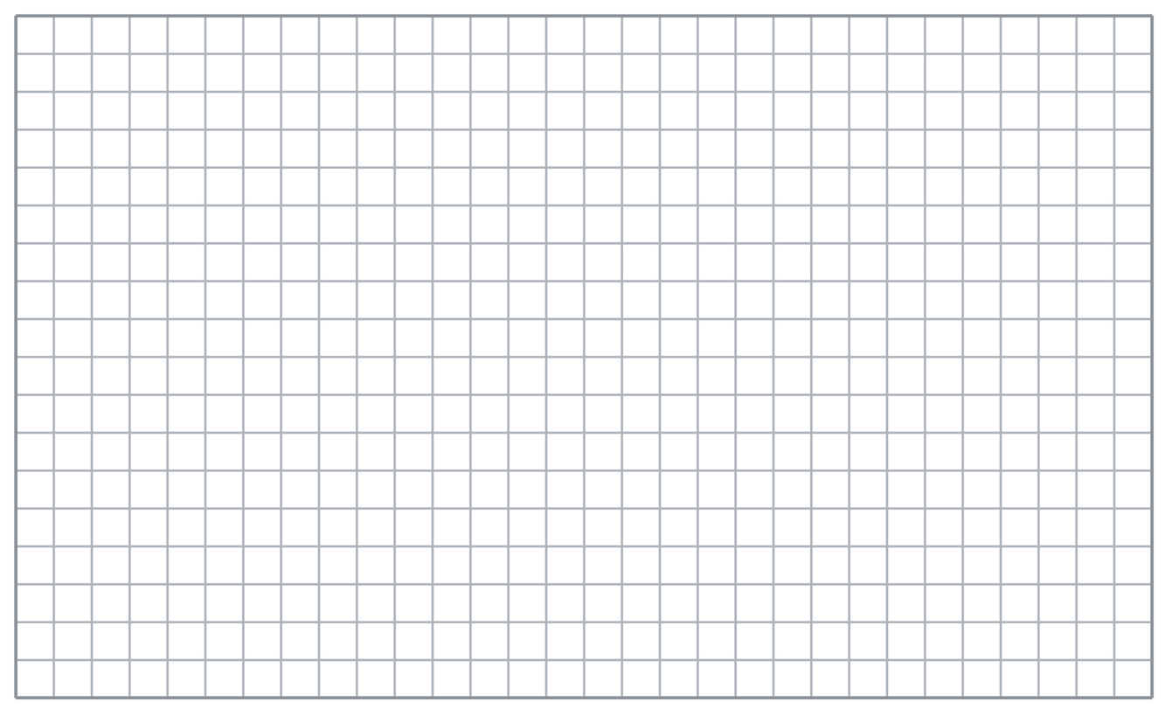
  TURN AND TALK
  How do a solid’s attributes tell you what its net has to look like?
PRACTICE WITH A PARTNER You Do Together · 10–12 min
2. Cereal Box. A cereal box is a rectangular prism 12 in. tall, 8 in. wide, and 2 in. deep.  a. Sketch the net. How many rectangles are there in all? __________  b. Find the area of the largest face. __________ | c. Net. Sketch the net on the grid below. Label the dimensions of every face and mark the matching pairs.​
  PARTNER TALK
  Which faces of this rectangular prism form congruent pairs? Explain.

3. Tent Net. A camping tent is a triangular prism. Each triangular end has a base of 7 ft and a height of 4 ft, and the tent is 10 ft long.  a. Sketch the net. How many triangle pieces does it contain? __________  b. Find the area of ONE triangular end. __________ | c. Net. Sketch the net on the grid below. Label the dimensions of every face and mark the matching pairs.​
  PARTNER TALK
  Where would you fold this net to build the tent? Describe the folds to your partner.

4. Juice Carton. A juice carton is a rectangular prism 6 cm long, 4 cm wide, and 15 cm tall.
a. Number of rectangles in the tea tin's net __________
b. Find the area of the largest face. __________
PARTNER TALK
How can you tell from your net which rectangles fold onto each other?

PRACTICE ON YOUR OWN You Do · 8 problems · 18–20 min
5. Gift Box. A gift box is a cube with edges of 9 cm.  Sketch a net for the cube. State how many faces it has and calculate the area of one face.  Hint All faces of a cube are identical squares. Draw four squares in a row, then attach one above and one below the same square.  Answer number of faces: ______; area of one face: ______ cm² | Net. Sketch the net on the grid below. Label the dimensions of every face and mark the matching pairs.​
  Show your work.

6. Display Pyramid. A store display is a square pyramid. Its base is 14 in. on each side and each triangular face has a height of 11 in.  Sketch the net and calculate the area of one triangular face.  Hint Each triangle's base matches a side of the square. Use A = ½bh to find the area of one triangular face.  Answer area of one triangular face: ______ in² | Net. Sketch the net on the grid below. Label the dimensions of every face and mark the matching pairs.​
  Show your work.

7. Maya’s Net. Maya drew a net made of 5 squares that are all the same size. She says it folds into a cube.
Justify or correct Elias’s claim about his net.
Hint Count a cube's faces, then compare that number with the number of squares in Elias's net.
Answer can all 7 squares become separate faces of a cube? Elias’s claim is ______ because a cube has ______ faces, but his net has ______ squares.

8. Pencil Case. A pencil case is a rectangular prism 18 cm long, 8 cm wide, and 5 cm tall.  Sketch a net for the pencil case and calculate the area of its largest face.  Hint Each rectangular face uses two of the three dimensions. Multiply the two longest dimensions to find the largest face's area.  Answer area of the largest face: ______ cm² | Net. Sketch the net on the grid below. Label the dimensions of every face and mark the matching pairs.​
  Show your work.

9. Museum Pyramid. A museum model is a square pyramid with a base 10 in. on each side. Each triangular face has a slant height of 7 in.  Sketch the net, then calculate the area of one triangular face  Hint Use a side of the square as the triangle’s base and the slant height as its height to find the area of one face.  Answer area of one triangular face: ______ in² | Net. Sketch the net on the grid below. Label the dimensions of every face and mark the matching pairs.​
  Show your work.

10. Square Pyramid. A square pyramid has a square base and 4 triangular faces. Describe the net you would draw.  Hint Start with one square and attach one triangle to each side.  Answer your description of the net | 11. Rectangular Prism. A rectangular prism is 6 cm by 4 cm by 3 cm. How many rectangles does its net contain, and which ones match?  Hint Pair each face with the opposite face that has the same dimensions.  Answer number of rectangles and matching pairs

12. Count the Faces. A triangular prism has two triangular ends and three rectangular sides.
a. How many faces does the model tent have? __________
b. How many shapes would you draw in the model tent’s net? __________
Hint Count one shape in the net for each face of the solid.
Answer a and b with the two counts
ANALYZE THE ERROR 5 min
13. Read the work below. Explain the mistake, then show the correct reasoning.
MAYA’S WORK

Caleb drew a net for a square pyramid: one square with three triangles attached to three of its sides. He says it will fold up correctly.
a. Maya says a square pyramid’s net needs one square and three triangles. Explain her mistake and state how many triangles the net needs. Complete: “Maya needs ___ triangles because ___.” | b. Show correct work by sketching a square pyramid’s net and labeling its faces.  Correct answer
  Show the correct work.
STRETCH YOUR THINKING multi-step reasoning · 8 min
14. Gift Box. A gift box is a rectangular prism 10 in. long, 5 in. wide, and 4 in. tall.
a. List the six rectangles in the carton’s net with their dimensions.
b. Identify the three pairs of rectangles with matching dimensions.
c. Explain how a net makes it easier to plan how much cardboard is needed to make the carton.
Answer the rectangle dimensions, matching pairs, and your explanation
TEST PRACTICE multiple choice · fill one box · 6 min
15. A net is a flat pattern that folds into a — | 16. A cube’s net contains how many squares?
  □ A. point | □ B. line | □ C. solid | □ D. circle
  □ A. 12 | □ B. 4 | □ C. 8 | □ D. 6

17. A square pyramid’s net contains — | 18. The number of shapes in a net equals the number of —
  □ A. 1 square, 4 triangles | □ B. 4 squares, 1 triangle | □ C. 6 squares | □ D. 2 triangles, 3 rectangles
  □ A. edges | □ B. faces | □ C. vertices | □ D. corners
SPIRAL REVIEW earlier skills · keep them sharp · 6 min
19. From Lesson 5-5 Session 2. A prism has volume 180 cm³, length 6 cm, and width 5 cm. Find its height.  Answer | 20. From Lesson 5-5 Session 1. A prism is 4 in. by 3 in. by 5 in. Find its volume.  Answer

21. From Lesson 4-4 Session 1. Find 60% of 150.  Answer | 22. From Lesson 3-6 Session 1. Convert 48 ounces to pounds.  Answer
CHECK YOUR UNDERSTANDING 5 min
23. Jewelry Box Net. A jewelry box is a rectangular prism 10 cm long, 7 cm wide, and 3 cm tall.  a. Draw a net for the jewelry box and label its edge lengths. Rectangles __________  b. Find the area of the top face __________  Hint Match each rectangle in your net with the rectangle representing its opposite face.  Answer | c. Net. Sketch the net on the grid below. Label the dimensions of every face and mark the matching pairs.​
  Show your work.

□ 4 — Can teach it | □ 3 — Got it | □ 2 — Need hint | □ 1 — Need help
Circle your confidence. Star one problem that shows your learning.

