Name |  | Date |  | Period
Lesson 5-6 · Session 2 · Version 2
Guided Practice · Version 2
Reading Nets and Solids
VOCABULARY read and say each word before you begin
EXPLORE TOGETHER Class Launch · 8–10 min
1. Mystery Net on the Board
A net on the board shows 6 identical squares, each 4 cm on a side, joined edge to edge with no pieces overlapping.
a. Describe. Shape of the pieces: __________ How many? ______ All the same? ______
b. Name It. Folded solid: __________ How do you know? __________
c. Count. Faces: ______ Edges: ______ Vertices: ______
d. Area. Area of ONE face: ______ cm² Area of all the faces together: ______ cm²
TURN AND TALK
How can a net tell you the name of a solid before anyone folds it?

PRACTICE WITH A PARTNER You Do Together · 10–12 min
2. Fold the Net. A net holds 2 rectangles that are 9 in. by 5 in., 2 rectangles that are 9 in. by 3 in., and 2 rectangles that are 5 in. by 3 in.  a. Name the folded solid. __________  b. Which pairs of faces will be opposite each other on the supply box? __________ | 3. Prism or Pyramid. Net A is made of 2 hexagons and 6 rectangles. Net B is made of 1 hexagon and 6 triangles.  a. Net A folds into a __________  b. Number of faces on each package: A __________
  PARTNER TALK
  Why does every rectangle in this net have an exact partner somewhere in it?
  PARTNER TALK
  What part of a net tells you prism versus pyramid? Explain your reasoning.

4. Game Box. A net holds 2 rectangles that are 12 in. by 12 in. and 4 rectangles that are 12 in. by 3 in.
a. Name the folded solid. __________
b. Total area of all six puzzle box faces __________
PARTNER TALK
How does a square base change this net from an ordinary box net?

PRACTICE ON YOUR OWN You Do · 8 problems · 18–20 min
5. Cube Count. A storage cube has edges of 7 cm.
Find the display cube's number of faces, edges, and vertices, then calculate the area of one face.
Hint Imagine rotating the display cube. Count its flat faces, the edges where faces meet, and its corner vertices.
Answer number of faces, edges, and vertices; area of one display cube face

6. Unfolding a Prism. A rectangular prism is 11 in. long, 6 in. wide, and 2 in. tall.  Help Maya sketch a net for the prism, then calculate the area of each different-sized face.  Hint Match the prism's faces in pairs. Each of its three different face sizes appears twice in the net.  Answer area of each of the three different-sized faces | Net. Sketch Maya's prism net on the grid below. Label every face with its dimensions and mark each matching pair.​  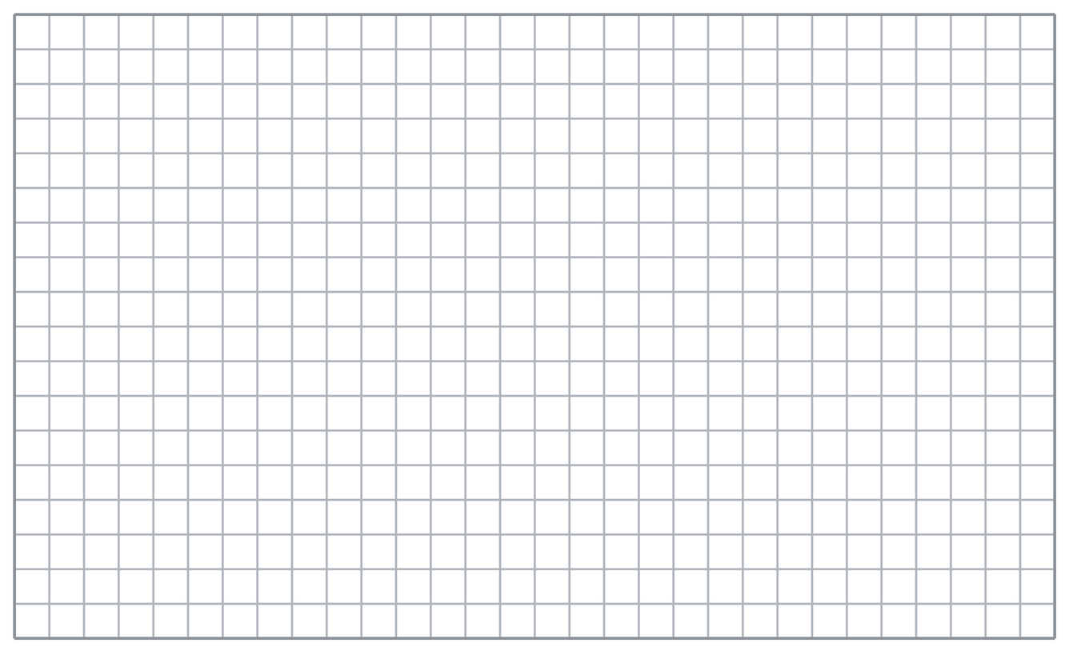
  Show your work.

7. Ravi’s Claim. Ravi sees a net made of 1 square and 4 triangles. He says it folds into a triangular prism.  Justify or correct Jordan’s answer. Complete the sentence: “Jordan is __________ because the net has __________, so it folds into a __________.”  Hint Count the polygon bases. A prism has two matching bases; a pyramid has one base with triangular faces that meet at a vertex.  Answer correct solid name and an explanation of whether Jordan is right | 8. Candle Box. A net is made of 2 identical octagons and 8 rectangles joined edge to edge.  Name the gift container's solid shape, then give its total number of faces.  Hint Identify the two matching bases to name the prism. Count both bases and all the rectangular faces.  Answer gift container's solid name and total number of faces

9. Ornament Net. A net is made of 1 triangle base with 3 triangles around it. Each of the 3 outer triangles has a base of 9 cm and a height of 8 cm.  Name the decoration's solid shape, then calculate the area of one outer triangle.  Hint The triangular faces fold up from one base to meet at a vertex. Find one outer face's area using half its base times its height.  Answer decoration's solid name and area of one outer triangle | 10. Name the Solid. A net is made of 2 identical triangles and 3 rectangles joined edge to edge. Name the solid.  Hint Two matching polygon bases joined by rectangular faces identify a prism.  Answer the name of the solid

11. Pyramid or Prism? A net has 1 square and 4 triangles. Name the solid and explain how you know.  Hint A single polygon base with triangular faces meeting at one vertex identifies a pyramid.  Answer the name of the solid and why | 12. Two Nets. Net A has 6 identical squares. Net B has 2 hexagons and 6 rectangles.  a. Name the solid that Net A forms. __________  b. Name the solid that Net B forms. __________  Hint Look for two matching polygon bases connected by rectangular faces to identify a prism.  Answer parts a and b
ANALYZE THE ERROR 5 min
13. Read the work below. Explain the mistake, then show the correct reasoning.
ELI’S WORK

Nadia says a cube has 6 faces, 6 edges, and 6 vertices, because everything about a cube comes in sixes.
a. Explain the mistake. Eli says a rectangular face of a cereal box has 3 edges and 3 vertices. Trace the face and count its edges and vertices. Complete: “Eli’s mistake is _____ because _____.” | b. Show correct work by stating the number of edges and vertices on one rectangular face.  Correct answer
  Show the correct work.
STRETCH YOUR THINKING multi-step reasoning · 8 min
14. Three Nets. Net 1: 2 triangles and 3 rectangles. Net 2: 1 square and 4 triangles. Net 3: 2 rectangles and 4 other rectangles.
a. Name the solid formed by each of the designer’s nets.
b. Explain how the bases and other faces help you distinguish a prism from a pyramid.
c. Explain why the number of shapes alone does not guarantee that they will fold into the intended solid.
Answer the names of all three solids and both explanations
TEST PRACTICE multiple choice · fill one box · 6 min
15. A net with 2 pentagons and 5 rectangles makes a — | 16. A net with 1 triangle and 3 triangles makes a —
  □ A. pentagonal prism | □ B. pentagonal pyramid | □ C. cube | □ D. triangular prism
  □ A. triangular prism | □ B. triangular pyramid | □ C. cube | □ D. rectangular prism

17. A prism is named for the shape of its — | 18. A net with 6 identical squares makes a —
  □ A. longest edge | □ B. rectangles | □ C. two identical ends | □ D. top point
  □ A. triangular prism | □ B. square pyramid | □ C. rectangular prism | □ D. cube
SPIRAL REVIEW earlier skills · keep them sharp · 6 min
19. From Lesson 5-6 Session 1. How many shapes are in the net of a rectangular prism?  Answer | 20. From Lesson 5-5 Session 1. A prism is 8 m by 2 m by 3 m. Find its volume.  Answer

21. From Lesson 4-5 Session 1. If 30 is 60% of a number, find the number.  Answer | 22. From Lesson 3-2 Session 2. Which is the better buy: 4 lb for $10.00 or 6 lb for $14.40?  Answer
CHECK YOUR UNDERSTANDING 5 min
23. Two Nets. Net P is made of 2 identical pentagons and 5 rectangles. Net Q is made of 1 square that is 8 cm on a side plus 4 triangles.
a. Amara’s Net P folds into a __________
b. Amara’s Net Q folds into a __________
Hint Check whether the net has two matching bases connected by rectangles or one base surrounded by triangles.
Answer

□ 4 — Can teach it | □ 3 — Got it | □ 2 — Need hint | □ 1 — Need help
Circle your confidence. Star one problem that shows your learning.

