Name |  | Date |  | Period
Lesson 5-7 · Session 1 · Version 2
Guided Practice · Version 2
Surface Area of Rectangular Prisms
VOCABULARY read and say each word before you begin
surface area  Spanish: área superficial | The total area of all the faces of a solid. | add every face
net | A flat pattern that folds up into a solid. | unfolded box
face | One flat side of a solid shape. | top, side, end
congruent  Spanish: congruente | Exactly the same size and shape. | opposite faces match
rectangular prism  Spanish: prisma rectangular | A box with six rectangular faces. | 3 congruent pairs
EXPLORE TOGETHER Class Launch · 8–10 min
1. Wooden Toy Chest  A wooden chest is a rectangular prism 5 ft long, 3 ft wide, and 2 ft tall. Mateo is staining the whole outside. One can of stain covers 20 square feet.  a. Net. Sketch the net. Faces in all: ______ Matching pairs: ______  b. Faces. Top face: ______ ft² Front face: ______ ft² End face: ______ ft²  c. Total. Double each one and add. ______ + ______ + ______ = ______ ft²  d. Apply. Cans of stain needed: ______ Why must you round up? __________ | e. Net. Draw the net on the grid below, label every face with its dimensions, and mark the matching pairs.​  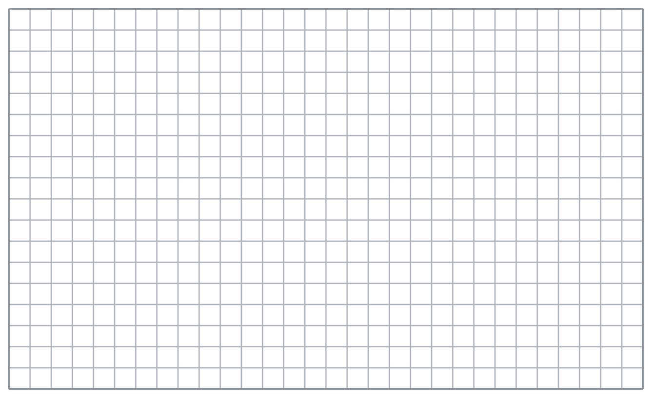
  TURN AND TALK
  Why is surface area measured in square units even though the chest is a solid?
PRACTICE WITH A PARTNER You Do Together · 10–12 min
2. Gift Wrap. A gift box is a rectangular prism 12 in. long, 10 in. wide, and 7 in. tall. Kai wants to cover the whole outside with paper.  a. The three different face areas __________  b. Surface area of the pedestal __________ | 3. Two Cubes. Cube A has edges of 5 cm. Cube B has edges of 7 cm. Both cubes will be covered in foil.  a. Area of ONE face: Cube A __________  b. Surface area: Cube A __________
  PARTNER TALK
  How does drawing a net make sure that no face gets left out of your total?
  PARTNER TALK
  What happens to the surface area when the edge of a cube gets longer? Explain.

4. Moving Crate. A moving crate is a rectangular prism 8 ft long, 6 ft wide, and 3 ft tall. Every face is closed.
a. The three different face areas __________
b. Surface area of the platform __________
PARTNER TALK
Which two edges make each face? Show your partner on the net.

PRACTICE ON YOUR OWN You Do · 8 problems · 18–20 min
5. Aquarium Glass. A tank is a rectangular prism 30 in. long, 14 in. wide, and 16 in. tall. The top of the tank is open, so it has no glass.  Find the total area of glass the tank needs  Hint Sketch the net and cross out the missing face before you add anything together.  Answer glass area in in² | Net. Draw the net on the grid below, label every face with its dimensions, and mark the matching pairs.​
  Show your work.

6. Storage Bin. A closed storage bin is a rectangular prism 13 cm long, 10 cm wide, and 7 cm tall.  Sketch a net, then find the surface area of the bin  Hint Find one face from each matching pair, add those three, then account for the twin faces.  Answer surface area in cm² | Net. Draw the net on the grid below, label every face with its dimensions, and mark the matching pairs.​
  Show your work.

7. Tessa’s Cube. A cube has edges of 12 in. Tessa says its surface area is 144 in².
Justify or correct Nolan’s answer. Nolan found ______, but surface area includes ______.
Hint Nolan found one face. How many faces make up the outside of a cube?
Answer true surface area (Is Nolan right?)

8. Locker Box. A closed locker box is a rectangular prism 16 in. long, 9 in. wide, and 6 in. tall.  Sketch a net, then find the surface area of the box  Hint Find one face from each matching pair, add those three, then account for the twin faces.  Answer surface area in in² | Net. Draw the net on the grid below, label every face with its dimensions, and mark the matching pairs.​
  Show your work.

9. Garden Planter. A planter is a rectangular prism 20 cm long, 12 cm wide, and 10 cm tall. The top is open, so it has no wood.  Find the total area of wood the planter needs  Hint Sketch the net and cross out the missing face before you add anything together.  Answer wood area in cm² | Net. Draw the net on the grid below, label every face with its dimensions, and mark the matching pairs.​
  Show your work.

10. From a Net. A rectangular prism is 9 cm long, 6 cm wide, and 4 cm tall. Find its surface area.  Hint Find 8×5, 8×3, and 5×3, then double each and add.  Answer cm² | 11. Shipping Box. A box is 10 in. by 5 in. by 3 in. Find its surface area.  Hint The three different face areas are 36, 18, and 8. Each has a matching partner.  Answer in²

12. A Cube. A cube has edges of 7 m.
a. Find the area of one face. __________
b. Find the surface area of the cube. __________
Hint Multiply the area of one square face by 6.
Answer a and b
ANALYZE THE ERROR 5 min
13. Read the work below. Explain the mistake, then show the correct reasoning.
ELENA’S WORK

A box is 10 cm long, 7 cm wide, and 5 cm tall. Jonah wrote: ‘Surface area = 10 × 7 × 5 = 350 cm².’
a. Explain the mistake. Elena multiplied length × width × height to find surface area. Surface area adds ______ instead of measuring ______. | b. Show correct work. Find the area of each face, then add all six face areas.  Correct answer
  Show the correct work.
STRETCH YOUR THINKING multi-step reasoning · 8 min
14. Painting a Crate. A wooden crate is 8 ft long, 5 ft wide, and 4 ft tall. One can of paint covers 40 square feet and costs $22.
a. Find the surface area of the display stand.
b. Find the number of cans needed to paint all six faces.
c. The bottom is not painted. Find the new area and the new number of cans.
Answer the area, the cans, and the revised plan
TEST PRACTICE multiple choice · fill one box · 6 min
15. A cube with edge 4 cm has surface area — | 16. Surface area is measured in —
  □ A. 64 cm² | □ B. 96 cm² | □ C. 16 cm² | □ D. 24 cm²
  □ A. linear units | □ B. cubic units | □ C. square units | □ D. degrees

17. A prism 5 by 4 by 2 has surface area — | 18. A rectangular prism has how many pairs of matching faces?
  □ A. 88 | □ B. 40 | □ C. 44 | □ D. 76
  □ A. 3 | □ B. 2 | □ C. 6 | □ D. 4
SPIRAL REVIEW earlier skills · keep them sharp · 6 min
19. From Lesson 5-6 Session 2. A net of 2 triangles and 3 rectangles makes what solid?  Answer | 20. From Lesson 5-5 Session 1. A prism is 5 cm by 5 cm by 6 cm. Find its volume.  Answer

21. From Lesson 4-1 Session 1. Write 8 out of 25 as a percent.  Answer | 22. From Lesson 3-6 Session 2. Convert 6 kilometres to meters.  Answer
CHECK YOUR UNDERSTANDING 5 min
23. Shipping Carton. A closed shipping carton is a rectangular prism 15 in. long, 12 in. wide, and 10 in. tall.
a. The three different face areas __________
b. Surface area of the case __________
Hint Find 14×11, 14×8, and 11×8. Double each face area, then add.
Answer

□ 4 — Can teach it | □ 3 — Got it | □ 2 — Need hint | □ 1 — Need help
Circle your confidence. Star one problem that shows your learning.

