Name |  | Date |  | Period
Lesson 5-7 · Session 2 · Version 2
Guided Practice · Version 2
Surface Area of Triangular Prisms
VOCABULARY read and say each word before you begin
triangular prism  Spanish: prisma triangular | A solid with two triangle bases and rectangle sides. | a tent shape
base  Spanish: base | One of the two matching end faces of a prism. | the two triangles
lateral face | Any face of a prism that is not a base. | the 3 rectangles
congruent  Spanish: congruente | Exactly the same size and shape. | the two triangle ends
surface area  Spanish: área superficial | The total area of all the faces of a solid. | add all 5 faces
EXPLORE TOGETHER Class Launch · 8–10 min
1. Triangular Candy Box  Ms. Rivera’s candy box is a triangular prism 20 cm long. Each triangular end has a base of 24 cm, a height of 5 cm, and two equal slanted sides of 13 cm.  a. Net. Sketch a net of the candy box. Count its faces. Triangles: ______ Rectangles: ______  b. Ends. Find the area of ONE triangular end: ______ cm² Both ends together: ______ cm²  c. Rectangles. Find each area. Bottom: ______ cm² Each slanted side: ______ cm² All three together: ______ cm²  d. Total. Add the areas of all five faces. Surface area of the candy box: ______ cm² | e. Net. Draw the candy box’s net on the grid below. Label every face with its dimensions and mark the matching pairs.​  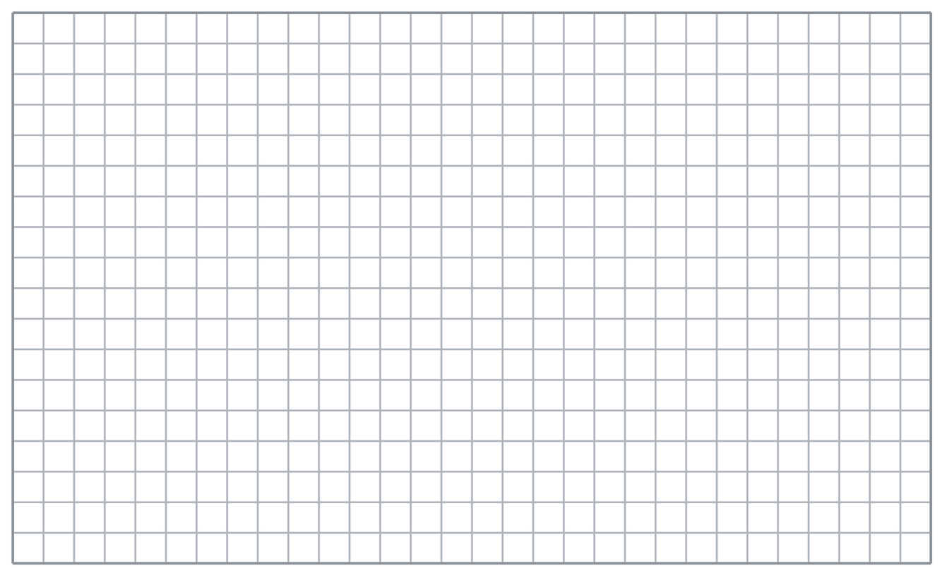
  TURN AND TALK
  Why do all three rectangles in this net share the same length?
PRACTICE WITH A PARTNER You Do Together · 10–12 min
2. Ramp Wedge. A wedge is a triangular prism 14 cm wide. Each triangular face is a right triangle with legs of 20 cm and 21 cm and a longest side of 29 cm.
a. Area of both triangular faces together, in cm² __________
b. Total area of the three rectangles, in cm² __________
PARTNER TALK
How do you decide which measure is the triangle’s height and which is just a side?

3. Display Stand. A display stand is a triangular prism 5 in. deep. Each triangular face is a right triangle with legs of 16 in. and 30 in. and a longest side of 34 in.  a. Sketch a net of the display stand. Find the area of both triangular faces together. __________  b. Find the total area of the three rectangular faces. __________ | c. Net. Draw the display stand’s net on the grid below. Label every face with its dimensions and mark the matching pairs.​
  PARTNER TALK
  Which triangle sides form rectangle edges? Explain why a leg can also be a triangle height.

4. Cheese Wedge. A cheese wedge is a triangular prism 6 cm thick. Each triangular face is a right triangle with legs of 5 cm and 12 cm and a longest side of 13 cm.
a. Area of both triangular faces together, in cm² __________
b. Total area of the three rectangles, in cm² __________
PARTNER TALK
Where does the 6 cm show up in every one of the three rectangles?

PRACTICE ON YOUR OWN You Do · 8 problems · 18–20 min
5. Doorstop. A doorstop is a triangular prism 13 cm wide. Each triangular face is a right triangle with legs of 18 cm and 24 cm and a longest side of 30 cm.  Sketch a net of Elena’s doorstop, then calculate its surface area.  Hint Your net needs two triangles and three rectangles. Use the prism’s width as one dimension of every rectangle.  Answer total surface area in cm² | Net. Draw the doorstop’s net on the grid below. Label every face with its dimensions and mark the matching pairs.​
  Show your work.

6. Roof Piece. A roof piece is a triangular prism 25 ft long. Each triangular end has a base of 36 ft, a height of 24 ft, and two equal slanted sides of 30 ft.  Find the surface area of the stage platform.  Hint Calculate the area of both triangular ends and each of the three rectangles. Add all five face areas.  Answer total surface area in ft² | 7. Nolan’s Ends. A triangular prism is 22 in. long. Each triangular end has a base of 14 in. and a height of 24 in. Nolan says both ends together cover 168 in².  Justify or correct Maya’s answer. Complete the sentence frame: “Maya’s answer is ______ because ______. Both ends together cover ______ in².”  Hint Find the area of one triangular end. Check whether Maya counted both ends.  Answer area of both ends (Is Maya right?)

8. Bookend. A bookend is a triangular prism 9 in. wide. Each triangular face is a right triangle with legs of 8 in. and 15 in. and a longest side of 17 in.  Sketch a net of Caleb’s bookend, then calculate its surface area.  Hint Include two triangular faces and three rectangular faces. Each rectangle has the 9 in. width as one of its dimensions.  Answer total surface area in in² | Net. Draw the doorstop’s net on the grid below. Label every face with its dimensions and mark the matching pairs.​
  Show your work.

9. Planter Wedge. A planter is a triangular prism 10 ft long. Each triangular end has a base of 16 ft, a height of 6 ft, and two equal slanted sides of 10 ft.  Find the surface area of the stage ramp  Hint Calculate the area of both triangular ends and each of the three rectangles. Add all five face areas.  Answer total surface area in ft² | 10. Right Triangle Ends. A triangular prism is 11 cm long. Each end is a right triangle with legs 3 cm and 4 cm and hypotenuse 5 cm. Find the surface area.  Hint Two triangles of 30 cm² plus rectangles 5×7, 12×7, and 13×7.  Answer __________ cm²

11. Tent Shape. A prism is 8 ft long. Each triangular end has base 6 ft, height 4 ft, and the two slanted sides measure 5 ft each. Find the surface area.  Hint Two triangles of 60 ft² plus rectangles 10×6, 13×6, and 13×6.  Answer __________ ft² | 12. Name the Pieces. A triangular prism is 10 m long with triangular ends of sides 6 m, 8 m, and 10 m and a triangle area of 24 m².  a. Find the total area of the sculpture’s two triangular ends. __________  b. Find the total area of the sculpture’s three rectangular faces. __________  Hint Each rectangle is one triangle side times 8 m.  Answer a and b: __________ m² and __________ m²
ANALYZE THE ERROR 5 min
13. Read the work below. Explain the mistake, then show the correct reasoning.
KAI’S WORK

Amara’s net of a triangular prism shows 2 triangles and 3 rectangles. She found all three rectangles and one triangle, added them, and stopped.
a. Explain the mistake. Kai’s face areas are each correct. Which face did he count too few times? Complete: “Kai counted only ___ triangular face, but the prism has ___ triangular faces.” | b. Show correct work by including the area of every face.  Correct answer
  Show the correct work.
STRETCH YOUR THINKING multi-step reasoning · 8 min
14. Camping Tent. A tent is a triangular prism 9 ft long. Its triangular ends have base 8 ft, height 3 ft, and slanted sides of 5 ft each. The floor is one of the rectangles.
a. Find the combined area of the booth’s two triangular ends.
b. Find the total surface area of the booth.
c. Find the fabric needed to cover the booth if the floor is not covered.
Answer the ends, the total, and the fabric: __________ ft², __________ ft², and __________ ft²
TEST PRACTICE multiple choice · fill one box · 6 min
15. A triangular prism has how many rectangular faces? | 16. Two triangles of 9 cm² each contribute —
  □ A. 5 | □ B. 2 | □ C. 4 | □ D. 3
  □ A. 18 cm² | □ B. 9 cm² | □ C. 81 cm² | □ D. 4.5 cm²

17. Each rectangle in the net uses one triangle side times the — | 18. A triangular prism has how many faces in total?
  □ A. triangle height | □ B. prism length | □ C. triangle area | □ D. prism volume
  □ A. 6 | □ B. 4 | □ C. 5 | □ D. 3
SPIRAL REVIEW earlier skills · keep them sharp · 6 min
19. From Lesson 5-7 Session 1. A cube has edges of 5 cm. Find its surface area.  Answer | 20. From Lesson 5-6 Session 2. A net of 6 identical squares makes what solid?  Answer

21. From Lesson 4-5 Session 1. If 24 is 40% of a number, find the number.  Answer | 22. From Lesson 3-3 Session 1. Scale 3 : 8 by 5.  Answer
CHECK YOUR UNDERSTANDING 5 min
23. Chocolate Box. A chocolate box is a triangular prism 18 in. long. Each triangular end is a right triangle with legs of 20 in. and 21 in. and a longest side of 29 in.
a. Area of both triangular ends of the case __________
b. Surface area of the case __________
Hint Each rectangle has a length of 16 in.; its other dimension is 8 in., 15 in., or 17 in.
Answer

□ 4 — Can teach it | □ 3 — Got it | □ 2 — Need hint | □ 1 — Need help
Circle your confidence. Star one problem that shows your learning.

