Name |  | Date |  | Period
Lesson 5-8 · Session 2
Guided Practice
Lateral Area of Pyramids
VOCABULARY read and say each word before you begin
pyramid  Spanish: pirámide | A solid with one base and triangular sides. | base + slanted faces
lateral face | A triangle side of a pyramid, not the bottom. | the slanted sides
lateral area | The area of the slanted faces only. | base is left out
slant height | The height of a side triangle, along its face. | used in ½ × b × slant
surface area  Spanish: área superficial | The area of every face, base included. | lateral area + base
EXPLORE TOGETHER Class Launch · 8–10 min
1. Canvas Art Frame  Maria’s frame is a pyramid with a triangle base 24 in. on each side. Its 3 slanted faces each have a slant height of 14 in. Only those faces get canvas.  a. Net. Sketch the net: a triangle with a triangle on each side. Faces to cover: ______  b. One Face. Area of ONE slanted face: ½ × ______ × ______ = ______ in²  c. Lateral. Canvas for all the slanted faces: ______ × ______ = ______ in²  d. Reasoning. Why is the middle triangle left out of the canvas total? __________ | e. Net. Draw the net on the grid below, label every face with its dimensions, and mark the matching pairs.​  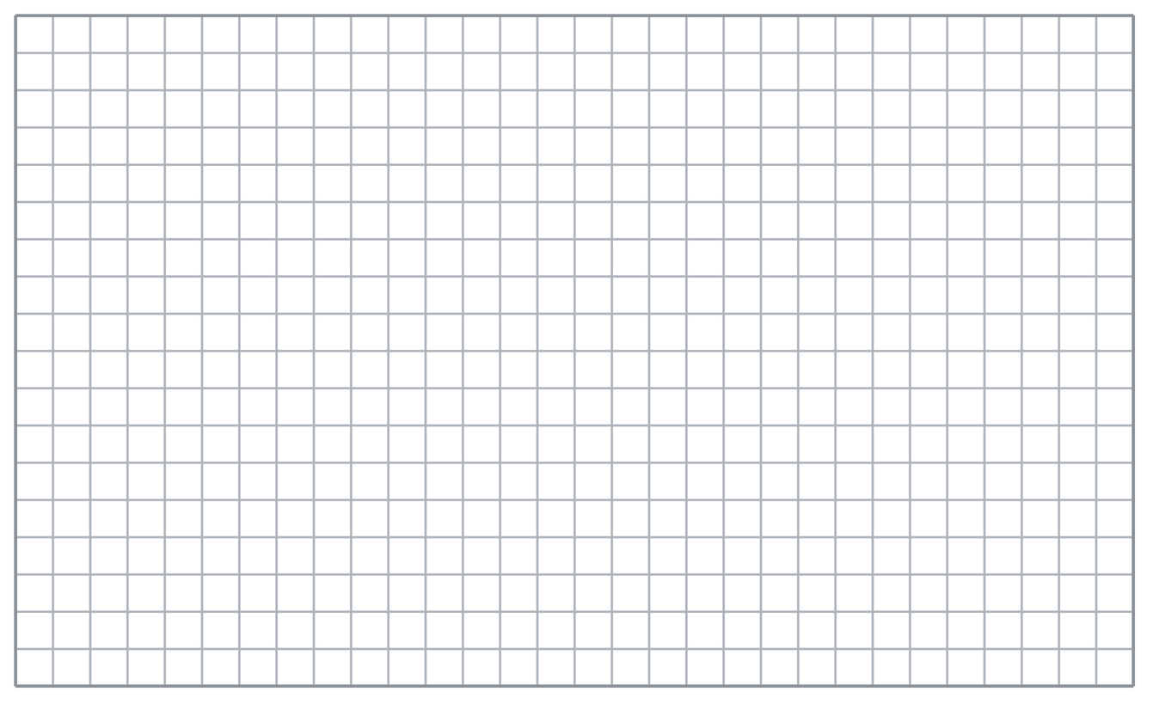
  TURN AND TALK
  When should you include the base in a total, and when should you leave it out?
PRACTICE WITH A PARTNER You Do Together · 10–12 min
2. Open-Bottom Tent. A tent is a square pyramid with a base 10 ft on each side and a slant height of 9 ft. The floor of the tent is open ground.  a. Area of ONE fabric panel __________  b. What the total WOULD be if the floor were covered too __________ | 3. Triangle-Base Pyramid. A pyramid has a triangle base with sides of 12 cm and an approximate base height of 10.4 cm. Its 3 slanted faces each have a slant height of 13 cm.  a. Area of ONE slanted face __________  b. Approximate area of the triangle base __________
  PARTNER TALK
  How much difference does the floor make to the total? Explain what changes.
  PARTNER TALK
  Why does this pyramid have three slanted faces instead of four?

4. Gazebo Roof. A gazebo roof is a square pyramid with a base 14 ft on each side and a slant height of 8 ft. Only the slanted faces get shingles.
a. Area of ONE slanted face __________
b. Shingled area for the whole roof __________
PARTNER TALK
What words in a problem tell you to leave the base out of the total?

PRACTICE ON YOUR OWN You Do · 8 problems · 18–20 min
5. Tower Cap. A tower cap is a square pyramid with a base 22 m on each side and a slant height of 17 m. Only the slanted faces are covered in copper.
Find the area of copper the cap needs
Hint Copper covers only the slanted faces, so the square at the bottom stays out of this total.
Answer copper area in m²

6. Display Pyramid. A store display is a square pyramid with a base 26 in. on each side and a slant height of 25 in. Every face is wrapped in paper, base included.  Sketch a net, then find the total area of paper needed  Hint This one wraps everything, so the base square joins all four slanted faces in your total.  Answer paper area in in² | Net. Draw the net on the grid below, label every face with its dimensions, and mark the matching pairs.​
  Show your work.

7. Kai’s Canvas. A square pyramid has a base 30 cm on each side and a slant height of 21 cm. Kai says canvas for the four slanted faces covers 1,215 cm².  Justify or correct Kai’s answer.  Hint Work out one slanted face carefully, then decide how many of those the canvas has to cover.  Answer true lateral area (Is Kai right?) | 8. Market Stall Top. The top of a market stall is a square pyramid with a base 18 m on each side and a slant height of 12 m. Only the slanted faces are covered in canvas.  Find the area of canvas the stall top needs  Hint Work out one slanted face, then decide how many of those the canvas has to cover.  Answer canvas area in m²

9. Feeder Roof. A bird feeder roof is a pyramid with a triangle base 16 cm on each side. Its 3 slanted faces each have a slant height of 9 cm. Only the slanted faces are painted.  Find the painted area of the feeder roof  Hint A triangle base gives three slanted faces, and the base itself stays out of the total.  Answer painted area in cm² | 10. Triangular Base. A pyramid has a triangle base with sides of 18 cm. Each of its 3 slanted faces has a base of 18 cm and a slant height of 14 cm. Find the lateral area.  Hint Each face is ½ × 18 × 14 = 126 cm²; there are 3.  Answer cm²

11. Square Base. A square pyramid has a base 11 in. on a side and a slant height of 10 in. Find the lateral area.  Hint Each face is 55 in²; there are 4.  Answer in² | 12. Lateral or Total? A square pyramid has a base 7 m on a side and a slant height of 9 m.  a. Find the lateral area. __________  b. Find the total surface area. __________  Hint Total surface area adds the base to the lateral area.  Answer a and b
ANALYZE THE ERROR 5 min
13. Read the work below. Explain the mistake, then show the correct reasoning.
ROSA’S WORK

A square pyramid has a base 14 cm on each side and a slant height of 8 cm. Only the slanted faces are painted. Rosa wrote: ‘Area = 196 + 224 = 420 cm².’
a. Explain the mistake. Only the slanted faces are painted. Which of Rosa’s numbers does not belong? | b. Show correct work  Correct answer
  Show the correct work.
STRETCH YOUR THINKING multi-step reasoning · 8 min
14. Tent Cover. A shelter is a square pyramid with a base 16 ft on a side and a slant height of 10 ft. Canvas costs $3 per square foot, and the floor is left open.
a. Find the lateral area of the shelter.
b. Find the cost of the canvas.
c. Find the total surface area, then explain why the lateral area is the right measure here.
Answer lateral area, cost, total area, and your explanation
TEST PRACTICE multiple choice · fill one box · 6 min
15. Lateral area leaves out the — | 16. Four faces of 25 cm² each give a lateral area of —
  □ A. edges | □ B. slanted faces | □ C. base | □ D. slant height
  □ A. 50 cm² | □ B. 25 cm² | □ C. 625 cm² | □ D. 100 cm²

17. Total surface area equals lateral area plus the — | 18. A pyramid with a triangular base has how many slanted faces?
  □ A. base area | □ B. slant height | □ C. volume | □ D. perimeter
  □ A. 4 | □ B. 3 | □ C. 5 | □ D. 2
SPIRAL REVIEW earlier skills · keep them sharp · 6 min
19. From Lesson 5-8 Session 1. A square pyramid has base 6 cm on a side and slant height 8 cm. Find the surface area.  Answer | 20. From Lesson 5-7 Session 1. A cube has edges of 8 in. Find its surface area.  Answer

21. From Lesson 4-5 Session 1. If 15 is 25% of a number, find the number.  Answer | 22. From Lesson 3-2 Session 1. A runner covers 105 km in 7 hours. Find the unit rate.  Answer
CHECK YOUR UNDERSTANDING 5 min
23. Two Pyramids. Pyramid A is a square pyramid with a base 9 in. on each side and a slant height of 12 in. Only its slanted faces are painted. Pyramid B has the same measures, but every face is painted.
a. Painted area on Pyramid A __________
b. Painted area on Pyramid B __________
Hint The two answers differ by exactly one face, so find the slanted faces once and decide what to add.
Answer

□ 4 — Can teach it | □ 3 — Got it | □ 2 — Need hint | □ 1 — Need help
Circle your confidence. Star one problem that shows your learning.

