UNIT 5 · LESSON 9 STANDARD 6.GR.1

Area of Regular Polygons
Student Notes Packet
Name: ______________________ Date: ____________ Period: ________
Level 3 · Enrichment

Today's Goals
Content: I can find the area of a regular polygon by decomposing it into triangles.
Language: I can explain my steps using the words regular polygon, decompose, triangle, and composite.

Key Vocabulary
Look at the picture, read the word, then read what it means.
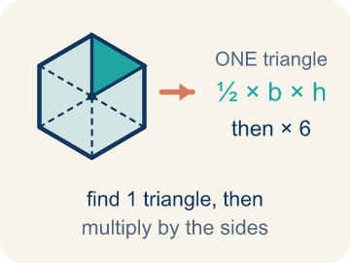 | Area of Regular Polygons Área de polígonos regulares  The space a regular polygon covers. Split it from the center into identical triangles, find one triangle's area, then multiply by how many there are.  Example: A hexagon splits into 6 identical triangles: (½ × 4 × 3.5) × 6 = 42 square units
 | Regular Polygon Polígono regular  A closed flat shape made of straight sides, where every side is the same length and every angle is the same size.  Example: A stop sign is a regular octagon — all 8 sides are the same length and all 8 angles are equal
 | Decompose Descomponer  To break a shape into smaller, simpler shapes.  Example: Draw lines from the center of a hexagon to each corner → you get 6 equal triangles you can find the area of
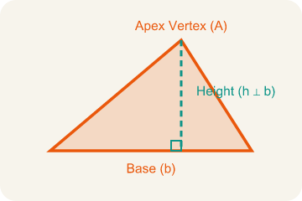 | Triangle Triángulo  A shape with three sides.  Example: Each triangle inside a decomposed hexagon has a base = one side of the hexagon and height = distance from center to side
 | Composite Compuesto  Made by putting two or more simple shapes together.  Example: 6 triangles, each with area 15 sq ft, combine to form a hexagon with total area = 6 × 15 = 90 sq ft
 | Formula Fórmula  A math rule written with symbols.  Example: For a regular hexagon: Total Area = 6 × (½ × b × h), where b = side length and h = height of each triangle

Guided Notes
Fill in each blank as we go. Use the Word Bank to help you.
WORD BANK
Area of Regular Polygons • Regular Polygon • Decompose • Triangle • Composite • Formula

1. The space inside a regular polygon, found with A = (½bh) × n, is the ________________.
2. A polygon with all sides and all angles equal is a ________________.
3. To break a shape into smaller shapes is to ________________ it.
4. A three-sided polygon is a ________________.
5. Made of two or more shapes combined, a figure is ________________.
6. A math rule written with symbols is a ________________.

Write About the Math
How much will the gazebo flooring cost?
¿Cuánto costará el piso del quiosco?
Say your answer to a partner first. Then write it, using at least two of these words:
☐ Regular Polygon · Polígono regular
☐ Decompose · Descomponer
☐ Triangle · Triángulo
☐ Composite · Compuesto
☐ Formula · Fórmula
Model: We decompose the hexagon into triangles because we already know how to find a triangle's area. — Students explain that splitting the hexagon into 6 equal triangles lets them use the triangle area formula they already know, then combine the parts.

Start Most language support
Complete the frames. Use the word bank.
Completa las oraciones. Usa el banco de palabras.
One triangle's area is ___ sq ft. The octagon has ___ triangles, so total area = ___ sq ft. The cost is ___ x $3 = $___.
My answer is ___ because ___.
Mi respuesta es ___ porque ___.

Build Some language support
Write two connected sentences. Use because, so, or but.
Escribe dos oraciones conectadas. Usa porque, entonces o pero.
My claim is ___.
Mi afirmación es ___.
My evidence is ___, so ___.
Mi evidencia es ___, entonces ___.

Explain Light language support
Write a claim, give math evidence, and explain your reasoning.
Escribe una afirmación, da evidencia matemática y explica tu razonamiento.

Check Your Explanation three quick checks
☐ I answered the question.
☐ I used math evidence: numbers, an equation, or a model.
☐ I used at least two math words.

Worked Example

Watch & Read I Do — follow along with your teacher
Blueprint Review
Your architecture firm is designing a hexagonal skylight for the lobby of a new museum. The glass fabricator needs to know the total area so they can cut the correct amount of glass. Each side of the hexagon is 6 feet, and the height of each triangle formed from the center is 5.2 feet. The height is rounded to the nearest tenth of a foot, so the area is approximate.

Think about:
• What shape is the skylight?
• How many sides does a hexagon have?
• Can you see smaller shapes inside the hexagon?
• How can we break a hexagon into shapes whose area we already know?
• Does this strategy work for other regular polygons?

Solved Example I Do — watch each step
Problem: A regular hexagon is divided into 6 equal triangles from the center. Each triangle has a base of 6 ft and a height of 5.2 ft. What is the area of one triangle? Use the given heights; nonsquare heights are rounded, so their areas are estimates.
A) 11.2 sq ft
B) 15.6 sq ft
C) 15.6 ft
D) 31.2 sq ft
Step 1: A = ½ × b × h = ½ × 6 × 5.2 = 15.6 square feet.
Answer: B. 15.6 sq ft

Independent Practice

On Your Own You Do — show your work
Solve each problem. Show your thinking in the work box.

Level 2 Enrichment stretch your thinking
1. Use total area = number of triangles × ½ × base × height to find each missing value. Nonsquare measurements are rounded; use the displayed values.

Exit Ticket
Answer on your own. This shows what you learned today.
★ A regular pentagon is decomposed into 5 triangles from its center. Each triangle has a base of 7 inches and a height of 4.8 inches. What is the total area of the pentagon? Use the given rounded height to estimate the area.
A) 16.8 sq in
B) 84 sq in
C) 84 in
D) 168 sq in

