Name Date Period
Lesson 6-3 · Homework Packet · Sheet 1 of 2
Writing Repeated Factors as Powers
Maryland Standard 6.EE.A.1 · Learning target — I can write repeated multiplication as a power and name its base and exponent.

REMEMBER  • A power shows a repeated factor: 5 × 5 × 5 = 5³.  • The base is the repeated factor. The exponent tells how many times it is a factor.  • Read 5³ as “5 to the third power” or “5 cubed.” Read 5² as “5 squared.” | WORKED EXAMPLE  Write 6 × 6 × 6 × 6 × 6 as a power. Name the base and the exponent.  Step 1 The repeated factor is 6. It is the base.  Step 2 Count the factors: there are 5. That is the exponent.  Step 3 Write the base with a raised exponent: 6⁵  Answer 6⁵; base 6, exponent 5
PRACTICE show your work · label units
1. Write each product as a power.
a. 4 × 4 × 4 = | b. 9 × 9 =
c. 2 × 2 × 2 × 2 × 2 × 2 × 2 = | d. 10 × 10 × 10 × 10 =
e. 1/3 × 1/3 × 1/3 = | f. 0.5 × 0.5 =
g. 6 × 6 × 6 × 6 × 6 = | h. 2/5 × 2/5 =

2. Complete the table.
Power | Base | Exponent | Expanded form
8³
 | 7 | 4
 |  |  | 11 × 11

3. Phone Tree. A coach calls 3 players. Each player calls 3 more players, and so on. In round 5, the number of calls is 3 × 3 × 3 × 3 × 3. Write this as a power.
Power

4. Find the Error. Rafael wrote 4 × 4 × 4 × 4 × 4 as 5⁴. Explain his mistake. Then write the correct power.

CHECK YOURSELF | □ I can do this on my own | □ I need a little help | □ I have a question about #
AT HOME Explain to someone at home why 2⁴ does not mean 2 × 4.
Name Date Period
Lesson 6-3 · Homework Packet · Sheet 2 of 2
Finding the Value of a Power
Maryland Standard 6.EE.A.1 · Learning target — I can find the value of a power by multiplying the base the number of times the exponent shows.

REMEMBER  • Write the expanded form, then multiply one factor at a time.  • 4³ = 4 × 4 × 4 = 64, not 4 × 3 = 12.  • Fraction and decimal bases work the same way: (1/2)² = 1/2 × 1/2 = 1/4. | WORKED EXAMPLE  Find the value of 2⁵.  Step 1 Expanded form: 2 × 2 × 2 × 2 × 2  Step 2 Multiply: 2 × 2 = 4, 4 × 2 = 8, 8 × 2 = 16, 16 × 2 = 32  Answer 2⁵ = 32
PRACTICE show your work · label units
1. Find the value of each power.
a. 7² = | b. 3⁴ = | c. 5³ =
d. 10⁵ = | e. 2⁶ = | f. 1⁸ =

2. Find the value. Write fractions in simplest form.
a. (1/2)³ = | b. 0.3² =

3. Write each number as a power of the given base.
a. 27 as a power of 3: | b. 10,000 as a power of 10:

4. Storage Cube. A storage cube has edges that are 7 inches long. Its volume is 7³ cubic inches. Find the volume.  Answer in³ | 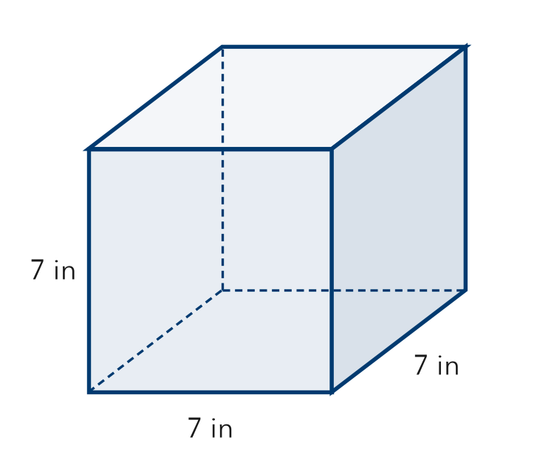
  Show your work.

5. Compare. Select the two powers that have the same value.
□ A 2⁶ | □ B 6² | □ C 4³ | □ D 3⁴

TEST PRACTICE choose the best answer
6. What is the value of 4³?
A 7 | B 12 | C 64 | D 81

7. Which expression has a value of 1,000?
A 10³ | B 3¹⁰ | C 10 × 3 | D 100³

CHECK YOURSELF | □ I can do this on my own | □ I need a little help | □ I have a question about #
AT HOME Ask someone at home to guess which is greater, 2⁵ or 5². Then find both values together.

