UNIT 6 · LESSON 6 STANDARD 6.AT.7

Identify Equivalent Algebraic Expressions
Student Notes Packet
Name: ______________________ Date: ____________ Period: ________
Level 1 · Support

Today's Goals
Content: I can show that two expressions are equivalent by simplifying and combining like terms.
Language: I can explain my work using the words equivalent, simplify, like terms, and combine.

Key Vocabulary
Look at the picture, read the word, then read what it means.
 | Equivalent Expressions Expresiones equivalentes  Expressions that look different but have the same value for every allowed variable value.  Example: 2(x + 3) and 2x + 6 are equivalent.
 | Equivalent Equivalente  Expressions that always have the same value.  Example: 2x + 4 and 2(x + 2): when x = 3, both = 10; when x = 7, both = 18 — always the same
Simplify Simplificar
To rewrite an expression in a shorter form that is still equal to the original.
Example: 3x + 2x + 5 simplifies to 5x + 5 — fewer terms, same value
 | Like Terms Términos semejantes  Terms with the same letter raised to the same power, like 2x and 5x.  Example: 3x and 7x are like terms (both x); 3x and 3y are NOT (x vs y); 3x and 3x² are NOT (x vs x²)
 | Combine Combinar  To add or subtract terms with the same letter into one.  Example: 4n + 3n = 7n — add the coefficients (4 + 3 = 7) and keep the variable (n)
 | Coefficient Coeficiente  The number in front of a letter, like the 3 in 3x.  Example: In 5x + 3, the coefficient of x is 5 — when x = 2, the 5x part equals 10
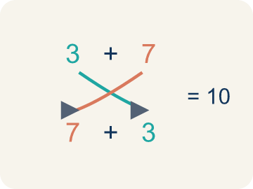 | Commutative Property Propiedad conmutativa  The order of the numbers can change in addition or multiplication without changing the result.  Example: a + b = b + a
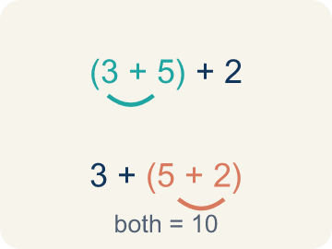 | Associative Property Propiedad asociativa  The grouping of the numbers can change in addition or multiplication without changing the result.  Example: (a + b) + c = a + (b + c)
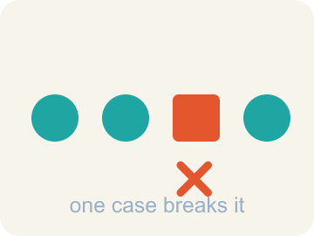 | Counterexample Contraejemplo  One test value that shows two expressions are not equivalent.  Example: One mismatch is enough.

Guided Notes
Fill in each blank as we go. Use the Word Bank to help you.
WORD BANK
Equivalent Expressions • Equivalent • Simplify • Like Terms • Combine • Coefficient • Commutative Property • Associative Property • Counterexample

1. Expressions with the same value for ________________ allowed number are equivalent.
2. Expressions that always have the same value are ________________.
3. Rewriting an expression in a shorter form that is still equal to it is to ________________ it.
4. Terms with the same variable raised to the same power, like 4x and 9x, are ________________.
5. To add or subtract like terms into one term is to ________________ them.
6. A number multiplied by a variable is a ________________.
7. The rule that a + b = b + a is the ________________.
8. The rule that (a + b) + c = a + (b + c) is the ________________.
9. One value that shows two expressions are not equal is a ________________.

Write About the Math
Are these expressions equivalent? How can you prove it?
¿Estas expresiones son equivalentes? ¿Cómo lo puedes probar?
Say your answer to a partner first. Then write it, using at least two of these words:
☐ Equivalent Expressions · Expresiones equivalentes
☐ Equivalent · Equivalente
☐ Simplify · Simplificar
☐ Like Terms · Términos semejantes
☐ Combine · Combinar
Model: 3x + 2x combines to 5x, so the two forms are equivalent. — Students explain 3x + 2x = 5x (combining like terms), so both equal 5x + 10, and verify by substituting a value like x = 4 to get 30 both ways.

Start Most language support
Complete the frames. Use the word bank.
Completa las oraciones. Usa el banco de palabras.
The expressions ___ equivalent because when I simplify 4h + 2h + 30, I get ___. I can prove it by substituting h = ___: both expressions equal ___.
My answer is ___ because ___.
Mi respuesta es ___ porque ___.

Build Some language support
Write two connected sentences. Use because, so, or but.
Escribe dos oraciones conectadas. Usa porque, entonces o pero.
My claim is ___.
Mi afirmación es ___.
My evidence is ___, so ___.
Mi evidencia es ___, entonces ___.

Explain Light language support
Write a claim, give math evidence, and explain your reasoning.
Escribe una afirmación, da evidencia matemática y explica tu razonamiento.

Check Your Explanation three quick checks
☐ I answered the question.
☐ I used math evidence: numbers, an equation, or a model.
☐ I used at least two math words.

Worked Example

Watch & Read I Do — follow along with your teacher
Remix Studio
At the music studio, two producers wrote formulas for the cost of renting equipment. Producer A wrote 3x + 2x + 10, and Producer B wrote 5x + 10. They look different, but are they really? Let's check: if x = 4, Producer A gets 3(4) + 2(4) + 10 = 30, and Producer B gets 5(4) + 10 = 30. Same result — they're equivalent expressions!

Think about:
• Why did both formulas give the same answer?
• What did Producer B do differently from Producer A?
• Would they still match if x = 10?
• Can two expressions look completely different but always give the same answer?
• Is there always a 'simplest' way to write an expression?

Solved Example I Do — watch each step
Problem: Which expression is equivalent to 4x + 3x?
A) 7x
B) 7x²
C) 12x
D) 43x
Step 1: 4x + 3x = 7x.
Step 2: Combine the coefficients: 4 + 3 = 7.
Answer: A. 7x

Guided Practice

Solve Together We Do — work with your class
Problem: Which expression is equivalent to 2(m + 5)?
A) 2m + 10
B) 2m + 5
C) 7m
D) m + 10
Step 1:

Step 2:

Answer:

A music studio charges different clients using different formulas. Client A pays 4h + 2h + 30 for h hours. Client B pays 6h + 30. A new client asks if the pricing is fair.
Are these expressions equivalent? How can you prove it?

Sentence frame: The expressions ___ equivalent because when I simplify 4h + 2h + 30, I get ___. I can prove it by substituting h = ___: both expressions equal ___.

Turn & Talk discuss with a partner
1. [Launch] Producer A wrote 3x + 2x + 10 and Producer B wrote 5x + 10. They look different but both give 30 when x = 4. Why are they equivalent?
Start with: These expressions are equivalent because 3x + 2x ___.
Estas expresiones son equivalentes porque 3x + 2x ___.
Word bank: Equivalent, Simplify, Like Terms, Combine
2. [Explore] How can you prove 2(n + 4) and 2n + 8 are equivalent? What two strategies could you use?
Start with: They are equivalent because distributing 2(n + 4) gives ___.
Son equivalentes porque distribuir 2(n + 4) da ___.
Word bank: Equivalent, Simplify, Combine, Like Terms
3. [Connect] Client A pays 4h + 2h + 30 and Client B pays 6h + 30. Is the pricing fair (equivalent)? How can you prove it?
Start with: The expressions ___ equivalent because 4h + 2h = ___.
Las expresiones ___ equivalentes porque 4h + 2h = ___.
Word bank: Equivalent, Simplify, Combine, Like Terms
4. [Practice] During practice on Equivalent Expressions, what strategy did you use when a problem felt tricky?
Start with: When a problem felt tricky, I ___ to solve it.
Cuando un problema fue difícil, yo ___ para resolverlo.
Word bank: Equivalent, Simplify, Like Terms, Combine

Independent Practice

On Your Own You Do — show your work
Solve each problem. Show your thinking in the work box.

Level 1 Support extra scaffolding
1. Which property is shown: 3(x + 7) = 3x + 21?
A) Commutative
B) Distributive
C) Associative
D) Identity

2. Simplify: 5n + 2n
A) 7n
B) 7n²
C) 10n
D) 52n

Exit Ticket
Answer on your own. This shows what you learned today.
★ Which expression is equivalent to 6n + 4 + 3n − 1?
A) 9n + 3
B) 9n + 5
C) 18n + 4
D) 63n

