UNIT 6 · LESSON 8 STANDARD 6.AT.7

Generate Equivalent Expressions
Student Notes Packet
Name: ______________________ Date: ____________ Period: ________
Level 2 · Standard

Today's Goals
Content: I can use the commutative, associative, and identity properties to rewrite expressions.
Language: I can explain my reasoning using the words commutative property, associative property, and identity property.

Key Vocabulary
Look at the picture, read the word, then read what it means.
 | Properties of Operations Propiedades de las operaciones  Rules that let you reorder or regroup numbers without changing an expression's value.  Example: 3 + 5 = 5 + 3 (commutative property).
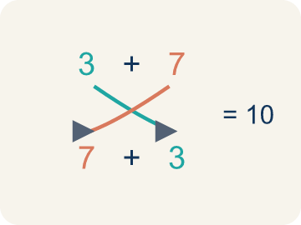 | Commutative Property Propiedad conmutativa  You can change the order and get the same answer.  Example: 3 + 7 = 7 + 3 = 10 both ways; 4 × 5 = 5 × 4 = 20 both ways — order does not matter
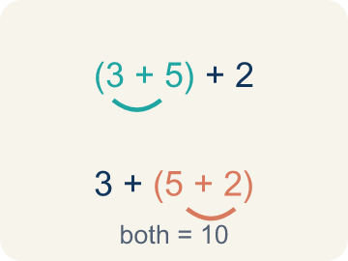 | Associative Property Propiedad asociativa  You can change the grouping and get the same answer.  Example: (2 + 3) + 4 = 5 + 4 = 9 and 2 + (3 + 4) = 2 + 7 = 9 — same answer, different grouping
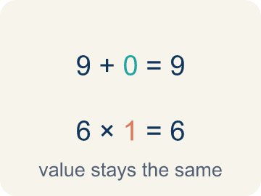 | Identity Property Propiedad de identidad  Adding 0 or multiplying by 1 keeps the same value.  Example: 9 + 0 = 9 (zero is the identity for addition); 6 × 1 = 6 (one is the identity for multiplication)
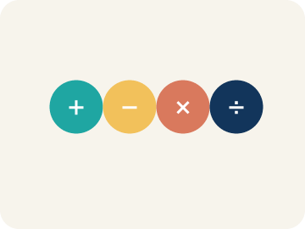 | Property Propiedad  A rule that is always true in math.  Example: Commutative works for + and ×, but NOT for − or ÷ (since 5 − 3 = 2 but 3 − 5 = −2)
 | Distributive Property Propiedad distributiva  Multiplying a number by everything inside the parentheses: a(b + c) = ab + ac.  Example: 5(7 + 2) = 5 × 7 + 5 × 2 = 35 + 10 = 45; and 5 × 9 = 45 — same answer either way
Equivalent expressions Expresiones equivalentes
Expressions that have the same value for every value of the variable.
Example: 6(y + 3) + 9y = 15y + 18
Expand Desarrollar
Multiply out an expression to remove the parentheses.
Example: 6(3x + 4) = 18x + 24
Factor an expression Factorizar una expresión
Pull a shared factor outside parentheses.
Example: 18x + 24 = 6(3x + 4)

Guided Notes
Fill in each blank as we go. Use the Word Bank to help you.
WORD BANK
Properties of Operations • Commutative Property • Associative Property • Identity Property • Property • Distributive Property • Equivalent expressions • Expand • Factor an expression

1. Rules that let you reorder or regroup without changing the ________________.
2. The rule that order does not change a sum or product, like a + b = b + a, is the ________________.
3. The rule that grouping does not change a sum or product, like (a + b) + c = a + (b + c), is the ________________.
4. The rule that adding 0 or multiplying by 1 keeps a number the same is the ________________.
5. A rule that is always true in math is a ________________.
6. The rule that lets you multiply a number across a sum, like a(b + c) = a × b + a × c, is the ________________.
7. Expressions that always have the same value are ________________.
8. Writing 6(3x + 4) as 18x + 24 is called ________________ the expression.
9. Writing 18x + 24 as 6(3x + 4) is called ________________.

Write About the Math
What properties did the engineer use, and why does rearranging make the calculation easier?
¿Qué propiedades usó la ingeniera, y por qué reacomodar hace más fácil el cálculo?
Say your answer to a partner first. Then write it, using at least two of these words:
☐ Properties of Operations · Propiedades de las operaciones
☐ Commutative Property · Propiedad conmutativa
☐ Associative Property · Propiedad asociativa
☐ Identity Property · Propiedad de identidad
☐ Property · Propiedad
Model: The commutative property lets you change the order of a sum without changing the total. — Students name the commutative property and explain that 3 + 5 + 2 gives 10 in any order because reordering addends does not change the sum.

Start Most language support
Complete the frames. Use the word bank.
Completa las oraciones. Usa el banco de palabras.
The engineer used the ___ property to change the ___ and the ___ property to change the ___. This makes it easier because 4 × 25 = ___, which is a friendly number to multiply by.
My answer is ___ because ___.
Mi respuesta es ___ porque ___.

Build Some language support
Write two connected sentences. Use because, so, or but.
Escribe dos oraciones conectadas. Usa porque, entonces o pero.
My claim is ___.
Mi afirmación es ___.
My evidence is ___, so ___.
Mi evidencia es ___, entonces ___.

Explain Light language support
Write a claim, give math evidence, and explain your reasoning.
Escribe una afirmación, da evidencia matemática y explica tu razonamiento.

Check Your Explanation three quick checks
☐ I answered the question.
☐ I used math evidence: numbers, an equation, or a model.
☐ I used at least two math words.

Worked Example

Watch & Read I Do — follow along with your teacher
Band Formation
You're a band director arranging musicians on stage. You have 3 guitarists, 5 drummers, and 2 keyboard players. Whether you seat the guitarists first or the drummers first, you still have 3 + 5 + 2 = 10 musicians. The order you arrange them doesn't change the total!

Think about:
• Does the order you add the musicians change the total?
• What if you group different sections together first — does the total change?
• What happens when you add 0 musicians to a group?
• Do these same rules work for subtraction or division?
• Can rearranging terms help make mental math easier?

Solved Example I Do — watch each step
Problem: Which property is shown? 5 + 13 = 13 + 5
A) Commutative Property
B) Associative Property
C) Identity Property
D) Distributive Property
Step 1: The order of the addends changed, so this is the Commutative Property of Addition.
Answer: A. Commutative Property

Guided Practice

Solve Together We Do — work with your class
Problem: Which property is shown? (6 × 3) × 2 = 6 × (3 × 2)
A) Commutative Property
B) Identity Property
C) Associative Property
D) Distributive Property
Step 1:

Step 2:

Answer:

A sound engineer needs to calculate 4 × 17 × 25 mentally to find the total cost of audio cables. Using the associative and commutative properties, she rearranges: 4 × 25 × 17 = 100 × 17.
What properties did the engineer use, and why does rearranging make the calculation easier?

Sentence frame: The engineer used the ___ property to change the ___ and the ___ property to change the ___. This makes it easier because 4 × 25 = ___, which is a friendly number to multiply by.

Turn & Talk discuss with a partner
1. [Launch] The band has 3 guitarists, 5 drummers, and 2 keyboard players. Whether you seat guitarists or drummers first, you still have 10 musicians. Which property explains this, and why does it work?
Start with: Changing the order still gives 10 because of the ___ property.
Cambiar el orden todavía da 10 por la propiedad ___.
Word bank: Commutative Property, Associative Property, Identity Property, Property
2. [Explore] How can you tell the commutative property from the associative property? Use 6 + 9 = 9 + 6 and (3 + 5) + 2 = 3 + (5 + 2) to explain.
Start with: The ___ property changes the order, like 6 + 9 = 9 + 6.
La propiedad ___ cambia el orden, como 6 + 9 = 9 + 6.
Word bank: Commutative Property, Associative Property, Identity Property, Property
3. [Connect] To find 4 × 17 × 25 mentally, the engineer rearranges to 4 × 25 × 17 = 100 × 17. Which properties did she use, and why does rearranging help?
Start with: She used the ___ property to change the order and the ___ property to regroup.
Usó la propiedad ___ para cambiar el orden y la propiedad ___ para reagrupar.
Word bank: Commutative Property, Associative Property, Property, Identity Property
4. [Practice] During practice on Properties of Operations, what strategy did you use when a problem felt tricky?
Start with: The ___ property changes the order, like 6 + 9 = 9 + 6.
La propiedad ___ cambia el orden, como 6 + 9 = 9 + 6.
Word bank: Commutative Property, Associative Property, Identity Property, Property

Exit Ticket
Answer on your own. This shows what you learned today.
★ Which property is shown? (8 + 5) + 2 = 8 + (5 + 2)
A) Commutative Property
B) Identity Property
C) Associative Property
D) Distributive Property

Answer Key & Teacher Guide
Teacher reference — remove or fold back before distributing to students.

Guided Notes (Fill-in)
Notes 1: Properties of Operations
Notes 2: Commutative Property
Notes 3: Associative Property
Notes 4: Identity Property
Notes 5: Property
Notes 6: Distributive Property
Notes 7: Equivalent expressions
Notes 8: Expand
Notes 9: Factor an expression

Worked Notes (I Do / We Do)
I Do: A. Commutative Property
We Do: C. Associative Property

Independent Practice
Watch for this mistake: A common mistake in Properties of Operations is applying the commutative property where it does not belong, or confusing it with the associative property. Students often assume 15 − 8 = 8 − 15 (it does not: 7 ≠ −7 — commutative only works for addition and multiplication), or they see parentheses move and call it "associative" even when the numbers inside just swapped places, like (2 + 3) + 4 = (3 + 2) + 4 (that is commutative — the order inside the parentheses changed, not the grouping). Before you label a property, ask: did only the order change (commutative), did only the grouping change (associative), or was a 0 or 1 involved (identity)?

Level 1 Support
1. D) Identity Property — Adding 0 does not change the value, so this is the Identity Property of Addition.
2. D) Commutative Property — Changing the order of factors is the Commutative Property of Multiplication.

Exit Ticket
C) Associative Property — The grouping (parentheses) changed but the numbers stayed in the same order, so this is the Associative Property of Addition.

Math Writing Criteria
The support level changes the amount of language scaffolding, not the mathematical expectation.
☐ The answer to the math question is correct.
☐ The evidence is real lesson mathematics (numbers, equation, or model), not restated claim.
☐ The support level changed the language scaffolding, never the mathematical expectation.

