Name Date Period
Lesson 7-3 · Homework Packet · Sheet 1 of 2
Absolute Value as Distance
Maryland Standard 6.NS.C.7c · Learning target — I can use absolute value to describe how far a number is from zero.

REMEMBER  • Absolute value is a number’s distance from 0. We write |−7| = 7.  • A number and its opposite have the same absolute value: |5| = |−5| = 5.  • Absolute value is never negative. A greater absolute value means farther from 0. | WORKED EXAMPLE  Which is farther from 0: −9 or 6?  Step 1 |−9| = 9 and |6| = 6.  Step 2 9 > 6, so −9 is farther from 0.  Answer −9
PRACTICE show your work · label units
1. Find each absolute value.
a. |−14| = | b. |8| = | c. |0| =
d. |−2.5| = | e. |3/4| = | f. |−1 1/2| =

2. Use the number line. Find the absolute value of each point.
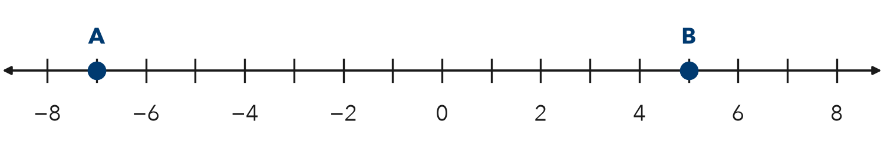
a. |A| = | b. |B| = | c. Farther from 0:

3. Compare. Write <, >, or = in each blank.
a. |−9| |7| | b. |−4| |4| | c. −10 |−3|
d. |−6.5| |6.5| | e. |−12| |−15| | f. 0 |−1|

4. Bank Balances. Rosa’s account balance is −$35 (she owes $35). Ben’s balance is $20.
a. Find the absolute value of each balance.
b. Whose balance is farther from $0?

5. Stretch. List all the integers with an absolute value less than 3.
Integers

6. Reasoning. Name two different numbers that have an absolute value of 4.5. Explain how you know.

CHECK YOURSELF | □ I can do this on my own | □ I need a little help | □ I have a question about #
AT HOME Ask someone at home: is it colder at −10 degrees or at 5 degrees? Which temperature is farther from 0?
Name Date Period
Lesson 7-3 · Homework Packet · Sheet 2 of 2
Absolute Value as Total Distance
Maryland Standard 6.NS.C.7c · Learning target — I can use absolute value to find the total distance between a negative and a positive reading.

REMEMBER  • Opposite sides of 0: add the absolute values.  • −3 to 5 is 3 + 5 = 8 units.  • Same side of 0: subtract the absolute values.  • −9 to −2 is 9 − 2 = 7 units. | WORKED EXAMPLE  A diver swims up from −24 feet to a boat deck at 6 feet. How far does she go?  Step 1 The numbers are on opposite sides of 0, so add.  Step 2 |−24| + |6| = 24 + 6 = 30  Answer 30 feet
PRACTICE show your work · label units
1. Use the number line. Find each distance.
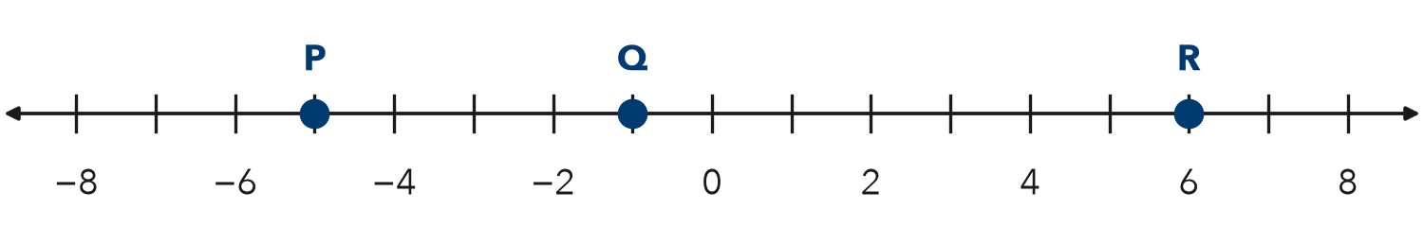
a. P to R: | b. Q to R: | c. P to Q:

2. Find the distance between each pair of numbers.
a. −7 and 3 | b. −12 and −4 | c. −2.5 and 4

3. Temperature Swing. It was −8 degrees at 6 a.m. and 15 degrees at 3 p.m. How much did it rise?
Answer degrees

4. Elevator. An elevator goes from parking level −3 up to floor 9. Street level is floor 0. How many floors does it travel?
Answer floors

5. Find the Error. To find the distance from −9 to 5, Omar wrote 9 − 5 = 4. Explain his mistake. Find the correct distance.

TEST PRACTICE choose the best answer
6. What is the distance between −13 and 6 on a number line?
A 7 | B 19 | C −19 | D −7

7. A cave floor is at −60 feet. A ledge is at −22 feet. How far apart are they?
A 82 feet | B 38 feet | C −38 feet | D 22 feet

CHECK YOURSELF | □ I can do this on my own | □ I need a little help | □ I have a question about #
AT HOME With someone at home, find how many degrees the temperature changed today.

