Name |  | Date |  | Period

Lesson 7-5 · Session 1
Homework
Plotting Points on the Coordinate Plane
Maryland Standard 6.NS.C.6c · Learning target — I can plot a point with rational coordinates and name the quadrant it lies in.
Show a model, calculation, or explanation for each exercise. Label units and answer every part.
Exercises 1–12 earn 1 point for a correct response and 1 for supporting work. Spiral Review and Test Practice earn 1 point each.
REMEMBER review this before you start
• A coordinate point (x, y) tells you how far to move right/left (x) and up/down (y) from the origin (0,0).
• The plane is divided into 4 quadrants by the x-axis and y-axis.
• Watch out — always move along the x-axis first; reversing the order lands you in the wrong place.
• Check it — the signs of the two coordinates name the quadrant before you even plot.
WORKED EXAMPLE the same steps you practiced in class
Plotting a Point with Rational Coordinates Plot the point (−3.5, 2.5) on a coordinate plane and name the quadrant it lands in.
Step 1 Start at the origin, the point where the two axes cross.
Step 2 The x-coordinate is −3.5, so move left three and a half units along the x-axis.
Step 3 The y-coordinate is 2.5, so move up two and a half units from there.
Step 4 Left and up together land the point in the upper left section. Label it.
Answer The point (−3.5, 2.5) sits in Quadrant II — left of the y-axis and above the x-axis.
EXERCISES 12 exercises · 24 points
1. Plot the point (3, −2) on a coordinate plane. Which quadrant is it in? ______

Coordinate plane. Plot and label the points on the plane below.​
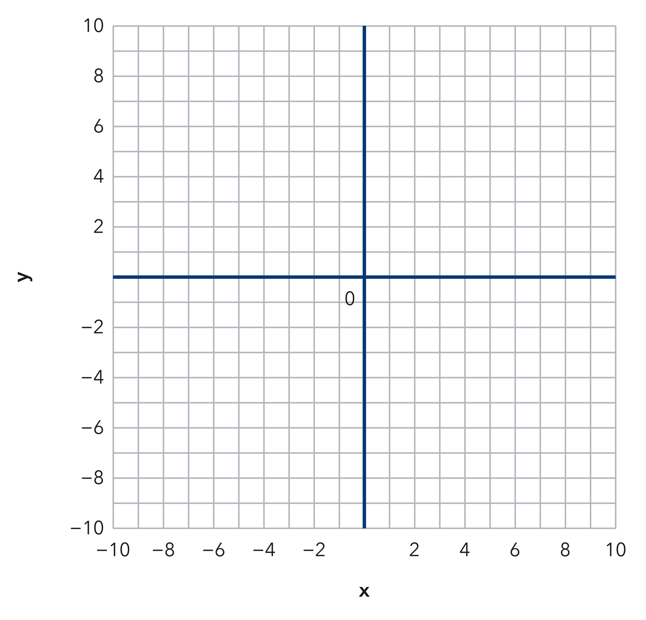
Show your work.
Answer
2. Plot the point (−4, 5). Which quadrant is it in? ______

Show your work.
Answer
3. Name the coordinates of a point in Quadrant III (where both x and y are negative).

Show your work.
Answer
4. Write each answer on the line.
a. Quadrant of (−6, −1): ______
b. Quadrant of (2, 8): ______
c. Quadrant of (9, −7): ______
d. The point (0, −4) sits on which axis? ______
e. The ordered pair for the origin is ______

Answer
5. Camp Map. On a camp map the flagpole is the origin. Plot the mess hall at (−7, 4) and the dock at (5, −8), then name the quadrant for each one.

Coordinate plane. Plot and label the points on the plane below.​
Show your work.

Answer
6. Rational Point. Plot the point (−2.5, −6.5) on a coordinate plane, then name the quadrant it lands in.

Coordinate plane. Plot and label the points on the plane below.​
Show your work.

Answer
7. Two Pairs. Plot (−3, 8) and (8, −3) on one grid. Explain why they do not name the same point.

Coordinate plane. Plot and label the points on the plane below.​
Show your work.

Answer
8. Tevin says every point with a negative number in it lands in Quadrant III. Explain why he is wrong, then give one point with a negative number that lands in Quadrant II.

Show your work.

Answer
9. Name the quadrant of (−6, −2) and of (3, 8).

Show your work.
Answer both quadrants
10. Name the quadrant of (−1.5, 4.5).

Show your work.
Answer the quadrant
11. Order Matters. Explain why (−7, 2) and (2, −7) are different points, and name each quadrant.

Show your work.
Answer your explanation and both quadrants
12. Find the Mistake. Asked to plot (−2, 5), Bo moved up 2 and left 5. Explain the mistake.

Show your work.
Answer the mistake
SPIRAL REVIEW earlier skills · 1 point each
13. From Lesson 7-4 Session 1. Which is greater, −5 or −8?
Answer
14. From Lesson 6-7 Session 1. Find the GCF of 18 and 27.
Answer
15. From Lesson 4-4 Session 1. Find 30% of 220.
Answer
TEST PRACTICE multiple choice · fill one box · 1 point each
16. The point (−3, −9) lies in —
□ A. Quadrant IV | □ B. Quadrant I | □ C. Quadrant II | □ D. Quadrant III
17. A point with a positive x and a negative y lies in —
□ A. Quadrant IV | □ B. Quadrant I | □ C. Quadrant II | □ D. Quadrant III
18. In (x, y), the second number moves you —
□ A. right or left | □ B. up or down | □ C. diagonally | □ D. nowhere
CHECK YOURSELF Score: ______ / 30
□ Solved on my own | □ Needed a hint | □ Need help on Question # ______
Check signs, scale, and labels. Use a number line or coordinate grid to verify one response.

