Name |  | Date |  | Period
Lesson 7-5 · Session 1 · Version 2
Guided Practice · Version 2
Plotting Points on the Coordinate Plane
VOCABULARY read and say each word before you begin
coordinate plane  Spanish: plano de coordenadas | A grid made by a horizontal and a vertical line. | x-axis across, y-axis up
ordered pair  Spanish: par ordenado | Two numbers (x, y) that locate one point. | (−3, 4) is an ordered pair
origin  Spanish: origen | The point (0, 0) where the two axes cross. | every plot starts here
quadrant  Spanish: cuadrante | One of the four parts of the grid, I to IV. | Quadrant II is upper left
x-coordinate | The first number; how far right or left. | in (−3, 4) it is −3
EXPLORE TOGETHER Class Launch · 8–10 min
1. Park Map Grid  Ms. Rivera’s class studies a park map with the fountain at the origin: Gate (3, 6), Pond (−8, 4), Bench (−2, −7), and Swing Set (6, −5).  a. Plot. Plot and label the four park locations on the coordinate plane below.  b. Quadrant. Identify each location’s quadrant. Gate ______ Pond ______ Bench ______ Swing Set ______  c. Signs. Write the sign of each coordinate for a point in Quadrant III. ( ______ , ______ ) | d. Origin. Write the fountain’s ordered pair: ( ______ , ______ ) Explain your answer. __________  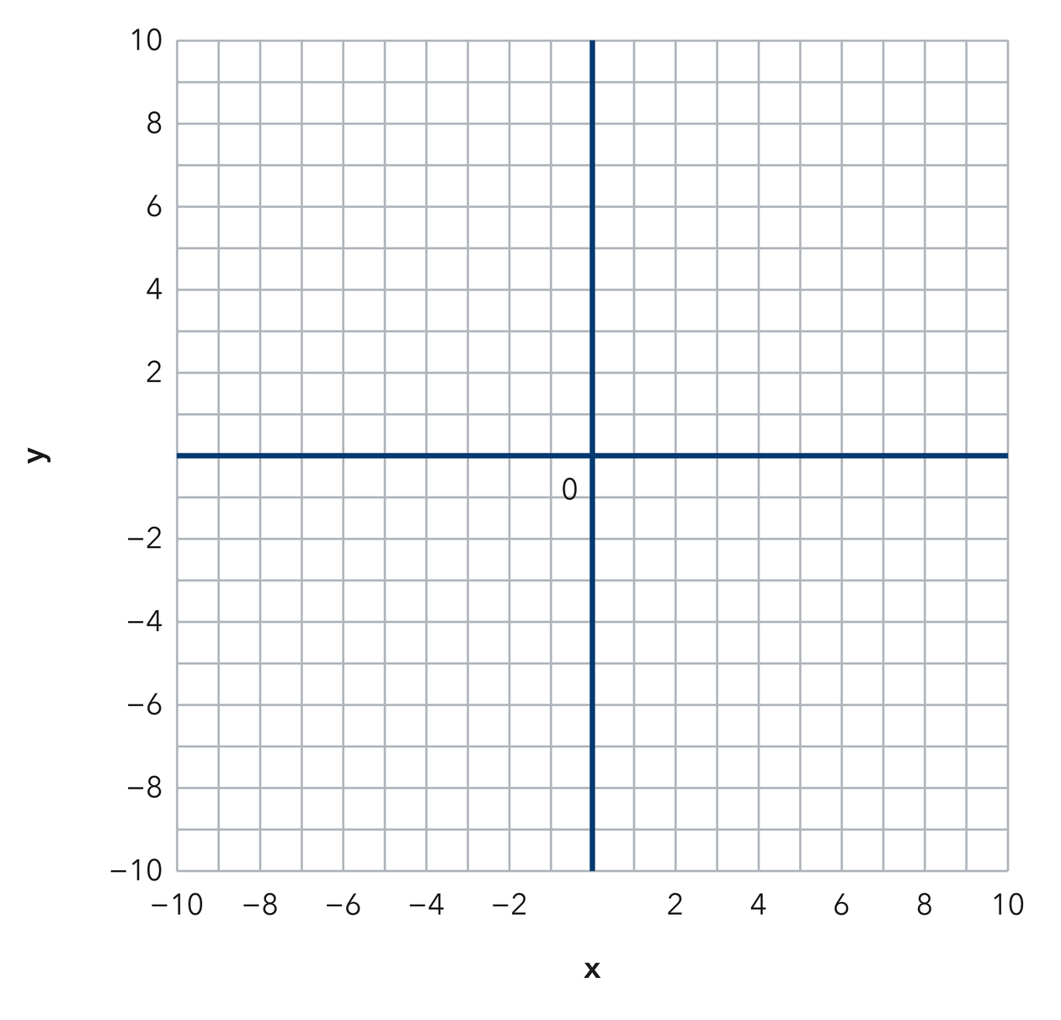​
  TURN AND TALK
  How do the signs inside an ordered pair tell you which quadrant a point lands in?
PRACTICE WITH A PARTNER You Do Together · 10–12 min
2. Treasure Grid. On a treasure grid the chest sits at (−9, −3) and the palm tree sits at (2, 7).  a. Plot and label the chest and palm tree on the same coordinate plane. __________  b. Name the quadrant containing the chest. __________ | c. Use the coordinate plane below. Begin at the origin, move along the x-axis, and then move parallel to the y-axis to each point.
  PARTNER TALK
  Why does swapping the order of the two numbers move the point somewhere else?

3. On the Axes. Two trail markers sit at (0, −5) and (8, 0) on a park grid.
a. Plot both lights, then describe each light’s position relative to the origin. __________
b. Which axis holds each light? First __________ Second __________
PARTNER TALK
Why does a point with a zero coordinate land on an axis instead of inside a quadrant?

4. Zoo Grid. On a zoo map the entrance is the origin. The aviary sits at (−2, 10) and the reptile house sits at (7, −4).  a. Plot and label the aviary and reptile house on the same coordinate plane. __________  b. Identify each location’s quadrant. Aviary __________ Reptile house __________ | c. Use the coordinate plane below. Begin at the origin, move along the x-axis, and then move parallel to the y-axis to each point.
  PARTNER TALK
  How do the two signs in an ordered pair name the quadrant before you plot anything?
PRACTICE ON YOUR OWN You Do · 8 problems · 18–20 min
5. Name the Quadrant. A worksheet lists four points: (−1, 6), (4, 4), (−8, −5), and (3, −9).
Plot the four drone positions, then identify the quadrant of each point.
Hint Use the first coordinate’s sign to choose left or right and the second coordinate’s sign to choose up or down.
Answer the four quadrant names in the order listed

6. Same Digits. Noor says (−2, 6) and (6, −2) name the same point because they use the same two numbers. Plot both points and explain why they are not the same.  Hint The first coordinate gives the horizontal movement. Follow each ordered pair in its written order.  Answer both quadrants and an explanation of whether Mateo is correct | Coordinate plane. Plot both of Mateo’s points here. Use their positions to support your explanation.
  Show your work.

7. Rational Coordinates. Two survey points read (−6.25, 0.75) and (7.5, −8).  Plot both sensors on the same grid, identify their quadrants, and explain how you located the fractional parts of the coordinates.  Hint Locate the whole units, then divide the next unit into halves or fourths as needed.  Answer two plotted points, their quadrants, and an explanation of the partial units | 8. Skate Park. A skate park map puts the ramp at (−10, −6) and the snack stand at (1, 9).  Plot both festival locations on the same grid, then name the quadrant of each location.  Hint Use x for horizontal movement and y for vertical movement.  Answer two plotted points, their quadrants, and an explanation of the partial units

9. Build the Pair. A point sits 6 units left of the y-axis and 11 units above the x-axis.
Write the weather station’s ordered pair and identify its quadrant.
Hint A position left of the y-axis has a negative x-coordinate. A position above the x-axis has a positive y-coordinate.
Answer the weather station’s ordered pair and quadrant

10. Plot a Point. Plot the point (−3.5, 2.5) and name its quadrant.  Hint Move left for the negative x-coordinate and up for the positive y-coordinate.  Answer the point’s quadrant | Coordinate plane. Plot the point here. For x, count 2 whole units left, then half of the next unit.
  Show your work.

11. Name the Quadrants. Name the quadrant of each point.  a. (7, −3) __________  b. (−4.5, −2.5) __________  Hint Match the signs of the x- and y-coordinates to a quadrant.  Answer the quadrant for a and the quadrant for b | 12. Order Matters. Consider the points (−5, 1) and (1, −5).  a. Identify the quadrant of each game piece. __________  b. Explain why switching the coordinates changes the game piece’s position. __________  Hint Read the horizontal coordinate first and the vertical coordinate second.  Answer the quadrant for a and the quadrant for b
ANALYZE THE ERROR 5 min
13. Read the work below. Explain the mistake, then show the correct reasoning.
JALEN’S WORK

Dmitri plotted (−5, 4) by moving down 5 units and then right 4 units, landing his point in Quadrant IV.
a. Explain Jalen’s mistake. Complete: “The first coordinate tells me to move ______, and the second tells me to move ______.” Include the direction and distance for each movement. | b. Show correct work. State the correct movements, ordered pair, and quadrant.  Correct answer
  Show the correct work.
STRETCH YOUR THINKING multi-step reasoning · 8 min
14. Map Points. A map places a school at (2.5, 3), a park at (−2.5, 3), and a pool at (−2.5, −3).  a. Identify the quadrant containing the school, park, and pool.  b. Name the two locations with equal y-coordinates and give that coordinate.  c. Give the direction and distance needed to travel straight from the park to the pool.  Answer the three quadrants, the locations sharing a y-coordinate, and the direction and distance of your route | d. Coordinate plane. Plot and label the school, park, and pool. Use your graph to answer parts a–c.
  Show your work.
TEST PRACTICE multiple choice · fill one box · 6 min
15. The point (−4, 7) lies in — | 16. In the ordered pair (x, y), the first number tells you to move —
  □ A. Quadrant IV | □ B. Quadrant I | □ C. Quadrant III | □ D. Quadrant II
  □ A. right or left | □ B. up or down | □ C. diagonally | □ D. nowhere

17. The point (5, −2) lies in — | 18. A point with both coordinates negative lies in —
  □ A. Quadrant I | □ B. Quadrant IV | □ C. Quadrant II | □ D. Quadrant III
  □ A. Quadrant II | □ B. Quadrant I | □ C. Quadrant III | □ D. Quadrant IV
SPIRAL REVIEW earlier skills · keep them sharp · 6 min
19. From Lesson 7-4 Session 2. Order −5, 1, and −12 from least to greatest.  Answer | 20. From Lesson 7-3 Session 1. Find |−33|.  Answer

21. From Lesson 6-8 Session 2. Factor 20x + 35.  Answer | 22. From Lesson 5-5 Session 1. A prism is 6 m by 3 m by 4 m. Find its volume.  Answer
CHECK YOUR UNDERSTANDING 5 min
23. City Map. A city map places the library at the origin. The museum sits at (−4, −7) and the stadium sits at (9, 1).  a. Plot and label both buildings, then identify their quadrants. Museum __________ Stadium __________  b. Write the ordered pair for the library: ( ______ , ______ )  Hint Begin at the origin. Use the x-coordinate for horizontal movement, then the y-coordinate for vertical movement.  Answer | c. Coordinate plane. Label the library at the origin, then plot and label the museum and stadium.
  Show your work.

□ 4 — Can teach it | □ 3 — Got it | □ 2 — Need hint | □ 1 — Need help
Circle your confidence. Star one problem that shows your learning.

