Name |  | Date |  | Period
Lesson 7-5 · Session 1
Guided Practice
Plotting Points on the Coordinate Plane
VOCABULARY read and say each word before you begin
coordinate plane  Spanish: plano de coordenadas | A grid made by a horizontal and a vertical line. | x-axis across, y-axis up
ordered pair  Spanish: par ordenado | Two numbers (x, y) that locate one point. | (−3, 4) is an ordered pair
origin  Spanish: origen | The point (0, 0) where the two axes cross. | every plot starts here
quadrant  Spanish: cuadrante | One of the four parts of the grid, I to IV. | Quadrant II is upper left
x-coordinate | The first number; how far right or left. | in (−3, 4) it is −3
EXPLORE TOGETHER Class Launch · 8–10 min
1. Park Map Grid  A park map uses a grid with the fountain at the origin: Gate (6, 3), Pond (−4, 8), Bench (−7, −2), and Swing Set (5, −6).  a. Plot. Plot and label all four park spots on the coordinate plane below.  b. Quadrant. Name the quadrant. Gate ______ Pond ______ Bench ______ Swing Set ______  c. Signs. What signs do both coordinates carry in Quadrant III? ( ______ , ______ ) | d. Origin. Ordered pair for the fountain: ( ______ , ______ ) Why? __________  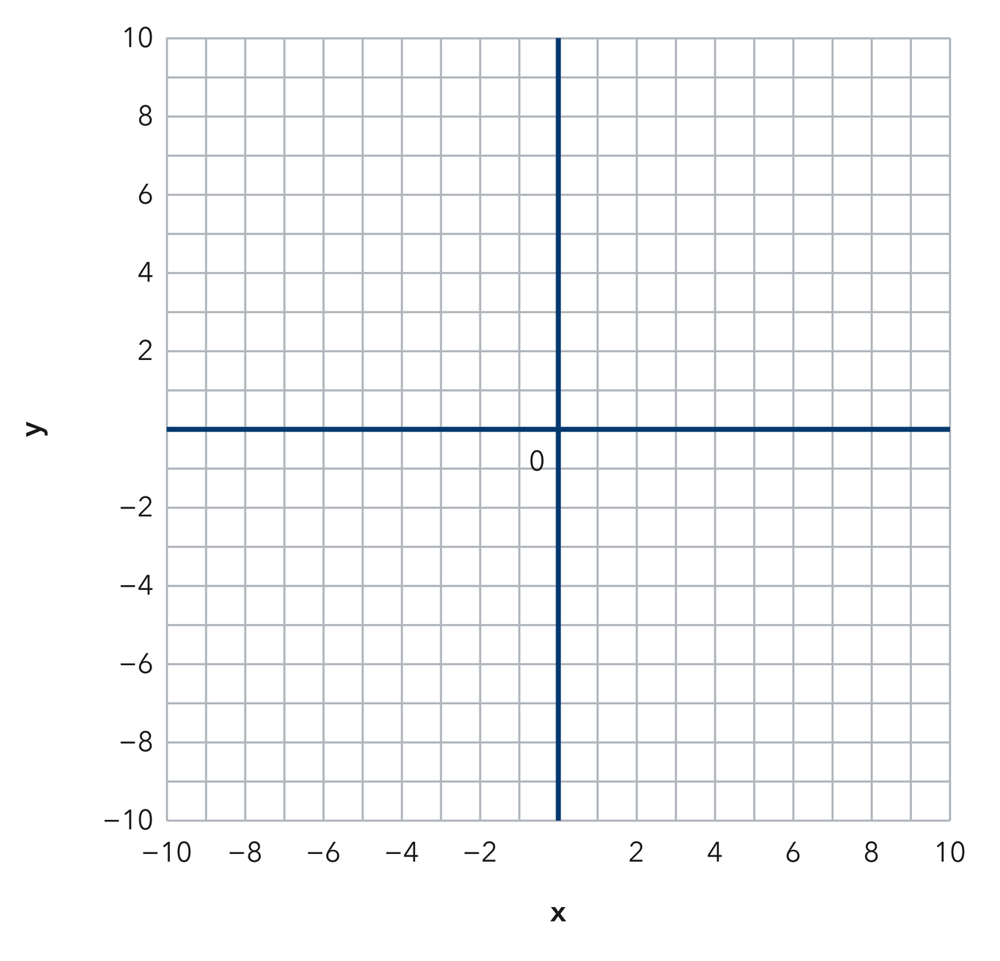​
  TURN AND TALK
  How do the signs inside an ordered pair tell you which quadrant a point lands in?
PRACTICE WITH A PARTNER You Do Together · 10–12 min
2. Treasure Grid. On a treasure grid the chest sits at (−9, −3) and the palm tree sits at (2, 7).  a. Plot and label both points on one coordinate plane __________  b. Quadrant of the chest __________ | c. Use the coordinate plane below. Start at the origin, run along the x-axis first, then move parallel to the y-axis.​
  PARTNER TALK
  Why does swapping the order of the two numbers move the point somewhere else?

3. On the Axes. Two trail markers sit at (0, −5) and (8, 0) on a park grid.
a. Plot both markers, then describe where each one lands __________
b. Which axis holds each marker? First __________
PARTNER TALK
Why does a point with a zero coordinate land on an axis instead of inside a quadrant?

4. Zoo Grid. On a zoo map the entrance is the origin. The aviary sits at (−2, 10) and the reptile house sits at (7, −4).  a. Plot and label both spots on one coordinate plane __________  b. Name the quadrant for each spot. Aviary __________ | c. Use the coordinate plane below. Start at the origin, run along the x-axis first, then move parallel to the y-axis.​
  PARTNER TALK
  How do the two signs in an ordered pair name the quadrant before you plot anything?
PRACTICE ON YOUR OWN You Do · 8 problems · 18–20 min
5. Name the Quadrant. A worksheet lists four points: (−1, 6), (4, 4), (−8, −5), and (3, −9).
Plot all four points, then name the quadrant each one lands in.
Hint Read each pair of signs. The first number decides left or right, the second up or down.
Answer four quadrant names

6. Same Digits. Noor says (−2, 6) and (6, −2) name the same point because they use the same two numbers. Plot both points and explain why they are not the same.  Hint In an ordered pair the first number always rides the x-axis. Try each pair in order.  Answer both quadrants (Is Noor right?) | Coordinate plane. Plot both of Noor’s points here; the picture is the proof.​
  Show your work.

7. Rational Coordinates. Two survey points read (−6.25, 0.75) and (7.5, −8).  Plot both points on one grid, name each quadrant, and explain how you placed the partial units.  Hint Count the whole units first, then split the last unit into equal parts for the decimal.  Answer two plotted points and quadrants | 8. Skate Park. A skate park map puts the ramp at (−10, −6) and the snack stand at (1, 9).  Plot both spots on one grid, then name the quadrant each one lands in  Hint The first number moves you left or right, and the second number moves you up or down.  Answer two plotted points and quadrants

9. Build the Pair. A point sits 6 units left of the y-axis and 11 units above the x-axis.
Write the ordered pair for the point and name its quadrant
Hint Left of the y-axis makes the x-coordinate negative; above the x-axis makes the y-coordinate positive.
Answer ordered pair and quadrant

10. Plot a Point. Plot the point (−3.5, 2.5) and name its quadrant.  Hint Negative x means left; positive y means up.  Answer the quadrant | Coordinate plane. Plot the point here. Count 3 whole units, then half of the next one.​
  Show your work.

11. Name the Quadrants. Name the quadrant of each point.  a. (4, −6) __________  b. (−2.5, −1.5) __________  Hint Check the sign of x, then the sign of y.  Answer a and b | 12. Order Matters. Consider the points (−5, 1) and (1, −5).  a. Name the quadrant of each point. __________  b. Explain why the two points are not the same. __________  Hint The first number is always x.  Answer a and b
ANALYZE THE ERROR 5 min
13. Read the work below. Explain the mistake, then show the correct reasoning.
DMITRI’S WORK

Dmitri plotted (−5, 4) by moving down 5 units and then right 4 units, landing his point in Quadrant IV.
a. Explain the mistake. Which number belongs to which axis, and which way does each sign send you? | b. Show correct work  Correct answer
  Show the correct work.
STRETCH YOUR THINKING multi-step reasoning · 8 min
14. Map Points. A map places a school at (2.5, 3), a park at (−2.5, 3), and a pool at (−2.5, −3).  a. Name the quadrant of each location.  b. Which two locations share the same y-coordinate?  c. Describe how you could travel from the park to the pool using only one direction.  Answer all three quadrants, the shared coordinate, and your route | d. Coordinate plane. Plot the school, the park and the pool, then answer parts a–c.​
  Show your work.
TEST PRACTICE multiple choice · fill one box · 6 min
15. The point (−4, 7) lies in — | 16. In the ordered pair (x, y), the first number tells you to move —
  □ A. Quadrant IV | □ B. Quadrant I | □ C. Quadrant III | □ D. Quadrant II
  □ A. right or left | □ B. up or down | □ C. diagonally | □ D. nowhere

17. The point (5, −2) lies in — | 18. A point with both coordinates negative lies in —
  □ A. Quadrant I | □ B. Quadrant IV | □ C. Quadrant II | □ D. Quadrant III
  □ A. Quadrant II | □ B. Quadrant I | □ C. Quadrant III | □ D. Quadrant IV
SPIRAL REVIEW earlier skills · keep them sharp · 6 min
19. From Lesson 7-4 Session 2. Order −5, 1, and −12 from least to greatest.  Answer | 20. From Lesson 7-3 Session 1. Find |−33|.  Answer

21. From Lesson 6-8 Session 2. Factor 20x + 35.  Answer | 22. From Lesson 5-5 Session 1. A prism is 6 m by 3 m by 4 m. Find its volume.  Answer
CHECK YOUR UNDERSTANDING 5 min
23. City Map. A city map places the library at the origin. The museum sits at (−4, −7) and the stadium sits at (9, 1).  a. Plot both buildings and name each quadrant. Museum __________  b. Write the ordered pair for the library: ( __________  Hint Start every plot at the origin, run along the x-axis first, then move parallel to the y-axis.  Answer | c. Coordinate plane. Plot the library at the origin, then the museum and the stadium.​
  Show your work.

□ 4 — Can teach it | □ 3 — Got it | □ 2 — Need hint | □ 1 — Need help
Circle your confidence. Star one problem that shows your learning.

