UNIT 7 · LESSON 7 STANDARD 6.NOS.9

Represent Polygons on the Coordinate Plane
Student Notes Packet
Name: ______________________ Date: ____________ Period: ________

Today's Goals
Content: I can draw polygons from their vertex coordinates on the coordinate plane, and use coordinates to find side lengths and solve perimeter and area problems.
Language: I can explain how I found a distance using the words vertices, coordinates, and absolute value.

Key Vocabulary
Look at the picture, read the word, then read what it means.
 | vertex vértice  A corner point of a polygon, named by an ordered pair on the coordinate plane.  Example: The park's corner at (2, 4) — one corner, named by an ordered pair.
 | polygon polígono  A closed figure made of line segments; on the plane you draw it by plotting the vertices and connecting them in order.  Example: Plot (2, 4), (5, 4), (5, −4), (2, −4) and join them — a rectangle appears.
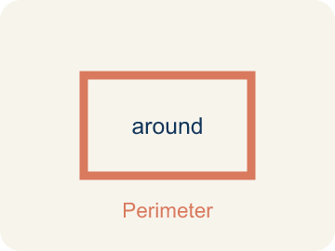 | perimeter perímetro  The total distance around a polygon — the sum of all its side lengths.  Example: 2(9.5) + 2(6.75) = 32.5 units around the deck.
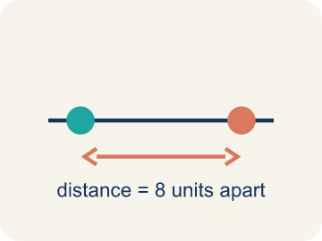 | distance between vertices distancia entre vértices  When two vertices share an x- or y-coordinate, the distance between them is the absolute difference of the other coordinates.  Example: (2, 4) and (5, 4) share y, so the side is |5 − 2| = 3 units.
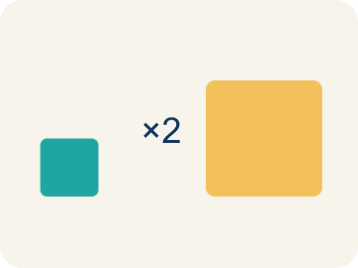 | scale escala  What one grid unit stands for in the real situation.  Example: Each grid unit = 100 feet, so 8 units of map is 800 real feet.
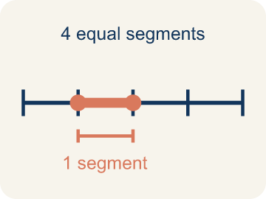 | Side length Longitud del lado  The distance between two vertices that are joined by a side.  Example: Found with absolute value when the points share a coordinate.

Guided Notes
Fill in each blank as we go. Use the Word Bank to help you.
WORD BANK
vertex • polygon • perimeter • distance between vertices • scale • Side length

1. A corner point of a polygon, named by an ordered pair, is a ________________.
2. A closed figure made of line segments is a ________________.
3. The total distance around a polygon is its ________________.
4. When two vertices share a coordinate, subtract the other and take the ________________ ________________.
5. What one grid unit stands for in the real situation is the ________________.
6. The distance between two joined vertices is a ________________.

Write About the Math
Where do the other two vertices go — and how do the known coordinates, the scale, and the area work together to tell you?
¿A dónde van los otros dos vértices — y cómo trabajan juntas las coordenadas conocidas, la escala y el área para decírtelo?
Say your answer to a partner first. Then write it, using at least two of these words:
☐ vertex · vértice
☐ polygon · polígono
☐ perimeter · perímetro
☐ distance between vertices · distancia entre vértices
☐ scale · escala
Model: When two vertices share the same y-coordinate, the segment between them is horizontal, so its length comes from the DIFFERENCE in the coordinate that changes — the x-coordinates. — A strong answer explains that the SHARED coordinate tells you the direction of the side, and the DIFFERING coordinate is what you subtract. A weak answer just says 'subtract the numbers' without identifying which pair.

Start Most language support
Complete the frames. Use the word bank.
Completa las oraciones. Usa el banco de palabras.
The park's width is ___ feet. Using the area formula, its length is ___ feet, which is ___ units on the map — so the new vertices sit that many units below the known ones.
My answer is ___ because ___.
Mi respuesta es ___ porque ___.

Build Some language support
Write two connected sentences. Use because, so, or but.
Escribe dos oraciones conectadas. Usa porque, entonces o pero.
My claim is ___.
Mi afirmación es ___.
My evidence is ___, so ___.
Mi evidencia es ___, entonces ___.

Explain Light language support
Write a claim, give math evidence, and explain your reasoning.
Escribe una afirmación, da evidencia matemática y explica tu razonamiento.

Check Your Explanation three quick checks
☐ I answered the question.
☐ I used math evidence: numbers, an equation, or a model.
☐ I used at least two math words.

Worked Example

Watch & Read I Do — follow along with your teacher
Unit 7 · Lesson 7
A polygon's vertices are given as coordinates: (-4.5, 3), (5, 3), (5, -3.75), and (-4.5, -3.75). What is its perimeter?

Solved Example I Do — watch each step
Problem: Vertices (-4.5, 3) and (5, 3) share y = 3. What is the distance between them?
A) 0.5 units
B) 1.5 units
C) 8 units
D) 9.5 units
Step 1: They differ only in x: |5 − (−4.5)| = 5 + 4.5 = 9.5 units.
Answer: D. 9.5 units

Guided Practice

Solve Together We Do — work with your class
Problem: Vertices (5, 3) and (5, -3.75) share x = 5. What is the distance between them?
A) 0.75 units
B) 5 units
C) 6.75 units
D) 8.75 units
Step 1:

Step 2:

Answer:

Designing the Town Square: a rectangular park will have an area of 240,000 square feet. Two vertices are already marked on the planning grid, 3 units apart, and each grid unit represents 100 feet.
Where do the other two vertices go — and how do the known coordinates, the scale, and the area work together to tell you?

Sentence frame: The park's width is ___ feet. Using the area formula, its length is ___ feet, which is ___ units on the map — so the new vertices sit that many units below the known ones.

Turn & Talk discuss with a partner
1. [Launch] The vertices (-4.5, 3) and (5, 3) share y = 3, so the side between them is horizontal, with length |5 − (−4.5)| = 9.5. Why is that side's length found by comparing the x-coordinates instead of the y-coordinates?
Start with: The side is horizontal because both vertices share the same ___-coordinate.
El lado es horizontal porque ambos vértices comparten la misma coordenada ___.
Word bank: vertex, coordinates, distance between vertices
2. [Explore] You sorted pairs of vertices into 'subtract coordinates' versus 'slanted.' How did you decide that (0, 0) and (4, 3) belonged in the slanted group?
Start with: (0, 0) and (4, 3) are slanted because they don't share the same ___ or the same ___.
(0, 0) y (4, 3) están inclinados porque no comparten la misma ___ ni la misma ___.
Word bank: vertex, coordinates, distance between vertices
3. [Connect] The Town Square park's two known vertices are 3 units apart, and each unit represents 100 feet, so the width is 300 feet. The park's area must be 240,000 square feet. How do you use that to find how many units below the known vertices the missing vertices go?
Start with: The length is 240,000 ÷ ___ = ___ feet.
La longitud es 240,000 ÷ ___ = ___ pies.
Word bank: scale, area, vertex
4. [Practice] Look back at a problem where you found the perimeter of a rectangle from its vertices. What were your steps from the coordinates to the final perimeter?
Start with: First I found the width using vertices ___ and ___, which gave ___ units.
Primero encontré el ancho usando los vértices ___ y ___, lo cual dio ___ unidades.
Word bank: perimeter, distance between vertices, vertex

Independent Practice

On Your Own You Do — show your work
Solve each problem. Show your thinking in the work box.

Level 1 Support extra scaffolding
1. What is the perimeter of the rectangle with side lengths 9.5 and 6.75 units?
A) 16.25 units
B) 26 units
C) 32.5 units
D) 64.125 units

2. Why are two of the terms multiplied by 2 in the perimeter calculation?
A) Because perimeter always doubles the area
B) Because there are two coordinates in each ordered pair
C) It is a rounding rule
D) A rectangle's opposite sides are equal, so each length appears on two sides

3. To draw a polygon from a list of vertices, you:
A) Plot only the first vertex
B) Connect the points in any random order
C) Add all the coordinates together
D) Plot each ordered pair, then connect them in order with segments

4. A square has vertices (1, 2), (6, 2), (6, -3), (1, -3). Find one side length and the perimeter.

On Level grade-level practice
5. The park's marked vertices are 3 units apart and each unit is 100 feet. What is the park's width?
A) 3 feet
B) 30 feet
C) 103 feet
D) 300 feet

6. The park's area must be 240,000 sq ft and its width is 300 ft. What is its length?
A) 720 feet
B) 800 feet
C) 80,000 feet
D) 240,300 feet

Exit Ticket
Answer on your own. This shows what you learned today.
★ A rectangle has vertices (-1, 4), (5, 4), (5, 1), (-1, 1). What is its perimeter?
A) 6 units
B) 9 units
C) 18 units
D) 18 square units

Answer Key & Teacher Guide
Teacher reference — remove or fold back before distributing to students.

Guided Notes (Fill-in)
Notes 1: vertex
Notes 2: polygon
Notes 3: perimeter
Notes 4: distance between vertices
Notes 5: scale
Notes 6: Side length

Worked Notes (I Do / We Do)
I Do: D. 9.5 units
We Do: C. 6.75 units

Independent Practice
Watch for this mistake: Subtracting coordinates without the absolute value — from y = 3 down to y = −3.75 the distance is 3 + 3.75 = 6.75 units, not 3.75 − 3 = 0.75. Distances that cross zero are the whole reason the absolute value is there.

Level 1 Support
1. C) 32.5 units — Perimeter = 2(9.5) + 2(6.75) = 19 + 13.5 = 32.5 units.
2. D) A rectangle's opposite sides are equal, so each length appears on two sides — The two 9.5 sides and the two 6.75 sides each come in pairs — that is what the 2 counts.
3. D) Plot each ordered pair, then connect them in order with segments — Graph the points on the plane and connect them in order — the closed figure that appears is the polygon.
4. Answers vary.

On Level
5. D) 300 feet — 3 units × 100 feet per unit = 300 feet.
6. B) 800 feet — Length = area ÷ width = 240,000 ÷ 300 = 800 feet.

Exit Ticket
C) 18 units — Width |5 − (−1)| = 6, height |4 − 1| = 3. Perimeter = 2(6) + 2(3) = 18 units.

Math Writing Criteria
The support level changes the amount of language scaffolding, not the mathematical expectation.
☐ The answer to the math question is correct.
☐ The evidence is real lesson mathematics (numbers, equation, or model), not restated claim.
☐ The support level changed the language scaffolding, never the mathematical expectation.

