Name |  | Date |  | Period
Lesson 7-7 · Session 1 · Version 2
Guided Practice · Version 2
Polygons and Perimeter on the Plane
VOCABULARY read and say each word before you begin
vertex  Spanish: vértice | A corner point of a polygon. | named by an ordered pair
polygon  Spanish: polígono | A closed figure made of line segments. | triangle, rectangle, square
perimeter  Spanish: perímetro | The total distance around a polygon. | add every side length
side length | The distance between two joined vertices. | found with absolute value
scale  Spanish: escala | What one grid unit stands for in real life. | 1 unit = 1 meter
EXPLORE TOGETHER Class Launch · 8–10 min
1. Community Garden Plot  Amara plans a garden plot with corners at (−4, 6), (9, 6), (9, −3), and (−4, −3). Each grid unit stands for one meter.  a. Draw. Plot the corners of Amara’s garden on the coordinate plane below and connect them in order.  b. Sides. Find the garden’s side lengths. Top side: ______ m Left side: ______ m  c. Perimeter. Amara needs fencing around the plot. Perimeter: ______ m How did you combine the side lengths? __________ | d. Shape. Name the polygon formed by the garden: ______ How do the coordinates support your answer? __________  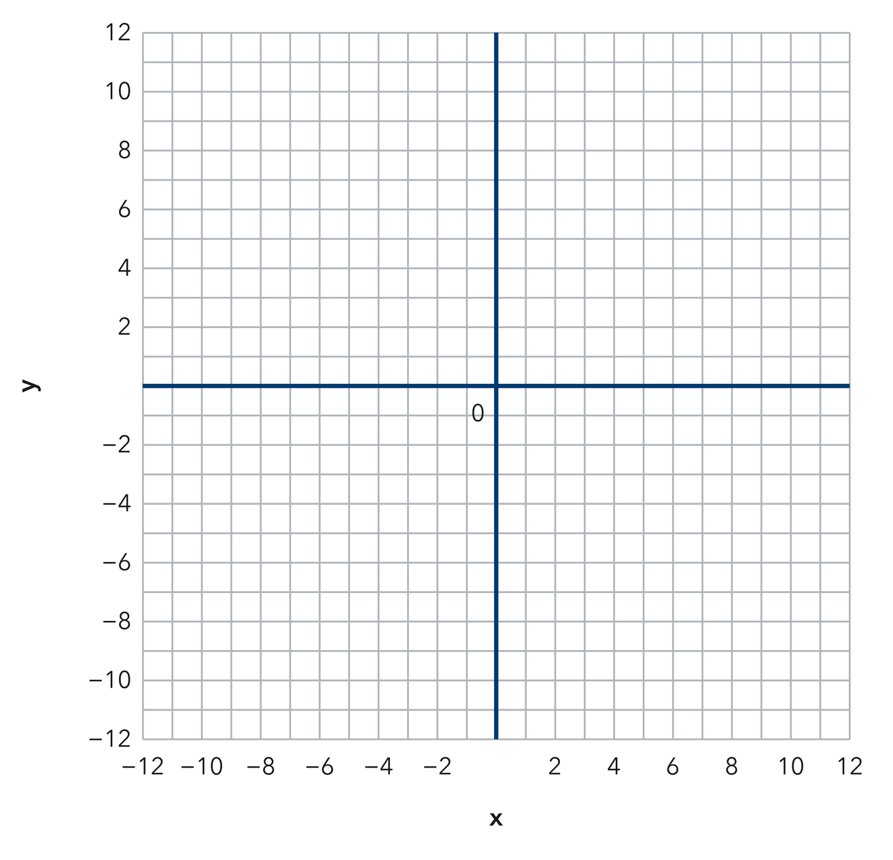​
  TURN AND TALK
  How do matching coordinates tell you which sides run across and which run up and down?
PRACTICE WITH A PARTNER You Do Together · 10–12 min
2. Animal Pen. A pen has vertices at (2, 8), (2, −4), (−10, −4), and (−10, 8) on a grid where each unit is one meter.  a. Length of one side of Mateo’s pen, in meters __________  b. Perimeter of Mateo’s pen, in meters __________ | c. Coordinate plane. Plot the four vertices and connect them in order to draw Mateo’s pen.
  PARTNER TALK
  How can the coordinates alone show you that a shape is a square?

3. Right Triangle. A right triangle has vertices at (−5, 2), (7, 2), and (7, −6) on a coordinate grid.  a. Length of the horizontal leg, in grid units __________  b. Which two vertices form the horizontal leg, and which coordinate do they share? __________ | c. Coordinate plane. Plot the three vertices and connect them to draw Nia’s triangle.
  PARTNER TALK
  Why can you count grid units for only two of this triangle’s three sides?

4. Dog Run. A dog run has vertices at (−7, 10), (11, 10), (11, −1), and (−7, −1) on a grid where each unit is one meter.
a. Length of the playground’s top side and left side, in meters __________
b. Perimeter of the playground, in meters __________
PARTNER TALK
Why does finding only two side lengths give you the whole perimeter of a rectangle?

PRACTICE ON YOUR OWN You Do · 8 problems · 18–20 min
5. Deck Outline. A rectangle has vertices at (−9, 5), (6, 5), (6, −7), and (−9, −7). Each unit is one foot.
Find both side lengths and the perimeter of Priya’s reading patio.
Hint The endpoints of each side share one coordinate. Find the distance between their other coordinates.
Answer patio side lengths and perimeter, in feet

6. Missing Vertex. Three corners of a rectangle sit at (−2, 9), (8, 9), and (8, 1). Find the fourth vertex, then find the perimeter.  Hint Each horizontal side has endpoints with the same y-coordinate. Each vertical side has endpoints with the same x-coordinate.  Answer missing vertex and perimeter, in grid units | Coordinate plane. Plot Lena’s three given corners, then complete the rectangle to locate the fourth corner.
  Show your work.

7. Deck Area. A rectangular deck has vertices at (−6, −2), (7, −2), (7, −9), and (−6, −9). Each unit is one yard.  Find the area of Theo’s picnic lawn and explain how you used the coordinates to find each dimension.  Hint Use the coordinate differences to find the length and width. Multiply those dimensions to find the area.  Answer picnic lawn area, in square yards | 8. Square Check. A polygon has vertices at (−5, 8), (9, 8), (9, −6), and (−5, −6) on a grid where each unit is one yard.  Find the side lengths of Sofia’s festival space, name the polygon, and find its perimeter.  Hint Compare the horizontal and vertical side lengths before deciding which polygon name is most specific.  Answer side lengths in yards, shape name, and perimeter in yards

9. Mural Outline. A mural outline has vertices at (−6, 5), (6, 5), (6, −1), (1, −1), (1, −7), and (−6, −7) on a grid where each unit is one foot.  Find the length of each side of Jordan’s mural outline, then find its perimeter in feet.  Hint Follow the mural outline one side at a time; the endpoints of each side have either the same x-coordinate or the same y-coordinate.  Answer the total distance around the mural, in feet | Coordinate plane. Mark each of the six vertices, then connect them in order to outline the mural.​
  Show your work.

10. Rectangle Perimeter. A rectangle has vertices at (−8.5, 7.5), (5.5, 7.5), (5.5, −2.5), and (−8.5, −2.5). Find its perimeter.  Hint Length is 6.5 + 8.5; width is 9.5 + 2.5.  Answer perimeter, in units | 11. Rectangle Area. For the same rectangle, find the area.  Hint Use the product of the display’s length and width.  Answer area, in square units

12. Find the Sides. A rectangle has vertices at (−3, 4), (6, 4), (6, −2), and (−3, −2).
a. Find the length of a horizontal side of the stage. __________
b. Find the length of a vertical side of the stage. __________
Hint Compare the x-coordinates for a horizontal side and the y-coordinates for a vertical side.
Answer the side lengths for a and b
ANALYZE THE ERROR 5 min
13. Read the work below. Explain the mistake, then show the correct reasoning.
PRIYA’S WORK

For a rectangle side joining (−5, 4) and (3, 4), Jorge wrote the length as 2 units, saying five minus three is two.
a. Explain the mistake. Priya finds the horizontal distance from (−4, 3) to (9, 3) by calculating 9 − 4 = 5 units. Complete: “The endpoints are on _____ sides of the y-axis, so I should _____ their distances from the y-axis.” | b. Show correct work for the distance from (−4, 3) to (9, 3).  Correct answer
  Show the correct work.
STRETCH YOUR THINKING multi-step reasoning · 8 min
14. Garden Plot. A rectangular plot has vertices at (−6, 5), (9, 5), (9, −4), and (−6, −4). Fencing costs $7 per unit and sod costs $2 per square unit.  a. Determine the length and width of the club’s plot.  b. Calculate the plot’s perimeter and the total fencing cost.  c. Calculate the plot’s area and the total sod cost.  Answer the plot’s length and width, total fencing cost, and total sod cost | d. Coordinate plane. Plot the four vertices, connect them to draw the garden plot, and label each side to be fenced.​
  Show your work.
TEST PRACTICE multiple choice · fill one box · 6 min
15. A rectangle with sides 8 and 5 has a perimeter of — | 16. A rectangle with sides 8 and 5 has an area of —
  □ A. 40 | □ B. 26 | □ C. 13 | □ D. 18
  □ A. 13 | □ B. 26 | □ C. 40 | □ D. 80

17. The distance from (−2, 0) to (7, 0) is — | 18. Perimeter is found by —
  □ A. −9 | □ B. 5 | □ C. 14 | □ D. 9
  □ A. adding all sides | □ B. multiplying sides | □ C. halving the area | □ D. counting vertices
SPIRAL REVIEW earlier skills · keep them sharp · 6 min
19. From Lesson 7-6 Session 2. Find the distance from (−3, 6) to (8, 6).  Answer | 20. From Lesson 7-5 Session 2. Reflect (5, −2) across the x-axis.  Answer

21. From Lesson 6-8 Session 2. Factor 24n + 36.  Answer | 22. From Lesson 5-1 Session 1. A parallelogram has base 13 cm and height 4 cm. Find its area.  Answer
CHECK YOUR UNDERSTANDING 5 min
23. Flag Outline. A flag outline has vertices at (−4, 7), (8, 7), (8, −5), and (−4, −5). Each unit is one inch.  a. Side lengths of Malik’s flag __________  b. Perimeter of Mateo’s pen, in meters __________  Hint Find the length of a horizontal side and a vertical side, then use those lengths to identify the figure.  Answer | c. Coordinate plane. Mark the four vertices and connect them in order to draw Malik’s flag outline.​
  Show your work.

□ 4 — Can teach it | □ 3 — Got it | □ 2 — Need hint | □ 1 — Need help
Circle your confidence. Star one problem that shows your learning.

