Name Date Period
Lesson 8-4 · Homework Packet · Sheet 1 of 2
Writing Inequalities
Maryland Standard 6.EE.B.8 · Learning target — I can write an inequality that describes a constraint in a real situation.

REMEMBER  • An inequality compares amounts using <, >, ≤, or ≥.  • more than: > less than, fewer than: <  • at least: ≥ at most, no more than: ≤  • “At least” and “at most” include the boundary. | WORKED EXAMPLE  A food pantry needs at least 40 volunteers on Saturday. Write an inequality for v, the number of volunteers.  Step 1 “At least 40” means 40 or more, so 40 is included.  Step 2 Use ≥ : v ≥ 40. Test: 40 and 52 work; 38 does not.  Answer v ≥ 40
PRACTICE show your work · label units
1. Write an inequality for each phrase. Use x.
a. more than 12 | b. at most 30 | c. fewer than 8
d. at least 15 | e. no more than 6 | f. greater than −3
g. below 0 | h. a maximum of 100

2. Write an inequality for each sign. Use the variable given.
Sign | Inequality
Riders must be at least 54 inches tall. (h)
Speed limit: 35 miles per hour. (s)
Buy more than 10 items to get a discount. (n)
Fewer than 120 people may be in this room. (p)

3. City Bus. A city bus can carry no more than 48 riders. Write an inequality for r, the number of riders. Can the bus carry 48 riders? Can it carry 50 riders? Explain.
Inequality

4. Reverse It. Write a real-world situation for t < 60. Name two solutions.
Situation and solutions

5. Same or Different? Jordan says “x is at most 10” and “x is less than 10” mean the same thing. Is he right? Use the number 10 to explain.

CHECK YOURSELF | □ I can do this on my own | □ I need a little help | □ I have a question about #
AT HOME Look for a sign with a limit (speed limit, height rule, room capacity). Write an inequality for it and tell someone at home what it means.
Name Date Period
Lesson 8-4 · Homework Packet · Sheet 2 of 2
Representing Inequalities
Maryland Standard 6.EE.B.8 · Learning target — I can represent an inequality with a set of solutions and describe them.

REMEMBER  • Open dot: boundary not included (< or >).  • Closed dot: boundary is included (≤ or ≥).  • Arrow: left for < and ≤, right for > and ≥. | WORKED EXAMPLE  Graph x ≤ 3.  Step 1 ≤ includes 3, so draw a closed dot at 3.  Step 2 Shade left: the solutions are 3 and less.  Answer Closed dot at 3, arrow left
PRACTICE use the number lines · show your work
1. Write the inequality shown on the number line. Use x.
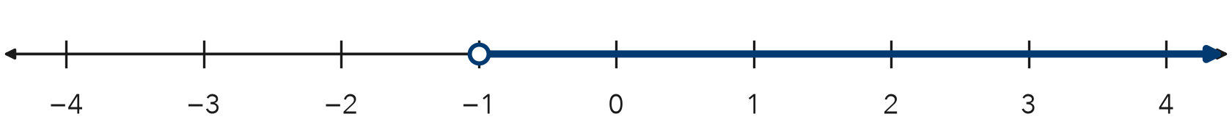
Inequality

2. Graph x ≥ 2 on the number line. Then name two solutions.
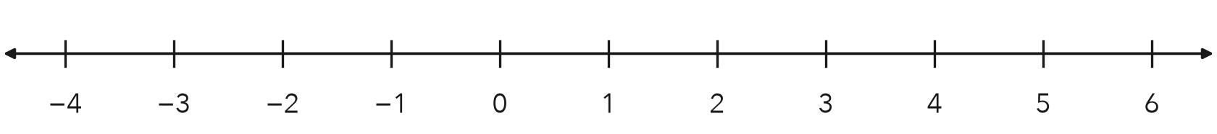
Two solutions

3. Each graph is described in words. Write the inequality for each graph. Use x.
a. open dot at 3, arrow right | b. closed dot at −2, arrow left

4. Water Bottle. A bottle holds at most 24 ounces of water. Write an inequality for w, the ounces of water. Graph it.
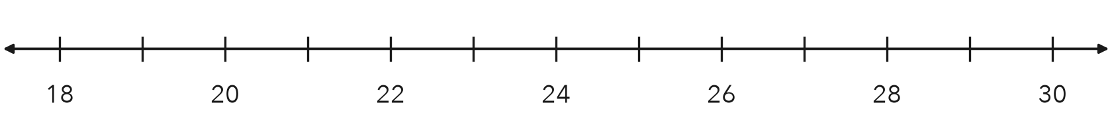
Inequality

5. Find the Error. Keon graphed n > 5 with a closed dot at 5 and an arrow to the right. Explain his mistake. Is 5 a solution?

TEST PRACTICE choose the best answer
6. Which inequality is shown on the number line?
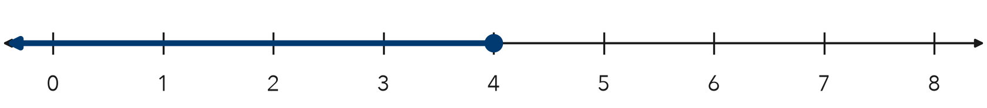
A x < 4 | B x ≤ 4 | C x > 4 | D x ≥ 4

7. Which number is a solution of n > −3?
A −5 | B −4 | C −3 | D 0

CHECK YOURSELF | □ I can do this on my own | □ I need a little help | □ I have a question about #

