Name |  | Date |  | Period

Lesson 8-4 · Session 2
Homework
Representing Inequalities
Maryland Standard 6.EE.B.8 · Learning target — I can represent an inequality with a set of solutions and describe them.
Show a model, calculation, or explanation for each exercise. Label units and answer every part.
Exercises 1–12 earn 1 point for a correct response and 1 for supporting work. Spiral Review and Test Practice earn 1 point each.
REMEMBER review this before you start
• A closed (filled-in) circle on a number line means the boundary number IS included (≥ or ≤).
• An open circle means the boundary number is not included (> or <).
• Watch out — one example is not a description; name the boundary and whether it is included.
• Check it — test the boundary value itself to decide which symbol you need.
WORKED EXAMPLE the same steps you practiced in class
Writing an Inequality and Plotting Solutions A backpack rule says a student may carry no more than 15 pounds. Show the weights that are allowed.
Step 1 Name the variable: let w = the pounds in a student’s backpack.
Step 2 The phrase ‘no more than’ allows 15 itself and every weight below it.
Step 3 That phrase matches ≤, so write w ≤ 15.
Step 4 Draw a number line near 15 and plot 15, 12, and 9 — each one is allowed.
Answer w ≤ 15, so any weight of 15 pounds or less is a solution.
EXERCISES 12 exercises · 24 points
1. Graph x ≥ 3 on a number line. Should the circle be open or closed? ______

Graph. Mark the boundary with an open or a closed dot, then shade the arrow.​
Show your work.
Answer
2. Graph x < −2 on a number line. Should the circle be open or closed? ______

Graph. Mark the boundary with an open or a closed dot, then shade the arrow.​
Show your work.
Answer
3. Write the inequality shown by a number line with an open circle at 5, shaded to the right.

Read the graph. This is the number line the problem describes.​
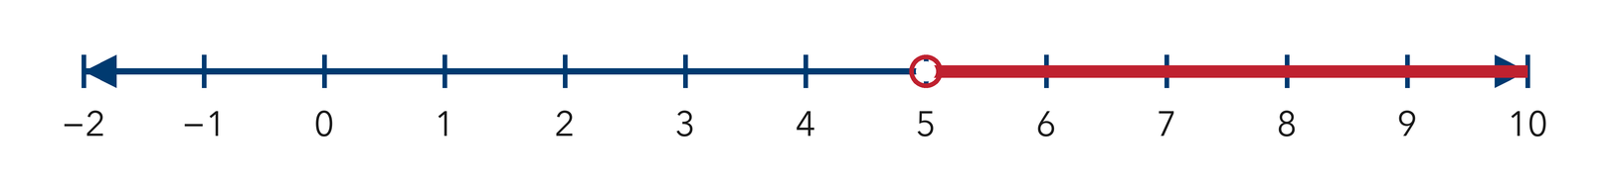
Show your work.
Answer
4. Write open or closed for the circle in each graph.
a. x ≤ 11 ______
b. n > 0 ______
c. p ≥ −4 ______
d. k < 8 ______
e. w ≤ −6 ______

Answer
5. Pool Depth. The shallow end of a pool stays no deeper than 4 feet. Write an inequality using d, then tell whether the circle at 4 is open or closed.

Show your work.

Answer
6. Write the inequality shown by a number line with a closed circle at 9, shaded to the left.

Read the graph. This is the number line the problem describes.​
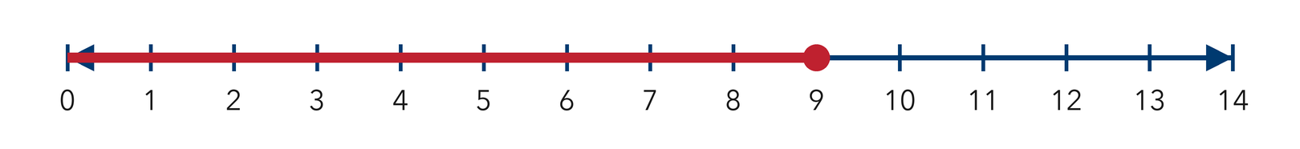
Show your work.

Answer
7. Scooter Speed. A campus rule says a scooter must travel slower than 12 miles per hour. Write an inequality using s, then draw a number line from 8 to 16 and graph it.

Graph. Mark the boundary with an open or a closed dot, then shade the arrow.​
Show your work.

Answer
8. Marisol graphed t ≥ 10 with an open circle at 10. Explain what an open circle tells a reader, why it is wrong for this inequality, and how she should fix the graph.

Show your work.

Answer
9. For n < 10, name three solutions and one number that is not a solution.

Show your work.
Answer three solutions and one non-solution
10. Describe every solution of p ≤ 25 in one sentence.

Show your work.
Answer your description
11. Two Rules. A rule says a score must be at least 60 and at most 100. Write both inequalities and name two valid scores.

Show your work.
Answer both inequalities and two scores
12. Find the Mistake. Sol says the only solution of n ≥ 8 is 8. Explain the mistake.

Show your work.
Answer the mistake
SPIRAL REVIEW earlier skills · 1 point each
13. From Lesson 8-4 Session 1. Write an inequality for “more than 15.”
Answer
14. From Lesson 8-3 Session 2. Solve n ÷ 8 = 6.
Answer
15. From Lesson 6-8 Session 2. Factor 9x + 12.
Answer
TEST PRACTICE multiple choice · fill one box · 1 point each
16. Which value is a solution of n < 3?
□ A. 10 | □ B. 3 | □ C. 4 | □ D. 2
17. Which value is a solution of x ≥ 20?
□ A. 20 | □ B. 19 | □ C. 15 | □ D. 0
18. The solutions of an inequality form a —
□ A. single value | □ B. set of values | □ C. graph point | □ D. pair
CHECK YOURSELF Score: ______ / 30
□ Solved on my own | □ Needed a hint | □ Need help on Question # ______
Test one proposed solution in the original equation or inequality. Show whether the statement is true.

