Name |  | Date |  | Period
Lesson 9-2 · Session 1 · Version 2
Guided Practice · Version 2
From Table to Graph
VOCABULARY read and say each word before you begin
graph  Spanish: gráfica | A picture on a coordinate plane of a relationship. | points that rise in a line
ordered pair  Spanish: par ordenado | Two numbers (x, y) that name one point on a graph. | (3, 12)
coordinates  Spanish: coordenadas | The two numbers inside an ordered pair. | x-coordinate, y-coordinate
axis  Spanish: eje | One of the two number lines that frame a graph. | x-axis and y-axis
plot | To mark a point where an ordered pair says to. | right first, then up
EXPLORE TOGETHER Class Launch · 8–10 min
1. Dog-walking Pay  Amara earns $9 for every dog she walks on weekends. She wants a table and a graph that show her pay for the first few dogs.  a. Label. Identify the variables. Independent variable: __________ Dependent variable: __________  b. Table. Find the pay for each number of dogs. x (dogs): 1, 2, 3, 5 and y (dollars): ______ , ______ , ______ , ______  c. Pairs. Write an ordered pair for each completed table row: ( __ , __ ) ( __ , __ ) ( __ , __ ) ( __ , __ ) | d. Graph. Use your ordered pairs to plot four points on the coordinate plane below. Match each value to the quantity labeled on its axis.  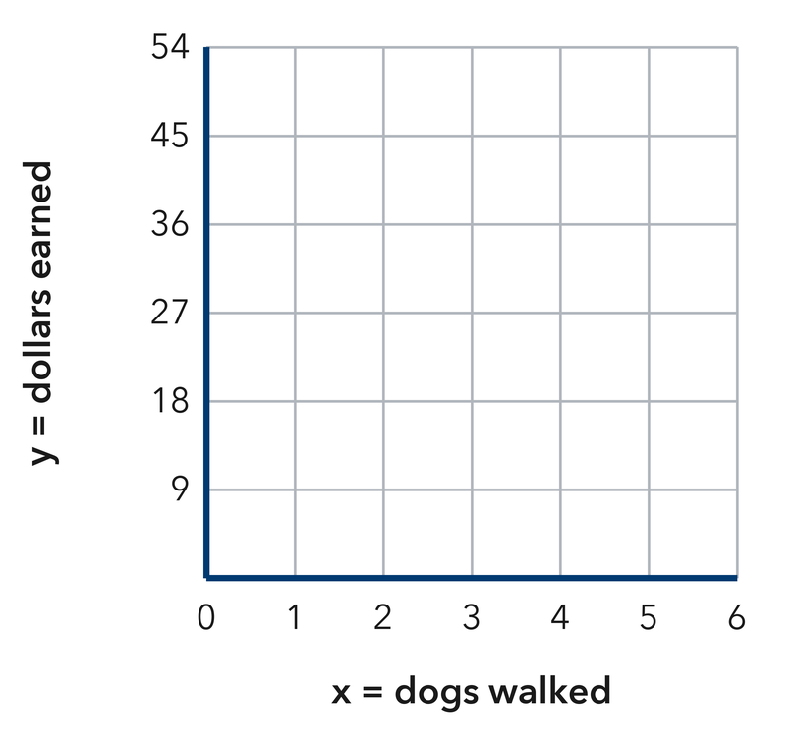​
  TURN AND TALK
  Why does the point (0, 0) belong on this graph? What would it mean?
PRACTICE WITH A PARTNER You Do Together · 10–12 min
2. Bus Fare. A city bus charges $2 for every ride Mateo takes to practice.  a. Complete it. Find the total fare for each ride count. x (rides): 3, 6, 9 and y (dollars) __________  b. Write the three table rows as ordered pairs: ( __ , __ ) ( __ , __ ) ( __ , __ ) | c. Graph. Plot all three ordered pairs on the coordinate plane below. Draw a straight line through the points.  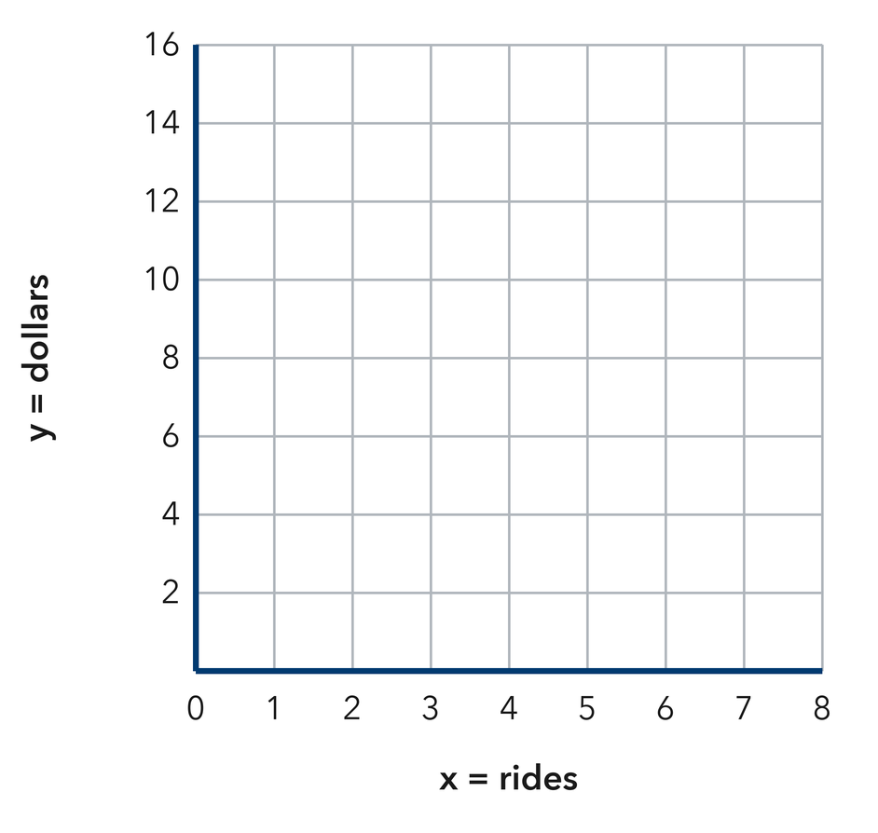
  PARTNER TALK
  What does one single point on this graph tell you about Mateo’s rides?

3. Filling a Pool. A garden hose adds 30 gallons of water to a wading pool every minute.  a. Complete it. x (minutes): 1, 3, 5 and y (liters) __________  b. Plot the three points in the work space. Which axis shows the time in minutes? __________ | 4. Party Balloons. A party store ties 16 balloons into every bunch it sells.  a. Complete it. x (kits): 2, 4, 6 and y (markers) __________  b. Write the three table rows as ordered pairs: ( __ , __ ) ( __ , __ ) ( __ , __ ) __________
  PARTNER TALK
  How would the graph look different if the hose ran more slowly? Explain.
  PARTNER TALK
  If you plotted one more bunch, where would that point sit compared with the others? Explain.
PRACTICE ON YOUR OWN You Do · 8 problems · 18–20 min
5. Craft Ribbon. Ribbon costs $3 for every yard a shopper buys at the craft store.  Show the cost of 2, 5, and 8 yards in a table. Write the corresponding ordered pairs and plot them in the work space.  Hint Use yards bought as the input. Write yards first and dollars second in each ordered pair.  Answer completed table, ordered pairs, and graph | Graph. Locate each ordered pair on the coordinate plane below. Draw a straight line through the plotted points.  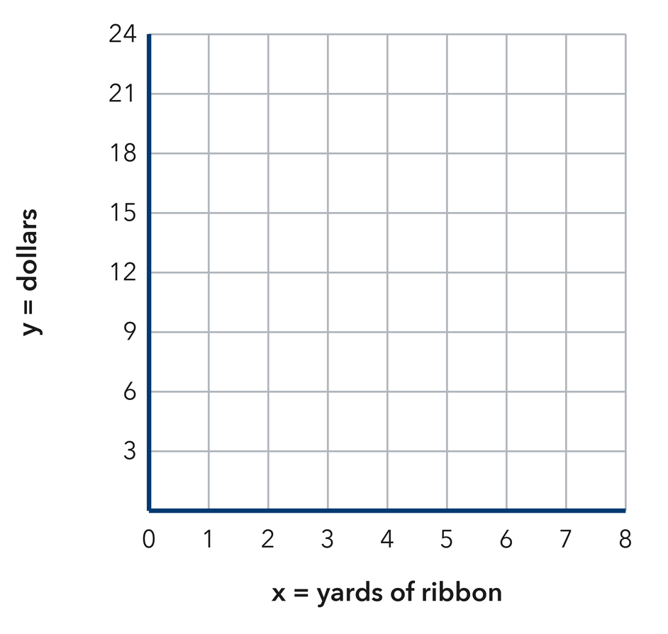
  Show your work.

6. Reading Log. Sofia’s log shows x: 1, 2, 3, 4 nights and y: 25, 50, 75, 100 minutes read. She plotted the point (75, 3) for the third night. Explain what she did wrong.  Hint The x value comes first in an ordered pair. Check which quantity is x in Micah’s table.  Answer explanation of Micah’s mistake + correct point | 7. Ski Lift. A ski lift rises 50 feet every second it runs up the mountain.  Write the ordered pairs for 3, 7, and 9 seconds, then explain what the last point means.  Hint Pair each time with the distance traveled, keeping seconds first.  Answer three ordered pairs with tickets first; meaning of the last point

8. Rec League Fee. A rec league charges a team $11 for every game it plays in the season.  Make a table for 1, 3, and 6 hours, write the ordered pairs, and plot them in the work space.  Hint Multiply the hours by 13 to fill the cost column. Write hours first in each ordered pair.  Answer completed table, ordered pairs, and graph | 9. Corn Rows. A community garden plants 18 corn seeds in every row it digs.  Write the ordered pairs for 2, 5, and 8 trays, then explain what the middle point means.  Hint Multiply each tray count by 12, then read each pair aloud as ‘trays, muffins.’  Answer three ordered pairs with tickets first; meaning of the last point

10. Movie Rentals. A site charges $7 per movie. Make a table for 1, 2, and 3 movies and list the ordered pairs.  Hint Multiply each ticket count by 8.  Answer three ordered pairs with tickets first | 11. From Pairs to a Pattern. A table gives the pairs (1, 5), (2, 10), and (3, 15).  a. Describe the rule that gives y from x. __________  b. Describe the shape the points make when plotted. __________  Hint Find the factor that multiplies each x to give its y.  Answer a. rule and b. shape

12. With a Fee. A service charges $4 plus $2 per item. List the ordered pairs for 1, 2, and 3 items and describe the graph.  Hint Multiply the number of items by 2, then add the $4 fee.  Answer three ordered pairs and a description of the graph | Graph. Plot the ordered pairs on the coordinate plane below, then draw a straight line through them. Extend the line to the y-axis and use the $4 fee to explain why it does not pass through the origin.  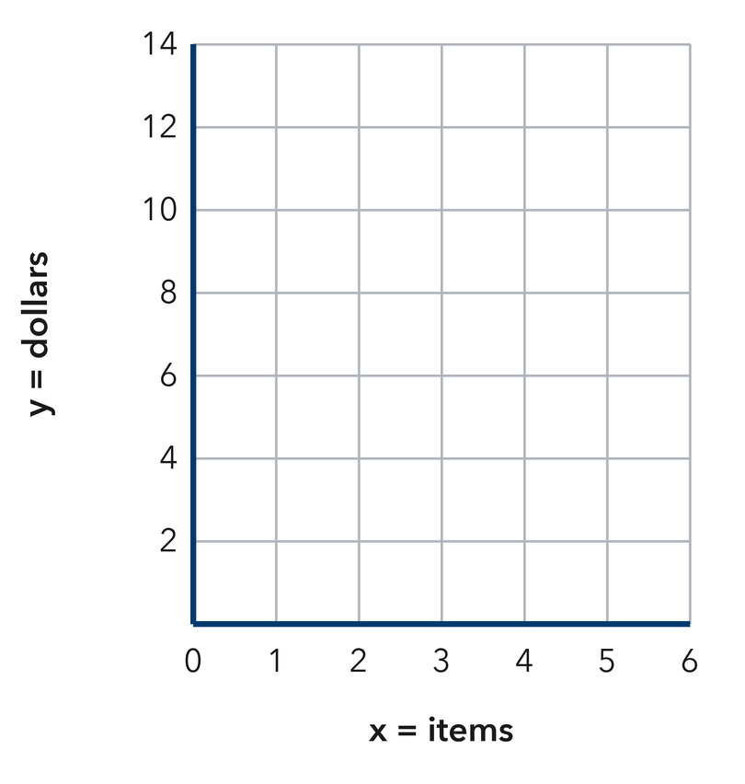
  Show your work.
ANALYZE THE ERROR 5 min
13. Read the work below. Explain the mistake, then show the correct reasoning.
ZURI’S WORK

A parking garage charges $5 per hour. Jonah plotted the points (15, 3) and (25, 5) on his graph.
a. Explain the mistake. Zuri wrote the output before the input in each ordered pair. Complete the sentence: Zuri reversed _____; the _____ value should come first. | b. Show correct work by rewriting Zuri’s ordered pairs with the input first.  Correct answer
  Show the correct work.
STRETCH YOUR THINKING multi-step reasoning · 8 min
14. Two Services. Service A charges $5 per hour. Service B charges $6 plus $3 per hour.  a. Write three ordered pairs for each service for 1, 2, and 3 hours, with hours first and dollars second.  b. Compare where the two graphs cross the y-axis.  c. Determine the number of hours when the two services have the same cost.  Answer both sets of ordered pairs, the y-axis comparison, and the tie point | d. Graph both services. Use the same coordinate plane for Service A and Service B. Draw and label each line.  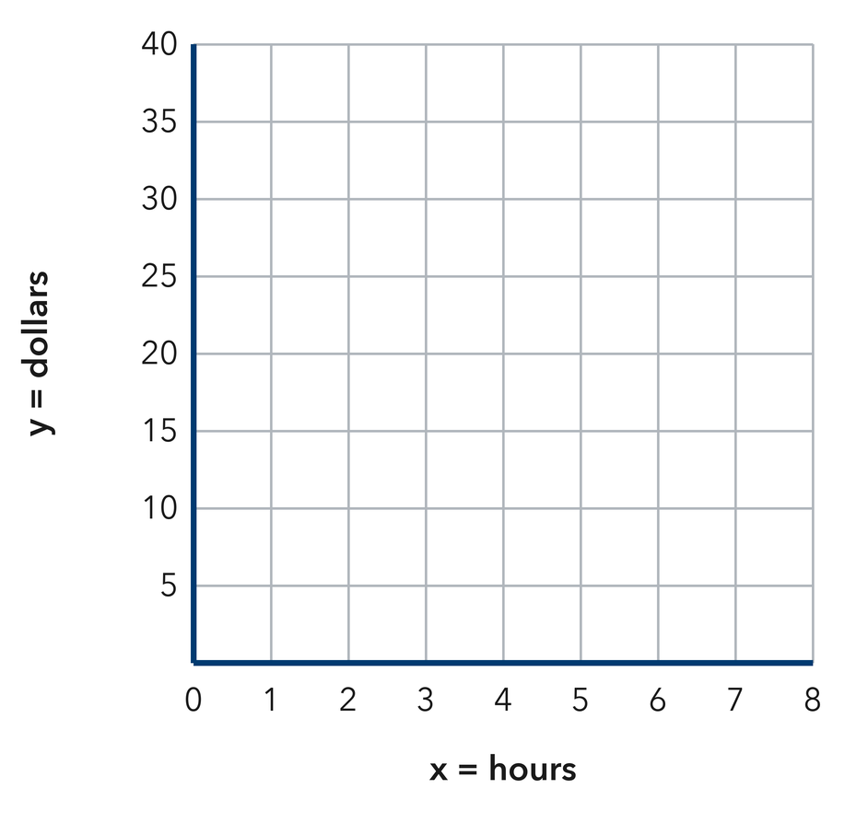
  Show your work.
TEST PRACTICE multiple choice · fill one box · 6 min
15. A table row of x = 4, y = 20 becomes the pair — | 16. Points from a constant rate form a —
  □ A. (24, 0) | □ B. (20, 4) | □ C. (4, 4) | □ D. (4, 20)
  □ A. straight line | □ B. circle | □ C. curve | □ D. square

17. At $9 per ticket, 3 tickets give the pair — | 18. The first column of a table gives the —
  □ A. (27, 3) | □ B. (3, 27) | □ C. (3, 9) | □ D. (9, 3)
  □ A. totals | □ B. y-values | □ C. x-values | □ D. labels
SPIRAL REVIEW earlier skills · keep them sharp · 6 min
19. From Lesson 9-1 Session 2. A rule multiplies x by 8. Find y when x = 6.  Answer | 20. From Lesson 8-5 Session 2. Is n = 7 a solution of n > 7?  Answer

21. From Lesson 7-7 Session 1. A rectangle with sides 12 and 5 has what area?  Answer | 22. From Lesson 5-2 Session 1. A triangle has base 22 cm and height 8 cm. Find its area.  Answer
CHECK YOUR UNDERSTANDING 5 min
23. Shipping by the Pound. A shipping store charges $12 for each pound a package weighs.  a. Complete it. Find the shipping cost for each weight. x (pounds): 1, 2, 5 and y (dollars) __________  b. Write the ordered pair for a 5-pound package, then plot it: (__________, __________)  Hint Multiply each weight by $12. Write pounds first and dollars second in the ordered pair.  Answer | c. Graph. Plot all three ordered pairs on the coordinate plane below. Draw a straight line through the points.  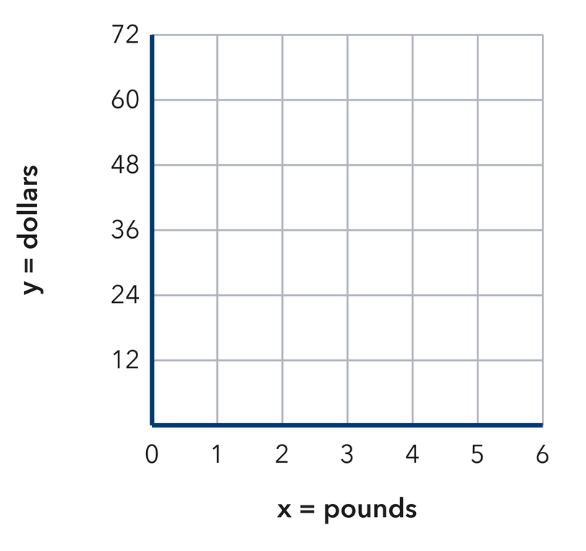
  Show your work.

□ 4 — Can teach it | □ 3 — Got it | □ 2 — Need hint | □ 1 — Need help
Circle your confidence. Star one problem that shows your learning.

