Name |  | Date |  | Period
Lesson 9-2 · Session 1
Guided Practice
From Table to Graph
VOCABULARY read and say each word before you begin
graph  Spanish: gráfica | A picture on a coordinate plane of a relationship. | points that rise in a line
ordered pair  Spanish: par ordenado | Two numbers (x, y) that name one point on a graph. | (3, 12)
coordinates  Spanish: coordenadas | The two numbers inside an ordered pair. | x-coordinate, y-coordinate
axis  Spanish: eje | One of the two number lines that frame a graph. | x-axis and y-axis
plot | To mark a point where an ordered pair says to. | right first, then up
EXPLORE TOGETHER Class Launch · 8–10 min
1. Dog-walking Pay  Priya earns $9 for every dog she walks after school. She wants a table and a graph that show her pay for the first few dogs.  a. Label. Independent variable: __________ Dependent variable: __________  b. Table. Complete it. x (dogs): 1, 2, 3, 5 and y (dollars): ______ , ______ , ______ , ______  c. Pairs. Write the four rows as ordered pairs: ( __ , __ ) ( __ , __ ) ( __ , __ ) ( __ , __ ) | d. Graph. Plot your four points on the coordinate plane below. Each axis is already labeled with its quantity.  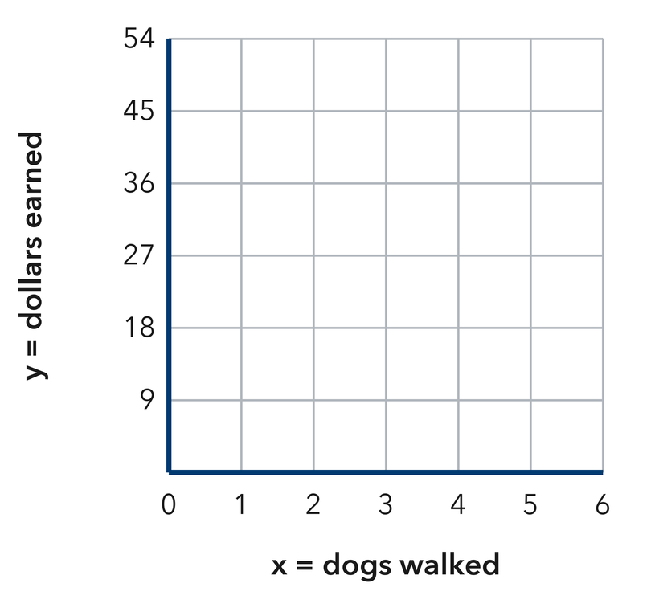​
  TURN AND TALK
  Why does the point (0, 0) belong on this graph? What would it mean?
PRACTICE WITH A PARTNER You Do Together · 10–12 min
2. Bus Fare. A city bus charges $2 for every ride Mateo takes to practice.  a. Complete it. x (rides): 3, 6, 9 and y (dollars) __________  b. Write the three ordered pairs: ( __ , __ ) ( __ , __ ) ( __ , __ ) | c. Graph. Plot the ordered pairs on the coordinate plane below, then draw a straight line through them.​  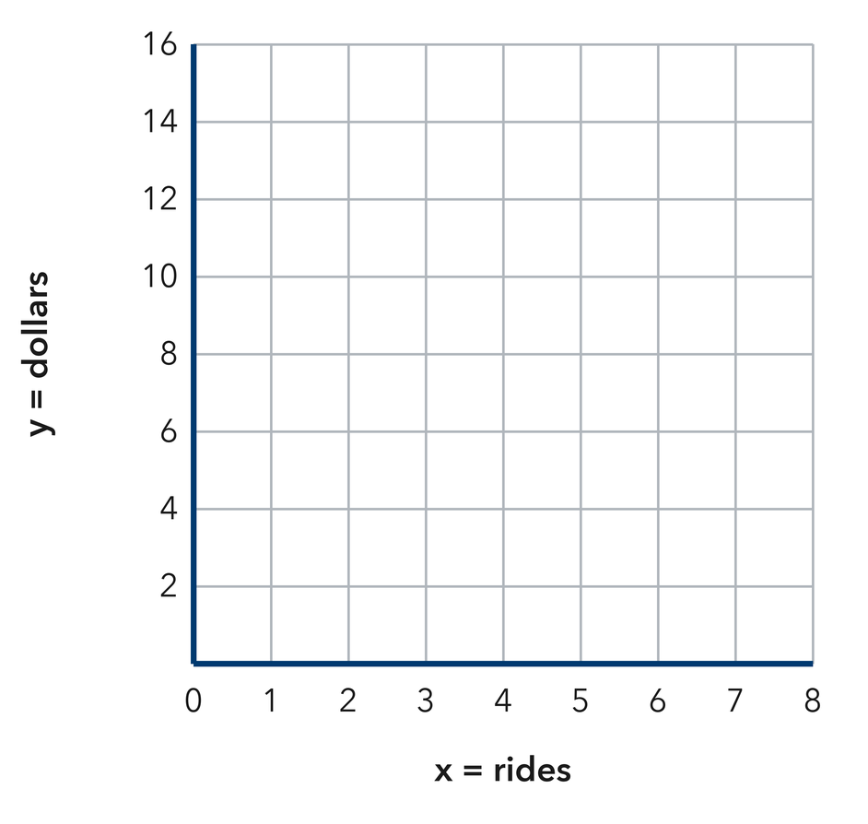
  PARTNER TALK
  What does one single point on this graph tell you about Mateo’s rides?

3. Filling a Pool. A garden hose adds 30 gallons of water to a wading pool every minute.  a. Complete it. x (minutes): 2, 4, 6 and y (gallons) __________  b. Plot the three points in the work space. Which axis shows minutes? __________ | 4. Party Balloons. A party store ties 16 balloons into every bunch it sells.  a. Complete it. x (bunches): 1, 3, 5 and y (balloons) __________  b. Write the three ordered pairs: ( __ , __ ) ( __ , __ ) ( __ , __ ) __________
  PARTNER TALK
  How would the graph look different if the hose ran more slowly? Explain.
  PARTNER TALK
  If you plotted one more bunch, where would that point sit compared with the others? Explain.
PRACTICE ON YOUR OWN You Do · 8 problems · 18–20 min
5. Craft Ribbon. Ribbon costs $3 for every yard a shopper buys at the craft store.  Make a table for 2, 5, and 8 yards, write the ordered pairs, and plot them in the work space.  Hint The yards bought is the input, so it names the first number in each ordered pair.  Answer table, ordered pairs, graph | Graph. Plot the ordered pairs on the coordinate plane below, then draw a straight line through them.​  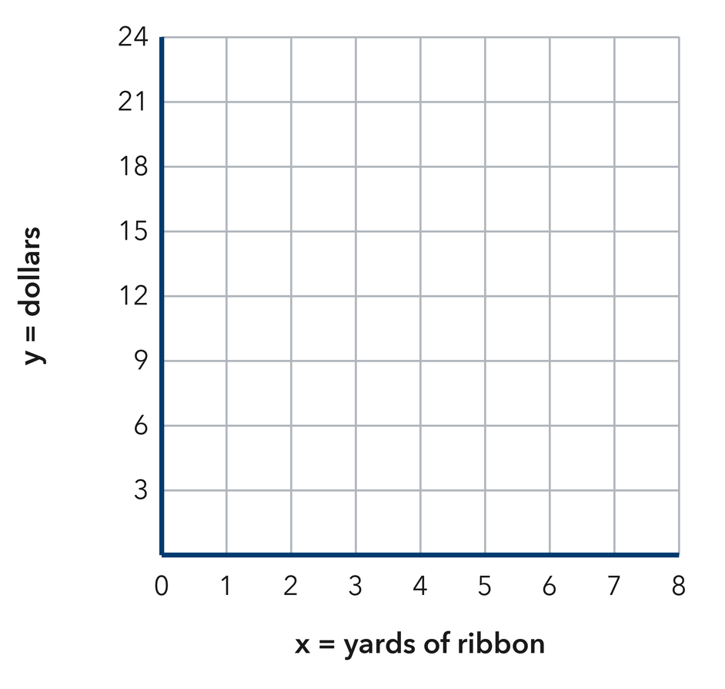
  Show your work.

6. Reading Log. Sofia’s log shows x: 1, 2, 3, 4 nights and y: 25, 50, 75, 100 minutes read. She plotted the point (75, 3) for the third night. Explain what she did wrong.  Hint In an ordered pair the x value is written first; check which quantity is x in her table.  Answer mistake + correct point | 7. Ski Lift. A ski lift rises 50 feet every second it runs up the mountain.  Write the ordered pairs for 2, 6, and 10 seconds, then explain what the last point means.  Hint Pair each time with the height that goes with it, keeping the input in front.  Answer three ordered pairs; meaning

8. Rec League Fee. A rec league charges a team $11 for every game it plays in the season.  Make a table for 2, 4, and 7 games, write the ordered pairs, and plot them in the work space  Hint Fill the cost column first, then keep the games in front when you write each pair.  Answer table, ordered pairs, graph | 9. Corn Rows. A community garden plants 18 corn seeds in every row it digs.  Write the ordered pairs for 3, 6, and 9 rows, then explain what the middle point means  Hint Multiply each row count by 18, then read each pair aloud as ‘rows, seeds.’  Answer three ordered pairs; meaning

10. Movie Rentals. A site charges $7 per movie. Make a table for 1, 2, and 3 movies and list the ordered pairs.  Hint Multiply each count by 7.  Answer three ordered pairs | 11. From Pairs to a Pattern. A table gives the pairs (1, 5), (2, 10), and (3, 15).  a. Describe the rule. __________  b. Describe the shape the points make. __________  Hint Compare each y with its x.  Answer a and b

12. With a Fee. A service charges $4 plus $2 per item. List the ordered pairs for 1, 2, and 3 items and describe the graph.  Hint Multiply by 2, then add 4.  Answer three pairs and the graph | Graph. Plot the ordered pairs on the coordinate plane below, then draw a straight line through them. This one does not start at the origin — the graph will show you why.​  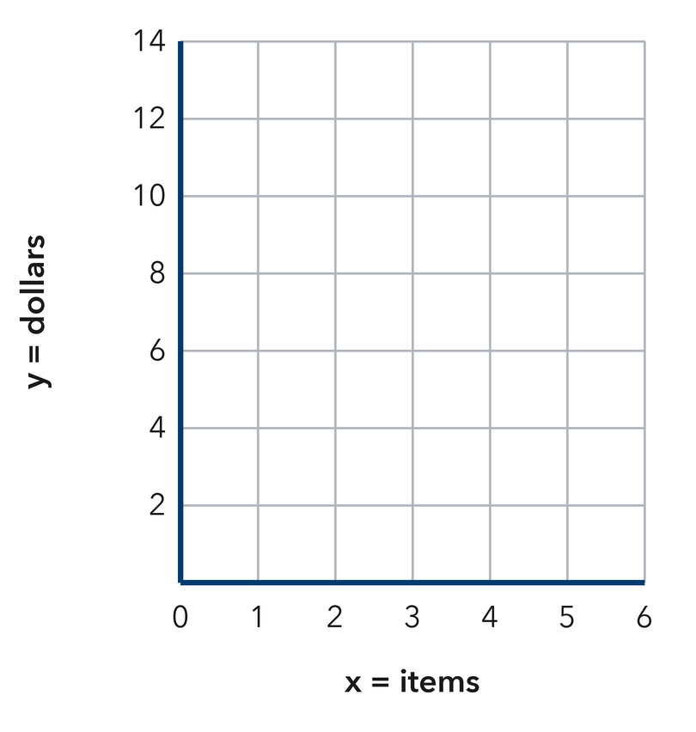
  Show your work.
ANALYZE THE ERROR 5 min
13. Read the work below. Explain the mistake, then show the correct reasoning.
JONAH’S WORK

A parking garage charges $5 per hour. Jonah plotted the points (15, 3) and (25, 5) on his graph.
a. Explain the mistake. Check the order of the numbers in Jonah’s ordered pairs. What went wrong? | b. Show correct work  Correct answer
  Show the correct work.
STRETCH YOUR THINKING multi-step reasoning · 8 min
14. Two Services. Service A charges $5 per hour. Service B charges $6 plus $3 per hour.  a. List three ordered pairs for each service using 1, 2, and 3 hours.  b. Describe how the two graphs differ at the y-axis.  c. Find the hours at which both services cost the same.  Answer both sets of pairs, the difference, and the tie point | d. Graph both services. Plot Service A and Service B on the same plane and label the two lines.​  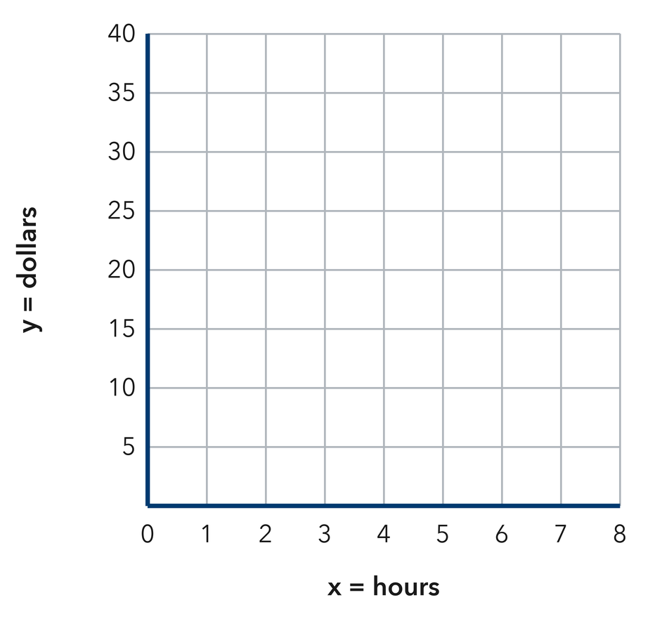
  Show your work.
TEST PRACTICE multiple choice · fill one box · 6 min
15. A table row of x = 4, y = 20 becomes the pair — | 16. Points from a constant rate form a —
  □ A. (24, 0) | □ B. (20, 4) | □ C. (4, 4) | □ D. (4, 20)
  □ A. straight line | □ B. circle | □ C. curve | □ D. square

17. At $9 per ticket, 3 tickets give the pair — | 18. The first column of a table gives the —
  □ A. (27, 3) | □ B. (3, 27) | □ C. (3, 9) | □ D. (9, 3)
  □ A. totals | □ B. y-values | □ C. x-values | □ D. labels
SPIRAL REVIEW earlier skills · keep them sharp · 6 min
19. From Lesson 9-1 Session 2. A rule multiplies x by 8. Find y when x = 6.  Answer | 20. From Lesson 8-5 Session 2. Is n = 7 a solution of n > 7?  Answer

21. From Lesson 7-7 Session 1. A rectangle with sides 12 and 5 has what area?  Answer | 22. From Lesson 5-2 Session 1. A triangle has base 22 cm and height 8 cm. Find its area.  Answer
CHECK YOUR UNDERSTANDING 5 min
23. Shipping by the Pound. A shipping store charges $12 for each pound a package weighs.  a. Complete it. x (pounds): 1, 2, 5 and y (dollars) __________  b. Write and plot the ordered pair for 5 pounds: ( __________  Hint Multiply to find each cost, then keep the pounds in front of the ordered pair.  Answer | c. Graph. Plot the ordered pairs on the coordinate plane below, then draw a straight line through them.​  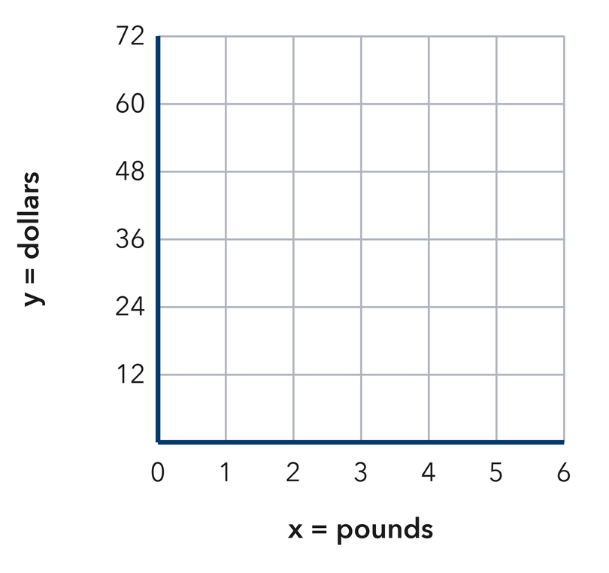
  Show your work.

□ 4 — Can teach it | □ 3 — Got it | □ 2 — Need hint | □ 1 — Need help
Circle your confidence. Star one problem that shows your learning.

