Name |  | Date |  | Period
Lesson 9-2 · Session 2 · Version 2
Guided Practice · Version 2
Analyzing a Graph
VOCABULARY read and say each word before you begin
rate of change  Spanish: tasa de cambio | How much y changes each time x goes up by one. | up $4 per hour
unit rate  Spanish: tasa unitaria | The amount of y that goes with exactly one unit of x. | 60 miles per hour
origin  Spanish: origen | The point (0, 0) where the two axes meet. | (0, 0)
steeper | With matching axes and scales, a larger rise per unit of x. | up 9 beats up 2
represent  Spanish: representar | To show one relationship as a table, graph, or rule. | table graph
EXPLORE TOGETHER Class Launch · 8–10 min
1. Scooter Rental Graph  Maya checks a scooter rental graph with minutes on the x-axis and cost in dollars on the y-axis. It passes through (1, 7), (2, 14), (4, 28), and (5, 35).  a. Read. What does the point (2, 14) tell Maya about this rental? __________  b. Rate. How much more does Maya pay for each additional minute? $ ______  c. Plot. Plot Maya’s four rental points on the coordinate plane below and connect them with a straight edge. | d. Predict. Maya rents a scooter for 3 minutes. Use your graph to find her cost: ______ Explain how you read the graph.  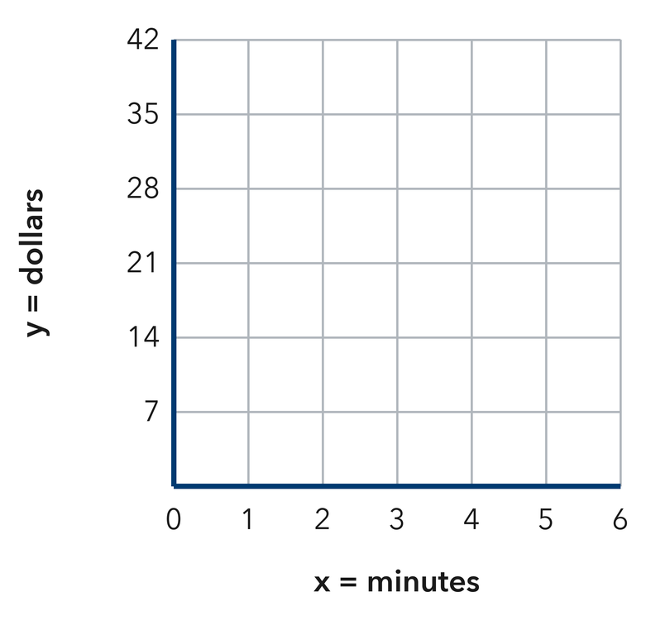​
  TURN AND TALK
  How does the steepness of a graph show the rate between two quantities?
PRACTICE WITH A PARTNER You Do Together · 10–12 min
2. Hiking Trail. A hiking graph shows hours on the x-axis and miles walked on the y-axis. It passes through (1, 2), (3, 6), and (5, 10).  a. How many miles does Theo’s club walk each hour? __________  b. Use the pattern to find how many miles Theo’s club walks after 7 hours __________ | c. Graph. Plot the hiking club’s ordered pairs on the coordinate plane below, then draw a straight line through them.  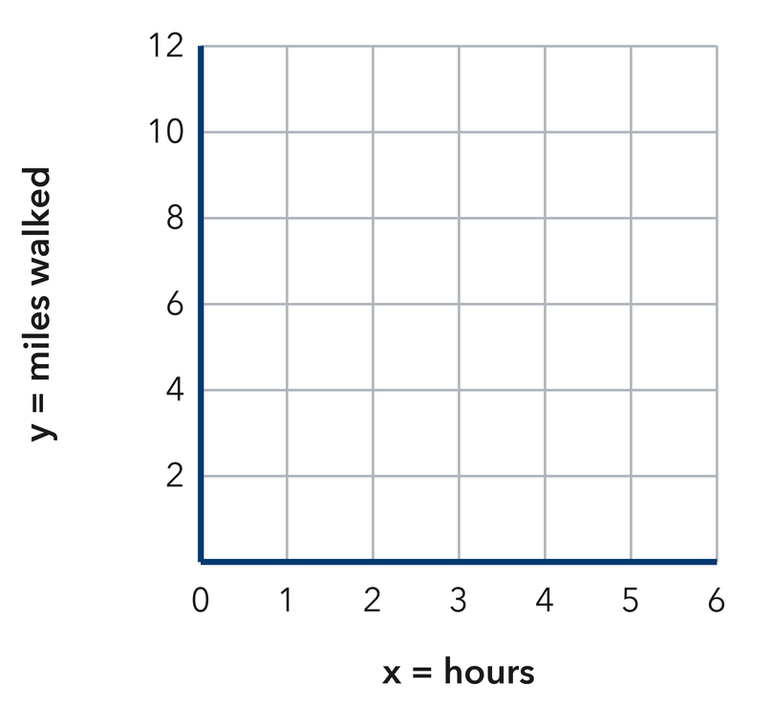
  PARTNER TALK
  Why do all of these points lie along one straight path?

3. Phone Storage. A storage graph shows songs downloaded on the x-axis and megabytes used on the y-axis. It passes through (2, 8), (5, 20), and (10, 40).  a. Dollars for one paintbrush __________  b. What do the coordinates of (4, 24) mean here? __________ | 4. Ferris Wheel. A ride graph shows minutes on the x-axis and turns of a Ferris wheel on the y-axis. It passes through (3, 9), (6, 18), and (8, 24).  a. Bracelets completed in one hour __________  b. Use the pattern to find the bracelets completed after 12 hours __________
  PARTNER TALK
  How can a single point on a graph tell you the unit rate? Explain.
  PARTNER TALK
  What would a flatter line on this same graph tell you about the ride?
PRACTICE ON YOUR OWN You Do · 8 problems · 18–20 min
5. Sunflower Growth. A sunflower graph shows weeks on the x-axis and height in inches on the y-axis. It passes through (2, 14), (4, 28), and (6, 42).  Find the rate of change, then determine the number of pages read after 11 days.  Hint Compare two points that sit three days apart, then scale that jump down to one day.  Answer __________ pages per day; __________ pages after 11 days | 6. Two Pay Graphs. Job A’s pay graph passes through (1, 6) and (3, 18). Job B’s pay graph passes through (1, 9) and (3, 27). Explain which graph is steeper and what that means about the pay.  Hint Work out how much each graph climbs for one minute, then compare those two climbs.  Answer __________ has the steeper graph because __________. This means __________.

7. Water Tank. A tank graph shows hours on the x-axis and gallons on the y-axis. It passes through (2, 50), (4, 100), and (7, 175).  Determine the unit rate, then write the ordered pair that belongs at 12 boxes.  Hint Divide the y value of one point by its x value to get the number of crayons in a single box.  Answer __________ crayons per box; ordered pair __________ | 8. Package Scanner. A warehouse graph shows minutes on the x-axis and packages scanned on the y-axis. It passes through (4, 16), (6, 24), and (10, 40).  Find the rate of change, then determine the miles traveled in 7 hours.  Hint Divide one point’s y value by its own x value to get the miles traveled in a single hour.  Answer __________ miles per hour; __________ miles in 7 hours

9. Lawn Signs. A fundraiser graph shows lawn signs sold on the x-axis and dollars raised on the y-axis. It passes through (3, 45) and (7, 105). Yusuf says the point (3, 45) means the group raises $45 each hour.
Explain the mistake in how Leila read the graph, then state what (4, 48) really means.
Hint Check what each axis measures before naming a rate, then divide to get the money from one tray of muffins.
Answer Leila’s mistake is __________. The point (4, 48) means __________. The group raises $__________ per tray of muffins.

10. Taxi Graph. A taxi graph passes through (1, 15), (2, 30), and (3, 45). Describe the relationship and give the rate.  Hint Divide each y-value by its matching x-value.  Answer the rate and a description of the relationship | Read the graph. Use this taxi graph to explain the relationship and identify the rate.​  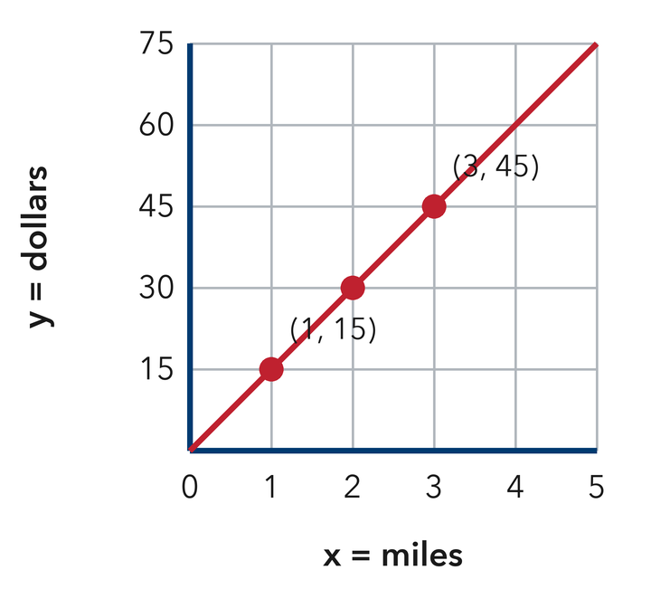
  Show your work.

11. Read the Rate. A graph passes through (2, 18) and (5, 45).  a. What is the rate of change? __________  b. When x = 8, what is y? __________  Hint Check that both points give the same value for y ÷ x.  Answer your results for a and b | c. Read the graph. Use the graph through both points to confirm the rate you calculated.​  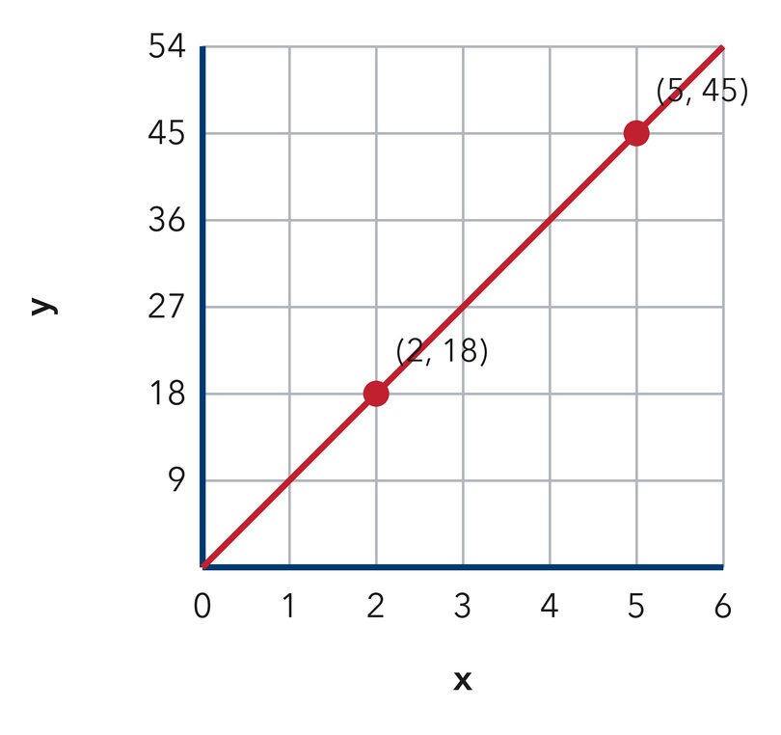
  Show your work.

12. Compare Steepness. Line P passes through (1, 4) and line Q through (1, 9). Both start at the origin.
a. Which line, R or S, is steeper? __________
b. What does the steeper line tell you about the bicycle rental cost per hour? __________
Hint Compare how much each cost rises during the same one-hour run.
Answer your results for a and b
ANALYZE THE ERROR 5 min
13. Read the work below. Explain the mistake, then show the correct reasoning.
AMIR’S WORK

A walking graph passes through (2, 100) and (4, 200). Bianca said the walker takes 100 steps each minute.
a. Explain the mistake. Check how Amir used the point (3, 120). What step did he skip? Complete: “Amir used _____ as the rate, but he should have _____.” | b. Show correct work to find the number of labels printed per minute.  Correct answer
  Show the correct work.
STRETCH YOUR THINKING multi-step reasoning · 8 min
14. Two Riders. Rider 1’s graph passes through (2, 24) and Rider 2’s through (3, 30). Both graph distance in kilometres against hours and start at the origin.  a. Find Elena’s and Marcus’s rates in kilometres per hour.  b. Whose line is steeper? Explain what its steepness tells you about that rider’s speed.  c. Calculate each rider’s distance after 5 hours and the difference between those distances.  Answer both riders’ rates, whose line is steeper, and the distance gap | d. Graph both riders. On the same plane, draw Elena’s line as 1 and Marcus’s line as 2. Compare their steepness.​  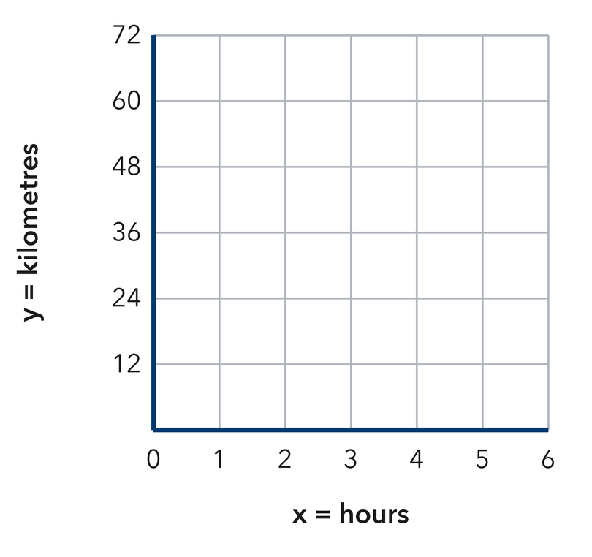
  Show your work.
TEST PRACTICE multiple choice · fill one box · 6 min
15. A graph through (1, 8) and (2, 16) shows a rate of — | 16. A steeper line shows a —
  □ A. 16 per unit | □ B. 8 per unit | □ C. 2 per unit | □ D. 24 per unit
  □ A. larger total only | □ B. smaller rate | □ C. larger rate | □ D. zero rate

17. A graph through (3, 21) has a rate of — | 18. The point where a line meets the y-axis shows the value when x is —
  □ A. 24 per unit | □ B. 21 per unit | □ C. 3 per unit | □ D. 7 per unit
  □ A. 0 | □ B. 1 | □ C. the rate | □ D. the total
SPIRAL REVIEW earlier skills · keep them sharp · 6 min
19. From Lesson 9-2 Session 1. At $8 per ticket, list the pair for 3 tickets.  Answer | 20. From Lesson 9-1 Session 1. Which variable goes on the y-axis?  Answer

21. From Lesson 8-3 Session 1. Solve 8n = 88.  Answer | 22. From Lesson 5-2 Session 1. A triangle has base 16 ft and height 7 ft. Find its area.  Answer
CHECK YOUR UNDERSTANDING 5 min
23. Movie Night Popcorn. A popcorn graph shows bags on the x-axis and dollars on the y-axis. It passes through (3, 24) and (6, 48).  a. How much does one bag cost? __________  b. Plot the two points and extend the path to determine what Jordan pays for 8 bags __________  Hint Find dollars per bag, then use that rate to continue the pattern on the graph.  Answer | c. Graph. Plot the hiking club’s ordered pairs on the coordinate plane below, then draw a straight line through them.  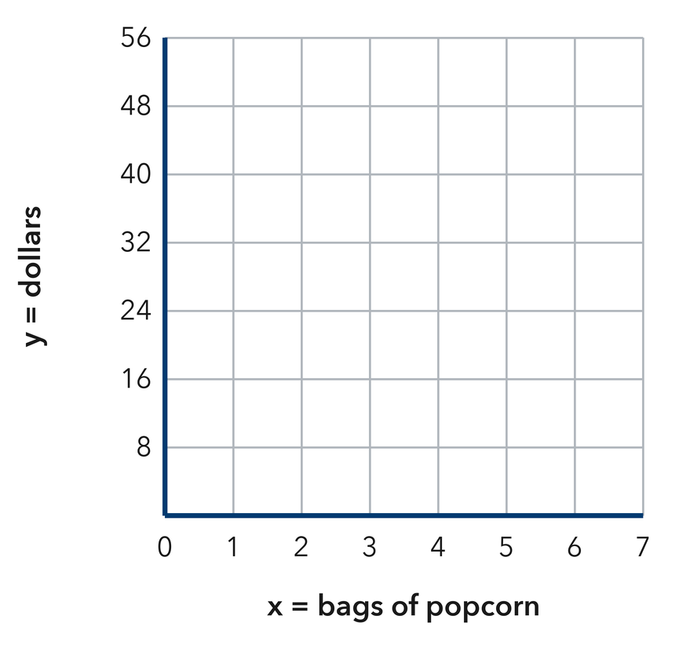
  Show your work.

□ 4 — Can teach it | □ 3 — Got it | □ 2 — Need hint | □ 1 — Need help
Circle your confidence. Star one problem that shows your learning.

