UNIT 1 · LESSON 6 STANDARD MPP.3

Math is Ours
Student Notes Packet
Name: ______________________ Date: ____________ Period: ________
Level 3 · Enrichment

Today's Goals
Content: I can describe my problem-solving process, name strategies for getting unstuck, and identify the behaviors that make our class a community of math thinkers.
Language: I can talk about problem solving using the phrases make sense of, get stuck, try a strategy, and work together.

Key Vocabulary
Look at the picture, read the word, then read what it means.
 | make sense of a problem comprender un problema  To figure out what a problem is asking — what you know, and what you don't know yet.  Example: KNOW: 16 wheels, 6 times as many. DON'T KNOW: how many bikes.
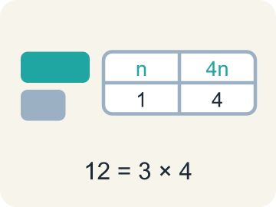 | representation representación  A way of showing a problem — a drawing, table, equation, or model — that helps you see it.  Example: The same 12 shown three ways: a tape diagram, a table, and 3 × 4.
 | strategy estrategia  A plan of attack for a problem — and something you can switch when you get stuck.  Example: “I will draw a tape diagram first, then divide” — chosen before computing.
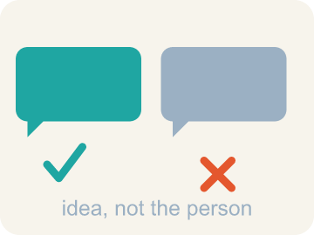 | critique criticar constructivamente  To examine an idea and say what is convincing or not — about the idea, never about the person.  Example: “That step assumes the boxes are full — how do we know?”
 | community agreement acuerdo comunitario  A rule the whole class agrees to so that everyone can learn together.  Example: “We take turns sharing, and we critique ideas, not people.”

Guided Notes
Fill in each blank as we go. Use the Word Bank to help you.
WORD BANK
make sense of a problem • representation • strategy • critique • community agreement

1. To work out what a problem asks — what you know and don't — is to ________________ ________________ ________________ ________________ ________________.
2. A drawing, table, or equation that shows the math in a situation is a ________________.
3. The plan you choose before you start computing is your ________________.
4. To examine an idea and say what is or is not convincing is to ________________ it.
5. A rule the whole class agrees to so everyone can learn is a ________________ ________________.

Write About the Math
What ideas do you recommend that the whole class agrees to so that math class is a community of learners?
¿Qué ideas recomiendas que toda la clase acepte para que la clase de matemáticas sea una comunidad de aprendices?
Say your answer to a partner first. Then write it, using at least two of these words:
☐ representation · representación
☐ strategy · estrategia
☐ critique · criticar constructivamente
☐ community agreement · acuerdo comunitario
Model: The rack with 8 bikes has 8 × 2 = 16 wheels, and the second rack has 6 times as many wheels as that. — A strong answer names a specific first move (like finding 8×2=16 before tackling '6 times as many') rather than jumping to the final answer. A weak answer just states a number with no process described.

Start Most language support
Complete the frames. Use the word bank.
Completa las oraciones. Usa el banco de palabras.
Propose a class agreement for working ___, and another for working alone, based on showing ___ for classmates. State each idea as a clear class ___ that helps everyone learn.
My answer is ___ because ___.
Mi respuesta es ___ porque ___.

Build Some language support
Write two connected sentences. Use because, so, or but.
Escribe dos oraciones conectadas. Usa porque, entonces o pero.
My claim is ___.
Mi afirmación es ___.
My evidence is ___, so ___.
Mi evidencia es ___, entonces ___.

Explain Light language support
Write a claim, give math evidence, and explain your reasoning.
Escribe una afirmación, da evidencia matemática y explica tu razonamiento.

Check Your Explanation three quick checks
☐ I answered the question.
☐ I used math evidence: numbers, an equation, or a model.
☐ I used at least two math words.

Worked Example

Watch & Read I Do — follow along with your teacher
Unit 1 · Lesson 6
What is math? This lesson's answer: math is about DOING — solving problems, getting stuck, trying again, and doing it together. Think about the last time you worked with someone to solve a math problem. What did you actually do?

Solved Example I Do — watch each step
Problem: A bicycle rack holds 8 bikes, and each bike has 2 wheels. How many wheels are on the rack?
A) 4
B) 10
C) 16
D) 82
Step 1: 8 bikes with 2 wheels each is 8 × 2 = 16 wheels.
Answer: C. 16

Independent Practice

On Your Own You Do — show your work
Solve each problem. Show your thinking in the work box.

Level 2 Enrichment stretch your thinking
1. A group solves a hard problem, but one student did all the talking while three stayed silent. By this lesson's standards, how did the GROUP do?
A) Perfectly — the answer was right, and that is all that matters
B) Not well — the talker should have stayed silent too
C) Perfectly — silent members were being respectful
D) Not well — a community shares thinking and takes turns, so three voices went unheard

2. Write THREE community agreements you would propose for our class — at least one for working together and one for working alone — and for each, say what it protects.
3. Solve this with your full process, narrating each step: a rack has 16 wheels, and another rack has 6 times as many wheels. If a third rack held HALF as many wheels as the big rack, how many bikes would fit on it?
4. A classmate says: 'Math class would be better with no group work — thinking is private.' Using this lesson, write a respectful critique of that IDEA.

Exit Ticket
Answer on your own. This shows what you learned today.
★ Which statement best captures what this lesson means by 'Math is Ours'?
A) Math belongs to whoever finishes first
B) Working together means one person solves while the others watch
C) Getting stuck means math is not for you
D) We are a community of math thinkers and doers — we work together and on our own, showing respect for our classmates, our community, ourselves, and our math ideas

