Name |  | Date |  | Period
Lesson 2-1 · Session 2
Guided Practice
Dot Plots and Shape
VOCABULARY read and say each word before you begin
dot plot | A number line with one dot for each data value. | One dot = one answer
data distribution  Spanish: distribución de datos | How the data sits and how spread out it is. | Most dots near the middle
most common value | The value with the tallest stack of dots. | Tallest stack sits above 2
symmetric  Spanish: simétrico | Nearly the same on the left and right sides. | Dots balance around the peak
least and greatest | The smallest and largest values in the set. | From 0 to 4
EXPLORE TOGETHER Class Launch · 8–10 min
1. Water Bottle Count  Mr. Lang asked nine students how many water bottles they filled at school on Friday: 2, 4, 1, 3, 2, 5, 2, 3, 2.  a. Organize. Order the values from least to greatest: __________  b. Plot. Stack one dot per student on the dot plot below.  c. Read. Least: ______ Greatest: ______ Most common value: ______ | d. Shape. Is the plot nearly symmetric? ______ Explain: __________  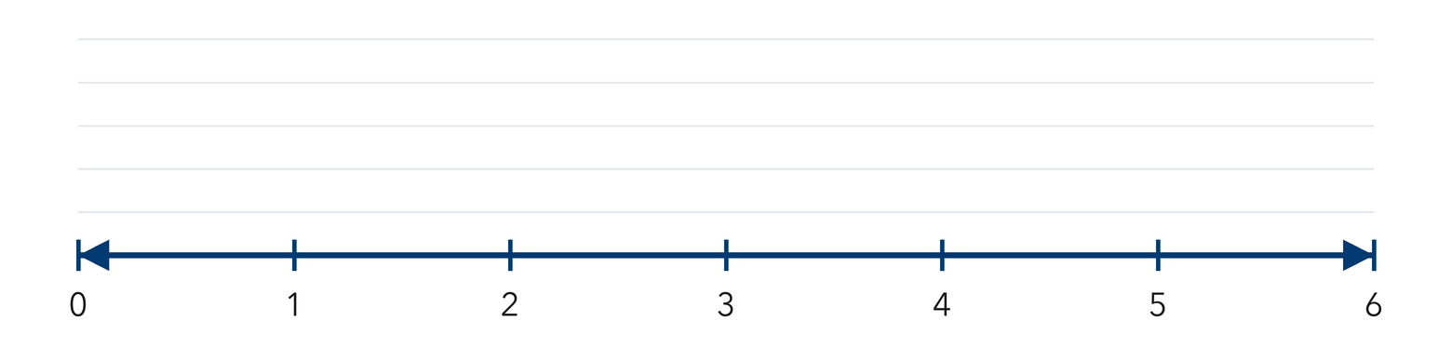​
  TURN AND TALK
  How does a dot plot show at a glance which answer came up most often?
PRACTICE WITH A PARTNER You Do Together · 10–12 min
2. Free Throws Made. Seven players made these free throws during practice: 6, 9, 7, 6, 8, 6, 10.  a. Order the data, then draw a dot plot from 6 to 10 __________  b. Most common __________ | c. Dot plot. Stack one dot per value above its number on the scale below.​  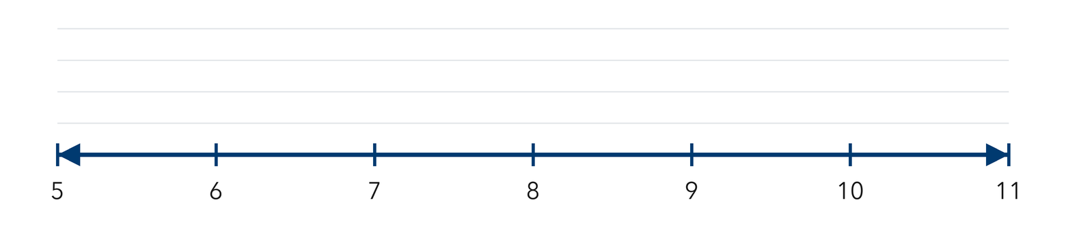
  PARTNER TALK
  What does one single dot on your plot stand for?

3. Siblings Survey. Eight students told how many siblings they have: 1, 0, 2, 3, 1, 2, 1, 4.  a. Draw the dot plot, then name the most common number of siblings __________  b. Nearly symmetric? __________ | c. Dot plot. Stack one dot per value above its number on the scale below.​  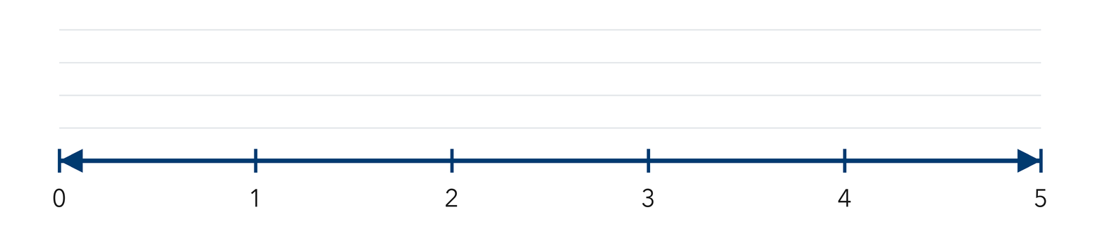
  PARTNER TALK
  How would the shape of your plot change if one more student answered 4?

4. Stickers Earned. Eight students earned these numbers of stickers: 3, 5, 4, 3, 6, 3, 4, 7.
a. Draw the dot plot from 3 to 7, then name the most common value __________
b. Greatest value __________
PARTNER TALK
Two students share the same stack. What does that stack tell you about them?

PRACTICE ON YOUR OWN You Do · 8 problems · 18–20 min
5. Piano Practice. Six students practiced piano for these numbers of minutes: 20, 30, 20, 40, 30, 20.  Draw a dot plot for the data, then write the most common value.  Hint Space the number line by tens so every value has its own mark before you stack dots.  Answer most common number of minutes | Dot plot. Stack one dot per value above its number on the scale below.​  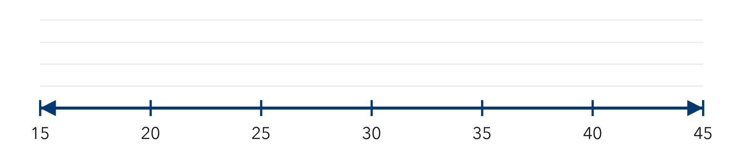
  Show your work.

6. Shape Claim. A dot plot shows these quiz scores: 7, 8, 8, 9, 8, 7, 9. Jonas says the shape is nearly symmetric.  Justify or correct Jonas’s claim using the dots.  Hint Count the dots to the left of the tallest stack, then count the dots to its right.  Answer Is Jonas right? Explain | 7. One More Reader. A dot plot shows pages read: 12, 15, 12, 18, 12, 15. Then one more student reports reading 18 pages.  Find the new most common value and explain whether the greatest value changes.  Hint Add the new dot to its own stack first, then look again at which stack is tallest.  Answer most common value; greatest value

8. Soccer Goals. Seven players scored these numbers of goals this season: 2, 5, 2, 3, 2, 4, 5.  Draw a dot plot for the data, then write the most common value  Hint Label every whole number from 2 to 5 first, then stack one dot per player.  Answer most common number of goals | 9. Bracelet Beads. A dot plot shows these bead counts: 9, 10, 10, 11, 11, 11, 12.  Name the most common value, then describe the shape of the plot  Hint Count the dots to the left of the tallest stack, then count the dots to its right.  Answer most common value; shape

10. Library Books. Ten students finished these numbers of books: 1, 3, 2, 3, 4, 3, 2, 5, 3, 2. Make a dot plot, then name the most common value.  Hint Count how many times each number appears before you draw.  Answer the most common value | Dot plot. Stack one dot per value above its number on the scale below.​
  Show your work.

11. Read the Stacks. On a dot plot, the value 6 has a stack of 5 dots and the value 7 has a stack of 2 dots.  a. How many students chose 6? __________  b. How many students are in the two stacks together? __________  Hint The number of dots is the number of students.  Answer a and b | 12. Describe the Shape. A dot plot of daily texts has dots spread evenly from 4 to 12 with a tall stack at 8. Describe the shape and name the most common value.  Hint A set with a middle peak and even sides is symmetric.  Answer shape and most common value
ANALYZE THE ERROR 5 min
13. Read the work below. Explain the mistake, then show the correct reasoning.
MARCUS’S WORK

For the data 3, 3, 6, 9, Marcus drew one dot above 3, one dot above 6, and one dot above 9.
a. Explain the mistake. Marcus has four data values but only three dots. What did he leave out? | b. Show correct work  Correct answer
  Show the correct work.
STRETCH YOUR THINKING multi-step reasoning · 8 min
14. Two Dot Plots. Class A’s dot plot of pets per student has a tall stack at 1 and a few dots at 4 and 5. Class B’s has dots spread evenly from 0 to 5.
a. Which class has the more common single answer? Explain.
b. Which class shows more variability? Explain.
c. Describe one thing both dot plots tell you that a single number could not.
Answer both comparisons and your explanation
TEST PRACTICE multiple choice · fill one box · 6 min
15. On a dot plot, what does the height of a stack tell you? | 16. A dot plot shows stacks of 2, 5, 3, and 1 dots. How many data values are plotted?
  □ A. the largest value | □ B. how many times | □ C. the average | □ D. the range
  □ A. 4 | □ B. 5 | □ C. 11 | □ D. 24

17. A dot plot’s tallest stack sits over 9. The value 9 is the — | 18. Data values are 2, 2, 3, 5, 5, 5. Which stack is tallest on the dot plot?
  □ A. total | □ B. range | □ C. least value | □ D. most common value
  □ A. over 5 | □ B. over 3 | □ C. over 2 | □ D. they are equal
SPIRAL REVIEW earlier skills · keep them sharp · 6 min
19. From Lesson 2-1 Session 1. Is “How many minutes did each student practice?” a statistical question?  Answer | 20. Grade 5. Find 3.6 + 1.45.  Answer

21. Grade 5. Find 15 × 12.  Answer | 22. Grade 5. Write 2/5 as a decimal.  Answer
CHECK YOUR UNDERSTANDING 5 min
23. Neighborhood Pets. Seven neighbors reported their number of pets: 2, 1, 2, 0, 3, 2, 4.  a. Draw the dot plot, then write the most common value __________  b. Least __________  Hint Build the line from the smallest value to the largest, then stack one dot per neighbor.  Answer | c. Dot plot. Stack one dot per value above its number on the scale below.​
  Show your work.

□ 4 — Can teach it | □ 3 — Got it | □ 2 — Need hint | □ 1 — Need help
Circle your confidence. Star one problem that shows your learning.

