Name |  | Date |  | Period

Lesson 2-2 · Session 1
Homework
Building a Histogram
Maryland Standard 6.SP.B.4 · Learning target — I can group data into equal intervals and build a histogram from a frequency table.
Show a model, calculation, or explanation for each exercise. Label units and answer every part.
Exercises 1–12 earn 1 point for a correct response and 1 for supporting work. Spiral Review and Test Practice earn 1 point each.
REMEMBER review this before you start
• A histogram groups numerical data into equal-width intervals and shows a bar for each interval — no gaps between bars.
• Unlike a dot plot, a histogram cannot show each individual data value.
• Watch out — intervals must be equal in width and must not overlap, or the bars will mislead.
• Check it — the frequencies must add up to the number of data values you started with.
WORKED EXAMPLE the same steps you practiced in class
Grouping Data into a Frequency Table Seven plants grew these heights in cm: 61, 74, 88, 76, 63, 71, 79. Use ten-unit intervals.
Step 1 Choose equal intervals that cover the data with no gaps: 60-69, 70-79, 80-89.
Step 2 Tally each value into exactly one interval. 61 and 63 both land in 60-69.
Step 3 Count each interval. 60-69 holds two plants, 70-79 holds four, 80-89 holds one.
Step 4 Draw touching bars at those heights above the three interval labels.
Answer The frequency table reads 60-69: 2, 70-79: 4, 80-89: 1, and the tallest bar is 70-79.
EXERCISES 12 exercises · 24 points
1. Ten quiz scores are: 62, 65, 71, 74, 78, 81, 84, 88, 91, 96. Complete the frequency table using intervals of 10.
Interval: 60-69 ______ 70-79 ______ 80-89 ______ 90-99 ______

Show your work.
Answer
2. Use your frequency table to draw a histogram with touching bars. Label the axes, scale, and intervals.

Histogram. Draw one touching bar per interval.​
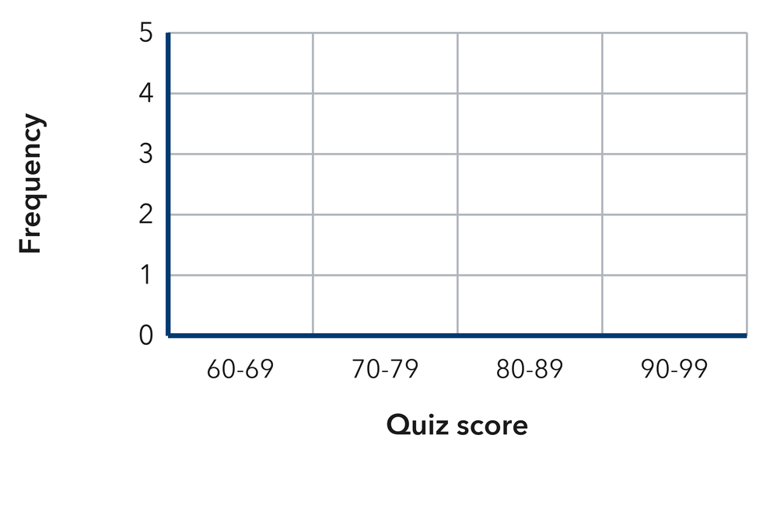
Show your work.
Answer
3. Which interval has the greatest frequency (the tallest bar)? ______

Show your work.
Answer
4. Use the data 14, 23, 8, 31, 27, 19, 35, 11 and intervals of 10.
a. 0-9 ______
b. 10-19 ______
c. 20-29 ______
d. 30-39 ______
e. Total values ______

Answer
5. Cereal Boxes. Nine boxes weigh these numbers of ounces: 12, 18, 25, 14, 21, 29, 16, 22, 11. Find the frequency for 10-14, 15-19, 20-24, and 25-29.

Show your work.

Answer
6. Skate Park Ages. Ten skaters are these ages: 9, 11, 14, 10, 13, 15, 12, 11, 16, 10. Build a frequency table for 9-11, 12-14, 15-17, then draw the histogram.

Histogram. Draw one touching bar per interval. Use the intervals 9-10, 11-12, 13-14 and 15-16.​
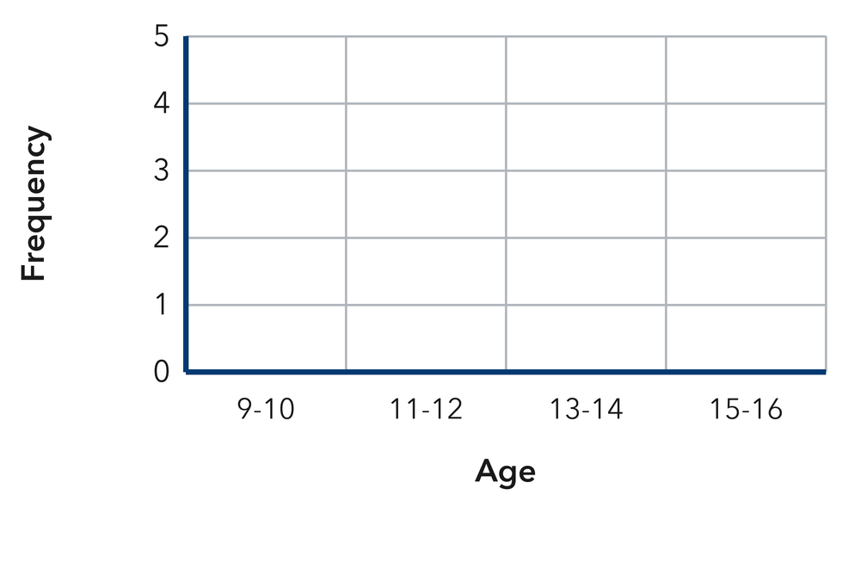
Show your work.

Answer
7. Missing Bar. A histogram of 20 phone calls has a bar of height 4 over 0-4 minutes, 9 over 5-9, and 3 over 15-19, plus one more bar over 10-14. Find the missing height.

Show your work.

Answer
8. Endpoint Trouble. Elena drew a histogram with the intervals 0-10, 10-20, 20-30. Explain the problem with her intervals and write a corrected set.

Show your work.

Answer
9. Nine scores are 44, 57, 61, 52, 48, 66, 59, 63, and 55. Give the frequency for 40–49, 50–59, and 60–69.

Show your work.
Answer three frequencies
10. A frequency table shows 20–29: 6, 30–39: 9, 40–49: 5. How many values are in the table?

Show your work.
Answer values
11. Pick Intervals. Daily temperatures run from 34° to 79°. Name the equal intervals of width 10 you would use.

Show your work.
Answer your intervals
12. Find the Mistake. Nia used the intervals 10–20, 20–30, and 30–40. Explain the problem and give a fix.

Show your work.
Answer the problem and the fix
SPIRAL REVIEW earlier skills · 1 point each
13. From Lesson 2-1 Session 2. Which value is most common in 4, 6, 6, 6, 9?
Answer
14. Grade 5. Find 5.4 + 3.8.
Answer
15. Grade 5. Write 1/4 as a decimal.
Answer
TEST PRACTICE multiple choice · fill one box · 1 point each
16. A histogram bar over 50–59 has height 8. This means —
□ A. there are 8 intervals | □ B. the mean is 8 | □ C. 8 values are 50–59 | □ D. the range is 8
17. Frequencies of 5, 3, 7, and 4 come from how many values?
□ A. 4 | □ B. 7 | □ C. 20 | □ D. 19
18. Histogram intervals must be —
□ A. equal in width | □ B. different widths | □ C. in a circle | □ D. listed backward
CHECK YOURSELF Score: ______ / 30
□ Solved on my own | □ Needed a hint | □ Need help on Question # ______
Check one response against the data. State which measure or feature supports your answer.

