Name |  | Date |  | Period
Lesson 2-2 · Session 2 · Version 2
Guided Practice · Version 2
Describing Histogram Shape
VOCABULARY read and say each word before you begin
shape of the data | The pattern the bars make across the intervals. | Tall middle, short sides
peak | The tallest bar in the display. | The middle bar is the peak
symmetric  Spanish: simétrico | The two sides of the display look about the same. | Matching bars on each side
frequency  Spanish: frecuencia | How many data values fall in one interval. | Bar height shows the count
distribution  Spanish: distribución | How the data spreads across the intervals. | Most values near the peak
EXPLORE TOGETHER Class Launch · 8–10 min
1. Tomato Plant Heights  Nine tomato plants in a school garden measured these heights in cm: 11, 23, 16, 27, 19, 22, 13, 21, 20.  a. Table. Counts for 10-14, 15-19, 20-24, 25-29: ______ ______ ______ ______  b. Graph. Draw four touching bars at those heights in the frame below. Label each interval under its bar.  c. Peak. Which interval has the tallest bar? ______ How many plants does it hold? ______ | d. Shape. Is it close to symmetric? ______ Compare the left and right sides: __________  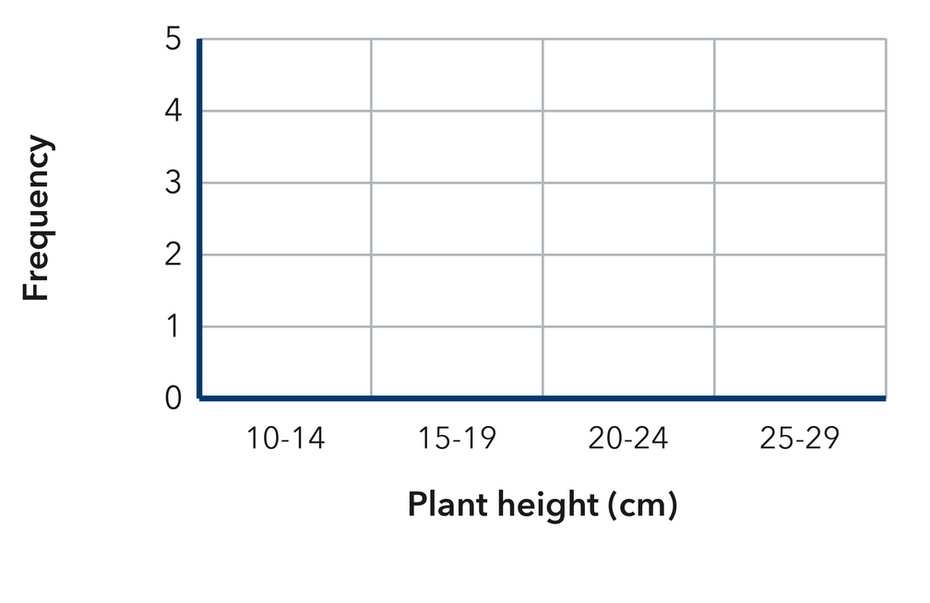​
  TURN AND TALK
  What does the peak of a histogram tell you about a typical plant in this group?
PRACTICE WITH A PARTNER You Do Together · 10–12 min
2. Movie Lengths. Eight movies run these numbers of minutes: 108, 142, 155, 121, 134, 117, 149, 166.  a. Frequencies for 20-39, 40-59, 60-79, 80-99 __________  b. Tell whether the shape is symmetric or skewed, and why __________ | 3. Laps Walked. Seven students walked these numbers of laps: 3, 11, 7, 15, 9, 13, 5.  a. Frequencies for 0-4, 5-9, 10-14, 15-19 __________  b. Which interval has the most students? __________
  PARTNER TALK
  Why is a histogram easier to read than a dot plot when the values are spread far apart?
  PARTNER TALK
  How does the shape of your graph shape your idea of what a typical student walked?

4. Cabbage Weights. A histogram shows bars of height 2 over 1-2 lb, 6 over 3-4 lb, 5 over 5-6 lb, and 1 over 7-8 lb.  a. Which interval is the peak, and how many cabbages are in it? __________  b. Is the shape symmetric or skewed? Explain in one sentence __________ | c. Read the histogram. This is the cabbage-weight histogram the problem describes.​  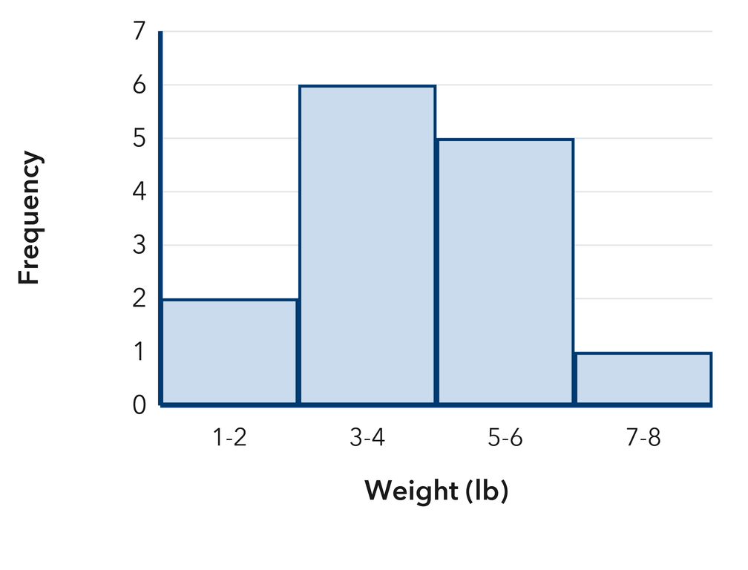
  PARTNER TALK
  How does the peak help you name a typical cabbage without listing every weight?
PRACTICE ON YOUR OWN You Do · 8 problems · 18–20 min
5. Museum Visitors. A histogram of daily visitors has bars of height 3 over 20-29, 8 over 30-39, 3 over 40-49, and 1 over 50-59.  Describe the shape, then tell which interval best represents a typical day.  Hint Find the tallest bar first, then compare the bars on its left and right sides.  Answer shape; interval of a typical day | Read the histogram. This is the visitor histogram the problem describes.​  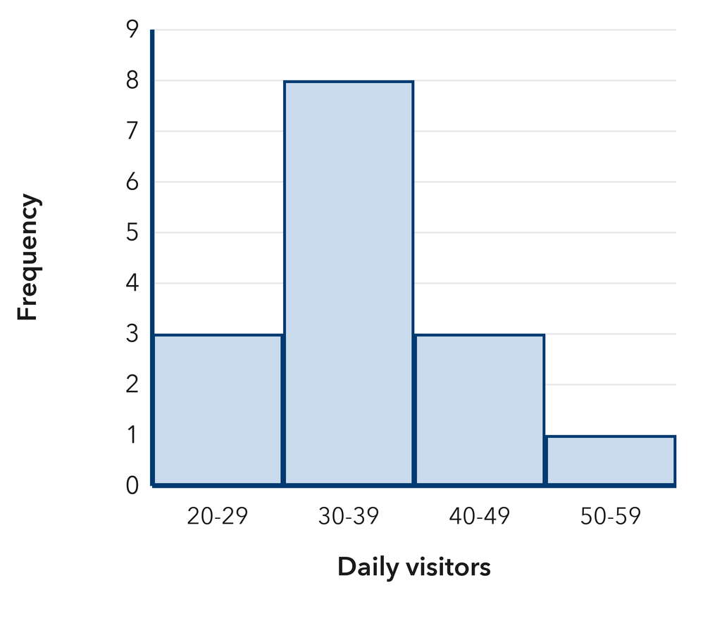
  Show your work.

6. Display Choice. Tariq recorded 120 temperatures, each to the nearest tenth of a degree, and plans to draw a dot plot.
Tell whether a dot plot or a histogram suits this data better, and explain why.
Hint Think about how many values would need their own spot on a dot plot if nearly every time is different.
Answer better display, with a reason

7. Symmetry Claim. A histogram has bars of height 1 over 0-9, 2 over 10-19, 9 over 20-29, 2 over 30-39, and 1 over 40-49. Desmond calls the shape symmetric.  Justify or correct Desmond’s claim.  Hint Compare each bar to the left of the peak with the bar the same distance to its right.  Answer Is Desmond right? Explain | Read the histogram. This is the histogram Desmond is describing.​  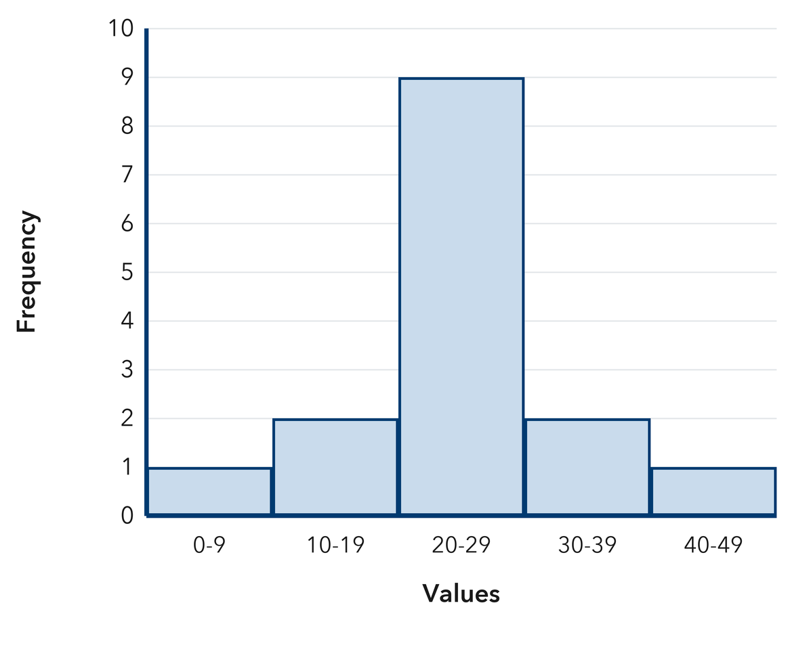
  Show your work.

8. Snow Totals. A histogram of snowfall has bars of height 1 over 0-2 in., 3 over 3-5 in., 7 over 6-8 in., 3 over 9-11 in., and 1 over 12-14 in.
Describe the shape, then name the interval that holds a typical commute
Hint Compare each bar to the left of the peak with the bar the same distance to its right.
Answer shape; interval of a typical commute

9. Two Peaks. A histogram of ticket prices has bars of height 6 over $0-$9, 2 over $10-$19, 1 over $20-$29, 6 over $30-$39, and 2 over $40-$49.  Tell how many peaks this shape has and explain why it is not symmetric  Hint Check whether more than one bar stands out as tall before you name a single peak.  Answer number of peaks; why it is not symmetric | Read the histogram. This is the ticket-price histogram the problem describes.​  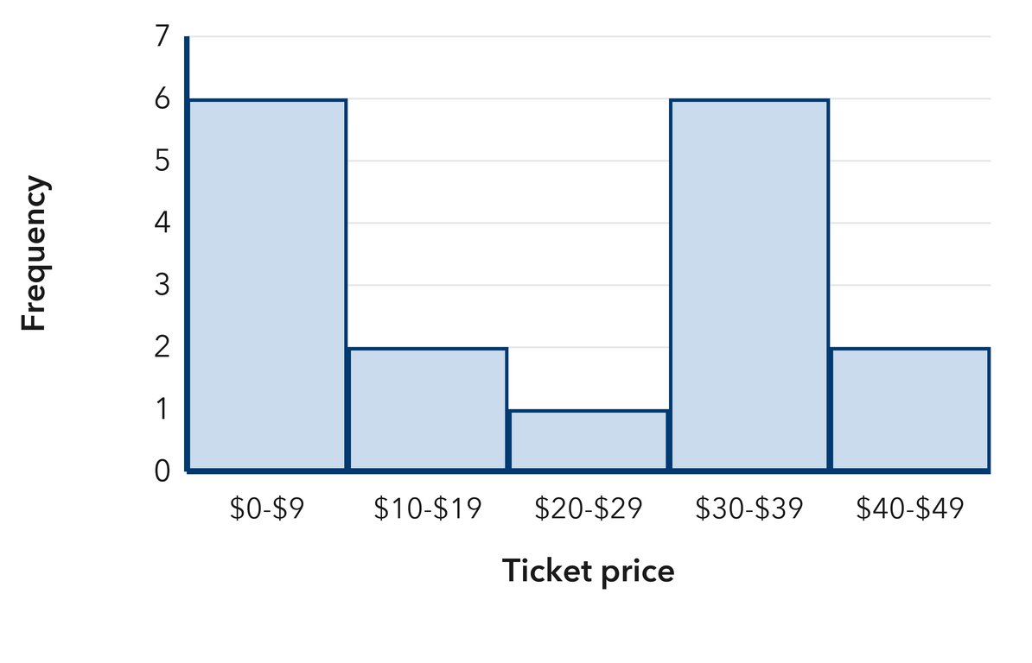
  Show your work.

10. Read the Bars. A histogram has bars of height 2 over 60–69, 7 over 70–79, and 3 over 80–89. Name the peak interval and the total number of values.  Hint Find the tallest bar for the peak, then add all the bar heights for the total.  Answer peak interval and total | 11. Symmetric or Skewed? A histogram has bars of height 1, 4, 8, 4, and 1 across five equal intervals. Describe its shape.  Hint Check whether the bars on each side of the middle match.  Answer the shape

12. Long Tail. A histogram of donation amounts has bars of height 9, 5, 2, 1, and 1 from least to greatest. Describe the shape and tell where most donations fall.
Hint When the bars trail off toward the greater values, the shape is skewed right.
Answer shape and where most values fall
ANALYZE THE ERROR 5 min
13. Read the work below. Explain the mistake, then show the correct reasoning.
DESHAWN’S WORK

A histogram has bars 2, 9, 2. Colette wrote: ‘The tallest bar means one single value showed up 9 times.’
a. Explain the mistake. The tallest bar stands for a whole interval, not a single value. What should Deshawn say instead? | b. Show correct work  Correct answer
  Show the correct work.
STRETCH YOUR THINKING multi-step reasoning · 8 min
14. Two Histograms. Histogram P has bars 2, 6, 9, 6, 2. Histogram Q has bars 10, 6, 4, 3, 2.  a. Describe the shape of each histogram.  b. Which histogram has its tallest bar in the lowest interval?  c. Each histogram shows 25 values. Explain how two data sets with the same number of values can have such different shapes.  Answer both shapes, the answer to b, and your explanation | d. Read histogram P.​  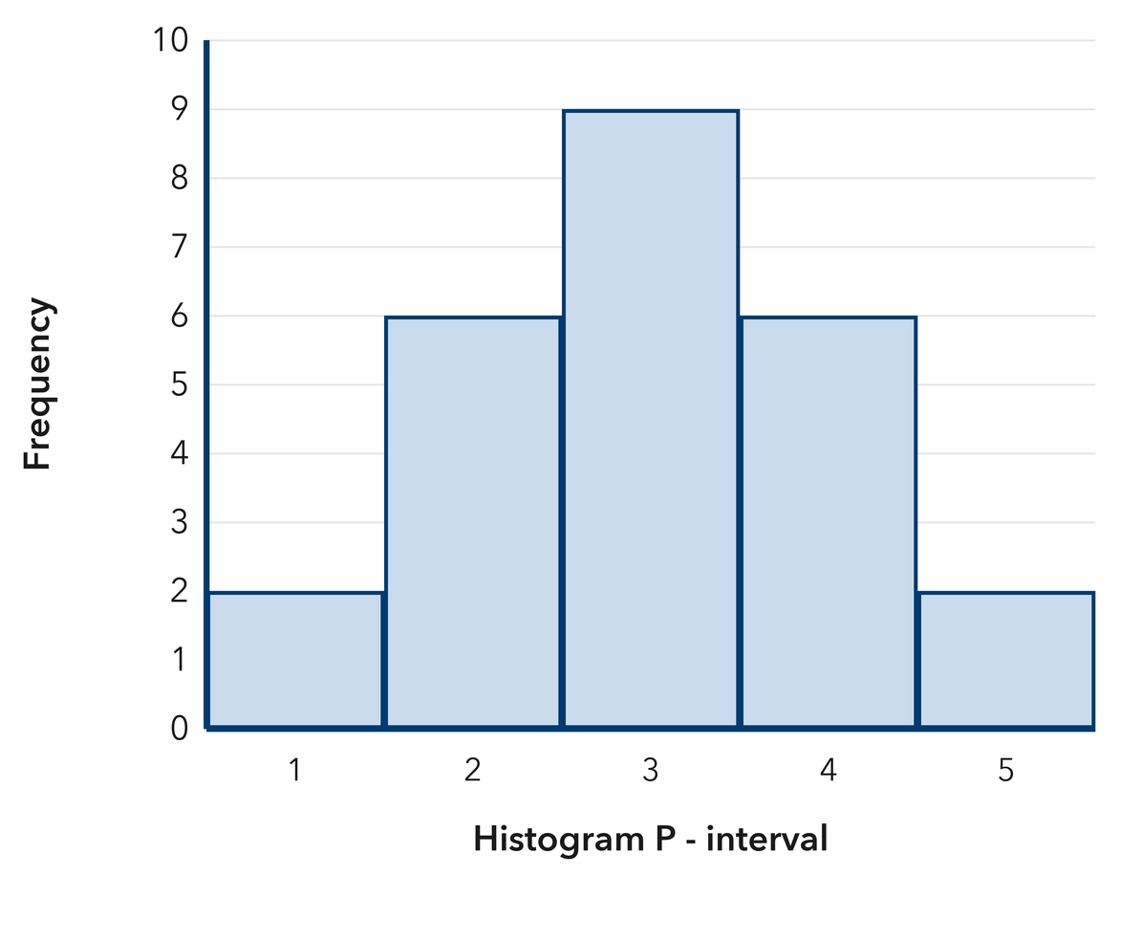  Read histogram Q.​  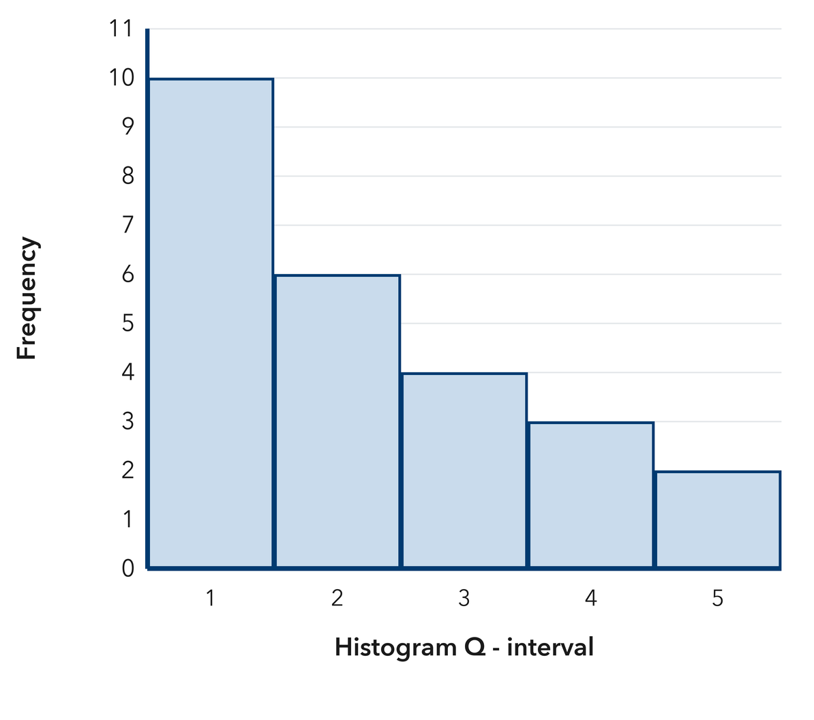
  Show your work.
TEST PRACTICE multiple choice · fill one box · 6 min
15. A histogram with matching left and right sides is — | 16. Bars of height 8, 4, 2, 1 from least to greatest describe a shape that is —
  □ A. symmetric | □ B. skewed left | □ C. skewed right | □ D. flat
  □ A. symmetric | □ B. skewed right | □ C. skewed left | □ D. a circle

17. The peak of a histogram is the interval with the — | 18. Bars of height 2, 3, 5, 9 from least to greatest describe a shape that is —
  □ A. least value | □ B. widest bar | □ C. tallest bar | □ D. most intervals
  □ A. flat | □ B. skewed right | □ C. symmetric | □ D. skewed left
SPIRAL REVIEW earlier skills · keep them sharp · 6 min
19. From Lesson 2-2 Session 1. Frequencies are 4, 6, and 5. How many values are in the table?  Answer | 20. From Lesson 2-1 Session 2. A dot plot stack of 7 dots over 5 means what?  Answer

21. Grade 5. Find 144 ÷ 12.  Answer | 22. Grade 5. Find 2.5 × 8.  Answer
CHECK YOUR UNDERSTANDING 5 min
23. Backpack Weights. Nine backpacks weigh these numbers of pounds: 12, 18, 15, 21, 14, 16, 19, 16, 17.  a. Frequencies for 12-14, 15-17, 18-20, 21-23 __________  b. Identify the peak interval and describe the shape __________  Hint Order the weights from least to greatest, then tally them into the four intervals before you describe the shape.  Answer | c. Histogram. Draw a bar for each interval, with no gaps between bars, at the height you counted. Use the intervals 10-14, 15-19 and 20-24.​  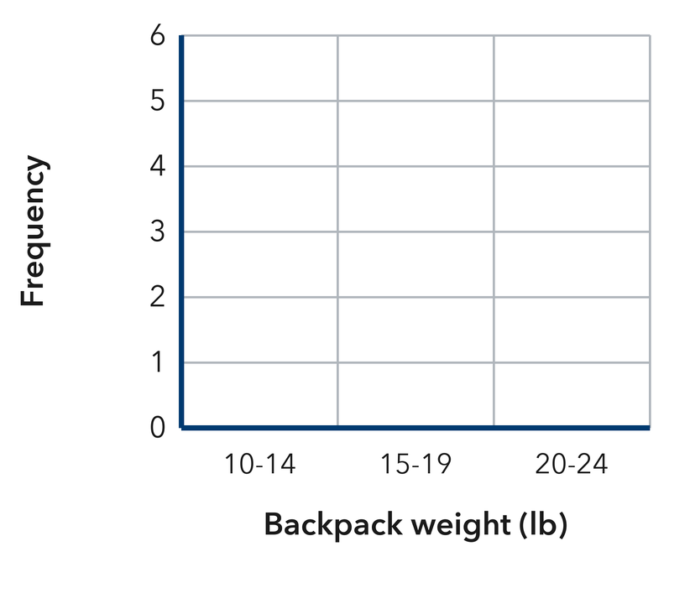
  Show your work.

□ 4 — Can teach it | □ 3 — Got it | □ 2 — Need hint | □ 1 — Need help
Circle your confidence. Star one problem that shows your learning.

