Name Date Period
Lesson 2-3 · Homework Packet · Sheet 1 of 2
Finding the Median
Maryland Standard 6.SP.B.5c · Learning target — I can find the median of a data set by ordering the values and taking the middle one.

REMEMBER  • The median is the middle value of a data set.  • First order the values from least to greatest.  • With an odd number of values, one value sits in the middle. | WORKED EXAMPLE  Find the median of 14, 9, 21, 6, 17.  Step 1 Order: 6, 9, 14, 17, 21  Step 2 Cross off one from each end until one is left: 14.  Answer Median = 14
PRACTICE show your work · label units
1. Find the median of each data set.
a. 8, 3, 6 | b. 12, 18, 10, 15, 11
c. 25, 40, 35, 30, 20 | d. 7, 2, 9, 4, 5, 8, 1

2. Sleep. The dot plot shows how many hours some students slept last night.  a. Number of students:  b. Median: hours | 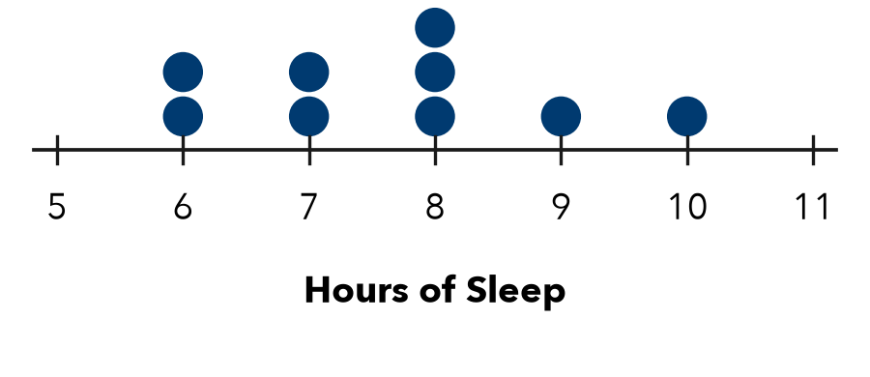

3. Bike Rides. Kiara rode her bike 7 times. She rode 4, 11, 7, 15, 9, 6, and 12 miles. Find the median distance.

Show your work.
Answer miles

4. Missing Score. Four of five scores are 82, 90, 75, 88. The median is 85. Find the fifth.
Answer points

5. Build a Set. Write a set of 5 different whole numbers that has a median of 12.
My set

6. Reason. The data set 4, 6, 9, 11, 30 has a median of 9. If 30 changes to 100, does the median change? Explain.

CHECK YOURSELF | □ I can do this on my own | □ I need a little help | □ I have a question about #
AT HOME Ask 5 people at home how many letters are in their first name. Find the median.
Name Date Period
Lesson 2-3 · Homework Packet · Sheet 2 of 2
Median of an Even Data Set
Maryland Standard 6.SP.B.5c · Learning target — I can find the median of a data set with an even number of values by averaging the two middle values.

REMEMBER  • With an even number of values, there are two middle values.  • The median is halfway between them: add the two, then divide by 2.  • The median does not have to be a data value. | WORKED EXAMPLE  Find the median of 12, 7, 15, 10, 20, 9.  Step 1 Order: 7, 9, 10, 12, 15, 20  Step 2 Two middle values: 10 and 12  Step 3 (10 + 12) ÷ 2 = 22 ÷ 2 = 11  Answer Median = 11
PRACTICE show your work · label units
1. Find the median of each data set.
a. 3, 9, 5, 7 | b. 20, 14, 18, 12
c. 11, 6, 9, 4, 13, 8 | d. 30, 45, 35, 50, 40, 25
e. 16, 9, 21, 12, 30, 14, 25, 10 | f. 5, 11, 8, 5

2. Cousins. The dot plot shows how many cousins 10 students have.  a. Two middle values:  b. Median: | 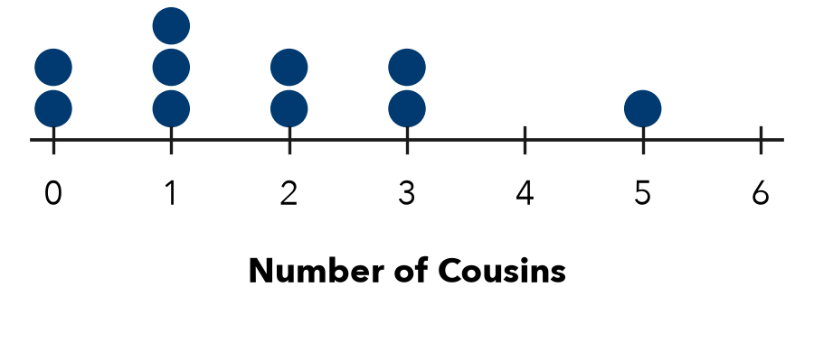

3. Puppies. Six puppies weigh 8, 12, 5, 15, 10, and 7 pounds. Find the median weight.
Answer pounds

4. Work Backward. Four values in order are 6, 10, , 20. The median is 12. Find the missing value.
Missing value

5. Find the Error. Ana says the median of 8, 2, 10, 6 is (2 + 10) ÷ 2 = 6. Explain her error.

TEST PRACTICE choose the best answer
6. What is the median of 15, 9, 12, 20?
A 13.5 | B 12 | C 14 | D 10.5

7. Six values have a median of 30. Which could be the two middle values?
A 28 and 32 | B 30 and 34 | C 25 and 30 | D 29 and 30

CHECK YOURSELF | □ I can do this on my own | □ I need a little help | □ I have a question about #
AT HOME Ask 4 or 6 people at home their shoe size. Find the median.

