Name |  | Date |  | Period
Lesson 2-4 · Session 1 · Version 2
Guided Practice · Version 2
Building a Box Plot
VOCABULARY read and say each word before you begin
box plot | A display built from five key numbers. | Box with two whiskers
quartile  Spanish: cuartil | A value that cuts the ordered data into fourths. | Q1, median, Q3
five-number summary | Minimum, Q1, median, Q3, and maximum. | 6, 8, 14, 19, 22
whisker | A line from the box out to an extreme value. | Left whisker reaches the min
middle half | The values from Q1 to Q3 — what the box covers. | The box holds half the data
EXPLORE TOGETHER Class Launch · 8–10 min
1. Pumpkin Weigh-in  Seven pumpkins weigh these numbers of pounds: 12, 27, 16, 30, 19, 23, 14.  a. Order. List the seven pumpkin weights from least to greatest: __________  b. Median. Median: ______ How many pumpkin weights are on each side of it? ______  c. Quartiles. Quartile 1 (middle of lower half): ______ Quartile 3 (middle of upper half): ______ | d. Draw. Draw the box plot on the scale below. Label each of the five markers.  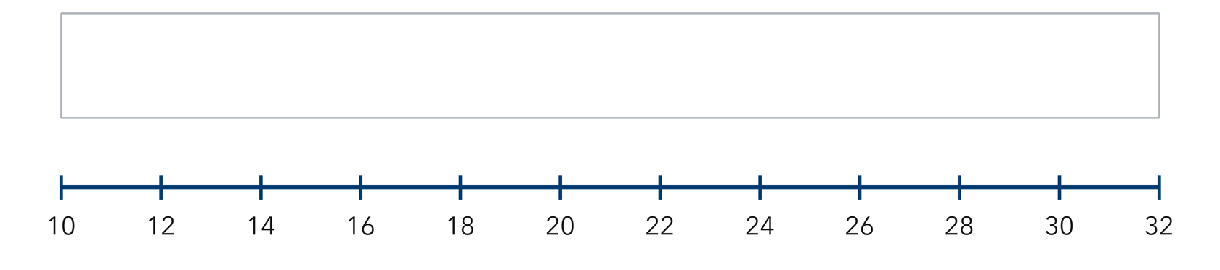​
  TURN AND TALK
  What part of the data does the box of a box plot cover?
PRACTICE WITH A PARTNER You Do Together · 10–12 min
2. Morning Bird Counts. Seven mornings brought these bird counts: 9, 17, 13, 25, 11, 20, 15.  a. Five-number summary __________  b. Draw the box plot. What is the width of the box from quartile 1 to quartile 3? __________ | c. Box plot. Mark each of the five values on the scale, then draw the box and both whiskers in the band above it.​  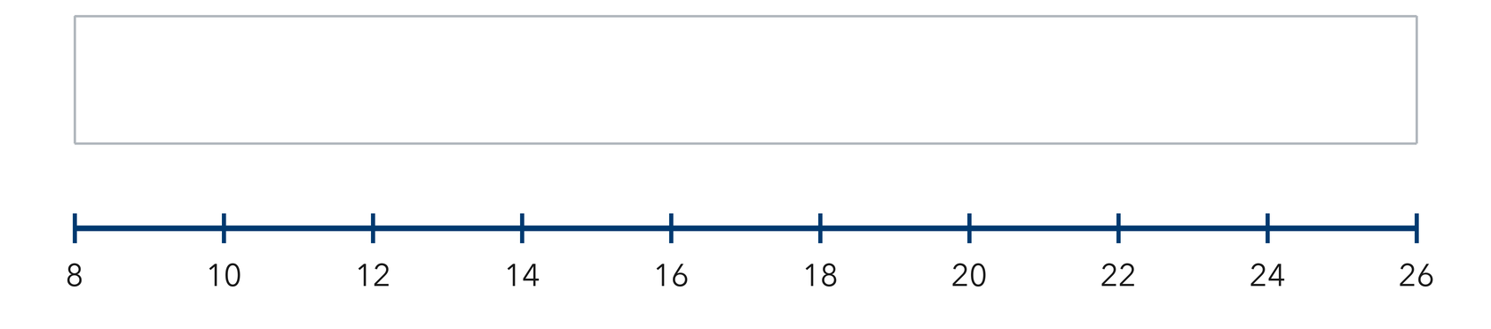
  PARTNER TALK
  What does a long box tell you about the middle half of the counts?

3. Cone Sales. Seven days of ice cream cone sales: 88, 108, 99, 120, 102, 115, 110.  a. Five-number summary __________  b. Which whisker is longer: left or right? __________ | 4. Sandwich Orders. Seven days brought these sandwich orders: 32, 45, 38, 56, 41, 50, 47.  a. Five-number summary __________  b. Width of the box from quartile 1 to quartile 3 __________
  PARTNER TALK
  How does the length of a whisker describe the values at that end of the data?
  PARTNER TALK
  What share of the seven days does the box of your plot cover?
PRACTICE ON YOUR OWN You Do · 8 problems · 18–20 min
5. Rainy Days. Seven months had these numbers of rainy days: 14, 6, 19, 10, 22, 8, 16.  Find the five-number summary, then draw the box plot on a number line.  Hint Find the median first; it divides the ordered list into the two halves that give the quartiles.  Answer five-number summary | 6. Whisker Claim. A box plot shows minimum 20, quartile 1 at 27, median 31, quartile 3 at 35, maximum 46. Kai says half the data sits between 20 and 27.  Justify or correct Lena’s statement.  Hint A box plot divides the data into four sections, and each section holds the same share of values.  Answer Is Kai right? Explain

7. Reading the Box. A box plot of ticket prices shows minimum 16, quartile 1 at 23, median 28, quartile 3 at 34, maximum 50.  Determine how wide the box is and explain what share of the book prices falls inside it.  Hint The box stretches from quartile 1 to quartile 3, so find the difference of those two markers.  Answer width of the box; share of prices | 8. Guitar Practice. Seven practice sessions lasted these numbers of minutes: 25, 40, 18, 47, 33, 29, 52.  Find the five-number summary, then draw the box plot on a number line  Hint Find the median first; it divides the ordered list into the two halves that give the quartiles.  Answer five-number summary

9. Long Whisker. A box plot of backpack weights shows minimum 6 lb, quartile 1 at 10 lb, median 13 lb, quartile 3 at 17 lb, maximum 28 lb. Adaeze says most of the weights sit between 17 lb and 28 lb because that stretch is the longest part of the plot.
Justify or correct Tomás’s statement
Hint Every one of the four sections of a box plot holds the same share of the values, no matter how long it is.
Answer Is Adaeze right? Explain

10. High Temperatures. Seven highs are 58, 71, 64, 83, 66, 77, and 61 degrees. Find the five-number summary.  Hint Put the values in order. The median is the 4th value; split the others into halves.  Answer min, Q1, median, Q3, max | Box plot. Mark each of the five values on the scale, then draw the box and both whiskers in the band above it.​  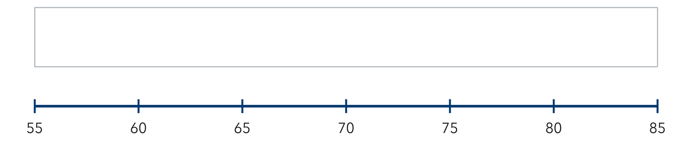
  Show your work.

11. Build the Box. A data set has min 12, Q1 18, median 24, Q3 31, and max 40.  a. Where does the right edge of the box sit? __________  b. Where does the left whisker end? __________  Hint The box stretches from Q1 to Q3; the whiskers extend out to the min and the max.  Answer a and b | c. Box plot. Mark each of the five values on the scale, then draw the box and both whiskers in the band above it.​  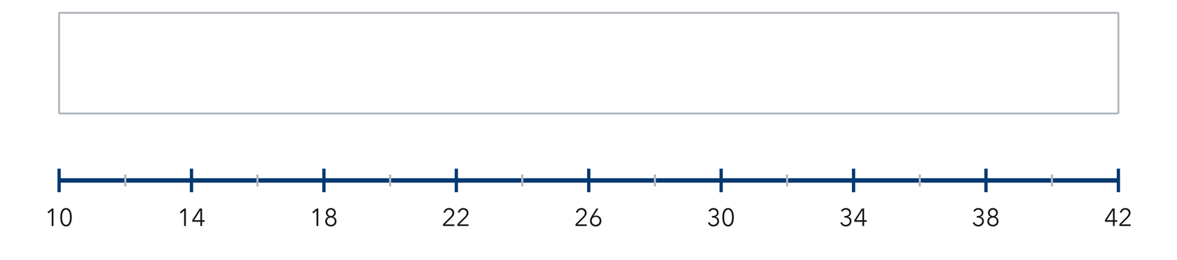

12. Eight Values. Eight scores are 44, 52, 61, 48, 57, 65, 50, and 59. Find the five-number summary.
Hint With eight values, the median is the average of the 4th and 5th values; each half holds four values.
Answer min, Q1, median, Q3, max
ANALYZE THE ERROR 5 min
13. Read the work below. Explain the mistake, then show the correct reasoning.
MARISOL’S WORK

For 5, 9, 12, 16, 20, 24, 30 Yusuf marked quartile 1 at 12 and quartile 3 at 20.
a. Explain the mistake. Marisol used the two values on either side of the median as the quartiles. Where do the quartiles really come from? | b. Show correct work  Correct answer
  Show the correct work.
STRETCH YOUR THINKING multi-step reasoning · 8 min
14. Field Trip Costs. Nine costs in dollars are 18, 25, 12, 30, 22, 27, 15, 33, and 20.
a. Find the five-number summary.
b. Describe where the middle half of the ride times falls.
c. Explain what the length of the box tells a reader about how spread out the ride times are.
Answer the summary and both explanations
TEST PRACTICE multiple choice · fill one box · 6 min
15. The box in a box plot stretches from — | 16. Q1 is the median of the —
  □ A. Q1 to Q3 | □ B. min to max | □ C. Q1 to median | □ D. median to max
  □ A. whole data set | □ B. lower half | □ C. upper half | □ D. two middles

17. For 4, 8, 12, 16, 20, what is the median? | 18. How many numbers are in a five-number summary?
  □ A. 8 | □ B. 16 | □ C. 12 | □ D. 60
  □ A. 3 | □ B. 4 | □ C. 6 | □ D. 5
SPIRAL REVIEW earlier skills · keep them sharp · 6 min
19. From Lesson 2-3 Session 2. Find the median of 6, 10, 14, 18.  Answer | 20. From Lesson 2-3 Session 1. Find the median of 31, 24, 39, 28, 35.  Answer

21. From Lesson 2-2 Session 1. Name equal intervals of width 10 for values from 22 to 58.  Answer | 22. Grade 5. Find 7.5 ÷ 5.  Answer
CHECK YOUR UNDERSTANDING 5 min
23. Cart Loads. Seven carts carried these numbers of boxes: 11, 29, 18, 35, 23, 14, 27.  a. Five-number summary __________  b. Draw the box plot. Which values does the box span? __________  Hint Put the loads in order, find the median, then find the middle of each half for the quartiles.  Answer | c. Box plot. Mark each of the five values on the scale, then draw the box and both whiskers in the band above it.​  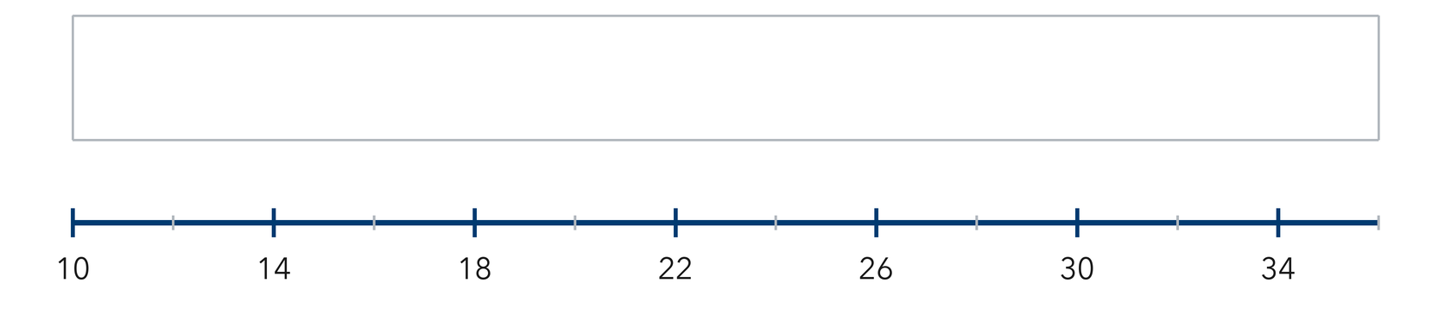
  Show your work.

□ 4 — Can teach it | □ 3 — Got it | □ 2 — Need hint | □ 1 — Need help
Circle your confidence. Star one problem that shows your learning.

