Name |  | Date |  | Period
Lesson 2-4 · Session 2 · Version 2
Guided Practice · Version 2
Comparing Box Plots
VOCABULARY read and say each word before you begin
box plot | A display built from five key numbers. | Box with two whiskers
median line  Spanish: mediana | The line inside the box; the center of the data. | Compare medians first
box width | How far the box reaches from Q1 to Q3. | Narrow box = tight middle
consistent | Values sit close together, with little spread. | A short box is consistent
compare  Spanish: comparar | Look at center and spread side by side. | Same median, different box
EXPLORE TOGETHER Class Launch · 8–10 min
1. Two Bus Routes  Route 1 times (min): 24, 30, 27, 41, 33, 36, 45. Route 2 times (min): 28, 34, 29, 37, 32, 43, 25.  a. Summary. Route 1 five-number summary: ______ , ______ , ______ , ______ , ______  b. Summary. Route 2 five-number summary: ______ , ______ , ______ , ______ , ______  c. Center. Which route has the shorter typical trip (lower median)? ______ By how many minutes? ______  d. Spread. Which route has the wider box? ______ What does that tell a commuter about trip times? ______ | e. Box plots. Draw Route 1 in the top band and Route 2 in the bottom band, on the shared scale.​  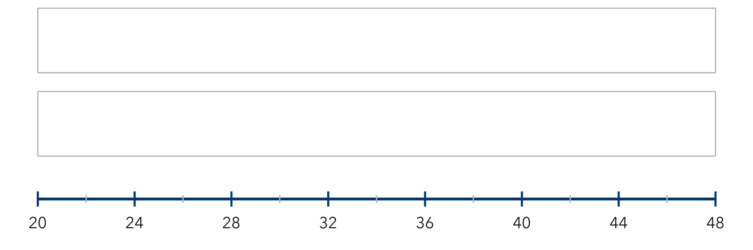
  TURN AND TALK
  Why do two box plots let you compare groups without listing every single value?
PRACTICE WITH A PARTNER You Do Together · 10–12 min
2. Two Gardens. Garden A heights (cm): 60, 68, 64, 72, 76, 65, 70. Garden B heights (cm): 58, 63, 74, 61, 80, 69, 67.
a. Five-number summary — A __________
b. Higher median? __________
PARTNER TALK
Which garden’s plants are more alike in height, and how does the box show it?

3. Two Quizzes. Quiz 1: min 5, Q1 7, median 9, Q3 11, max 14. Quiz 2: min 3, Q1 6, median 10, Q3 13, max 16.  a. Which quiz has the higher median score? __________  b. Which quiz has the wider box? __________ | c. Read the box plots. These are the two quiz plots the problem describes.​  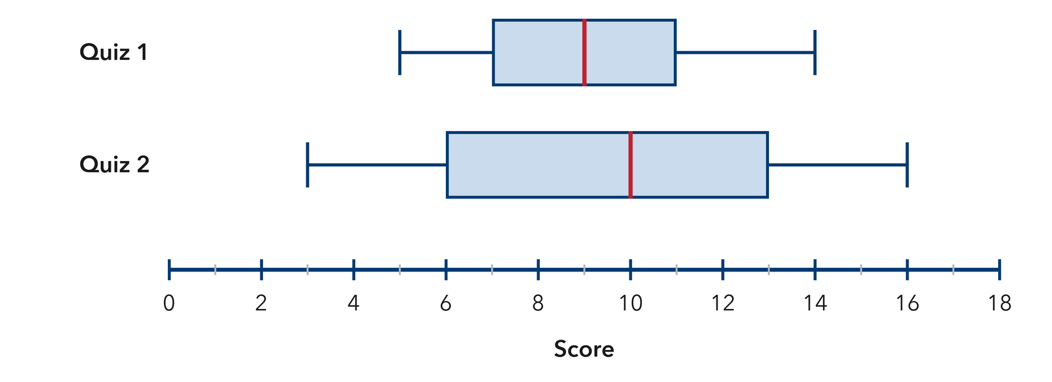
  PARTNER TALK
  Two quizzes can have the same range but different boxes. Why does that matter?

4. Two Art Classes. Class M: min 22, Q1 28, median 33, Q3 37, max 44. Class N: min 25, Q1 30, median 36, Q3 46, max 52.  a. Which class has the higher median? __________  b. Which class has the wider box? __________ | c. Read the box plots. These are the two art-class plots the problem describes.​  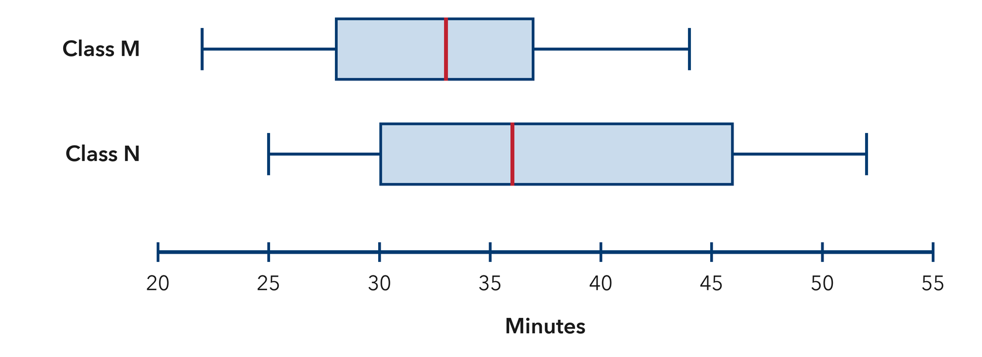
  PARTNER TALK
  Which class’s middle half is easier to predict, and how does the box show it?
PRACTICE ON YOUR OWN You Do · 8 problems · 18–20 min
5. Two Teams. Team Red points: 42, 50, 46, 54, 48, 56, 52. Team Blue points: 41, 45, 49, 43, 55, 37, 58.  Find both five-number summaries, then explain which club was more consistent.  Hint Find Q3 − Q1 for each club; the smaller width means the middle half is packed closer together.  Answer both summaries; the more consistent team | 6. Equal Spread Claim. Box plot M spans 20 to 90 with a box from 45 to 65. Box plot N spans 50 to 70 with a box from 55 to 60. Jamal says M and N are equally spread.  Justify or correct Priya’s claim using both the whiskers and the box.  Hint Compare the ranges (max − min) first, then compare the box widths (Q3 − Q1).  Answer Is Jamal right? Explain

7. Same Median. Two box plots both show a median of 30. Plot C has a box from 27 to 33 and Plot D has a box from 18 to 42.  Explain what the two plots tell you about center and what they tell you about spread.  Hint Equal medians mean equal centers; now compare how wide each box is.  Answer what matches; what differs | 8. Two Snack Stands. Stand A sales: 15, 21, 18, 24, 27, 20, 23. Stand B sales: 10, 26, 16, 30, 22, 13, 28.  Find both five-number summaries, then explain which cart was steadier  Hint Put each list in order separately, then compare Q3 − Q1 for both carts.  Answer both summaries; the steadier stand

9. Matching Boxes. Plot W spans 10 to 60 with a box from 30 to 40. Plot Z spans 28 to 44 with a box from 30 to 40. Omar says the two plots show the same spread because the boxes match.
Justify or correct Keisha’s claim
Hint The boxes match, so check where each set of whiskers ends.
Answer Is Omar right? Explain

10. Two Groups. Group A: min 40, Q1 47, median 53, Q3 59, max 66. Group B: min 38, Q1 50, median 57, Q3 63, max 70. Which group has the greater median, and how many points greater is it?  Hint Find each median line, then subtract the smaller from the larger.  Answer group and difference | Read the box plots. These are the two group plots the problem describes.​  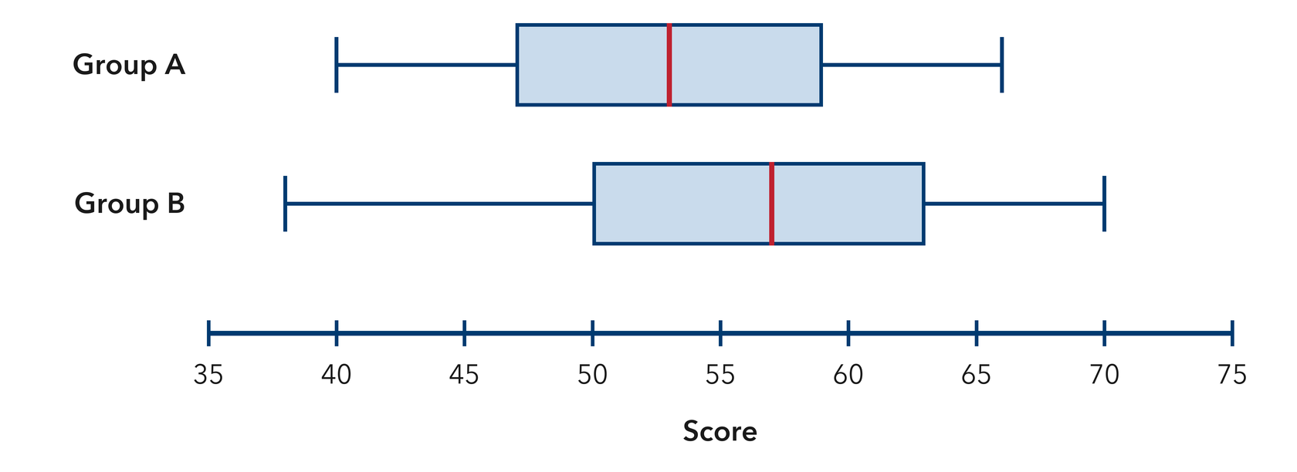
  Show your work.

11. Which Is More Consistent? Box plot P has Q1 22 and Q3 30. Box plot Q has Q1 18 and Q3 36. Which group is more consistent in its middle half? Explain.  Hint Subtract Q1 from Q3 for each plot, then compare.  Answer group and why | 12. Read Both Ways. Team X: min 12, median 20, max 35. Team Y: min 15, median 20, max 24.  a. Which club has the larger range? __________  b. The medians are equal. Explain what still makes the two clubs different.  Hint To find the range, subtract the minimum from the maximum.  Answer a and b
ANALYZE THE ERROR 5 min
13. Read the work below. Explain the mistake, then show the correct reasoning.
DMITRI’S WORK

Comparing two box plots, Bianca wrote: ‘Plot E has a longer right whisker, so Plot E has the greater median.’
a. Explain the mistake. A whisker end is not the median line. What should Dmitri compare instead? | b. Show correct work  Correct answer
  Show the correct work.
STRETCH YOUR THINKING multi-step reasoning · 8 min
14. Two Bus Routes. Route 1: min 18, Q1 24, median 28, Q3 33, max 52 minutes. Route 2: min 22, Q1 26, median 29, Q3 31, max 36 minutes.  a. Which route has the higher median travel time?  b. Which route is more predictable? Use the box widths in your answer.  c. A commuter needs to arrive at work on time every day. Tell which route you would recommend and why.  Answer both comparisons and your advice | d. Read the box plots. These are the two route plots the problem describes.​  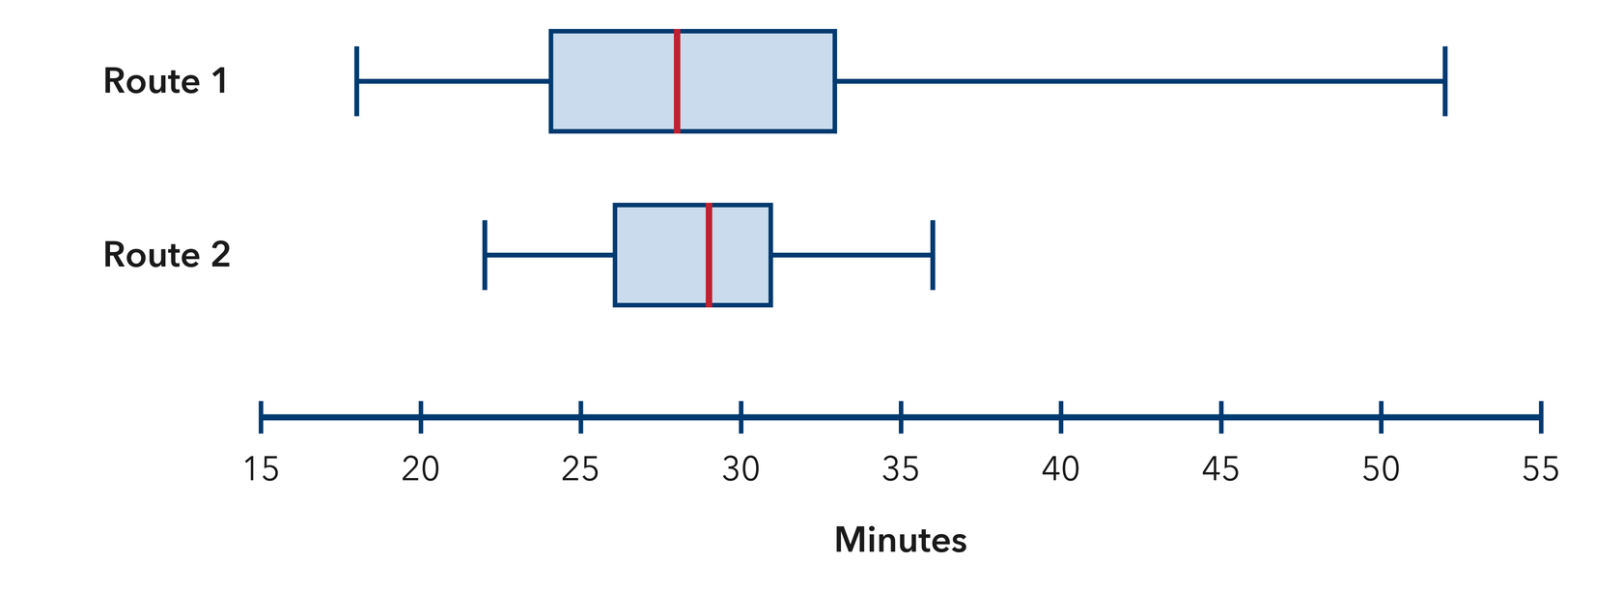
  Show your work.
TEST PRACTICE multiple choice · fill one box · 6 min
15. The line inside a box plot’s box shows the — | 16. A wider box means the middle half of the data is —
  □ A. mean | □ B. range | □ C. median | □ D. maximum
  □ A. always lower | □ B. more consistent | □ C. always higher | □ D. more spread out

17. Group A’s median is 50 and Group B’s is 62. Group B’s center is higher by — | 18. A box plot with min 20 and max 45 has a range of —
  □ A. 12 | □ B. 6 | □ C. 18 | □ D. 112
  □ A. 20 | □ B. 25 | □ C. 45 | □ D. 65
SPIRAL REVIEW earlier skills · keep them sharp · 6 min
19. From Lesson 2-4 Session 1. Find the median of 15, 22, 30, 41, 18.  Answer | 20. From Lesson 2-3 Session 2. Find the median of 8, 14, 20, 26.  Answer

21. From Lesson 2-2 Session 1. Frequencies are 6, 6, and 8. How many values in all?  Answer | 22. Grade 5. Find 15.5 − 6.8.  Answer
CHECK YOUR UNDERSTANDING 5 min
23. Two Hiking Groups. Group J: min 8, Q1 11, median 16, Q3 21, max 28. Group K: min 6, Q1 14, median 16, Q3 20, max 24.  a. Which group has the wider box? __________  b. Write one sentence comparing the centers and spreads of the two groups __________  Hint The medians are the same, so compare Q3 − Q1 for each group to describe the difference.  Answer | c. Read the box plots. These are the two hiking-group plots the problem describes.​  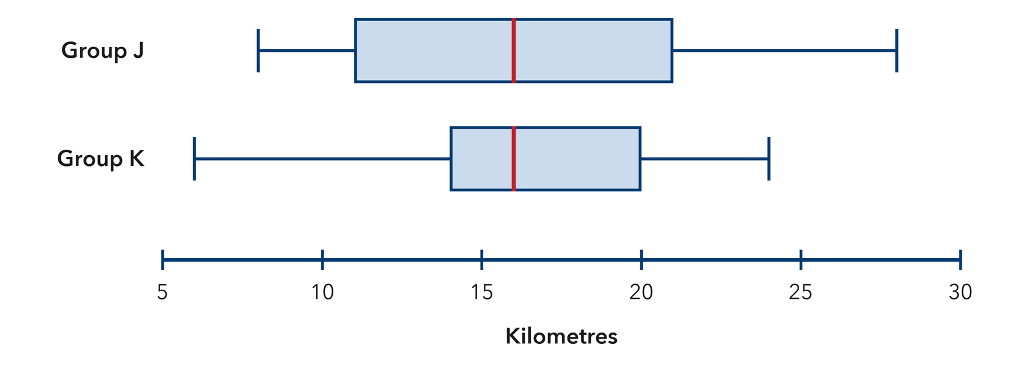
  Show your work.

□ 4 — Can teach it | □ 3 — Got it | □ 2 — Need hint | □ 1 — Need help
Circle your confidence. Star one problem that shows your learning.

