Name |  | Date |  | Period
Lesson 2-4 · Session 2
Guided Practice
Comparing Box Plots
VOCABULARY read and say each word before you begin
box plot | A display built from five key numbers. | Box with two whiskers
median line  Spanish: mediana | The line inside the box; the center of the data. | Compare medians first
box width | How far the box reaches from Q1 to Q3. | Narrow box = tight middle
consistent | Values sit close together, with little spread. | A short box is consistent
compare  Spanish: comparar | Look at center and spread side by side. | Same median, different box
EXPLORE TOGETHER Class Launch · 8–10 min
1. Two Bus Routes  Route 1 times (min): 24, 30, 27, 41, 33, 36, 45. Route 2 times (min): 28, 34, 29, 37, 32, 43, 25.  a. Summary. Route 1 five-number summary: ______ , ______ , ______ , ______ , ______  b. Summary. Route 2 five-number summary: ______ , ______ , ______ , ______ , ______  c. Center. Which route has the lower median? ______ By how many minutes? ______  d. Spread. Which route has the wider box? ______ What does that mean for riders? ______ | e. Box plots. Draw Route 1 in the top band and Route 2 in the bottom band, on the shared scale.​  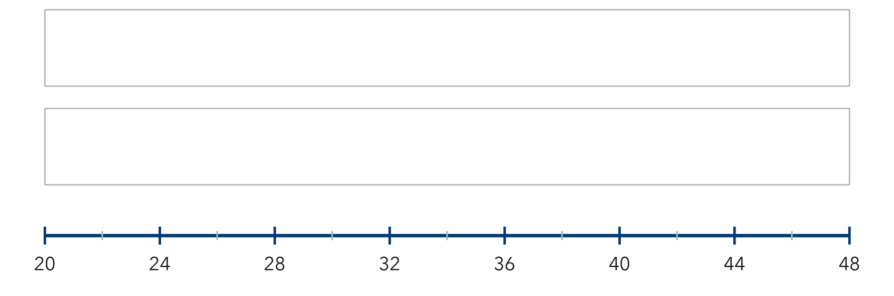
  TURN AND TALK
  Why do two box plots let you compare groups without listing every single value?
PRACTICE WITH A PARTNER You Do Together · 10–12 min
2. Two Gardens. Garden A heights (cm): 60, 68, 64, 72, 76, 65, 70. Garden B heights (cm): 58, 63, 74, 61, 80, 69, 67.
a. Five-number summary — A __________
b. Higher median? __________
PARTNER TALK
Which garden’s plants are more alike in height, and how does the box show it?

3. Two Quizzes. Quiz 1: min 5, Q1 7, median 9, Q3 11, max 14. Quiz 2: min 3, Q1 6, median 10, Q3 13, max 16.  a. Higher typical score? __________  b. Wider middle half? __________ | c. Read the box plots. These are the two quiz plots the problem describes.​  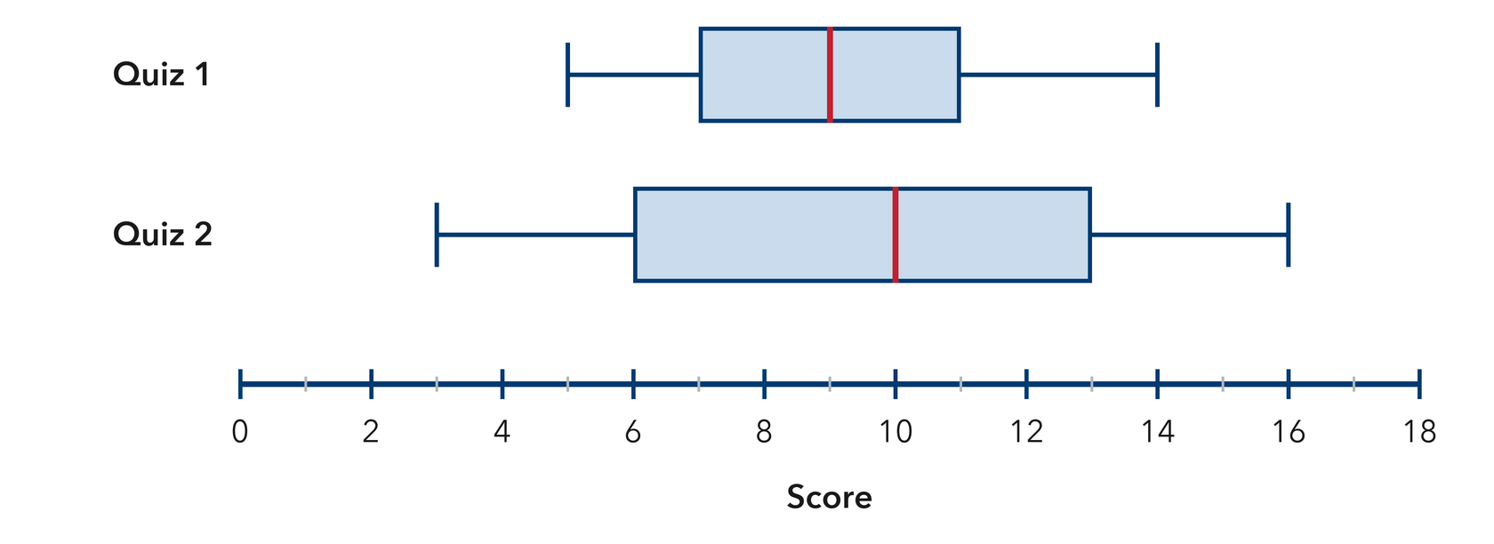
  PARTNER TALK
  Two quizzes can have the same range but different boxes. Why does that matter?

4. Two Art Classes. Class M: min 22, Q1 28, median 33, Q3 37, max 44. Class N: min 25, Q1 30, median 36, Q3 46, max 52.  a. Higher median __________  b. Wider box __________ | c. Read the box plots. These are the two art-class plots the problem describes.​  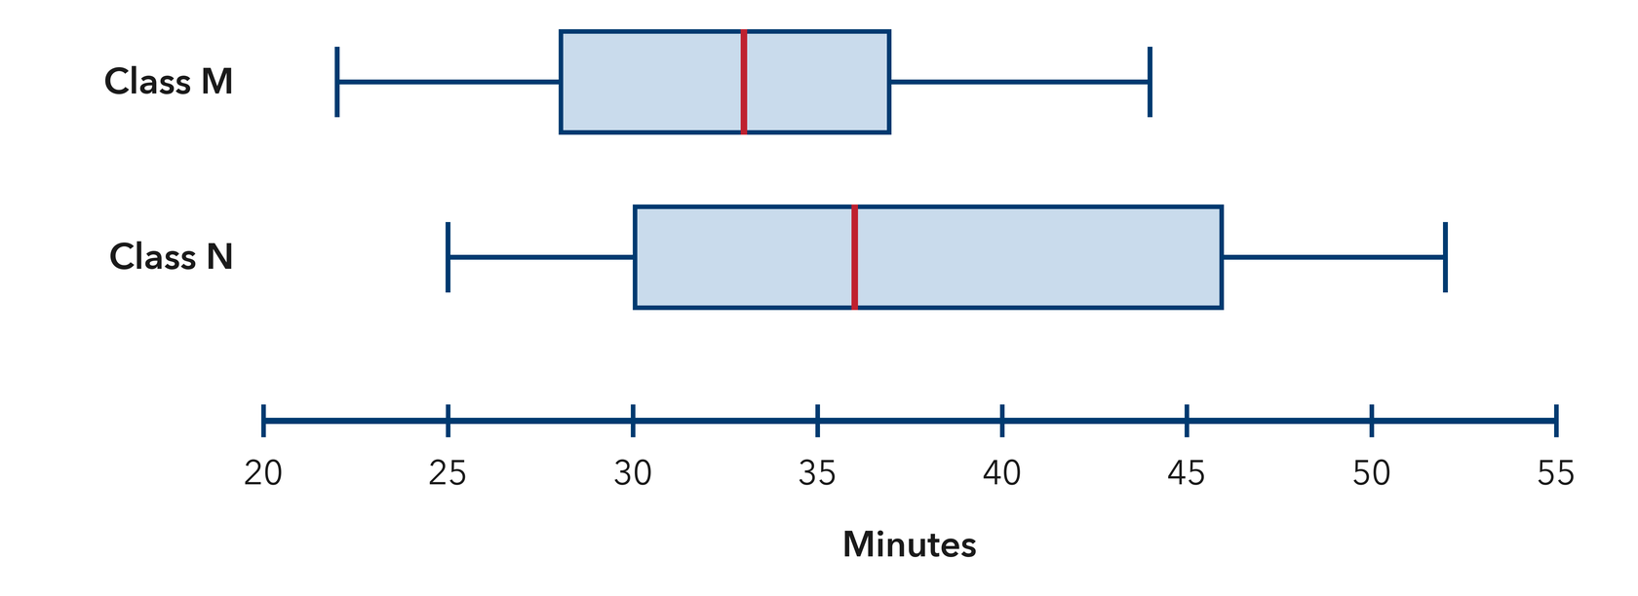
  PARTNER TALK
  Which class’s middle half is easier to predict, and how does the box show it?
PRACTICE ON YOUR OWN You Do · 8 problems · 18–20 min
5. Two Teams. Team Red points: 42, 50, 46, 54, 48, 56, 52. Team Blue points: 41, 45, 49, 43, 55, 37, 58.  Find both five-number summaries, then explain which team was more consistent.  Hint Compare the two box widths; the narrower box marks the tighter middle half.  Answer both summaries; the more consistent team | 6. Equal Spread Claim. Box plot M spans 20 to 90 with a box from 45 to 65. Box plot N spans 50 to 70 with a box from 55 to 60. Jamal says M and N are equally spread.  Justify or correct Jamal’s claim using both the whiskers and the box.  Hint Look at the full span from whisker tip to whisker tip, then look at the box width.  Answer Is Jamal right? Explain

7. Same Median. Two box plots both show a median of 30. Plot C has a box from 27 to 33 and Plot D has a box from 18 to 42.  Explain what the two plots tell you about center and what they tell you about spread.  Hint Matching medians settle the center question; the boxes still have something to say.  Answer what matches; what differs | 8. Two Snack Stands. Stand A sales: 15, 21, 18, 24, 27, 20, 23. Stand B sales: 10, 26, 16, 30, 22, 13, 28.  Find both five-number summaries, then explain which stand was steadier  Hint Order each list on its own, then compare the two box widths.  Answer both summaries; the steadier stand

9. Matching Boxes. Plot W spans 10 to 60 with a box from 30 to 40. Plot Z spans 28 to 44 with a box from 30 to 40. Omar says the two plots show the same spread because the boxes match.
Justify or correct Omar’s claim
Hint Compare the whisker tips as well as the box edges.
Answer Is Omar right? Explain

10. Two Groups. Group A: min 40, Q1 47, median 53, Q3 59, max 66. Group B: min 38, Q1 50, median 57, Q3 63, max 70. Which group has the higher median, and by how much?  Hint Subtract the two medians.  Answer group and difference | Read the box plots. These are the two group plots the problem describes.​  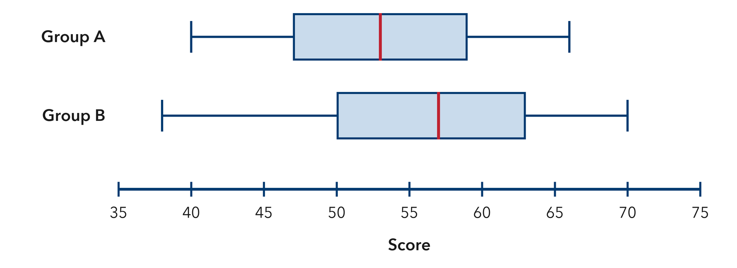
  Show your work.

11. Which Is More Consistent? Box plot P has Q1 22 and Q3 30. Box plot Q has Q1 18 and Q3 36. Which group is more consistent in its middle half? Explain.  Hint Find each box width, then compare.  Answer group and why | 12. Read Both Ways. Team X: min 12, median 20, max 35. Team Y: min 15, median 20, max 24.  a. Which team has the larger range? __________  b. The medians are equal. Explain what still makes the two teams different.  Hint Range is maximum minus minimum.  Answer a and b
ANALYZE THE ERROR 5 min
13. Read the work below. Explain the mistake, then show the correct reasoning.
BIANCA’S WORK

Comparing two box plots, Bianca wrote: ‘Plot E has a longer right whisker, so Plot E has the greater median.’
a. Explain the mistake. A whisker is not the median line. What should Bianca compare instead? | b. Show correct work  Correct answer
  Show the correct work.
STRETCH YOUR THINKING multi-step reasoning · 8 min
14. Two Bus Routes. Route 1: min 18, Q1 24, median 28, Q3 33, max 52 minutes. Route 2: min 22, Q1 26, median 29, Q3 31, max 36 minutes.  a. Which route has the higher median travel time?  b. Which route is more predictable? Use the box widths in your answer.  c. A rider must not be late. Tell which route you would advise and why.  Answer both comparisons and your advice | d. Read the box plots. These are the two route plots the problem describes.​  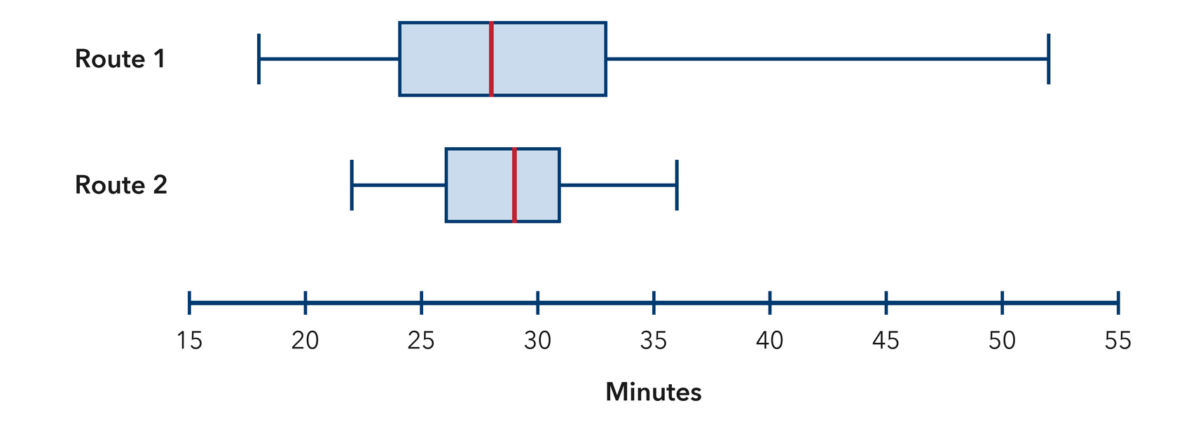
  Show your work.
TEST PRACTICE multiple choice · fill one box · 6 min
15. The line inside a box plot’s box shows the — | 16. A wider box means the middle half of the data is —
  □ A. mean | □ B. range | □ C. median | □ D. maximum
  □ A. always lower | □ B. more consistent | □ C. always higher | □ D. more spread out

17. Group A’s median is 50 and Group B’s is 62. Group B’s center is higher by — | 18. A box plot with min 20 and max 45 has a range of —
  □ A. 12 | □ B. 6 | □ C. 18 | □ D. 112
  □ A. 20 | □ B. 25 | □ C. 45 | □ D. 65
SPIRAL REVIEW earlier skills · keep them sharp · 6 min
19. From Lesson 2-4 Session 1. Find the median of 15, 22, 30, 41, 18.  Answer | 20. From Lesson 2-3 Session 2. Find the median of 8, 14, 20, 26.  Answer

21. From Lesson 2-2 Session 1. Frequencies are 6, 6, and 8. How many values in all?  Answer | 22. Grade 5. Find 15.5 − 6.8.  Answer
CHECK YOUR UNDERSTANDING 5 min
23. Two Hiking Groups. Group J: min 8, Q1 11, median 16, Q3 21, max 28. Group K: min 6, Q1 14, median 16, Q3 20, max 24.  a. Wider box? __________  b. One sentence comparing the two groups __________  Hint Matching medians mean the centers agree, so let the box widths carry your comparison.  Answer | c. Read the box plots. These are the two hiking-group plots the problem describes.​  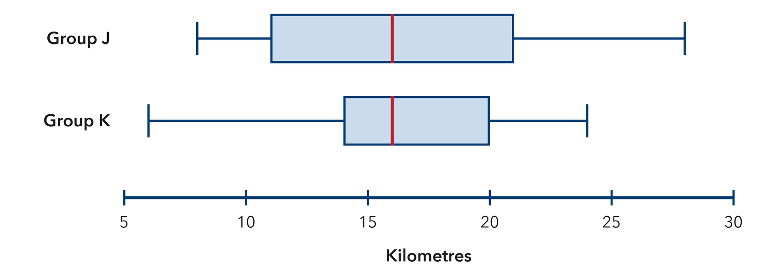
  Show your work.

□ 4 — Can teach it | □ 3 — Got it | □ 2 — Need hint | □ 1 — Need help
Circle your confidence. Star one problem that shows your learning.

