Name Date Period
Lesson 2-8 · Homework Packet · Sheet 1 of 2
Finding the Mean
Maryland Standard 6.SP.B.5c · Learning target — I can find the mean of a data set by sharing the total equally among the values.

REMEMBER  • The mean is a fair share: add all the values, then divide by how many values there are.  • Mean = sum ÷ number of values. Count every value, including repeats and zeros.  • The mean is between the least and greatest values. It does not have to be in the data set. | WORKED EXAMPLE  Kiara read 12, 9, 15, 8, and 11 pages on five nights. Find the mean.  Step 1 Add: 12 + 9 + 15 + 8 + 11 = 55  Step 2 Count: there are 5 values.  Step 3 Divide: 55 ÷ 5 = 11. Check: 11 is between 8 and 15.  Answer 11 pages
PRACTICE show your work · label units
1. Find the mean of each data set.
a. 6, 9, 12 | b. 15, 20, 25, 40 | c. 7, 0, 5, 8
d. 3, 3, 9, 4, 6 | e. 2.5, 3.5, 4.5 | f. 18, 22, 14, 26, 30

2. Soccer Goals. The dot plot shows the goals a team scored in each game this season.  a. Total goals:  b. Number of games:  c. Mean goals per game: | 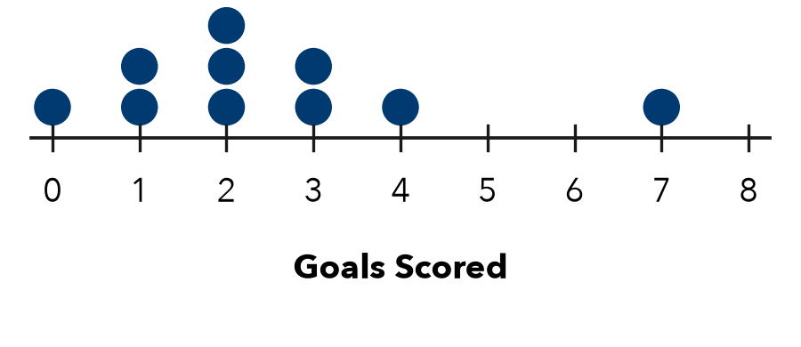

3. Rainfall. Rain fell on five days: 0.4 in, 1.2 in, 0 in, 0.9 in, and 0.5 in. Find the mean daily rainfall.

Show your work.
Answer in

4. New Value. The mean of 8, 10, and 12 is 10. A fourth value, 20, is added. What happens to the mean?
□ It goes up. | □ It goes down. | □ It stays the same.
New mean

5. Find the Error. To find the mean of 8, 0, 6, and 10, Darnell added to get 24. Then he divided by 3 because “zero does not count.” Explain his error and find the mean.

CHECK YOURSELF | □ I can do this on my own | □ I need a little help | □ I have a question about #
AT HOME Ask 4 people at home how many glasses of water they drink in a day. Find the mean.
Name Date Period
Lesson 2-8 · Homework Packet · Sheet 2 of 2
Reaching a Target Mean
Maryland Standard 6.SP.B.5c · Learning target — I can find the value a data set still needs in order to reach a target mean.

REMEMBER  • Target total = target mean × number of values (count the missing value too).  • Missing value = target total − sum so far. Check: the new total ÷ count should equal the target mean. | WORKED EXAMPLE  Jamal’s quiz scores are 78, 85, and 90. What score on quiz 4 gives a mean of 85?  Step 1 Target total: 85 × 4 = 340  Step 2 Sum so far: 78 + 85 + 90 = 253  Step 3 Missing: 340 − 253 = 87. Check: 340 ÷ 4 = 85  Answer 87 points
PRACTICE show your work · label units
1. Complete the table.
 | Values | Target mean | Target total | Sum so far | Missing value
A | 3 | 12 |  | 25
B | 4 |  | 64 | 49

2. Bowling. Aaliyah bowled 112, 98, 105, and 121. What score in game 5 gives her a mean of 110?
Answer points

3. Car Wash. A club raised $45, $60, $52, and $38 on four Saturdays. What must it raise on the fifth Saturday for a mean of $50?
Answer

4. Push-Ups. The dot plot shows how many push-ups Nia did on each of 7 days.  a. Mean for the 7 days:  b. Day 8 for a mean of 14: | 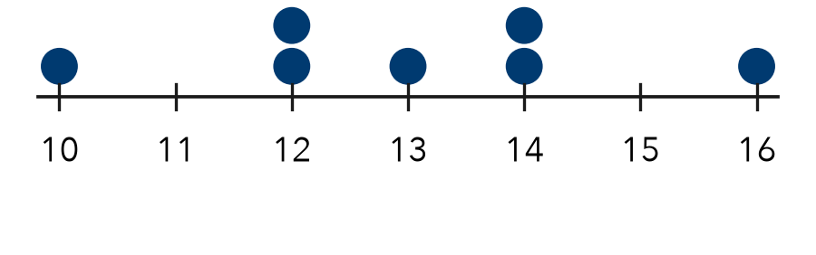

5. Find the Error. Brianna scored 82, 86, and 78. For a mean of 85 on 4 tests, she wrote 85 × 3 − 246 = 9. Explain her error. What score does she need?

TEST PRACTICE choose the best answer
6. Four numbers have a mean of 9. Three of them are 7, 10, and 8. What is the fourth number?
A 9 | B 11 | C 2 | D 36

7. A player’s points in 5 games have a mean of 14. What is her total number of points?
A 2.8 | B 19 | C 70 | D 9

CHECK YOURSELF | □ I can do this on my own | □ I need a little help | □ I have a question about #

