Name Date Period
Lesson 2-9 · Homework Packet · Sheet 1 of 2
Finding Mean Absolute Deviation (MAD)
Maryland Standard 6.SP.B.5c · Learning target — I can find the mean absolute deviation of a data set and explain what it measures.

REMEMBER  • The MAD (mean absolute deviation) is the average distance of the values from the mean. Distances are never negative.  • Find the mean. Find each value’s distance from the mean. Then find the mean of the distances. | WORKED EXAMPLE  Ruth’s quiz scores are 6, 8, 9, and 13. Find the MAD.  Step 1 Mean: 36 ÷ 4 = 9  Step 2 Distances from 9: 3, 1, 0, 4  Step 3 Mean of distances: 8 ÷ 4 = 2  Answer MAD = 2 points
PRACTICE show your work · label units
1. The mean of 5, 7, 10, 12, and 16 is 10. Complete the table. Then find the MAD.
Value | 5 | 7 | 10 | 12 | 16
Distance from 10
MAD

2. The mean is given. Find the MAD.
a. 1, 3, 5, 7 (mean 4) | b. 20, 25, 35, 40 (mean 30)
c. 6, 6, 6, 6, 6 (mean 6) | d. 2, 5, 8, 9, 11 (mean 7)

3. Pets. The dot plot shows the number of pets 8 students have.  a. Mean: pets  b. MAD: pets | 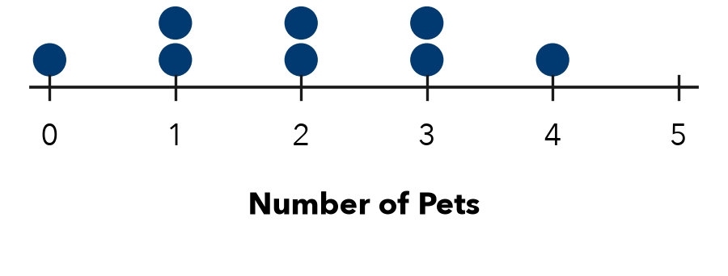

4. Wait Times. Six patients waited 10, 14, 15, 17, 18, and 22 minutes at a clinic. Find the mean and the MAD.

Show your work.
Mean and MAD

5. Find the Error. For 3, 5, 9, 11, 12 (mean 8), Eli found the distances 5, 3, 1, 3, 4. Their sum is 16. He wrote MAD = 16 ÷ 8 = 2. Explain his error and find the MAD.

CHECK YOURSELF | □ I can do this on my own | □ I need a little help | □ I have a question about #
AT HOME Tell someone at home what a MAD of 0 would mean for a set of test scores.
Name Date Period
Lesson 2-9 · Homework Packet · Sheet 2 of 2
Comparing Data Sets Using MAD
Maryland Standard 6.SP.B.5c · Learning target — I can compare two data sets that share a mean by comparing their mean absolute deviations.

REMEMBER  • When two data sets have the same mean, compare their MADs. State both numbers.  • A smaller MAD means values are closer to the mean: more consistent. A larger MAD means more variability. | WORKED EXAMPLE  Baker A’s loaves: 496, 500, 500, 504 g. Baker B’s: 488, 496, 504, 512 g. Both means are 500 g. Who is more consistent?  Step 1 A’s distances: 4, 0, 0, 4. MAD = 8 ÷ 4 = 2 g  Step 2 B’s distances: 12, 4, 4, 12. MAD = 32 ÷ 4 = 8 g  Answer Baker A (MAD 2 g versus 8 g)
PRACTICE show your work · label units
1. Basketball. Both players have a mean of 12 points. Kai: 10, 11, 12, 13, 14. Leo: 4, 8, 12, 16, 20.
a. Kai’s MAD: | b. Leo’s MAD: | c. More consistent:

2. Summer Reading. The dot plot shows the books read by 8 students in Club B. Club A has a mean of 6 books and a MAD of 0.5 book.  a. Club B mean:  b. Club B MAD:  c. More spread out: | 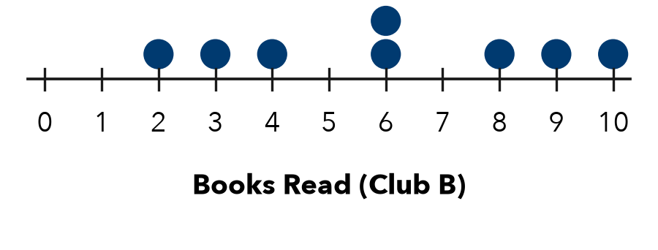

3. Tomatoes Picked. Both means are 20. Garden A: 18, 19, 21, 22. Garden B: 12, 16, 24, 28.
a. A’s MAD: | b. B’s MAD: | c. More consistent:

4. Bus Routes. Both routes have a mean time of 24 min. Route 5: MAD 1.5 min. Route 9: MAD 6 min. Which is more predictable?
□ Route 5 | □ Route 9 | □ They are the same

5. Find the Error. Jordan says Set R (49, 50, 50, 51) must have a greater MAD than Set S (2, 6, 14, 18) because its numbers are bigger. Find both MADs and explain.

TEST PRACTICE choose the best answer
6. Sets A and B both have a mean of 40. A’s MAD is 2.5. B’s MAD is 8. Which is true?
A A varies less. | B B varies less. | C Same spread. | D Cannot tell.

7. What is the MAD of 3, 5, 7, 9?
A 0 | B 2 | C 6 | D 8

CHECK YOURSELF | □ I can do this on my own | □ I need a little help | □ I have a question about #

