Name |  | Date |  | Period

Lesson 3-1 · Session 2
Homework
Ratios and Tape Diagrams
Maryland Standard 6.RP.A.1 · Learning target — I can use a tape diagram to share a total according to a given ratio.
Show a model, calculation, or explanation for each exercise. Label units and answer every part.
Exercises 1–12 earn 1 point for a correct response and 1 for supporting work. Spiral Review and Test Practice earn 1 point each.
REMEMBER review this before you start
• A tape diagram uses equal-size boxes to show the two quantities in a ratio.
• The number of boxes for each quantity matches the numbers in the ratio.
• Watch out — the total is shared across every box, so count all the boxes before you divide.
• Check it — your two amounts must add back to the original total.
WORKED EXAMPLE the same steps you practiced in class
Sharing a Total Using a Ratio Paint mixes 3 cups blue for every 1 cup white. The painter needs 24 cups in all.
Step 1 Add the terms to find total parts. 3 + 1 = 4 parts
Step 2 Divide the total by the parts. 24 ÷ 4 = 6 cups in each box
Step 3 Multiply each row by 6. blue: 3 × 6 = 18 white: 1 × 6 = 6
Step 4 Check by adding. 18 + 6 = 24
Answer The painter needs 18 cups blue and 6 cups white.
EXERCISES 12 exercises · 24 points
1. The ratio of red to blue marbles is 2:3. Draw a tape diagram with 2 boxes for red and 3 boxes for blue.

Tape diagram. Write the unit value in every box.​
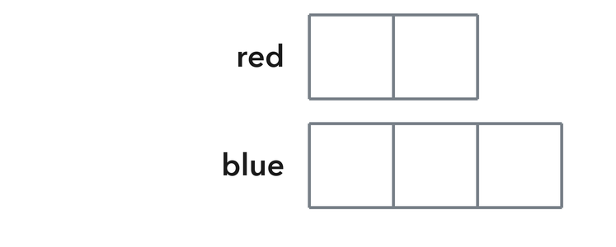
Show your work.
Answer
2. If each box in problem 1 represents 4 marbles, how many red marbles are there? ______ How many blue marbles? ______

Show your work.
Answer
3. A recipe ratio of flour to sugar is 4:1. If there are 20 cups of flour, use a tape diagram to find the cups of sugar.

Tape diagram. Write the unit value in every box.​
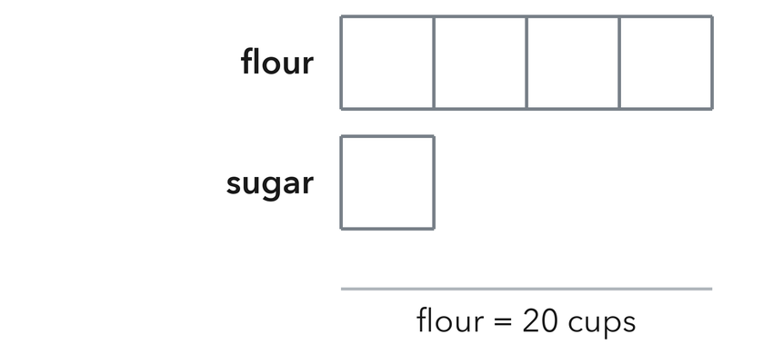
Show your work.
Answer
4. Add the terms to find the total number of equal parts in each ratio.
a. 3 : 5 ______ parts
b. 7 : 2 ______ parts
c. 4 : 6 ______ parts
d. 5 : 5 ______ parts
e. 1 : 8 ______ parts

Answer
5. Soccer Snacks. A cooler holds juice boxes and water bottles in a ratio of 5 to 4. There are 45 drinks in all. Draw a tape diagram, then find how many water bottles are in the cooler.

Tape diagram. Write the unit value in every box.​
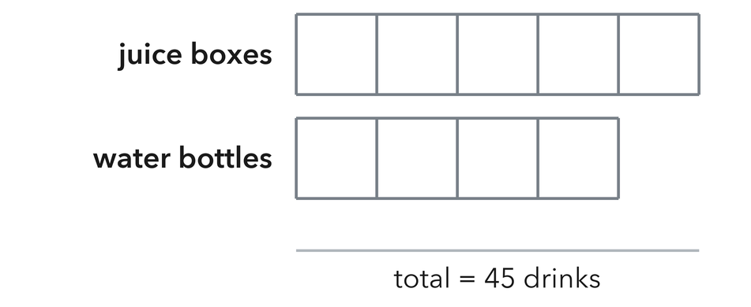
Show your work.

Answer
6. Hallway Tiles. A hallway is tiled with gray and white tiles in a ratio of 7 to 3. The crew lays 60 tiles. How many tiles of each color did the crew lay?

Show your work.

Answer
7. A tape diagram is drawn with 6 equal boxes and the total is 54. What is the value of one box?

Tape diagram. Write the unit value in every box.​
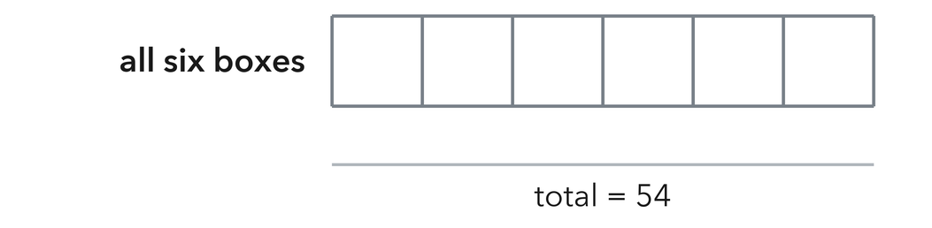
Show your work.

Answer
8. Nia drew a tape diagram for a 2 to 7 ratio with a total of 36. She said each box is worth 18 because 36 ÷ 2 = 18. Explain her mistake, then find the correct value of one box.

Show your work.

Answer
9. Share $56 in the ratio 3 : 4. Find both shares.

Show your work.
Answer both shares
10. A mix uses 2 parts oats to 3 parts seeds for 40 grams in all. Find each amount.

Show your work.
Answer oats and seeds
11. Work Backward. A recipe uses 3 parts water to 1 part syrup. It uses 9 cups of water. How many cups does the recipe make in all?

Show your work.
Answer cups
12. Find the Mistake. To share 40 in the ratio 3 : 5, Nia divided 40 by 3. Explain the mistake and give the correct shares.

Show your work.
Answer the mistake and the shares
SPIRAL REVIEW earlier skills · 1 point each
13. From Lesson 3-1 Session 1. Write the ratio 14 : 21 in simplest form.
Answer
14. From Lesson 2-8 Session 1. Find the mean of 30, 34, 38, 42.
Answer
15. From Lesson 2-7 Session 1. Find 36.9 ÷ 9.
Answer
TEST PRACTICE multiple choice · fill one box · 1 point each
16. Sharing 36 in the ratio 1 : 3 gives —
□ A. 12 and 24 | □ B. 9 and 27 | □ C. 6 and 30 | □ D. 18 and 18
17. For the ratio 2 : 5, one box of a 63-unit total is worth —
□ A. 18 | □ B. 7 | □ C. 9 | □ D. 45
18. A tape diagram shows a ratio as —
□ A. a bar graph | □ B. a number line | □ C. a circle | □ D. equal-sized boxes
CHECK YOURSELF Score: ______ / 30
□ Solved on my own | □ Needed a hint | □ Need help on Question # ______
Check that corresponding quantities stay in order. Label units and explain what your answer means.

