Name |  | Date |  | Period
Lesson 3-1 · Session 2 · Version 2
Guided Practice · Version 2
Ratios with Tape Diagrams
VOCABULARY read and say each word before you begin
tape diagram  Spanish: diagrama | A drawing that uses equal boxes to show a ratio. | 3 : 1 |
unit  Spanish: unidad | The value of ONE box in the tape diagram. | 24 ÷ 4 boxes = 6 in each box
total parts | Add the two terms of the ratio. | 3 + 1 = 4 parts
equal groups | Every box in the diagram holds the same amount. | each = 6
EXPLORE TOGETHER Class Launch · 8–10 min
1. Trail Mix Recipe  A camp cook uses 2 cups of granola for every 3 cups of cranberries. The cook makes a 25-cup batch for a hiking trip.  a. Ratio Parts. Granola parts: ______ Cranberry parts: ______ Total parts: ______ equal units  b. Unit Value. Divide total cups by total parts: 25 ÷ 5 parts = ______ cups in each unit box.  c. Find Amounts. Granola: 2 × ______ = ______ cups | Cranberries: 3 × ______ = ______ cups | d. Tape diagram. Write the unit value in every box, then add the boxes in each bar.​  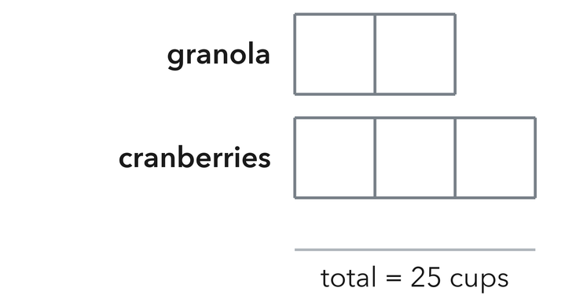
  TURN AND TALK
  How does dividing the total (25) by the total parts (5) help you find each ingredient?
  Sentence frame: “Dividing the total by 5 parts tells us how many cups are in…”
PRACTICE WITH A PARTNER You Do Together · 10–12 min
2. Smoothie Fruit Blend. A smoothie recipe uses 3 strawberries for every 2 bananas. A pitcher uses 20 total fruits.  a. How many total units are in this ratio? 3 + 2 = __________  b. Find value of 1 unit: 20 ÷ 5 = __________ | c. Tape diagram. Write the unit value in every box, then add the boxes in each bar.​  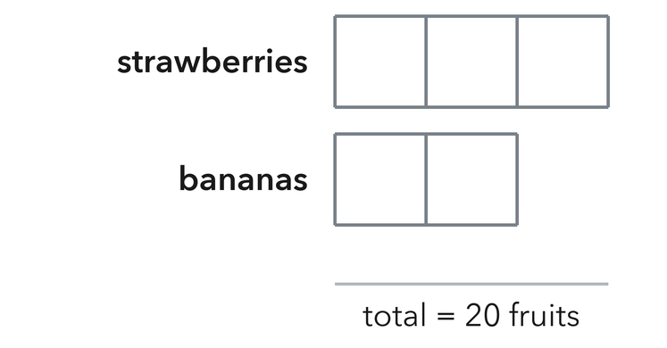
  PARTNER TALK
  Confirm that strawberries + bananas = 20 total fruits.

3. Mural Paint Mix. An art club mixes 4 cups of blue with 1 cup of white paint to make sky blue. They need 35 cups.  a. Total units: 4 + 1 = 5 units. Value of 1 unit: 35 ÷ 5 = __________  b. White paint needed __________ | c. Tape diagram. Write the unit value in every box, then add the boxes in each bar.​  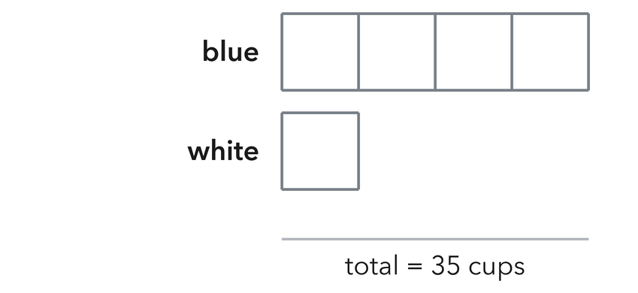
  PARTNER TALK
  Add your two amounts together. Do they come back to 35 cups?

4. Band Uniform Buttons. A band jacket uses 5 gold buttons for every 3 silver buttons. One jacket set uses 64 buttons in all.
a. Total units 3 + 4 = __________
b. Value of 1 unit 56 ÷ 7 = __________
PARTNER TALK
Multiply each row by the value of one unit. Do your two amounts add back to 64 buttons?

PRACTICE ON YOUR OWN You Do · 8 problems · 18–20 min
5. Fish Tank Species. A tank has goldfish and guppies in a ratio of 5 to 3. There are 32 fish in all.  How many cats are in the shelter?  Hint Add the parts to find the total units, divide 35 by that, then multiply by the cat parts.  Answer goldfish | 6. Camp Counselors. A camp has 1 counselor for every 6 campers. If there are 42 campers, how many counselors are needed?  Hint Divide 56 students by 8 to find chaperones.  Answer counselors

7. Cookie Bakery. A bakery bakes chocolate chip and sugar cookies in a ratio of 4 to 3. In one batch, they bake 49 cookies. How many are chocolate chip?
Hint Divide 54 by the total number of units, then multiply by the blueberry parts.
Answer chocolate chip cookies

8. Recycling Bins. A school sorts paper and plastic in a ratio of 6 to 5. One week the school collects 77 pounds in all.  Find how many pounds of plastic the center collected  Hint Add 6 and 5 to find the total units, divide 77 by that number, then multiply by the plastic parts.  Answer pounds of paper | Tape diagram. Write the unit value in every box, then add the boxes in each bar.​  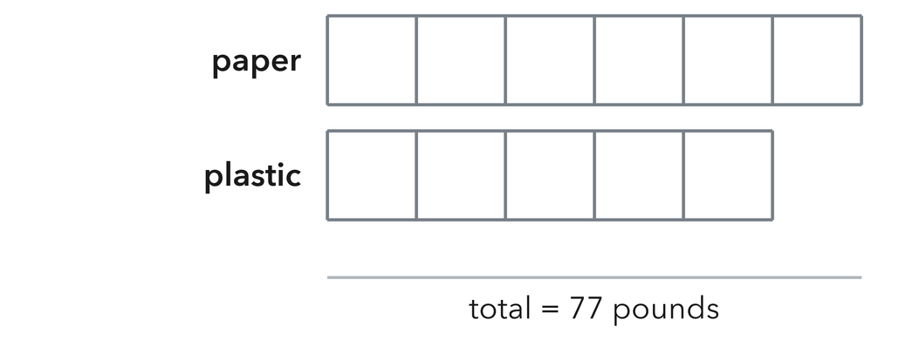
  Show your work.

9. Choir Voices. A choir has altos and sopranos in a ratio of 4 to 9. The choir has 39 singers in all.  Find how many nonfiction books are in the library  Hint Divide 44 by the total units, then multiply that value by the nonfiction parts.  Answer sopranos | 10. Mixing Paint. Paint mixes 3 cups blue to 1 cup white, and the painter needs 24 cups in all. Find the cups of each color.  Hint There are 6 boxes in all. Divide 18 by 6 to size one box.  Answer blue and white

11. Splitting Money. Two cousins share $45 in the ratio 4 : 5. Find each cousin’s share.  Hint Seven boxes in all; one box is $8.  Answer both shares | 12. Find the Total. A trail mix uses 2 parts raisins to 5 parts nuts. The recipe calls for 15 ounces of nuts.  a. How many ounces is one part? __________  b. How many ounces of snack mix does the recipe make? __________  Hint Four boxes hold 20 ounces, so one box holds 5 ounces.  Answer a and b
ANALYZE THE ERROR 5 min
13. Read the work below. Explain the mistake, then show the correct reasoning.
DIEGO’S WORK
A pot of chili uses 3 cups rice and 4 cups beans (total 42 cups). Diego divided 42 by 3 and got 14 cups rice.

a. Explain the mistake. Why was dividing by 3 wrong? What should Diego have divided 42 by?  Sentence frame: “Diego should have added 3 + 4 = 7 total parts, then divided 42 by 7 to get…” | b. Show correct work  Correct answer
  Show the correct work.
STRETCH YOUR THINKING multi-step reasoning · 8 min
14. Garden Beds. A gardener plants beans and corn in the ratio 5 : 3 and uses 96 seeds in all.  a. Find the number of seeds of each crop.  b. How many fewer corn seeds than bean seeds are planted?  c. Next year the club wants equal numbers of each crop with the same 96 seeds. Explain what ratio to use.  Answer both amounts, the difference, and next year’s ratio | d. Tape diagram. Write the unit value in every box, then add the boxes in each bar.​  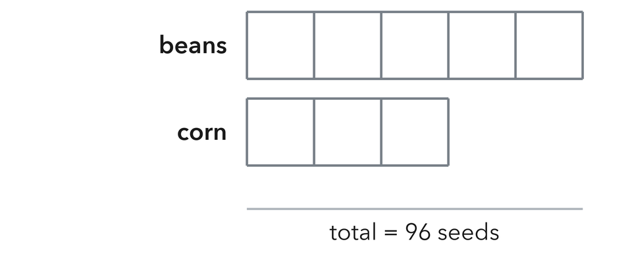
  Show your work.
TEST PRACTICE multiple choice · fill one box · 6 min
15. A ratio of 2 : 3 shares a total of 30. One box is worth — | 16. For the ratio 3 : 4, how many boxes are in the whole tape diagram?
  □ A. 5 | □ B. 6 | □ C. 10 | □ D. 15
  □ A. 4 | □ B. 3 | □ C. 7 | □ D. 12

17. A ratio of 1 : 4 shares 25 cookies. The larger share is — | 18. To size one box, divide the total by the —
  □ A. 24 | □ B. 5 | □ C. 21 | □ D. 20
  □ A. number of boxes | □ B. first ratio number | □ C. second ratio number | □ D. difference
SPIRAL REVIEW earlier skills · keep them sharp · 6 min
19. From Lesson 3-1 Session 1. A box has 8 markers and 12 crayons. Write the ratio of markers to crayons in simplest form.  Answer | 20. From Lesson 2-9 Session 2. Two sets share a mean. Which is steadier: MAD 2 or MAD 11?  Answer

21. From Lesson 2-7 Session 2. Find 8.8 ÷ 0.8.  Answer | 22. From Lesson 2-3 Session 1. Find the median of 17, 12, 25, 19, 14.  Answer
CHECK YOUR UNDERSTANDING 5 min
23. Carnival Tickets. Game tickets and ride tickets are in a ratio of 7 to 2. Marcus receives 54 tickets in all.  a. How many game tickets did Priya receive? __________  b. How many ride tickets did Priya receive? __________  Hint Add the parts to find the total units, divide 54 by that, then multiply by each part.  Answer | c. Tape diagram. Write the unit value in every box, then add the boxes in each bar.​  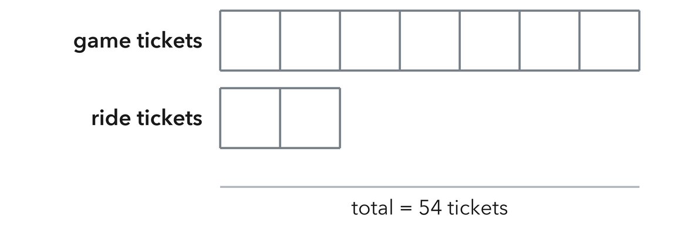
  Show your work.

□ 4 — Can teach it | □ 3 — Got it | □ 2 — Need hint | □ 1 — Need help
Circle your confidence. Star one problem that shows your learning.

