Name Date Period
Lesson 3-4 · Homework Packet · Sheet 1 of 2
Graphing Ratios on the Coordinate Plane
Maryland Standard 6.RP.A.3a · Learning target — I can turn a ratio into ordered pairs and plot them on a coordinate plane.

REMEMBER  • Write each pair from a ratio table as an ordered pair (x, y). The first quantity is x.  • Points for equivalent ratios lie on a straight line through (0, 0). | WORKED EXAMPLE  A pack holds 4 juice boxes. Let x = packs and y = juice boxes. Write ordered pairs for 1, 2, and 3 packs.  Step 1 Table: 1 pack, 4 boxes; 2 packs, 8 boxes; 3 packs, 12 boxes  Step 2 Ordered pairs: (1, 4), (2, 8), (3, 12)  Answer (0, 0), (1, 4), (2, 8), (3, 12) lie on one line.
PRACTICE show your work · label units
1. Each bag holds 3 oranges. Complete the table. Then write each column as an ordered pair.
Bags (x) | 1 | 2 | 3 | 4
Oranges (y) | 3
(x, y) | (1, 3)

2. Plot the ordered pairs from Exercise 1. Draw a line through the points. Does the line pass through (0, 0)? What does (0, 0) mean?  (0, 0) means | 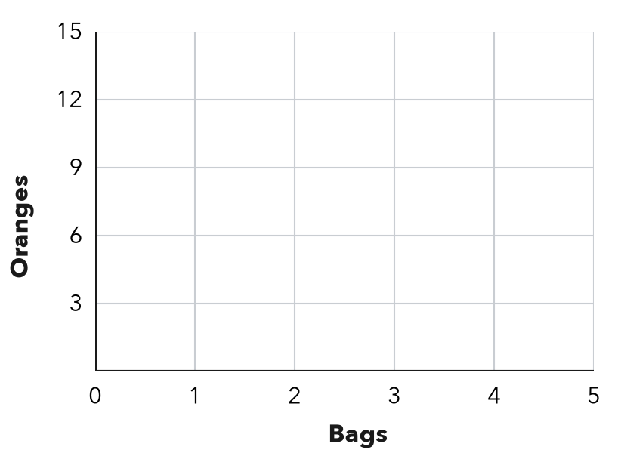

3. A muffin batch uses 2 cups of flour (x = batches, y = cups). Write the ordered pair for:
a. 7 batches | b. 18 cups of flour

4. Garden Rows. Each row in a garden has 5 plants. Let x = rows and y = plants.
a. Write the ordered pair for 8 rows.
b. Write the ordered pair for 0 rows. What does it mean?

5. Same Line? Do the points (1, 5), (2, 10), and (3, 14) all lie on one straight line through (0, 0)?
□ Yes | □ No

6. Find the Error. Tickets cost $2 each. On a graph with x = tickets and y = cost, Ruby plotted (12, 6) for 6 tickets. Explain her mistake and write the correct point.

CHECK YOURSELF | □ I can do this on my own | □ I need a little help | □ I have a question about #
AT HOME Make a table for something that comes in packs at home. Say two of its ordered pairs.
Name Date Period
Lesson 3-4 · Homework Packet · Sheet 2 of 2
Interpreting Points on Ratio Graphs
Maryland Standard 6.RP.A.3a · Learning target — I can explain what a point on a ratio graph means in the situation it describes.

REMEMBER  • Each point (x, y) is a pair of amounts. Say both with units.  • The point (1, y) shows the unit rate: y ÷ x for any point. (0, 0) means zero of both. | WORKED EXAMPLE  A graph of hours worked (x) and dollars earned (y) passes through (3, 45). What does the point mean?  Step 1 (3, 45): 3 hours of work earns $45  Step 2 Unit rate: 45 ÷ 3 = 15, so (1, 15) is on the line  Answer $15 per hour
PRACTICE show your work · label units

1. The graph shows time (x, hours) and distance (y, miles) for a cyclist.  a. What does the point (2, 24) mean?  b. What is the unit rate? miles per hour  c. At this rate, how far does the cyclist ride in 6 hours? miles | 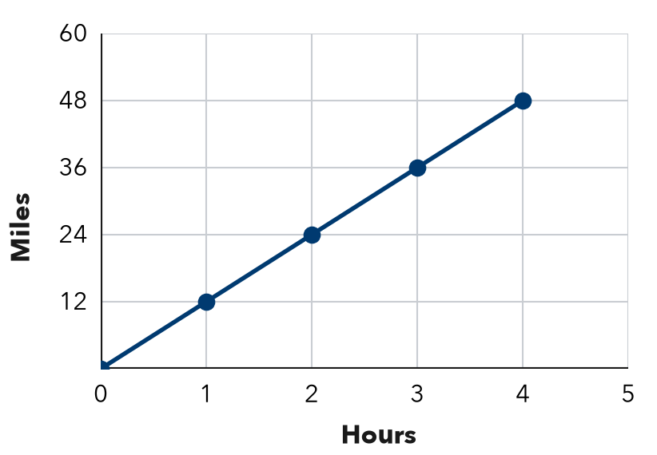

2. A ratio graph of trays (x) and muffins (y) passes through (1, 12). Find each missing value.
a. x = 4, y = | b. y = 60, x =
c. x = 7, y = | d. y = 36, x =
e. x = 10, y = | f. y = 96, x =

3. Same Line? A ratio graph of pounds of grapes (x) and cost in dollars (y) passes through (4, 10).
a. What is the unit rate? per pound
b. Is (6, 15) on the line? Is (8, 18)? Show how you know.

4. Find the Error. A graph of laps (x) and minutes (y) passes through (3, 12). Omar says it means 12 laps in 3 minutes. What is wrong?

TEST PRACTICE choose the best answer
5. A ratio graph passes through (5, 40). Which point is also on the line?
A (1, 8) | B (6, 41) | C (8, 5) | D (10, 45)

6. A graph of hours (x) and dollars earned (y) passes through (2, 18). What does (1, 9) mean?
A $9 per hour | B 9 hours for $1 | C $18 in 1 hour | D $2 per hour

CHECK YOURSELF | □ I can do this on my own | □ I need a little help | □ I have a question about #
AT HOME Tell someone at home what (1, 9) means on a graph of hours and dollars.

