Name |  | Date |  | Period
Lesson 3-4 · Session 1 · Version 2
Guided Practice · Version 2
Graphing Ratios on Coordinate Planes
VOCABULARY read and say each word before you begin
coordinate plane | The grid where points are plotted. | x across, y up
ordered pair  Spanish: par ordenado | Two numbers naming one point: (x, y). | (2, 14)
origin  Spanish: origen | The point (0, 0) where the axes meet. | 0 pages, 0 stickers
x-axis / y-axis | x runs across (the thing you count); y runs up (the result). | x = pages, y = stickers
EXPLORE TOGETHER Class Launch · 8–10 min
1. Soccer Equipment Bags  Coach Rivera packs 6 soccer balls in each bag. Let x = bags and y = total balls.  a. Table. Complete the table: (1 bag, ______ balls), (2 bags, ______ balls), (3 bags, ______ balls).  b. Ordered Pairs. Write points: (1, 6), (2, 12), (3, 18), (5, ______)  c. Graph Shape. All points form a straight ray that passes through the origin (0, 0). | d. Graph. Plot the ordered pairs on the coordinate plane, then draw a straight line through the points and the origin.​  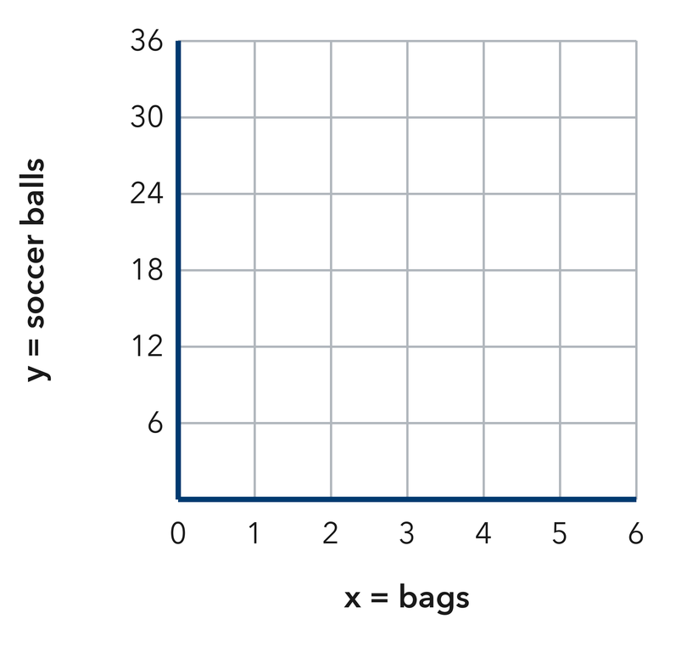
  Bags (x) | 1 | 2
  Balls (y) | 6 | 12
  Point (x, y) | (1, 6) | (2, 12)
  TURN AND TALK
  What does the origin (0, 0) mean in this situation?
  Sentence frame: “The point (0, 0) means that 0 bags contain…”
PRACTICE WITH A PARTNER You Do Together · 10–12 min
2. Hiking Trail Climb. Hikers climb at a steady rate of 3 miles every 1 hour (x = hours, y = miles).  a. Write ordered pairs for 1, 2, 3, and 4 hours: (1, 3), (2, ______ ), (3, ______ ), (4, ______ )  b. What point shows the distance after 5 hours? (5, __________ | c. Graph. Plot the ordered pairs on the coordinate plane, then draw a straight line through the points and the origin.​  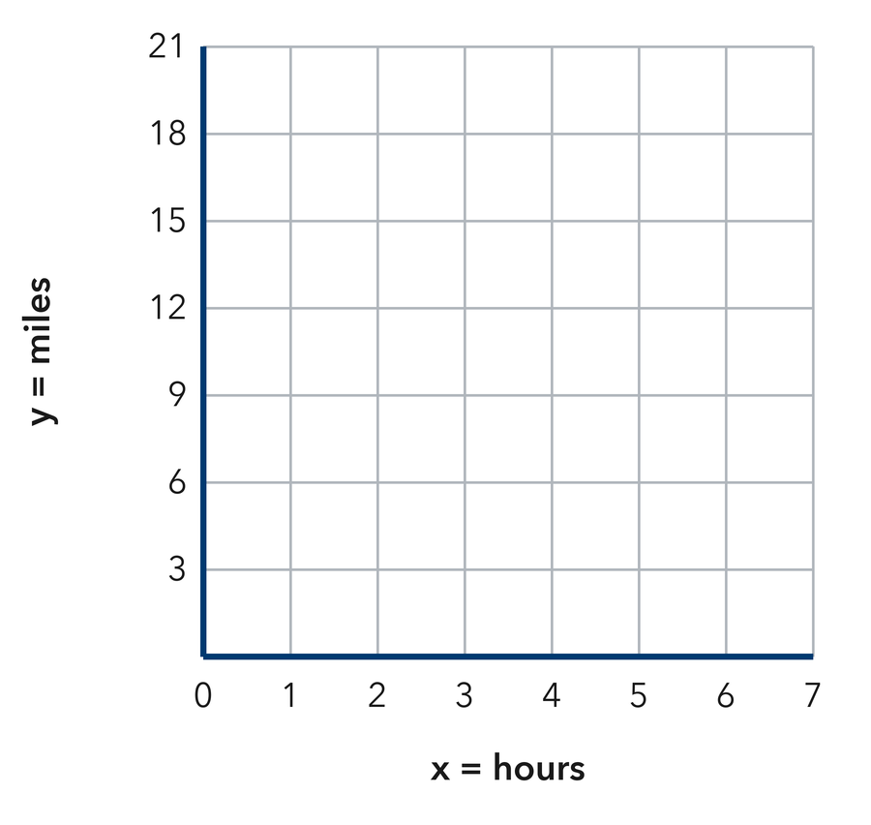
  Hours (x) | 1 | 2 | 3 | 4
  Miles (y) | 3 | 6
  PARTNER TALK
  Does multiplying x by 3 give y for every single point?

3. File Downloads. A computer downloads 5 GB every 2 minutes (x = minutes, y = GB).  a. Ordered pairs for 3, 6, 9 min: (3, 9), (6, 18), (9, __________  b. How many liters are pumped in 15 minutes? __________ | 4. Street Tree Planting. A city crew plants 7 trees on every block. Let x = blocks and y = trees.  a. Ordered pairs (1, 9), (2, ______ ), (3, ______ )  b. Point for 5 parks (5, __________
  PARTNER TALK
  How many 2-minute blocks fit in 10 minutes? Compare your GB answers.
  PARTNER TALK
  Does multiplying the x-value by 7 give the y-value for every point you wrote?
PRACTICE ON YOUR OWN You Do · 8 problems · 18–20 min
5. Allowance Savings. Maya saves $4 each week (x = weeks, y = dollars).  a. Write ordered pairs for 1, 2, 4, 6 weeks: (1, 4), (2, ______ ), (4, ______ ), (6, ______ ).  b. Find y for the point (7, y): y = __________  Hint Multiply weeks by 4.  Answer dollars in 8 weeks | c. Graph. Plot the ordered pairs on the coordinate plane, then draw a straight line through the points and the origin. Label the point for 7 weeks.​  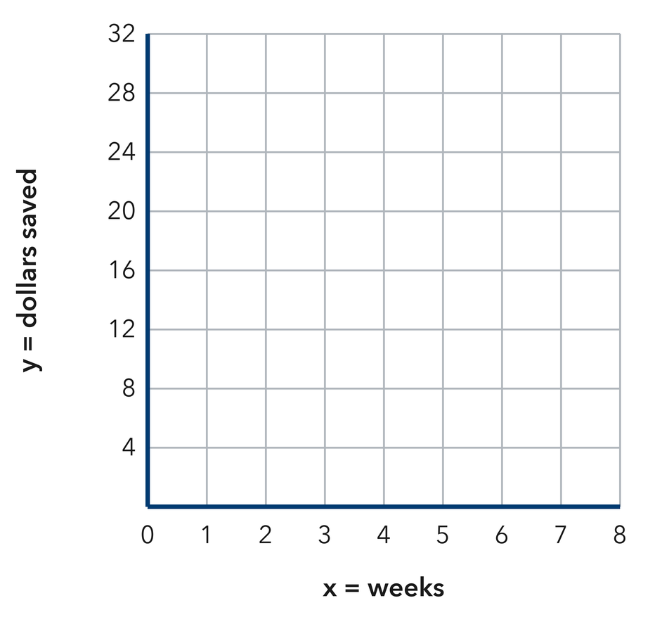
  Show your work.

6. Poster Printing. A printer prints 8 posters each minute.  a. Write the equation: y = __________  b. What does (0, 0) mean here?  Hint y = (rate) • x.  Answer equation and meaning | 7. Scooter Range. A scooter goes 15 miles per battery charge. Which point is on its graph: (2, 25), (3, 45), or (4, 55)?  Hint Test each point with y = 20x. Does 20 times the x-value give the y-value?  Answer correct point

8. Recess Jump Ropes. Each bin holds 5 jump ropes. Let x = bins and y = jump ropes.  Write the ordered pairs for 1, 3, and 7 cups, then find y for the point (10, y)  Hint Multiply the number of cups by 8 to get the paintbrushes.  Answer pairs and the y-value for 12 bins | 9. Garden Hose Fill. A hose adds 11 gallons to a barrel every minute. Let x = minutes and y = gallons.  Write the equation for this graph, then decide which point is on it: (4, 50), (6, 78), or (8, 100)  Hint Write y = 13x, then test each point by multiplying its x-value by 13.  Answer equation and the correct point

10. Sticker Sheets. A sheet holds 7 stickers. Let x = sheets and y = stickers. Give the ordered pairs for 1, 2, 3, and 4 sheets.  Hint Multiply each x by 12 to get y.  Answer four ordered pairs | 11. Read the Pairs. A ratio graph passes through (2, 10) and (5, 25).  a. What is the y-value when x = 1? __________  b. What is the y-value when x = 11? __________  Hint Both pairs simplify to the same unit ratio.  Answer a and b

12. Plot and Describe. A recipe uses 3 cups of water for every 1 cup of rice. Give three ordered pairs (rice, water), then describe the graph.  Hint Begin with 1 cup of rice and 3 cups of water, then scale up.  Answer pairs and your description | Graph. Plot your three ordered pairs on the coordinate plane, draw the line through the origin, then describe the graph below.​  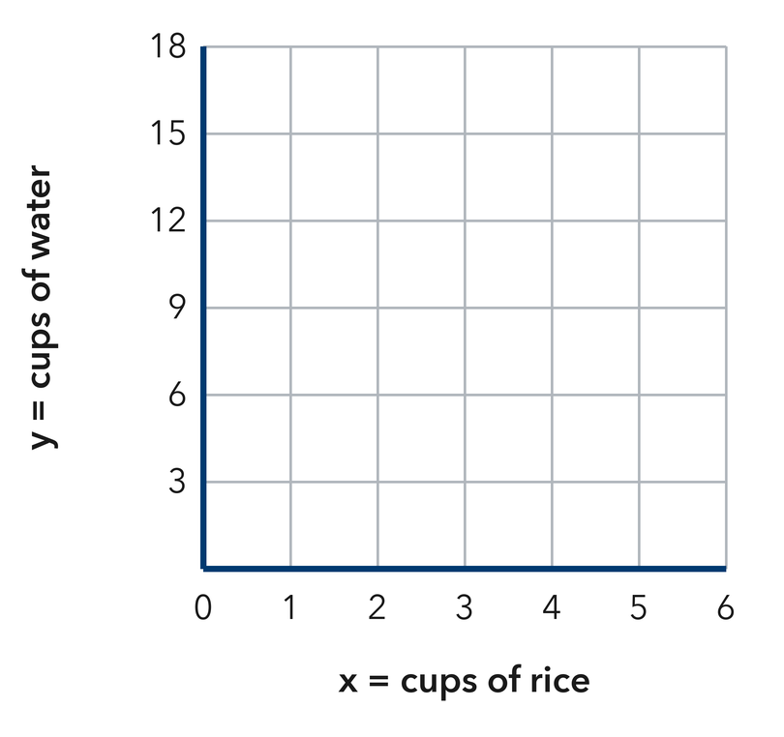
  Show your work.
ANALYZE THE ERROR 5 min
13. Read the work below. Explain the mistake, then show the correct reasoning.
MATEO’S WORK
A train travels 60 mph. Mateo plotted the points backwards as (60, 1) and (120, 2).

a. Explain the mistake. What mistake did Mateo make?  Sentence frame: “Mateo flipped x and y; time goes on the x-axis, so points should be (1, 60) and (2, 120)…” | b. Show correct work  Correct answer
  Show the correct work.
STRETCH YOUR THINKING multi-step reasoning · 8 min
14. Two Stores. Store A sells notebooks at 3 for $6. Store B sells them at 4 for $10.  a. Give two ordered pairs (notebooks, cost) for each store.  b. Which store’s line would be steeper? Explain what steeper means here.  c. Find the cost of 8 notebooks at each store.  Answer the pairs, the steeper line, and both costs | d. Graph both stores. Plot each store’s pairs on the same plane and draw both lines. Label them A and B.​  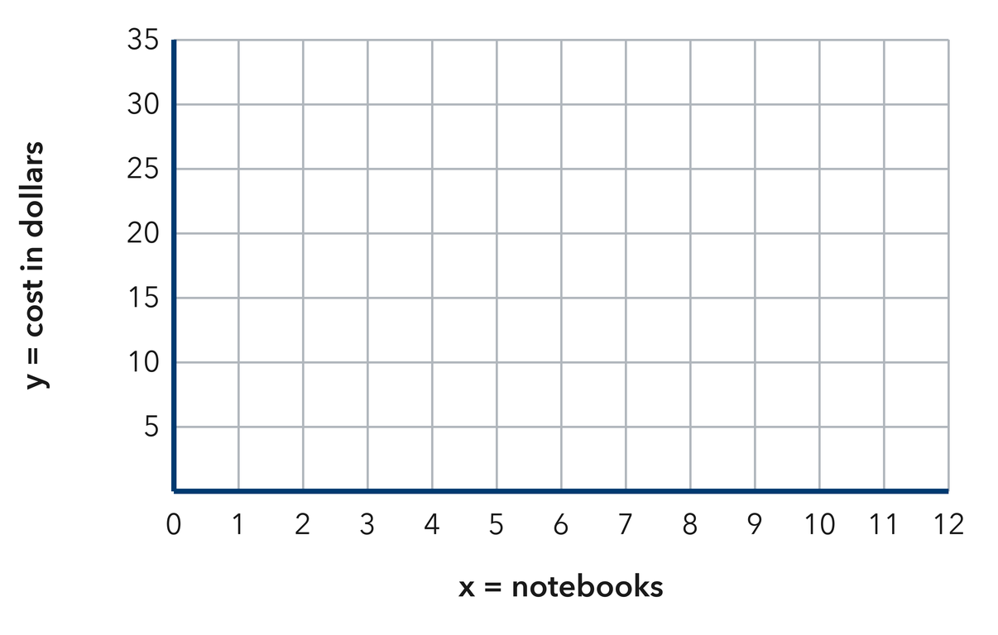
  Show your work.
TEST PRACTICE multiple choice · fill one box · 6 min
15. In the ordered pair (4, 12), the number 4 is the — | 16. A ratio of 1 : 6 gives which ordered pair when x = 3?
  □ A. x-value | □ B. y-value | □ C. origin | □ D. slope
  □ A. (18, 3) | □ B. (3, 18) | □ C. (3, 6) | □ D. (6, 3)

17. Points from equivalent ratios always form a — | 18. A ratio graph always passes through —
  □ A. curve | □ B. circle | □ C. straight line | □ D. square
  □ A. (1, 0) | □ B. (1, 1) | □ C. (0, 1) | □ D. (0, 0)
SPIRAL REVIEW earlier skills · keep them sharp · 6 min
19. From Lesson 3-3 Session 2. For 6 : 15, how much goes with 10?  Answer | 20. From Lesson 3-2 Session 1. A machine fills 240 bottles in 5 minutes. Find the unit rate.  Answer

21. From Lesson 3-1 Session 2. Share 55 in the ratio 3 : 8. Find both shares.  Answer | 22. From Lesson 2-3 Session 1. Find the median of 34, 29, 41, 37, 31.  Answer
CHECK YOUR UNDERSTANDING 5 min
23. Bread Baking Graph. A bakery bakes 4 loaves per batch.  a. Write ordered pairs for 1, 2, and 3 batches __________  b. What does the point (5, 20) mean in words? __________  Hint Multiply batches by 4.  Answer | c. Graph. Plot the ordered pairs on the coordinate plane, then draw a straight line through the points and the origin.​  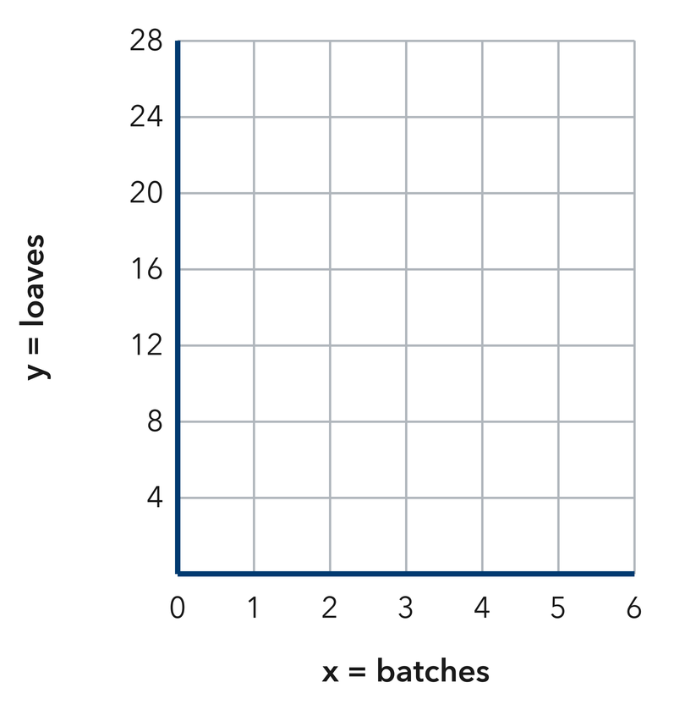
  Show your work.

□ 4 — Can teach it | □ 3 — Got it | □ 2 — Need hint | □ 1 — Need help
Circle your confidence. Star one problem that shows your learning.

