Name |  | Date |  | Period
Lesson 4-1 · Session 1 · Version 2
Guided Practice · Version 2
Percent Means Per Hundred
VOCABULARY read and say each word before you begin
percent  Spanish: por ciento | A ratio that compares a number to 100. | 40% = 40 out of every 100
per hundred | For every group of 100 — the meaning inside percent. | 7% means 7 per hundred
decimal grid | A 10-by-10 grid of 100 squares; each square is 1%. | 62 shaded squares = 62%
part-to-whole | Compares one part against the whole amount. | shaded squares to all squares
equivalent ratio  Spanish: razón equivalente | Same value; multiply both terms by the same number. | 2 : 5 40 : 100
EXPLORE TOGETHER Class Launch · 8–10 min
1. Camp Activity Sign-ups  At Ms. Rivera’s camp, out of every 25 campers, 14 chose canoeing, 7 chose archery, and 4 chose crafts. Ms. Rivera wants each choice written as a percent.  a. Scale. What factor changes 25 to one hundred? ______ Multiply each activity count by that factor.  b. Percent. Write canoeing as a per-hundred ratio and a percent: ______ out of one hundred = ______ %  c. Percent. Write crafts as a per-hundred ratio and a percent: ______ out of one hundred = ______ %  d. Meaning. Complete: “At the same rate, about ______ out of one hundred campers would choose canoeing.” | e. Decimal grids. Use one grid for each activity and shade its percent. Each square represents one camper out of a hundred.​  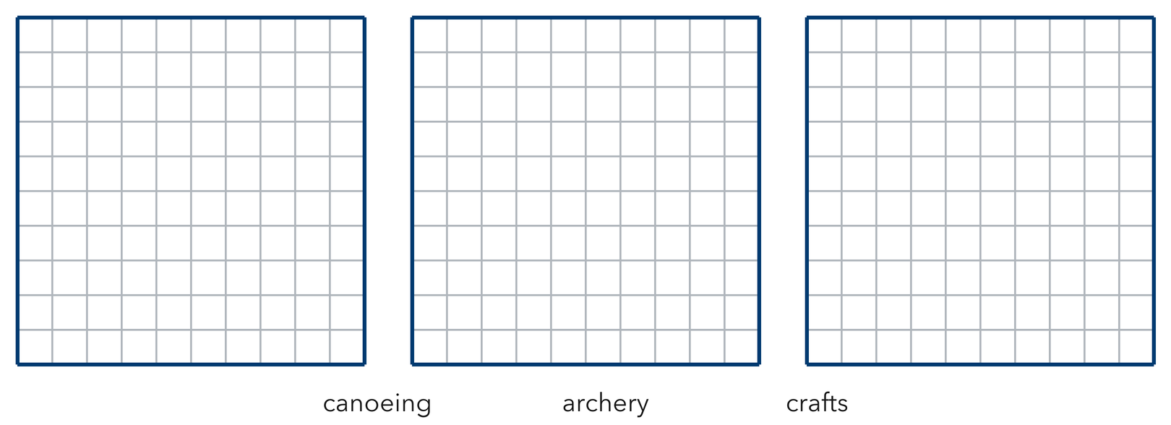
  TURN AND TALK
  Why can we compare these groups as percents even though only 25 campers were counted?
PRACTICE WITH A PARTNER You Do Together · 10–12 min
2. Coupon Counters. At a market, 13 out of every 20 shoppers used a coupon.
a. Scale it: 11 × __________
b. What percent were not returned on time? __________
PARTNER TALK
Why must the coupon percent and the no-coupon percent together make one whole hundred?

3. Grid Shading. Amaya shades 62 squares on a decimal grid (a hundred equal squares).  a. Write the percent shaded __________  b. Express the shaded amount as a decimal __________ | c. Decimal grid. Shade Leila’s 62 squares, then use the grid to identify the percent and decimal.​  
  PARTNER TALK
  How does the grid show the part and the whole at the same time?

4. Sneaker Survey. Out of every 50 sixth graders surveyed, 33 wear sneakers with laces.
a. Scale it 29 out of 50 = ______ out of 100 __________
b. Percent that grow vegetables __________
PARTNER TALK
You multiplied both numbers by 2. Why does that keep the comparison true?

PRACTICE ON YOUR OWN You Do · 8 problems · 18–20 min
5. Bike Riders. In a school survey, 2 out of every 5 students bike to school.  Write the bus riders as an equivalent per-hundred ratio, then write the percent  Hint Find the factor that changes 5 to one hundred, then multiply both terms by that factor.  Answer percent who read before bed who ride the bus | 6. Visitor Claim. Trey says 12 out of every 25 visitors equals 12%. Justify or correct his claim with a per-hundred ratio.  Hint 8 compares to 25, not to one hundred. Scale the ratio first. Complete: “Malik’s claim is ______ because 8 out of 25 equals ______ out of 100, or ______%.”  Answer true percent (Is Malik right?)

7. Quilt Patches. A quilt has 25 patches. 16 are star patches and the rest are moon patches.  Find the number of tulips, then write the tulips as a percent of all plants  Hint Subtract to count the tulips first, then build a per-hundred ratio from tulips out of 25.  Answer percent who read before bed tulips | 8. Snack Cart. A snack cart holds 20 snacks. 11 of them are granola bars and the rest are fruit cups.  Find the number of crayons, then write the crayons as a percent of all the drawing tools  Hint Subtract to count the crayons first, then ask what number times 20 reaches one hundred.  Answer number of crayons, then the percent

9. Locker Check. A hallway has 50 lockers and 39 of them are in use.  Write the occupied seats as a per-hundred ratio, then write the percent  Hint Multiply 50 by 2 to reach one hundred, and multiply the occupied-seat count by 2 too.  Answer per-hundred ratio of occupied seats, then the percent | 10. Packed Lunches. In a survey, 18 out of every 50 sixth graders pack their lunch. What percent is that?  Hint Scale 21 : 50 by 2 to reach a denominator of 100.  Answer percent who read before bed

11. Quiz Score. A student answered 17 of 20 questions correctly. What percent is that?  Hint Scale 19 : 20 by 5.  Answer percent who read before bed | 12. Two Ways. A club has 12 members and 9 of them play an instrument.  a. Write the ratio of shelter volunteers to members. __________  b. Express that ratio as a percent. __________  Hint 12 : 16 simplifies to 3 : 4, which scales to 75 : 100.  Answer a. ratio and b. percent
ANALYZE THE ERROR 5 min
13. Read the work below. Explain the mistake, then show the correct reasoning.
ELENA’S WORK

Nia surveyed 25 classmates and 11 chose soccer. She wrote: ‘So 11% of my classmates chose soccer.’
a. Explain the mistake. Elena writes that 9 out of 25 seedlings sprouted, so 9% sprouted. What must happen before the ratio can become a percent? Complete: “Elena must ______ because percent means ______.” | b. Show correct work for 9 out of 25 seedlings. Write an equivalent per-hundred ratio and the correct percent.  Correct answer
  Show the correct work.
STRETCH YOUR THINKING multi-step reasoning · 8 min
14. Field Day Results. Of 40 students, 26 finished the obstacle course and the rest did not.
a. What percent used the recycling pickup service?
b. What percent did not use the recycling pickup service?
c. Explain how the two percents together let you check your answers without calculating either percent again.
Answer both household percents and your check
TEST PRACTICE multiple choice · fill one box · 6 min
15. The word percent means — | 16. 14 out of 25 written as a percent is —
  □ A. per dozen | □ B. per ten | □ C. per thousand | □ D. per hundred
  □ A. 56% | □ B. 14% | □ C. 25% | □ D. 39%

17. 9 out of 20 written as a percent is — | 18. A percent compares a part to a whole of —
  □ A. 9% | □ B. 45% | □ C. 20% | □ D. 29%
  □ A. 1 | □ B. 10 | □ C. 100 | □ D. 50
SPIRAL REVIEW earlier skills · keep them sharp · 6 min
19. From Lesson 3-7 Session 2. At 5 mg per kg, what dose does a 14-kg animal need?  Answer | 20. From Lesson 3-6 Session 1. Convert 7 feet to inches.  Answer

21. From Lesson 3-2 Session 1. A car travels 220 miles in 4 hours. Find the unit rate.  Answer | 22. From Lesson 2-8 Session 1. Find the mean of 18, 22, 26.  Answer
CHECK YOUR UNDERSTANDING 5 min
23. Inbox Check. Of every 20 emails Mr. Cole gets, 17 are read the same day.
a. Percent submitted on time __________
b. Percent not submitted on time __________
Hint Scale 13 out of 20 to a per-hundred ratio; the two percents together must equal the whole.
Answer

□ 4 — Can teach it | □ 3 — Got it | □ 2 — Need hint | □ 1 — Need help
Circle your confidence. Star one problem that shows your learning.

