Name |  | Date |  | Period
Lesson 4-1 · Session 1
Guided Practice
Percent Means Per Hundred
VOCABULARY read and say each word before you begin
percent  Spanish: por ciento | A ratio that compares a number to 100. | 40% = 40 out of every 100
per hundred | For every group of 100 — the meaning inside percent. | 7% means 7 per hundred
decimal grid | A 10-by-10 grid of 100 squares; each square is 1%. | 62 shaded squares = 62%
part-to-whole | Compares one part against the whole amount. | shaded squares to all squares
equivalent ratio  Spanish: razón equivalente | Same value; multiply both terms by the same number. | 2 : 5 40 : 100
EXPLORE TOGETHER Class Launch · 8–10 min
1. Camp Activity Sign-ups  Out of every 25 campers, 14 chose canoeing, 7 chose archery, and 4 chose crafts. The camp director wants each choice written as a percent.  a. Scale. What number times 25 gives one hundred? ______ Multiply every count by that number.  b. Percent. Canoeing as a per-hundred ratio and a percent: ______ out of one hundred = ______ %  c. Percent. Crafts as a per-hundred ratio and a percent: ______ out of one hundred = ______ %  d. Meaning. Finish: “If one hundred campers signed up, about ______ of them would choose canoeing.” | e. Decimal grids. Shade one grid per activity. Every square is one camper out of a hundred.​  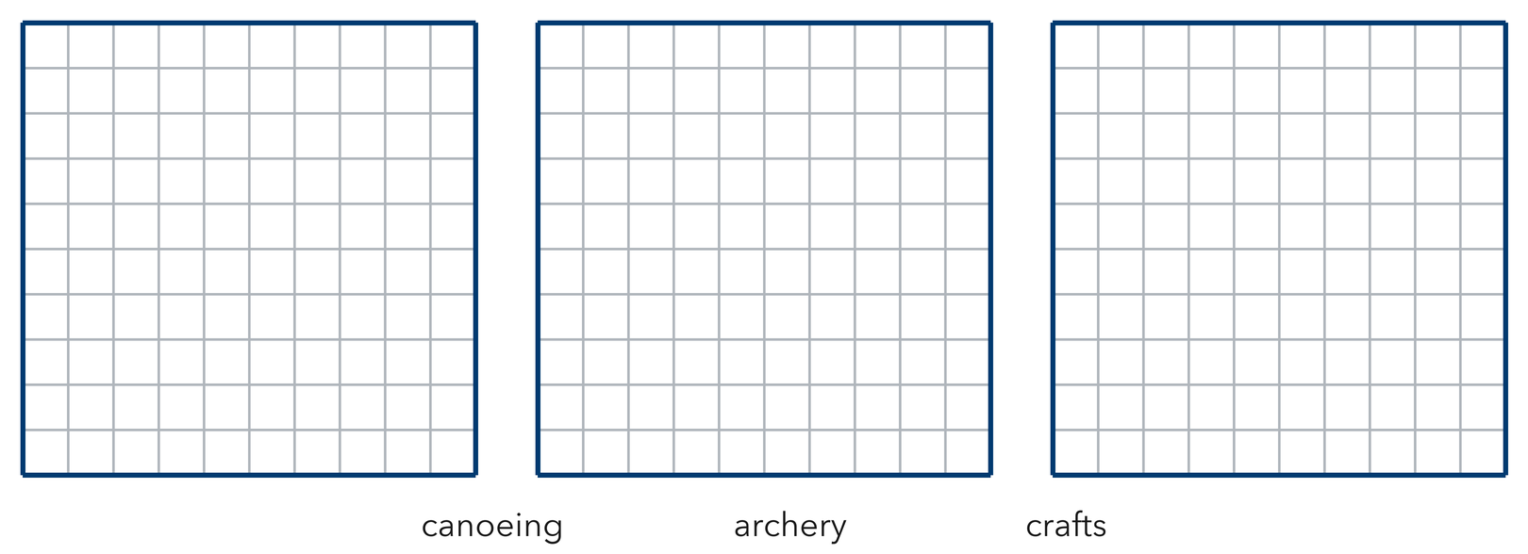
  TURN AND TALK
  Why can we compare these groups as percents even though only 25 campers were counted?
PRACTICE WITH A PARTNER You Do Together · 10–12 min
2. Coupon Counters. At a market, 13 out of every 20 shoppers used a coupon.
a. Scale it: 13 × __________
b. What percent did not use a coupon? __________
PARTNER TALK
Why must the coupon percent and the no-coupon percent together make one whole hundred?

3. Grid Shading. Amaya shades 62 squares on a decimal grid (a hundred equal squares).  a. Percent shaded __________  b. Write the shaded amount as a decimal __________ | c. Decimal grid. Shade Amaya’s 62 squares, then read the percent and the decimal straight off the grid.​  
  PARTNER TALK
  How does the grid show the part and the whole at the same time?

4. Sneaker Survey. Out of every 50 sixth graders surveyed, 33 wear sneakers with laces.
a. Scale it 33 out of 50 = ______ out of 100 __________
b. Percent with laces __________
PARTNER TALK
You multiplied both numbers by 2. Why does that keep the comparison true?

PRACTICE ON YOUR OWN You Do · 8 problems · 18–20 min
5. Bike Riders. In a school survey, 2 out of every 5 students bike to school.  Write an equivalent per-hundred ratio, then write the percent  Hint Ask what number times 5 reaches one hundred, then multiply both terms by it.  Answer percent who bike | 6. Visitor Claim. Trey says 12 out of every 25 visitors equals 12%. Justify or correct his claim with a per-hundred ratio.  Hint 12 compares to 25, not to one hundred. Scale the ratio first, then look at Trey’s percent again.  Answer true percent (Is Trey right?)

7. Quilt Patches. A quilt has 25 patches. 16 are star patches and the rest are moon patches.  Find the number of moon patches, then write the moon patches as a percent of all patches  Hint Subtract to count the moons first, then build a per-hundred ratio from moons out of 25.  Answer percent moon patches | 8. Snack Cart. A snack cart holds 20 snacks. 11 of them are granola bars and the rest are fruit cups.  Find the number of fruit cups, then write the fruit cups as a percent of all the snacks  Hint Subtract to count the fruit cups first, then ask what number times 20 reaches one hundred.  Answer number of fruit cups, then the percent

9. Locker Check. A hallway has 50 lockers and 39 of them are in use.  Write the lockers in use as a per-hundred ratio, then write the percent  Hint Fifty doubles to one hundred, so double the other term too.  Answer per-hundred ratio, then the percent | 10. Packed Lunches. In a survey, 18 out of every 50 sixth graders pack their lunch. What percent is that?  Hint Scale 18 : 50 by 2 to reach a denominator of 100.  Answer percent

11. Quiz Score. A student answered 17 of 20 questions correctly. What percent is that?  Hint Scale 17 : 20 by 5.  Answer percent | 12. Two Ways. A club has 12 members and 9 of them play an instrument.  a. Write the ratio of instrument players to members. __________  b. Write that ratio as a percent. __________  Hint 9 : 12 simplifies to 3 : 4, which scales to 75 : 100.  Answer a and b
ANALYZE THE ERROR 5 min
13. Read the work below. Explain the mistake, then show the correct reasoning.
NIA’S WORK

Nia surveyed 25 classmates and 11 chose soccer. She wrote: ‘So 11% of my classmates chose soccer.’
a. Explain the mistake. Nia’s ratio compares 11 to 25. What must happen before it can become a percent? | b. Show correct work  Correct answer
  Show the correct work.
STRETCH YOUR THINKING multi-step reasoning · 8 min
14. Field Day Results. Of 40 students, 26 finished the obstacle course and the rest did not.
a. What percent finished the course?
b. What percent did not finish?
c. Explain how you can check the two percents without recomputing either one.
Answer both percents and your check
TEST PRACTICE multiple choice · fill one box · 6 min
15. The word percent means — | 16. 14 out of 25 written as a percent is —
  □ A. per dozen | □ B. per ten | □ C. per thousand | □ D. per hundred
  □ A. 56% | □ B. 14% | □ C. 25% | □ D. 39%

17. 9 out of 20 written as a percent is — | 18. A percent compares a part to a whole of —
  □ A. 9% | □ B. 45% | □ C. 20% | □ D. 29%
  □ A. 1 | □ B. 10 | □ C. 100 | □ D. 50
SPIRAL REVIEW earlier skills · keep them sharp · 6 min
19. From Lesson 3-7 Session 2. At 5 mg per kg, what dose does a 14-kg animal need?  Answer | 20. From Lesson 3-6 Session 1. Convert 7 feet to inches.  Answer

21. From Lesson 3-2 Session 1. A car travels 220 miles in 4 hours. Find the unit rate.  Answer | 22. From Lesson 2-8 Session 1. Find the mean of 18, 22, 26.  Answer
CHECK YOUR UNDERSTANDING 5 min
23. Inbox Check. Of every 20 emails Mr. Cole gets, 17 are read the same day.
a. Percent read the same day __________
b. Percent not read the same day __________
Hint Scale 17 out of 20 to a per-hundred ratio; the two answers together must make the whole.
Answer

□ 4 — Can teach it | □ 3 — Got it | □ 2 — Need hint | □ 1 — Need help
Circle your confidence. Star one problem that shows your learning.

