Name |  | Date |  | Period
Lesson 4-3 · Session 1 · Version 2
Guided Practice · Version 2
Estimate with Benchmarks
VOCABULARY read and say each word before you begin
estimate  Spanish: estimar | A close-enough answer found without exact math. | about 70% used
benchmark percent | A friendly landmark percent used for estimating. | 10%, 25%, 50%, 75%
double number line | Two lined-up lines: amounts above, percents below. | 0, 30, 60 GB over 0%, 50%
the whole | The amount that counts as 100% right now. | all of the storage
about | A signal that an answer is an estimate. | about one quarter full
EXPLORE TOGETHER Class Launch · 8–10 min
1. Phone Storage Check  Jordan’s phone holds 120 GB. About 72 GB are used, including about 54 GB of photos.  a. Whole. What amount represents one hundred percent of Jordan’s phone storage? ______ GB  b. Estimate. Use the double number line below — Jordan’s whole phone holds 120 GB. About what percent of its storage is used? ______ %  c. New Whole. Treat Jordan’s used space as the whole. About what percent of that space holds photos? ______ % | d. Meaning. Explain why the whole changes when you compare photos with used space. __________  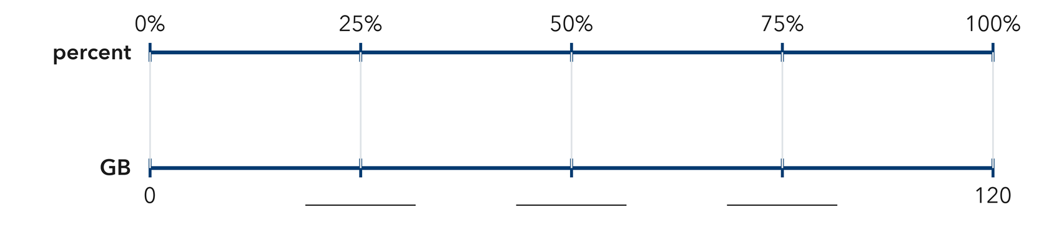​
  TURN AND TALK
  Why does naming the whole first change the percent that you estimate?
PRACTICE WITH A PARTNER You Do Together · 10–12 min
2. Reading Goal. Ana’s goal is 240 pages this month. So far she has read 118 pages.  a. Benchmarks on a double number line for Mira’s 240-page goal: 25% __________  b. About what percent of Mira’s reading goal has she completed? __________ | c. Double number line. Write the page amounts on the bottom scale that match each percent. Mark the benchmarks, then locate Mira’s 118 pages between two of them.  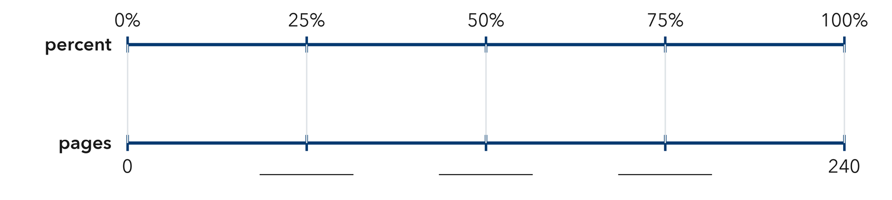
  PARTNER TALK
  How does a benchmark let you judge an answer without doing exact arithmetic?

3. Class Fundraiser. A class wants to raise $400 for a field trip. So far they have raised $310.  a. Benchmark amounts for the garden goal: 10% __________  b. About what percent of the garden goal has been collected? __________ | 4. Gym Water Jug. A water jug for the gym holds 32 cups and has 17 cups left in it.  a. Benchmark Half of the aquarium’s capacity, in liters __________  b. Estimate About what percent of the aquarium’s capacity is filled? __________
  PARTNER TALK
  Why is an estimate good enough for a progress report like this one?
  PARTNER TALK
  Why is an answer of about half close enough for a question like this one?
PRACTICE ON YOUR OWN You Do · 8 problems · 18–20 min
5. Bus Seats. A school bus has 44 seats and 21 of them are filled.  Estimate what percent of the bicycle rack is occupied, and write the benchmark you used  Hint Find how many bicycles would fill half the rack, then compare that amount with the parked bicycles.  Answer estimated percent occupied | 6. Estimate Check. Kwame says that 19 out of 60 is about 50%. Justify or correct his estimate using a benchmark.  Hint Find half of 80, then compare Soren’s 23 puzzles with the 25% and 50% benchmark amounts.  Answer better estimate (Is Soren right?)

7. Trail Progress. A hiking trail is 36 km long. A hiker has already walked 27 km of it.  Estimate the percent of the mural painted, then find the percent still left to paint  Hint Divide the mural’s area into four equal parts. Find one quarter first, then count how many parts are painted.  Answer percent painted, percent left | 8. Parking Lot. A parking lot has 80 spaces and 61 of them are taken.  Estimate the percent of the planting cells that contain seedlings, and name the benchmark you used  Hint Split 120 into four equal groups of 30. Compare the number of seedlings with those quarter marks.  Answer estimated percent containing seedlings

9. Chorus Tickets. A chorus printed 480 tickets for its concert and has sold 47 of them.  Estimate the percent of the guides handed out, then estimate the percent not yet handed out  Hint Ten percent of 350 is 35. Compare the number of guides handed out with that ten percent mark.  Answer percent handed out, then percent not handed out | 10. Tablet Storage. A tablet holds 64 GB and 47 GB are used. About what percent is used?  Hint Half of 88 is 44 and three fourths is 66. Which is 65 closer to?  Answer about what percent of the shelf’s capacity is used

11. Reading Progress. A reader has finished 62 pages of a 240-page book. About what percent is finished?  Hint One fourth of 280 is 70.  Answer about what percent of the shelf’s capacity is used | 12. Pick the Benchmark. A jar holds 80 marbles and 41 are blue.  a. Which benchmark percent is closest to the percent of yarn balls that are green? __________  b. Explain how you used a benchmark amount to decide. __________  Hint Half of 96 is 48.  Answer a and b: the benchmark percent and your reasoning
ANALYZE THE ERROR 5 min
13. Read the work below. Explain the mistake, then show the correct reasoning.
DARIUS’S WORK

A drive holds 200 GB. Elena has used 150 GB, and 30 GB of that is music. She said music is about 75% of the drive.
a. Explain the mistake. A community center has 160 chairs. Of these, 80 are in the auditorium, and 60 of the auditorium chairs are occupied. Darius writes, “60 ÷ 80 = 75%, so 75% of all the center’s chairs are occupied auditorium chairs.” Which whole does Darius’s 75% really describe? About what percent of all 160 chairs are occupied auditorium chairs? Use the frame: “Darius used _____ as the whole, but the question uses _____.” | b. Show correct work using all 160 chairs as the whole.  Correct answer
  Show the correct work.
STRETCH YOUR THINKING multi-step reasoning · 8 min
14. Class Fundraiser. A class set a goal of $500 and has raised $124.
a. Name the benchmark percent closest to the amount of the can collection goal completed.
b. About how many more cans are needed to reach 50% of the goal?
c. Explain why an estimate helps the class judge its progress even though the exact percent can be found.
Answer the benchmark, the number of cans needed, and your explanation
TEST PRACTICE multiple choice · fill one box · 6 min
15. 10% of an amount is the same as — | 16. 19 out of 40 is about —
  □ A. one fifth | □ B. one tenth | □ C. one half | □ D. one hundredth
  □ A. 75% | □ B. 25% | □ C. 50% | □ D. 10%

17. 25% is the same as — | 18. 31 out of 120 is about —
  □ A. one fifth | □ B. one third | □ C. one half | □ D. one fourth
  □ A. 25% | □ B. 50% | □ C. 75% | □ D. 10%
SPIRAL REVIEW earlier skills · keep them sharp · 6 min
19. From Lesson 4-2 Session 2. Which is greater, 0.7 or 68%?  Answer | 20. From Lesson 4-1 Session 1. Write 7 out of 25 as a percent.  Answer

21. From Lesson 3-7 Session 2. At 4 mg per kg, what dose does an 11-kg animal need?  Answer | 22. From Lesson 2-9 Session 1. Find the MAD of 20, 24, 28.  Answer
CHECK YOUR UNDERSTANDING 5 min
23. Sticker Sheet. A sticker sheet holds 160 stickers and 38 of them have already been used.
a. About what percent of the ribbon has been used? __________
b. About what percent of the ribbon is still left? __________
Hint Find the quarter marks for the full spool, then decide which mark the used length is nearest to.
Answer

□ 4 — Can teach it | □ 3 — Got it | □ 2 — Need hint | □ 1 — Need help
Circle your confidence. Star one problem that shows your learning.

