Name Date Period
Lesson 4-4 · Homework Packet · Sheet 1 of 2
Find the Percent of a Number
Maryland Standard 6.RP.A.3c · Learning target — I can find the percent of a number exactly.

REMEMBER  • The whole comes after “of.” In 30% of 80, the whole is 80.  • Percent to decimal, then multiply: 0.3 × 80 = 24.  • Or use 10%: 10% of 80 = 8, so 30% = 3 × 8 = 24. | WORKED EXAMPLE  Find 35% of 60.  Step 1 Write 35% as a decimal: 0.35.  Step 2 Multiply: 0.35 × 60 = 21.  Step 3 Check with 10%: 6 + 6 + 6 + 3 = 21.  Answer 21
PRACTICE show your work · label units
1. Find each part.
a. 20% of 45 = | b. 75% of 64 = | c. 6% of 350 =
d. 45% of 80 = | e. 150% of 30 = | f. 12% of 250 =

2. Lunch from Home. A grade has 180 students. 40% of them bring lunch from home. Fill in the double number line. Then find how many students bring lunch.
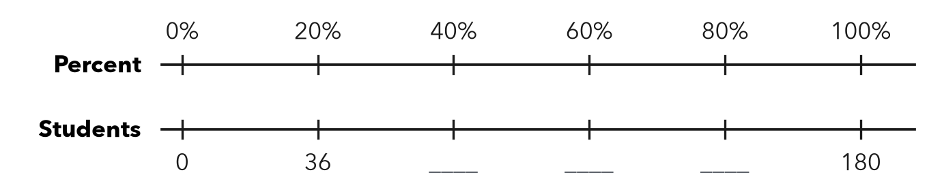
Answer students

3. Jacket Sale. A jacket costs $64. It is on sale for 25% off. How much money is taken off? What is the sale price?
a. Discount:
b. Sale price:

Show your work.

4. Soccer Team. A soccer team has 40 players. 15% of the players are new this year. How many players are new?
Answer players

5. Compare. Which is greater: 30% of 90, or 90% of 30? Show both amounts. Explain what you notice.

CHECK YOURSELF | □ I can do this on my own | □ I need a little help | □ I have a question about #
AT HOME Find a sale sign or a tip suggestion. Work out the exact amount with someone at home.
Name Date Period
Lesson 4-4 · Homework Packet · Sheet 2 of 2
Compare Percents
Maryland Standard 6.RP.A.3c · Learning target — I can compare two records fairly by converting each one to a percent.

REMEMBER  • Compare records fairly: write each as a percent.  • Scale to out of 100, or divide part ÷ whole.  • More hits is not always a better rate. | WORKED EXAMPLE  Mia made 14 of 20 shots. Leo made 18 of 25. Who has the better rate?  Step 1 Mia: 14/20 = 70/100 = 70%. Leo: 18/25 = 72/100 = 72%.  Step 2 Compare: 72% > 70%.  Answer Leo has the better rate.
PRACTICE show your work · label units
1. Write each record as a percent.
a. 21 out of 30 = % | b. 13 out of 20 = % | c. 9 out of 12 = %

2. Softball Hits. Complete the table. Circle the player with the best record.
Player | Hits | At bats | Percent
Ava | 9 | 20
Ben | 12 | 25
Cruz | 22 | 50

3. Spelling Tests. Rosa spelled 34 of 40 words correctly. Kai spelled 42 of 50 words correctly. Write each as a percent. Who did better?
Percents and who did better

4. Select all the records that are greater than 70%.
□ A 15 out of 20 | □ B 17 out of 25 | □ C 36 out of 50 | □ D 7 out of 10

5. Find the Error. Deja says 18 out of 24 = 24 out of 30. Is she right? Explain.

TEST PRACTICE choose the best answer
6. Which record has the greatest percent?
A 13 out of 20 | B 16 out of 25 | C 33 out of 50 | D 6 out of 10

7. Team A won 12 of 16 games. Team B won 15 of 25 games. Which is true?
A B did better. It won more games. | B A won 75%, B won 60%. A did better.
C Both teams did equally well. | D A won 12%, B won 15%.

CHECK YOURSELF | □ I can do this on my own | □ I need a little help | □ I have a question about #
AT HOME Compare two game records at home by changing both to percents.

