Name |  | Date |  | Period
Lesson 4-4 · Session 1 · Version 2
Guided Practice · Version 2
Find the Percent of a Number
VOCABULARY read and say each word before you begin
base | The whole amount that follows the word of. | 45% of 300 base is 300
part | The amount that the percent describes. | 45% of 300 is 135
equation  Spanish: ecuación | A number sentence with an equal sign. | part = 0.45 × 300
percent  Spanish: por ciento | A ratio that compares a number to 100. | 45% = 0.45
double number line | Percents on one line, amounts on the other. | 0%–100% over 0–300
EXPLORE TOGETHER Class Launch · 8–10 min
1. Cafeteria Drink Vote  Ms. Rivera collected votes from 200 students for a new cafeteria drink. 30% chose milk, 55% chose water, and the rest chose juice.  a. Base. How many students represent one hundred percent? ______ Percent that chose juice: ______ %  b. Equation. Find the milk count: part = ______ × ______ = ______ students  c. Model. Use the double number line below, from zero to the base of 200 students. Locate the number who chose water: ______ students | d. Check. Does the sum of the milk, water, and juice counts equal the base? ______ Show the sum: __________  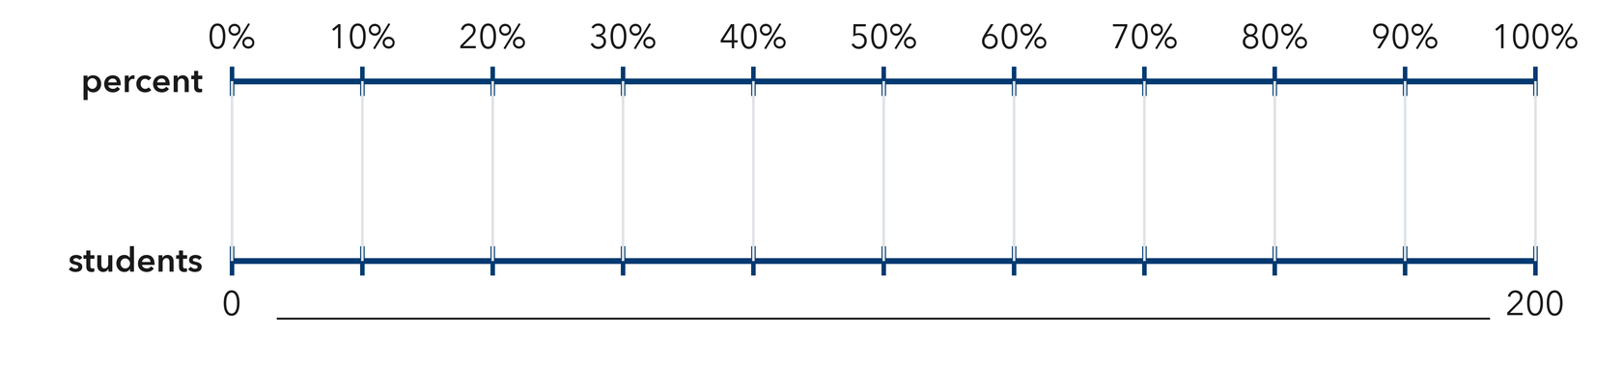​
  TURN AND TALK
  Why do you multiply by the percent written in hundredths instead of by the percent number itself?
PRACTICE WITH A PARTNER You Do Together · 10–12 min
2. Music Playlist. A playlist holds 80 songs, and 25% of them are new releases.  a. Percent in hundredths __________  b. Number of paintings __________ | 3. Book Pages. A book has 320 pages, and Lena has already read 65% of it.  a. Meters he has walked __________  b. Meters still left __________
  PARTNER TALK
  How can you check a percent answer without doing the whole multiplication again?
  PARTNER TALK
  Why do the read percent and the unread percent have to fill one whole together?

4. Pizza Orders. A shop sold 160 pizzas on Friday night, and 35% of them were cheese.
a. Hundredths Percent written in hundredths __________
b. Part Number of blueberry muffins __________
PARTNER TALK
Before you multiply, how do you know the answer has to be less than 160?

PRACTICE ON YOUR OWN You Do · 8 problems · 18–20 min
5. Team Jerseys. A team ordered 60 jerseys and 15% of that order is size small.  Write an equation and solve it to find the number of poetry books  Hint Write the percent in hundredths, then multiply by the total number of books in the order.  Answer number of poetry books | 6. Discount Claim. A $48 jacket is marked 20% off. Sam says the discount is $20. Justify or correct his claim with an equation.  Hint Identify the original price as the base. Convert the discount percent to hundredths and multiply.  Answer true discount (Is Priya right?)

7. School Garden. A garden holds 180 seedlings. 40% of them are peppers and 35% of them are tomatoes.  Find the number of cats, then find how many animals are neither cats nor dogs  Hint Find each animal group's percent of the whole, then determine what percent belongs to the other animals.  Answer cats, then the other animals | 8. Class Supplies. A school bought 450 pencils, and 12% of that order is mechanical pencils.  Write an equation and solve it to find the number of keychains  Hint Write 16% in hundredths, then multiply by the total number of souvenirs.  Answer number of keychains

9. Bus Ride Survey. A survey of 350 riders found that 26% ride the bus every day and 18% ride it twice a week.  Find how many students chose swimming, then find how many students chose neither swimming nor cycling  Hint Find each activity's share of the students, then subtract both counts from the total.  Answer students who chose swimming, then the other students | 10. Blue Hats. A display holds 250 hats and 36% of them are blue. How many are blue?  Hint Multiply 300 by 0.28.  Answer photos

11. Sales Tax. A $45 purchase has a 6% sales tax. Find the tax.  Hint Multiply 35 by 0.08.  Answer dollars | 12. Two Steps. A school of 640 students had 15% absent on Monday.  a. How many campers were away on the field trip? __________  b. How many campers remained at camp? __________  Hint Find 25% first, then subtract from 720.  Answer a and b
ANALYZE THE ERROR 5 min
13. Read the work below. Explain the mistake, then show the correct reasoning.
IMANI’S WORK: To find 30% of 90 craft beads, Imani wrote 30 × 90 = 2,700 beads.

To find 30% of 70 dollars, Hana multiplied 30 × 70 and wrote: ‘The part is 2,100 dollars.’
a. Explain the mistake. Here the percent is less than 100%, so the result must be less than the whole. What should Imani have multiplied by instead? Complete: Imani should multiply 90 by ______ because 30% means ______ hundredths. | b. Show correct work to find 30% of 90 craft beads  Correct answer
  Show the correct work.
STRETCH YOUR THINKING multi-step reasoning · 8 min
14. Concert Tickets. A hall seats 1,200 people. For one show 65% of the seats sold, and each ticket cost $18.
a. How many tour tickets were sold?
b. How much money was collected from the tour tickets?
c. How many tour spots were unsold, and what percent of all the spots is that?
Answer tickets, money, and the unsold spots with their percent
TEST PRACTICE multiple choice · fill one box · 6 min
15. 20% of 150 is — | 16. 45% written as a decimal is —
  □ A. 30 | □ B. 3 | □ C. 300 | □ D. 130
  □ A. 4.5 | □ B. 0.45 | □ C. 45 | □ D. 0.045

17. 8% of 400 is — | 18. To find a percent of a number you —
  □ A. 320 | □ B. 3.2 | □ C. 32 | □ D. 50
  □ A. subtract | □ B. divide | □ C. add | □ D. multiply
SPIRAL REVIEW earlier skills · keep them sharp · 6 min
19. From Lesson 4-3 Session 2. Estimate 20% of 510.  Answer | 20. From Lesson 4-2 Session 1. Write 0.85 as a percent.  Answer

21. From Lesson 4-1 Session 1. Write 6 out of 25 as a percent.  Answer | 22. From Lesson 3-6 Session 2. Convert 8 kilometres to meters.  Answer
CHECK YOUR UNDERSTANDING 5 min
23. Movie Night. A theater has 240 seats and 80% of them are sold for the evening show.
a. Equation for the spots reserved: part = __________
b. Spots reserved __________
Hint Write the percent in hundredths, multiply by the base, then subtract to find the unreserved spots.
Answer

□ 4 — Can teach it | □ 3 — Got it | □ 2 — Need hint | □ 1 — Need help
Circle your confidence. Star one problem that shows your learning.

