Name |  | Date |  | Period
Lesson 4-4 · Session 1
Guided Practice
Find the Percent of a Number
VOCABULARY read and say each word before you begin
base | The whole amount that follows the word of. | 45% of 300 base is 300
part | The amount that the percent describes. | 45% of 300 is 135
equation  Spanish: ecuación | A number sentence with an equal sign. | part = 0.45 × 300
percent  Spanish: por ciento | A ratio that compares a number to 100. | 45% = 0.45
double number line | Percents on one line, amounts on the other. | 0%–100% over 0–300
EXPLORE TOGETHER Class Launch · 8–10 min
1. Cafeteria Drink Vote  200 students voted for a new cafeteria drink. 30% chose milk, 55% chose water, and the rest chose juice.  a. Base. What number is the base, or one hundred percent? ______ Percent that chose juice: ______ %  b. Equation. Milk: part = ______ × ______ = ______ students  c. Model. Use the double number line below, from zero to the base of 200 students. Mark the water count: ______ students | d. Check. Do your three counts add back to the base? ______ Show the sum: __________  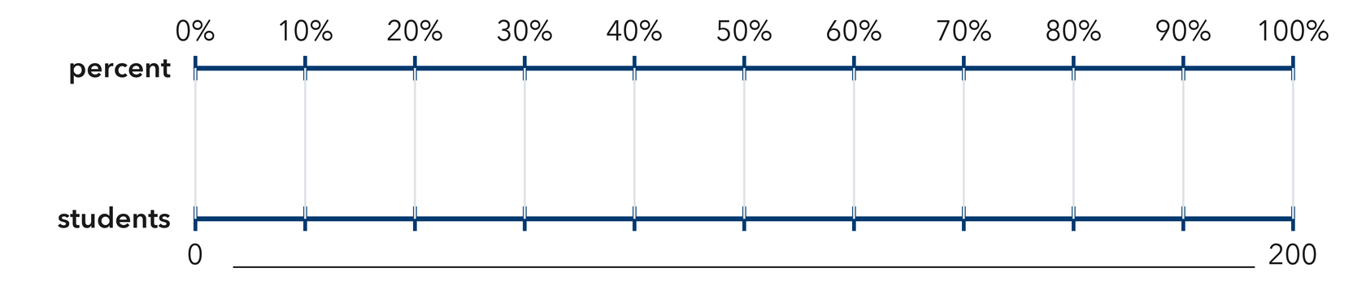​
  TURN AND TALK
  Why do you multiply by the percent written in hundredths instead of by the percent number itself?
PRACTICE WITH A PARTNER You Do Together · 10–12 min
2. Music Playlist. A playlist holds 80 songs, and 25% of them are new releases.  a. Percent in hundredths __________  b. Number of new releases __________ | 3. Book Pages. A book has 320 pages, and Lena has already read 65% of it.  a. Pages she has read __________  b. Pages still left __________
  PARTNER TALK
  How can you check a percent answer without doing the whole multiplication again?
  PARTNER TALK
  Why do the read percent and the unread percent have to fill one whole together?

4. Pizza Orders. A shop sold 160 pizzas on Friday night, and 35% of them were cheese.
a. Hundredths Percent written in hundredths __________
b. Part Number of cheese pizzas __________
PARTNER TALK
Before you multiply, how do you know the answer has to be less than 160?

PRACTICE ON YOUR OWN You Do · 8 problems · 18–20 min
5. Team Jerseys. A team ordered 60 jerseys and 15% of that order is size small.  Write an equation and solve it to find the number of small jerseys  Hint Change the percent to hundredths first, then multiply by the base that follows the word of.  Answer number of small jerseys | 6. Discount Claim. A $48 jacket is marked 20% off. Sam says the discount is $20. Justify or correct his claim with an equation.  Hint The percent describes a part of the price, not the price itself. Check which number is the base here.  Answer true discount (Is Sam right?)

7. School Garden. A garden holds 180 seedlings. 40% of them are peppers and 35% of them are tomatoes.  Find the number of peppers, then find how many seedlings are neither peppers nor tomatoes  Hint Handle one percent at a time, then think about what percent of the garden is left over at the end.  Answer peppers, then the other seedlings | 8. Class Supplies. A school bought 450 pencils, and 12% of that order is mechanical pencils.  Write an equation and solve it to find the number of mechanical pencils  Hint Write 12% in hundredths, then multiply by the base that follows the word of.  Answer number of mechanical pencils

9. Bus Ride Survey. A survey of 350 riders found that 26% ride the bus every day and 18% ride it twice a week.  Find how many riders ride every day, then find how many riders do neither  Hint Work one percent at a time, then subtract both parts from the base at the end.  Answer everyday riders, then the other riders | 10. Blue Hats. A display holds 250 hats and 36% of them are blue. How many are blue?  Hint Multiply 250 by 0.36.  Answer hats

11. Sales Tax. A $45 purchase has a 6% sales tax. Find the tax.  Hint Multiply 45 by 0.06.  Answer dollars | 12. Two Steps. A school of 640 students had 15% absent on Monday.  a. How many students were absent? __________  b. How many students were present? __________  Hint Find 15% first, then subtract from 640.  Answer a and b
ANALYZE THE ERROR 5 min
13. Read the work below. Explain the mistake, then show the correct reasoning.
HANA’S WORK

To find 30% of 70 dollars, Hana multiplied 30 × 70 and wrote: ‘The part is 2,100 dollars.’
a. Explain the mistake. Here the percent is less than 100%, so the result must be less than the whole. What should Hana have multiplied by instead? | b. Show correct work  Correct answer
  Show the correct work.
STRETCH YOUR THINKING multi-step reasoning · 8 min
14. Concert Tickets. A hall seats 1,200 people. For one show 65% of the seats sold, and each ticket cost $18.
a. How many tickets were sold?
b. How much money was collected?
c. How many seats were empty, and what percent of the hall is that?
Answer tickets, money, and the empty seats
TEST PRACTICE multiple choice · fill one box · 6 min
15. 20% of 150 is — | 16. 45% written as a decimal is —
  □ A. 30 | □ B. 3 | □ C. 300 | □ D. 130
  □ A. 4.5 | □ B. 0.45 | □ C. 45 | □ D. 0.045

17. 8% of 400 is — | 18. To find a percent of a number you —
  □ A. 320 | □ B. 3.2 | □ C. 32 | □ D. 50
  □ A. subtract | □ B. divide | □ C. add | □ D. multiply
SPIRAL REVIEW earlier skills · keep them sharp · 6 min
19. From Lesson 4-3 Session 2. Estimate 20% of 510.  Answer | 20. From Lesson 4-2 Session 1. Write 0.85 as a percent.  Answer

21. From Lesson 4-1 Session 1. Write 6 out of 25 as a percent.  Answer | 22. From Lesson 3-6 Session 2. Convert 8 kilometres to meters.  Answer
CHECK YOUR UNDERSTANDING 5 min
23. Movie Night. A theater has 240 seats and 80% of them are sold for the evening show.
a. Equation for the seats sold: part = __________
b. Seats sold __________
Hint Write the percent in hundredths, multiply by the base, then subtract to find the empty seats.
Answer

□ 4 — Can teach it | □ 3 — Got it | □ 2 — Need hint | □ 1 — Need help
Circle your confidence. Star one problem that shows your learning.

