Name |  | Date |  | Period
Lesson 4-5 · Session 1 · Version 2
Guided Practice · Version 2
Find the Whole
VOCABULARY read and say each word before you begin
part | The amount you already know. | $42 is the sale price
whole  Spanish: entero | The full amount the percent is measured against. | the original price
double number line | Amounts on one line, percents on the other. | $0, $7, $70 · 0%, 10%, 100%
equivalent ratio  Spanish: razón equivalente | The same ratio, scaled up or down. | 42 : 60 = 7 : 10
scale | Multiply or divide both terms equally. | divide both rows by 6
EXPLORE TOGETHER Class Launch · 8–10 min
1. Field Trip Deposit  Ms. Rivera’s class paid a $54 deposit toward a field trip. That deposit is 30% of the full cost of the trip.  a. Name. What dollar amount represents the part? ______ What percent represents the whole? ______ %  b. Scale. Use the double number line below. The 30% mark is $54. Scale down to 10%, then scale up to 100%. How many dollars represent ten percent? ______  c. Whole. Total cost of the field trip: ______ Describe your scaling: __________ | d. Check. Find 30% of your full cost. Does it equal the $54 deposit? ______  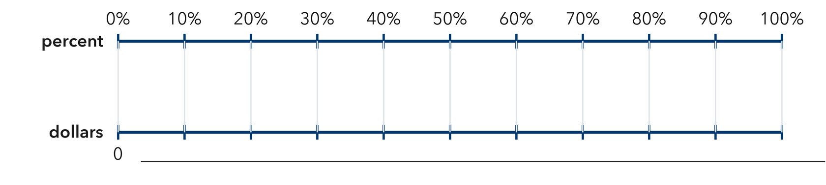​
  TURN AND TALK
  Why does finding ten percent first make the whole so much easier to build?
PRACTICE WITH A PARTNER You Do Together · 10–12 min
2. Puzzle Pieces. Nadia has placed 84 puzzle pieces so far, and that is 70% of the whole puzzle.  a. Ten percent of the colored pencils is __________  b. Total number of colored pencils __________ | 3. Water Bottle. A bottle has 45 mL of water left in it, and that is 15% of the full bottle.  a. Five percent of the container is __________  b. Full container __________
  PARTNER TALK
  How does a double number line show the part and the whole at the same time?
  PARTNER TALK
  Why must both rows of your ratio table be scaled by the same number?

4. Library Books. A class has returned 48 library books, and that is 60% of the books it borrowed.
a. Ten percent Number of permission slips representing ten percent __________
b. Whole Total permission slips handed out __________
PARTNER TALK
Before you scale up, how do you know the total has to be greater than 48?

PRACTICE ON YOUR OWN You Do · 8 problems · 18–20 min
5. Movie Tickets. A theater sold 96 tickets for a show, and that is 75% of all its seats.  Use a double number line or a ratio table to determine the theater’s total number of seats  Hint Scale down to a friendly percent, then scale up to one hundred percent.  Answer total number of theater seats | Double number line. Write the ticket amounts on the bottom scale to match each percent. The 75% mark represents 96 tickets.​  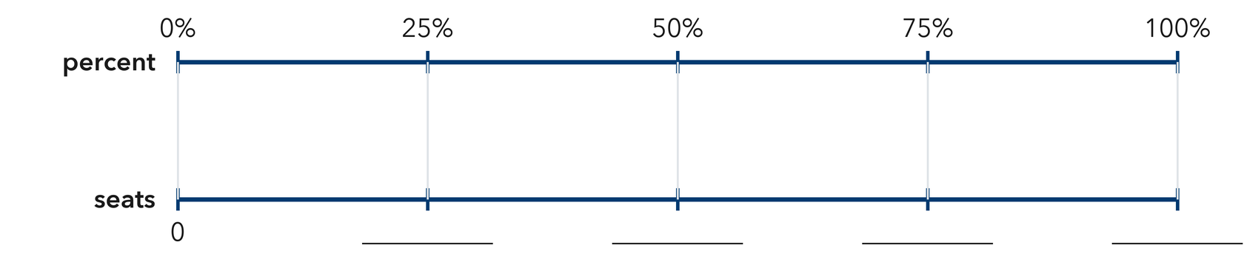
  Show your work.

6. Sale Claim. A hat sells for $21, which is 70% of its first price. Kip says the first price was $14.70. Justify or correct his claim.  Hint The whole has to be larger than the sale price. Check which direction Mateo scaled his ratio.  Answer true first price (Is Mateo right?) | 7. Reading Goal. Mia has read 56 pages of her book, and that is 20% of the whole book.  Find the total length of the route, then find how many meters Priya still has left to walk  Hint Step down to five percent, scale up to one hundred percent, then subtract the meters already walked.  Answer total meters, then meters left

8. Soccer Goals. A team has scored 27 goals so far, and that is 45% of the goals it scored all of last season.  Use a double number line or a ratio table to determine how many goals the team scored last season  Hint Scale both terms down to five percent, then scale both terms up to one hundred percent.  Answer total goals scored last season | Double number line. Write the goal amounts on the bottom scale to match each percent. The 45% mark represents 27 goals. Scale down to 5% first.​  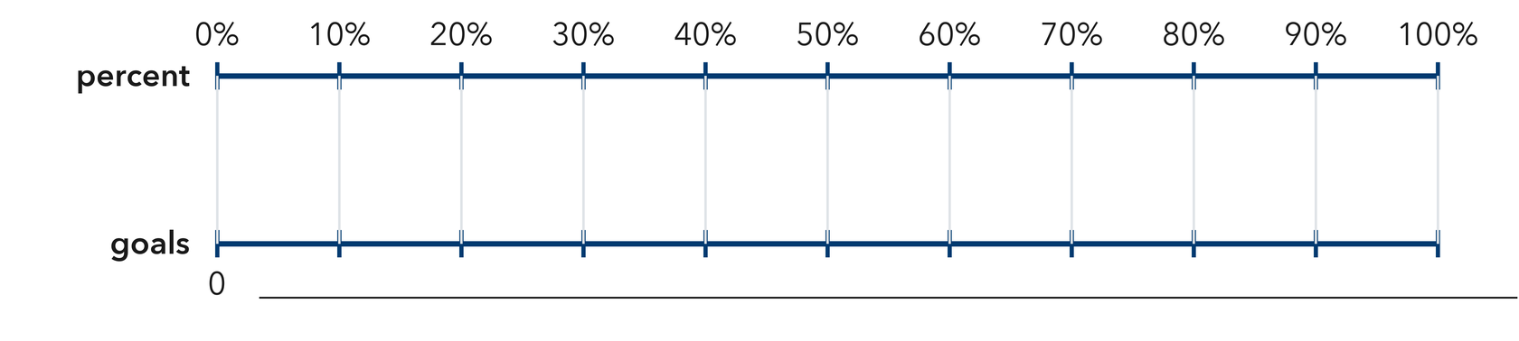
  Show your work.

9. Garden Fence. A crew has built 91 m of a garden fence, and that is 65% of the whole fence.  Find the total length of the trail, then find how many meters are still left to pave  Hint Step down to five percent first, scale up to one hundred percent, then subtract the length already paved.  Answer total trail length, then meters left | 10. Games Played. A team has won 24 games, and that is 40% of the games it played. How many games did it play?  Hint One percent is 42 ÷ 60 = 0.7, so the whole is 70.  Answer seedlings

11. Class Size. In a class, 18 students ride the bus, which is 75% of the class. How many students are in the class?  Hint Divide 28 by 0.80.  Answer visitors | 12. Two Steps. A jar holds red and blue marbles. There are 21 red marbles, which is 35% of the jar.  a. How many pieces of fruit are in the basket? __________  b. How many are oranges? __________  Hint Find the whole first, then subtract the apples.  Answer a and b
ANALYZE THE ERROR 5 min
13. Read the work below. Explain the mistake, then show the correct reasoning.
AVERY’S WORK

A jacket is on sale for $36, which is 80% of its first price. Caleb wrote: ‘First price = 0.8 × 36 = $28.80.’
a. Explain the mistake. A first price should be larger than the sale price. What move did Avery need instead? Complete: Avery needed to ______ because ______. | b. Show correct work and check that the given percent of the first price equals the sale price  Correct answer
  Show the correct work.
STRETCH YOUR THINKING multi-step reasoning · 8 min
14. Book Fair. A book fair sold 84 books on Friday, which was 28% of the week’s total sales.
a. How many muffins were sold in the whole week?
b. How many muffins were sold on the other days?
c. Explain how you can use 32% to check your answer to part a in one step.
Answer the week’s total muffins, the muffins sold on other days, and your check
TEST PRACTICE multiple choice · fill one box · 6 min
15. If 30 is 50% of a number, the number is — | 16. If 12 is 25% of a number, the number is —
  □ A. 80 | □ B. 15 | □ C. 30 | □ D. 60
  □ A. 48 | □ B. 3 | □ C. 37 | □ D. 24

17. To find the whole from a part and its percent you — | 18. If 45 is 90% of a number, the number is —
  □ A. multiply | □ B. divide | □ C. add | □ D. subtract
  □ A. 135 | □ B. 40 | □ C. 50 | □ D. 405
SPIRAL REVIEW earlier skills · keep them sharp · 6 min
19. From Lesson 4-4 Session 2. Which is better: 16 out of 20 or 20 out of 25?  Answer | 20. From Lesson 4-4 Session 1. Find 15% of 240.  Answer

21. From Lesson 4-2 Session 1. Write 0.95 as a percent.  Answer | 22. From Lesson 3-6 Session 2. Convert 6500 grams to kilograms.  Answer
CHECK YOUR UNDERSTANDING 5 min
23. Charity Walk. A walker has raised $132 in pledges, and that is 55% of her fundraising goal.
a. Five percent of Serena’s goal is __________
b. Serena’s full fundraising goal is __________
Hint Divide both amounts to reach five percent, then scale up to one hundred percent.
Answer

□ 4 — Can teach it | □ 3 — Got it | □ 2 — Need hint | □ 1 — Need help
Circle your confidence. Star one problem that shows your learning.

