Name Date Period
Lesson 5-1 · Homework Packet · Sheet 1 of 2
Area of Parallelograms
Maryland Standard 6.G.A.1 · Learning target — I can find the area of a parallelogram by multiplying the base by the perpendicular height.

REMEMBER  • Cut a triangle off a parallelogram and slide it over to make a rectangle: A = b × h.  • The height h is perpendicular to the base. Do not use the slanted side.  • Area is in square units (cm², in², ft²). | WORKED EXAMPLE  Find the area: base 15 in, slanted side 8 in, height 6 in.  Step 1 Use the perpendicular height: h = 6 (skip the 8 in side)  Step 2 A = b × h = 15 × 6  Step 3 Multiply: 15 × 6 = 90  Answer 90 in²
PRACTICE show your work · label units

1. Find the area of the parallelogram.  Answer cm² | 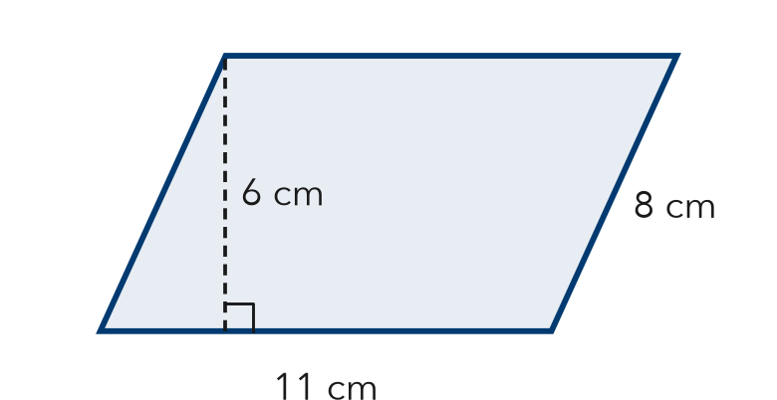
  Show your work.

2. Find the area of each parallelogram with base b and height h.
a. b = 12 ft, h = 7 ft ft² | b. b = 9 m, h = 9 m m²
c. b = 20 in, h = 4 in in² | d. A = 63 m², h = 7 m; b = m

3. Parking Lot. A lot has 10 parking spaces. Each space is a parallelogram with a base of 9 ft and a perpendicular height of 18 ft. What total area do the spaces cover?

Show your work.
Answer ft²

4. Mural. A mural is painted on a parallelogram-shaped wall section. The area is 108 ft² and the base is 12 ft. What is the perpendicular height?
Answer ft

5. Find the Error. A parallelogram has a base of 10 cm, a slanted side of 7 cm, and a height of 5 cm. Kiara says its area is 70 cm². Explain her mistake and find the correct area.

CHECK YOURSELF | □ I can do this on my own | □ I need a little help | □ I have a question about #
AT HOME Find a parallelogram shape at home or on the street (a tile, a sign, a parking space). Show someone where its base and height are.
Name Date Period
Lesson 5-1 · Homework Packet · Sheet 2 of 2
Area of Rhombuses
Maryland Standard 6.G.A.1 · Learning target — I can find the area of a rhombus using the base and height or the two diagonals.

REMEMBER  • A rhombus is a parallelogram, so A = b × h works.  • With the diagonals: A = (d1 × d2) ÷ 2. Do not forget to divide by 2. | WORKED EXAMPLE  Find the area: diagonals 12 cm and 9 cm.  Step 1 Multiply the diagonals: 12 × 9 = 108  Step 2 Divide by 2: 108 ÷ 2 = 54  Answer 54 cm²
PRACTICE show your work · label units

1. Find the area of the rhombus.  Answer cm² | 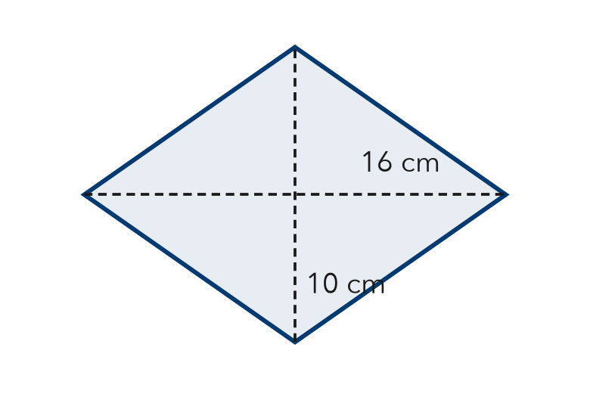
  Show your work.

2. Find the area of each rhombus. Choose the formula that fits.
a. diagonals 14 m and 10 m m² | b. base 9 ft, height 7 ft ft²

3. Window. A rhombus window has an area of 60 ft². One diagonal is 10 ft. Find the other diagonal d.  Answer ft | 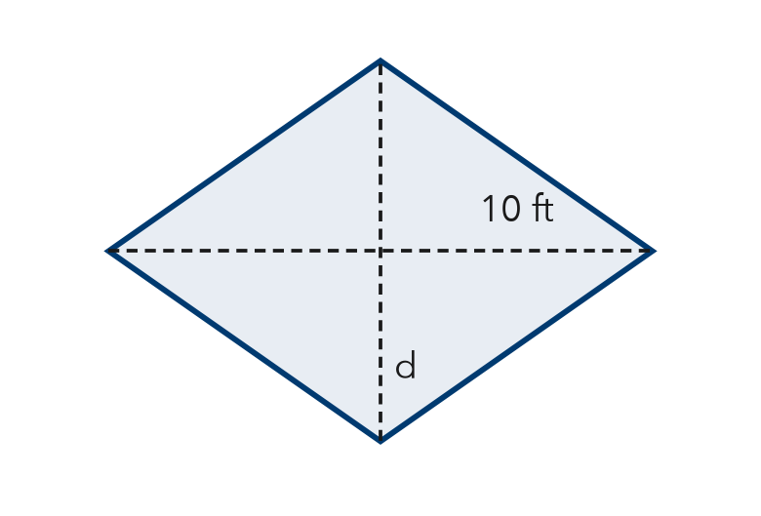

4. Stretch. Rhombus A has diagonals of 12 ft and 8 ft. Rhombus B has a base of 8 ft and the same area as Rhombus A. What is the height of Rhombus B?
Answer ft

5. Find the Error. Ravi says a rhombus with diagonals of 18 in and 8 in has an area of 144 in². Explain his mistake and find the correct area.

TEST PRACTICE choose the best answer
6. A rhombus has sides of 7 m and a perpendicular height of 5 m. What is its area?
A 12 m² | B 17.5 m² | C 35 m² | D 49 m²

7. A rhombus has diagonals of 20 in and 9 in. What is its area?
A 29 in² | B 45 in² | C 90 in² | D 180 in²

CHECK YOURSELF | □ I can do this on my own | □ I need a little help | □ I have a question about #

