Name |  | Date |  | Period
Lesson 5-3 · Session 1 · Version 2
Guided Practice · Version 2
Trapezoids by Decomposing
VOCABULARY read and say each word before you begin
trapezoid  Spanish: trapecio | A four-sided shape with one pair of parallel sides. | top base and bottom base
parallel  Spanish: paralelo | Sides that stay the same distance apart. | the two bases
base  Spanish: base | One of the two parallel sides of a trapezoid. | b1 (top), b2 (bottom)
height | The perpendicular distance between the two parallel base lines. | h, meets bases squarely
decompose  Spanish: descomponer | Break a figure into simpler shapes. | rectangle + 2 triangles
EXPLORE TOGETHER Class Launch · 8–10 min
1. Craft Room Tabletop  Ms. Rivera’s craft tabletop is an isosceles trapezoid. The top base is 10 in., the bottom base is 22 in., and the height between the bases is 15 in.  a. Sketch. Help Maya draw the tabletop. Label the bases 10 in. and 22 in. and the 15 in. height.  b. Decompose. Show how Maya can split the tabletop into a rectangle and two matching triangles. Rectangle area: ______ in²  c. Triangles. Find the leftover base length: ______ − ______ = ______ , split in half: ______ in. each. Both triangles: ______ in²  d. Total. Find the tabletop’s area by adding the pieces. ______ + ______ = ______ in² | e. Sketch. Draw and label Ms. Rivera’s tabletop on the grid below. Let one square stand for a convenient number of units, and mark the perpendicular height with a square corner.  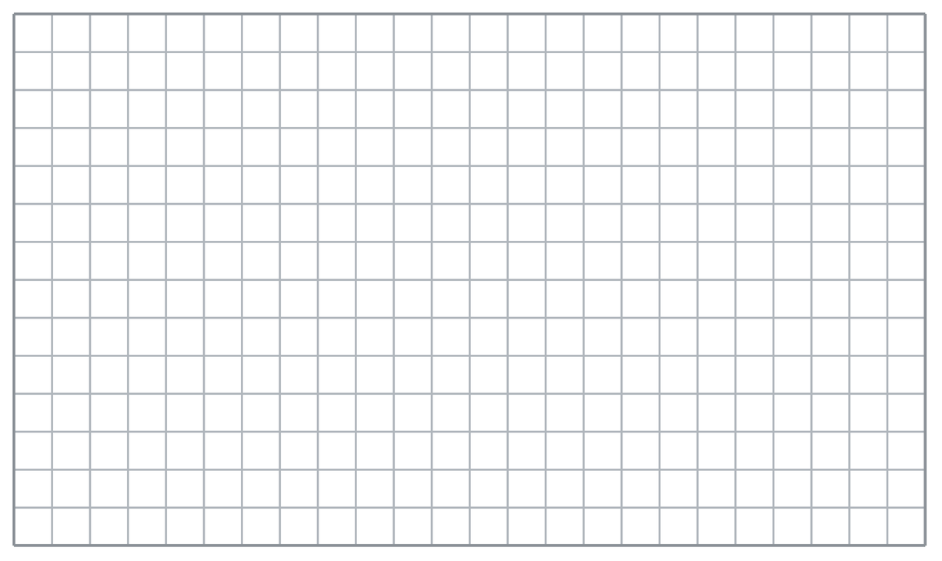
  TURN AND TALK
  Why must the two end triangles be the same size on this tabletop?
PRACTICE WITH A PARTNER You Do Together · 10–12 min
2. Window Frame. A trapezoid window has a top base of 13 cm, a bottom base of 25 cm, and a height of 11 cm. Its two slanted sides are equal.
a. Rectangle piece Find its area in cm²: __________
b. Both triangles together Find their combined area in cm²: __________
PARTNER TALK
How does cutting the window into simpler shapes make the area easier to find?

3. Right-Angle Deck. A deck is a trapezoid with one square corner. Its parallel sides measure 16 ft and 24 ft, and the height between them is 10 ft.  a. Sketch Mr. Chen’s deck and show the decomposition. Rectangle piece __________  b. Total deck area Add the rectangle and triangle areas: __________ | c. Sketch. Draw and label Mr. Chen’s deck on the grid below. Let one square stand for a convenient number of units, and mark the perpendicular height with a square corner.
  PARTNER TALK
  Why does a deck with a square corner need only one triangle instead of two?

4. Bus Shelter Roof. A roof panel on a bus shelter is an isosceles trapezoid. The top base is 8 m, the bottom base is 18 m, and the height between them is 6 m.
a. Rectangle piece Find its area in cm²: __________
b. Both triangles together Find their combined area in cm²: __________
PARTNER TALK
How do you know the leftover bottom splits into two equal pieces?

PRACTICE ON YOUR OWN You Do · 8 problems · 18–20 min
5. Stage Apron. A stage apron is an isosceles trapezoid with bases of 17 m and 27 m and a height of 10 m.  Help Theo decompose the stage apron on a sketch and find its total area  Hint Draw perpendicular cuts to separate the two end triangles from the middle rectangle, then add the areas of all three pieces.  Answer Ms. Brooks’s stage apron: total area in m² | Sketch. Draw and label the stage apron on the grid below. Let one square stand for a convenient number of units, and mark the perpendicular height with a square corner.
  Show your work.

6. Corner Garden. A garden is a trapezoid with one square corner. Its parallel sides are 11 yd and 19 yd, and the height between them is 13 yd.  Help Sofia sketch Mr. Patel’s garden, decompose it, and find its area  Hint Separate the garden into a rectangle and one triangle. Subtract the shorter parallel side from the longer one to find the triangle’s base.  Answer Mr. Patel’s garden: area in yd² | Sketch. Draw and label the stage apron on the grid below. Let one square stand for a convenient number of units, and mark the perpendicular height with a square corner.
  Show your work.

7. Tray and Mat. A lunch tray is an isosceles trapezoid with bases 19 in. and 29 in. and a height of 16 in. A rectangular placemat measures 24 in. by 16 in.
Find each area, then explain whether Elena’s sign and poster have the same area.
Hint Decompose the sign into a rectangle and two triangles, then find the poster’s area separately before comparing.
Answer sign area, poster area, same or not

8. Concession Counter. A concession counter is an isosceles trapezoid with bases of 16 in. and 28 in. and a height of 9 in.  Help Amir decompose the concession counter on a sketch and find its total area  Hint Separate the counter into a middle rectangle and two matching end triangles, then add the areas of all three pieces.  Answer Ms. Williams’s concession counter: total area in in² | Sketch. Draw and label the stage apron on the grid below. Let one square stand for a convenient number of units, and mark the perpendicular height with a square corner.
  Show your work.

9. Parking Strip. A parking strip is a trapezoid with one square corner. Its parallel sides are 9 yd and 17 yd, and the height between them is 12 yd.  Sketch the strip, show its rectangle and triangle pieces, and find its total area  Hint Separate the strip into a rectangle and one triangle. The difference between the parallel sides gives the triangle’s base.  Answer Mr. Patel’s garden: area in yd² | Sketch. Draw and label the stage apron on the grid below. Let one square stand for a convenient number of units, and mark the perpendicular height with a square corner.
  Show your work.

10. Isosceles Trapezoid. A trapezoid has a top base of 8 m, a bottom base of 14 m, and a height of 5 m. Decompose it and find the area.  Hint A middle rectangle 10 m by 6 m plus two triangles with bases totalling 8 m.  Answer m² | 11. Right Trapezoid. A trapezoid has bases of 6 in. and 10 in. and a height of 4 in., with one square corner. Decompose and find the area.  Hint A 7-by-6 rectangle plus a triangle with base 6 and height 6.  Answer in²

12. Name the Pieces. A trapezoid has bases of 12 cm and 20 cm and a height of 7 cm.
a. What is the area of the middle rectangle piece? __________
b. What is the combined area of the triangle pieces? __________
Hint The rectangle uses the shorter base; the triangles share the extra 10 cm.
Answer a and b
ANALYZE THE ERROR 5 min
13. Read the work below. Explain the mistake, then show the correct reasoning.
AMINA’S WORK

A trapezoid has bases of 11 m and 21 m and a height of 10 m. Kwame cut it into a rectangle and two triangles, then wrote: ‘Area = 110 m².’
a. Explain the mistake. Amina’s middle rectangle is correct, but she used only its area as the trapezoid’s total. Complete the sentence: Amina left out __________. | b. Show correct work by finding the missing triangle areas and adding them to the rectangle’s area  Correct answer
  Show the correct work.
STRETCH YOUR THINKING multi-step reasoning · 8 min
14. Deck Plan. A deck is a trapezoid with bases of 10 ft and 18 ft and a height of 6 ft.
a. Decompose the stage and find the area of each piece.
b. Find the total area of the stage.
c. Stage flooring costs $7 per square foot. Find the total cost.
Answer the pieces, the total area, and the cost
TEST PRACTICE multiple choice · fill one box · 6 min
15. A trapezoid can be decomposed into a rectangle and — | 16. Every piece of a decomposed trapezoid shares the same —
  □ A. circles | □ B. triangles | □ C. cubes | □ D. spheres
  □ A. area | □ B. base | □ C. height | □ D. perimeter

17. A rectangle 9 cm by 4 cm plus a triangle of area 10 cm² gives a total of — | 18. After decomposing, you find the total area by —
  □ A. 40 cm² | □ B. 36 cm² | □ C. 13 cm² | □ D. 46 cm²
  □ A. adding the pieces | □ B. subtracting the pieces | □ C. multiplying them | □ D. dividing them
SPIRAL REVIEW earlier skills · keep them sharp · 6 min
19. From Lesson 5-2 Session 2. A triangle has area 60 cm² and base 15 cm. Find its height.  Answer | 20. From Lesson 5-2 Session 1. A triangle has base 14 m and height 8 m. Find its area.  Answer

21. From Lesson 4-1 Session 1. Write 12 out of 25 as a percent.  Answer | 22. From Lesson 3-2 Session 2. Which is the better buy: 5 lb for $12.50 or 8 lb for $19.20?  Answer
CHECK YOUR UNDERSTANDING 5 min
23. Patio Panel. A patio panel is an isosceles trapezoid. Its top base is 15 ft, its bottom base is 27 ft, and the height between the bases is 10 ft.  a. Sketch the panel and divide it into a rectangle and two triangles. Area of the rectangle piece __________  b. Add the areas of all three pieces. Total area of the panel __________  Hint Subtract the shorter base from the longer base, then divide the difference equally between the two triangle bases.  Answer | c. Sketch. Draw and label Mr. Chen’s deck on the grid below. Let one square stand for a convenient number of units, and mark the perpendicular height with a square corner.
  Show your work.

□ 4 — Can teach it | □ 3 — Got it | □ 2 — Need hint | □ 1 — Need help
Circle your confidence. Star one problem that shows your learning.

