Name Date Period
Lesson 5-4 · Homework Packet · Sheet 1 of 2
Area of Regular Polygons
Maryland Standard 6.G.A.1 · Learning target — I can find the area of a regular polygon by finding the area of one triangle and multiplying.

REMEMBER  • Regular polygon: equal sides, equal angles.  • Lines from the center to each vertex make n congruent triangles. Each one’s height is the apothem.  • A = n × (½ × side × apothem). Use ≈ if rounded. | WORKED EXAMPLE  Regular hexagon: side 8 cm, apothem ≈ 6.9 cm.  Step 1 A hexagon makes 6 congruent triangles.  Step 2 One triangle: ½ × 8 × 6.9 = 27.6  Step 3 Six triangles: 6 × 27.6 = 165.6  Answer ≈ 165.6 cm²
PRACTICE show your work · label units

1. Find the area of the regular octagon. The apothem is rounded.  Answer m² | 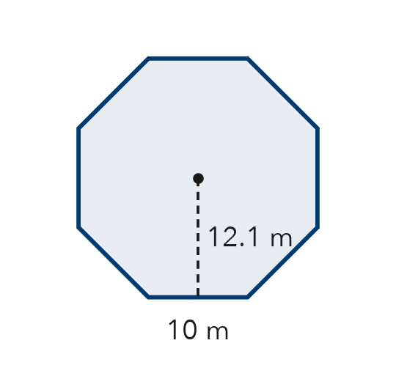
  Show your work.

2. Complete the table. Each apothem is rounded, so mark each area with ≈.
Regular polygon | Side | Apothem | Perimeter | Area
Hexagon | 4 cm | 3.5 cm
Pentagon | 10 ft | 6.9 ft

3. Each regular polygon has perimeter P and rounded apothem a. Find each area. Mark it with ≈.
a. pentagon: P = 30 cm, a ≈ 4.1 cm cm² | b. hexagon: P = 60 ft, a ≈ 8.7 ft ft²

4. Gazebo Floor. A gazebo floor is a regular hexagon with sides of 6 ft and an apothem of about 5.2 ft. Tile costs $3 per square foot. About how much will the tile cost?

Show your work.
Answer

5. Find the Error. Andre says a regular pentagon with sides of 8 cm and an apothem of 5.5 cm has area ½ × 8 × 5.5 = 22 cm². Explain his mistake and find the area.

CHECK YOURSELF | □ I can do this on my own | □ I need a little help | □ I have a question about #
Name Date Period
Lesson 5-4 · Homework Packet · Sheet 2 of 2
Composite Figures
Maryland Standard 6.G.A.1 · Learning target — I can find the area of a composite figure by adding or subtracting the areas of simpler shapes.

REMEMBER  • A composite figure is made of simpler shapes.  • Add the areas of joined shapes. Subtract a piece that is cut out.  • Use the sides you know to find missing sides. | WORKED EXAMPLE  House front: a 10 ft × 6 ft rectangle with a triangular roof on top. The roof’s base is 10 ft and it is 4 ft tall.  Step 1 Rectangle: 10 × 6 = 60  Step 2 Triangle: ½ × 10 × 4 = 20  Step 3 The shapes are joined, so add: 60 + 20 = 80  Answer 80 ft²
PRACTICE show your work · label units

1. Find the area of the L-shaped figure. All corners are right angles.  Answer m² | 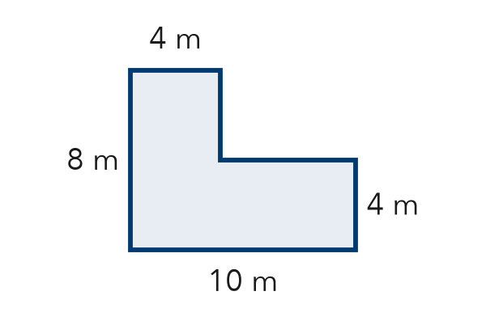
  Show your work.

2. Write add or subtract to tell how you would find each area.
a. a wall, not counting its window: | b. a bedroom plus its closet:

3. Find the area of the T-shaped figure. All corners are right angles.  Answer in² | 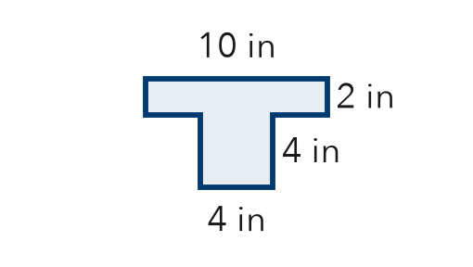

4. A triangle notch 4 cm deep is cut from the top of a rectangle. Find the area that is left.  Answer cm² | 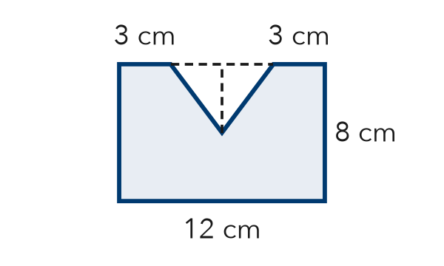

5. Backyard. A yard is a rectangle 20 ft by 12 ft. A square garden 5 ft on each side sits in one corner and will not be paved. Find the paved area.
Answer ft²

TEST PRACTICE choose the best answer
6. A rectangle 9 m by 6 m has a square 2 m by 2 m cut out. What area is left?
A 50 m² | B 58 m² | C 54 m² | D 13 m²

7. A 10 in by 4 in rectangle is joined to a triangle with base 4 in and height 3 in. What is the total area?
A 34 in² | B 40 in² | C 46 in² | D 52 in²

CHECK YOURSELF | □ I can do this on my own | □ I need a little help | □ I have a question about #

