Name |  | Date |  | Period
Lesson 5-4 · Session 1
Guided Practice
Area of Regular Polygons
Use the given rounded heights to estimate areas. Mark estimated answers with ≈.
VOCABULARY read and say each word before you begin
regular polygon  Spanish: polígono regular | A polygon with all sides equal and all angles equal. | stop sign, hexagon tile
decompose  Spanish: descomponer | Break a figure into simpler shapes. | hexagon 6 triangles
congruent  Spanish: congruente | Exactly the same size and shape. | all center triangles match
composite figure  Spanish: figura compuesta | A shape built from two or more simple shapes. | triangles joined together
area  Spanish: área | How much flat space is inside a shape. | add up all the pieces
EXPLORE TOGETHER Class Launch · 8–10 min
1. Hexagon Gazebo Floor  A gazebo floor is a regular hexagon with 6 equal sides of 9 ft. A triangle drawn from the center out to one side has an approximate height of 7.8 ft.  a. Decompose. Sketch the floor and draw a line from the center to each corner. Triangles formed: ______  b. One Piece. Area of ONE triangle: ½ × ______ × ______ = ______ ft²  c. Total. Multiply by the number of triangles. ______ × ______ = ______ ft²  d. Reasoning. Why does the number of triangles match the number of sides? __________ | e. Sketch. Draw and label the figure on the grid below. Let one square stand for a convenient number of units, and mark the perpendicular height with a square corner.​  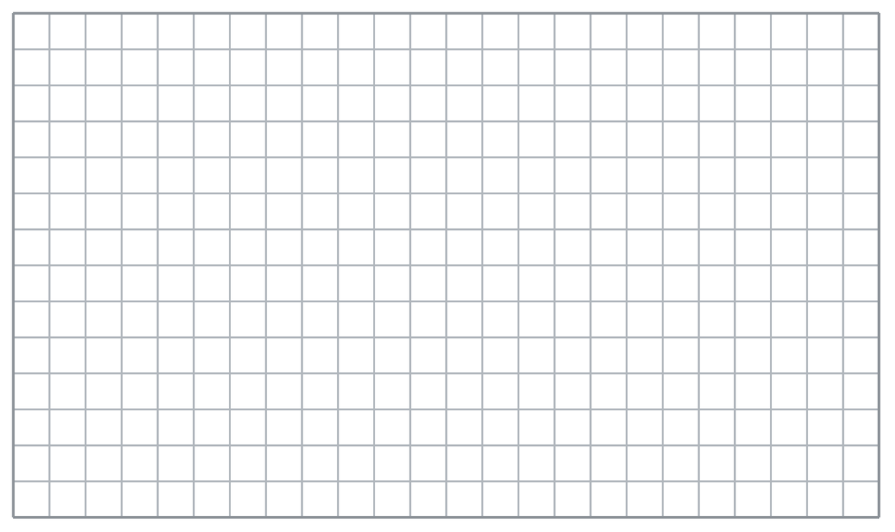
  TURN AND TALK
  How do you know every one of those triangles has exactly the same area?
PRACTICE WITH A PARTNER You Do Together · 10–12 min
2. Pentagon Sign. A regular pentagon road sign has 5 equal sides of 16 in. Each triangle drawn from the center has an approximate height of 11 in.
a. Area of ONE triangle: ½ × __________
b. Area of the whole sign __________
PARTNER TALK
Why is finding one triangle enough to reach the area of the whole sign?

3. Decagon Tabletop. A regular decagon tabletop has 10 equal sides of 6 cm. Each triangle drawn from the center has an approximate height of 9 cm.  a. Sketch the tabletop with all its triangles. One triangle __________  b. Total area of the tabletop __________ | c. Sketch. Draw and label the figure on the grid below. Let one square stand for a convenient number of units, and mark the perpendicular height with a square corner.​
  PARTNER TALK
  How would the total change if the tabletop had more sides of the same length?

4. Stepping Stone. A stepping stone is a regular octagon with 8 equal sides of 7 cm. Each triangle drawn from the center has an approximate height of 8 cm.
a. Area of ONE triangle: ½ × __________
b. Area of the whole stone __________
PARTNER TALK
Where does each triangle’s height start and end inside the stone?

PRACTICE ON YOUR OWN You Do · 8 problems · 18–20 min
5. Flower Bed. A flower bed is a regular hexagon with 6 sides of 24 ft. Each triangle drawn from the center has an approximate height of 21 ft.
Find the area of the flower bed
Hint Find the area of one center triangle first, then scale it up by how many triangles the shape has.
Answer area in ft²

6. Pentagon Patio. A patio is a regular pentagon with 5 sides of 18 m. Each triangle drawn from the center has an approximate height of 12.4 m.  Sketch the patio, decompose it, and find its area  Hint Draw every triangle from the center. They all share the same height, so one calculation does most of the work.  Answer area in m² | Sketch. Draw and label the figure on the grid below. Let one square stand for a convenient number of units, and mark the perpendicular height with a square corner.​
  Show your work.

7. Jamal’s Tile. A tile is a regular hexagon with 6 sides of 10 cm and an approximate center-triangle height of 9 cm. Jamal says the tile’s area is 45 cm².
Justify or correct Jamal’s answer.
Hint Compare what Jamal found with what the whole tile needs. How many pieces make up the tile?
Answer true area (Is Jamal right?)

8. Window Grate. A window grate is a regular hexagon with 6 sides of 14 in. Each triangle drawn from the center has an approximate height of 12 in.  Sketch the grate, decompose it, and find its area  Hint Find one center triangle first, then scale it up by the number of sides.  Answer area in in² | Sketch. Draw and label the figure on the grid below. Let one square stand for a convenient number of units, and mark the perpendicular height with a square corner.​
  Show your work.

9. Band Platform. A band platform is a regular pentagon with 5 sides of 20 m. Each triangle drawn from the center has an approximate height of 14 m.  Find the area of the platform  Hint All five triangles share the same base and height, so one calculation does most of the work.  Answer area in m² | 10. Regular Octagon. A regular octagon has sides of 12 in. A triangle from the center to one side has a height of 14.5 in. Find the octagon’s area.  Hint One triangle is ½ × 12 × 14.5; there are 8 of them.  Answer in²

11. Regular Hexagon. A regular hexagon has sides of 10 cm and a triangle height of 8.7 cm from the center. Find its area.  Hint One triangle is ½ × 10 × 8.7; there are 6.  Answer cm² | 12. Count the Triangles. A regular pentagon has sides of 6 m and a triangle height of 4.1 m.  a. How many identical triangles make the pentagon? __________  b. Find the pentagon’s area. __________  Hint A pentagon has 5 sides, so 5 triangles.  Answer a and b
ANALYZE THE ERROR 5 min
13. Read the work below. Explain the mistake, then show the correct reasoning.
LENA’S WORK

A regular pentagon has 5 sides of 22 in. and an approximate center-triangle height of 15 in. Lena wrote: ‘A = 22 × 15 × 5 = 1,650 in².’
a. Explain the mistake. Lena used the right base and height. What is wrong with her first step? | b. Show correct work  Correct answer
  Show the correct work.
STRETCH YOUR THINKING multi-step reasoning · 8 min
14. Tile Design. A floor uses regular hexagon tiles with sides of 8 cm and a triangle height of 6.9 cm.
a. Find the area of one hexagon tile.
b. Find the total area covered by 25 tiles.
c. Explain why finding one triangle first makes this problem easier.
Answer tile area, total area, and your explanation
TEST PRACTICE multiple choice · fill one box · 6 min
15. A regular hexagon splits into how many identical triangles? | 16. One triangle has area 20 cm² in a regular pentagon. The pentagon’s area is —
  □ A. 6 | □ B. 3 | □ C. 8 | □ D. 12
  □ A. 20 cm² | □ B. 100 cm² | □ C. 25 cm² | □ D. 4 cm²

17. To find a regular polygon’s area you multiply one triangle’s area by the — | 18. A regular octagon splits into how many triangles?
  □ A. height | □ B. side length | □ C. number of sides | □ D. perimeter
  □ A. 16 | □ B. 6 | □ C. 4 | □ D. 8
SPIRAL REVIEW earlier skills · keep them sharp · 6 min
19. From Lesson 5-3 Session 2. A trapezoid has bases 6 cm and 10 cm and height 5 cm. Find its area.  Answer | 20. From Lesson 5-2 Session 1. A triangle has base 12 m and height 7 m. Find its area.  Answer

21. From Lesson 4-4 Session 1. Find 35% of 200.  Answer | 22. From Lesson 3-3 Session 1. Scale 4 : 7 by 6.  Answer
CHECK YOUR UNDERSTANDING 5 min
23. Hexagon Planter. The top of a planter is a regular hexagon with 6 sides of 30 cm. Each triangle drawn from the center has an approximate height of 26 cm.
a. Area of ONE center triangle __________
b. Area of the whole planter top __________
Hint One triangle first, then count how many identical triangles a regular hexagon breaks into.
Answer

□ 4 — Can teach it | □ 3 — Got it | □ 2 — Need hint | □ 1 — Need help
Circle your confidence. Star one problem that shows your learning.

